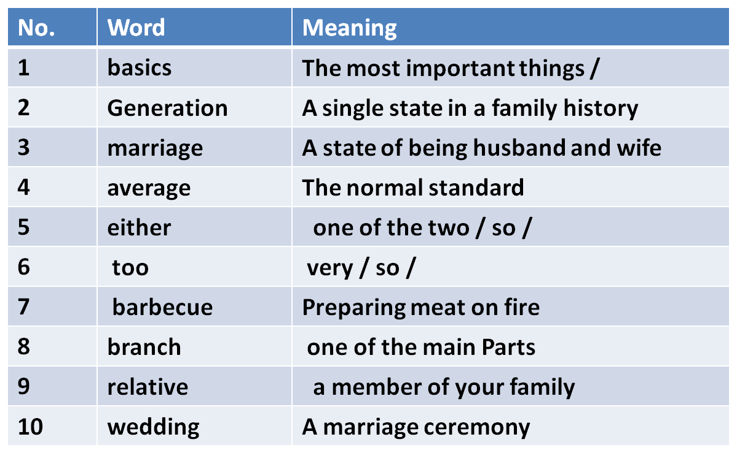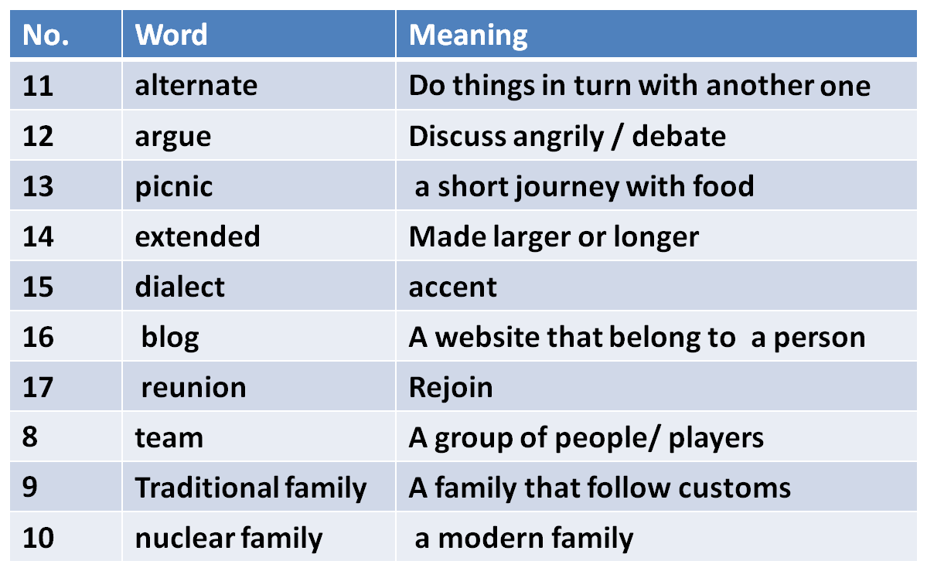
Fifth Lecture
Grammar – Vocabulary - Reading
Chapter Three

Elements of Lecture 5

I- Previewing Vocabulary
2- Present Simple Tense
3- Negative Forms
4. Forming Questions
5- Spelling & Pronunciation Of Final – es
6- Scanning & Skimming Reading Text

1. Vocabulary Previewing ( Interaction Textbook pages 45, 50, 56,57, 61)

Vocabulary Previewing ( pages 45, 50, 56,57, 61)

I. Exercise
1. I speaks speak English fluently and Reem does, ___________
a. either b. too c. so d. neither

2. My ________ in this term is 84.3 %.
a. marriage b. package c. garage d. average
3. All members in __________ families were living in one house.
a. traditional b. nuclear c. rich d. bad
4. We went for a picnic by the sea and had a ___________.It was a very
delicious meal.
a. problem b. barbecue c. test d. camera
5. My uncle and my aunt are called my _______________.
a. relatives b. brothers c. friends d. neighbors
6. Group of people/ playing a sport is called a ________________.
a. family b. friend c. team d. match

2. Simple Present:
The Importance of Time
Verb tense expresses the time of an event or action. Time and how it is expressed in writing is very important to English readers. The English language has twelve different tenses. In this lesson, we will review the meaning of each verb tense.
Use the simple present tense to tell about things that happen again and again.
The Present Tense
Americans eat turkey on Thanksgiving.
Japanese always bows to others.
The Simple Present Tense
This tense also expresses general truths or facts that are timeless.

Snow falls in the December in Minnesota.
Water boils at 100 degrees Celsius.
Use the simple present tense to tell facts.
The Present Tense
Water freezes at 32 degrees.
32º
Triangles have three sides.
Daily Customs
She usually works on her basket after dinner.
He usually drinks tea after a meal.
They go to a dance every Sunday.
They take a walk with their son every day.
Exercise

1. She _______________ her mother in the house.
a. help b. doesn’t help c. don’t help d. doesn’t helps

2. The men __________ their work in the best way.
a. don’t do b. does c. doesn’t do d. don’t
3. _______________ doesn’t smoke nowadays .
a. My brothers b. You c. My father d. I
4. ____ they play football every week?
a. Do b. Does c. Are d. Done
5. Why ____ he always come late?
a. is b. do c. does d. was

Use contractions like don’t and doesn’t for
negative statements in speaking or in informal
writing.
3. Negative Statements
Some women don’t wear a lot of makeup.
Maria doesn’t eat pizza.

The Simple Present Tense
Expresses a habit or often repeated action. The action can be a habit, a hobby, a daily event, a scheduled event or something that often happens. It can also be something a person often forgets or usually does not do.
Adverbs of frequency such as, often, seldom, sometimes, never, etc. are used with this tense.

She goes to work everyday.
They always eat lunch together.


§ Negative and question forms
Use DOES (=the third person of the auxiliary'DO') + the infinitive of the verb.
He wants. Does he want? He does not want.

4. Simple Present –Forming Questions
We have two forms forms:-
A. Doesn’t When the verb ends with s:-
Kamal Lives in an apartment.
Does Kamal live in an apartment ?
Where does Kamal live? – In an apartment

B. Don’t when the verb is infinitive without to
We live in an apartment
Do you live in an apartment ?
Where do you live? We live in ----

Affirmative

Interrogative

Negative

I think

Do I think?

I do not think

You think

Do you think?

You don't think

he, she, it thinks

Does he, she, it think?

He, she, it doesn't think

We think

Do we think?

We don't think

You think

Do you think?

You don't think

Present Simple, form:

Example: to think, present simple

.Put in : do/don't/does/doesn't

1.Excuse me, _____________ you speak English?

. .Where's Ann? I _____________ know.2

George is a good tennis player but he ___________ play very often.3

Write the questions for the following answers. (Present Simple)

. ?__________________________________1.
I work in a bank.

?_____________________________________2.
My brother is an engineer.

3.___________________________________?
He lives in an apartment building.

Put an –s or –es ending on third-person singular (he, she, it).
5. Third-Person Singular (Spelling and Pronunciation)
He need a shirt.
She want an apple.
It catch the stick.
s
s
es

Present Simple, third person singular
Note:
he, she, it
in the third person singular the verb,
always ends in :
s
he want
s
she need
s
Grammatical View
A:


Add
es
to verbs ending in: pronunciation : /z/
ss
x
sh
ch
he pass
she catch
he fix
it push
B.
o
es
es
es
es
He go
es
Third-Person Singular

Verbs ending in
y
;the third person changes the
to
ies
fly
fl
cry
C:
y
ies
cr
ies
Exception:
If there is a vowel before the :
y
s
pray
play
play
pray
s
Third-Person Singular

Third-person singular forms of have, do, and go are not regular.
Irregular Forms
have
do
go
does
has
goes
He has a new shirt.
She does the work.
He goes to school.

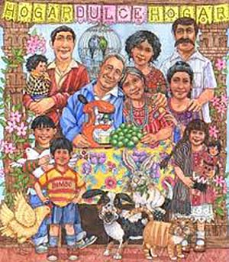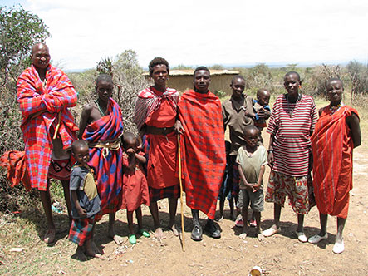
6. Scanning & Skimming Reading paragraph
( Interaction, Page 47)
These were all family members- grandparents, aunts, uncles, cousins, children, and grandchildren. But now this traditional family is breaking into smaller groups.
The traditional family in Mexico was also big. One generation ago, the average Mexican woman had seven children. Today, she has an average of only 2.5 children. Now , without so many children, families don’t need to spend so much money on basics, such as food, clothing and housing.
Families in almost every country are changing. This is true in rich countries and poor ones. It is true in Africa, the Americas, Asia and Europe. All over the world, families are getting smaller.
In North Africa , in the past, many people lived in extended families. Fifty to hundred people lived together in a group of houses.

Scan and skim the previous paragraph

1. The underlined word “ ones” refers to _______________.
a. families b. countries c. children d. Americas

2. Food and clothing are __________ .
a. grandchildren b. families c. members d. basics
3. The underlined pronoun “ she” refers to_______________ .
a. a brother b. an aunt c. a Mexican women d. a family
4. How many children did a Mexican woman have?
a. 2.5 b. 7 c. 4 d. 3
5. What happened to the traditional family?________________
a. getting larger b. breaking into smaller groups
c. became rich d. had no children

1. Ask your friends questions about what they do at different times. Also ask about their families.
- "What time do you get up?" - "When do your brothers go to bed?"
Write down the questions and give them to your teacher for checking.

Activities
Exercise
1. My uncle _________ us every week.
a. visit b. visits c. visiting d. has visited

2. Water __________ at 100 degree centigrade.
a. boiled b. boiling c. boil d. boils
3. They _______________ the work at 7 every morning.
a. begins b. have begun c. begin d. beginning
4. ____ drinks milk before sleeping.
a. The child b. The children c. The boys d. You
5. I usually ____ carefully when it rains.
a. drove b. drives c. driving d. drive
6. My mother cooks rice and meat _____________________.
a. now b. yesterday c. once a week d. last month

Exercise
1. The underlined letter /s/ in the word ‘ leaks” has the same
pronunciation of the letter /s/ in the word: ____________ .
a. hats b. toys c. windows d. rains

2. The underlined letter /es/ in the word ‘ fixes” has the same
pronunciation of the letter /s/ in the word: ____________ .
a. employs b. rooms c. matches d. helps

3. The underlined letter /s/ in the word ‘ goes” has the same
pronunciation of the letter /s/ in the word: ____________ .
a. heats b. repairs c. breaks d. catches

