Lecture Three
Eng 101
Grammar – Vocabulary - Reading
Chapter Three

Elements of the Lecture
I- Articles ( A , An )
2- Pronouns
3- Verbs to Be
4. Have / Has / Had
5. Previewing Vocabulary

1. Articles- Indefinite
There are 2 indefinite articles in English:
A= used before singular nouns that begin with consonants.
An= used before singular nouns that begin with vowels
Consonants= all letters in English except ( a , e , i, o , u )
Vowels= ( a, e , i ,o , u )
Examples.
__book __orange __ car __story __ egg __lecture
__ man __umbrella __apple __ pencil __table __ email
Note: 1.Remember that all the above words are Singular
2. We can’t use ( A or An ) before proper nouns, cities, days, months, etc

I. Exercise ( an & a )
1. Could you please give me _____ piece of cake?
a. an b. two c. a d. many

2. ___ dog is ____ animal.
a. An/a b. An/an c. A/an d. A/a
3. I visited ____Ahmed last week.
a. an b. the c. a d. Nothing
4. The capital of Saudi Arabia is ____ Riyadh.
a. Nothing b. an c. a d. the
5. I finished ____ unit in English language course.
a. an b. a c. three d. few
6. I take___ umbrella when it rains.
a. a b. an c. two d. several

(The ) – Definite Article
The = definite article (a specific object that both the person speaking and the listener know)
The car over there is fast.
The teacher is very good, isn't he?

The first time you speak of something use "a or an", the next time you repeat that object use "the".
I live in a house. The house is quite old and has four

DO NOT use an article with countries, states, counties or provinces, lakes and mountains except when the country is a collection of states such as "The United States".
He lives in Washington near Mount Rainier.
They live in northern British Columbia.

Use an article with bodies of water, oceans and seas -
My country borders on the Pacific Ocean

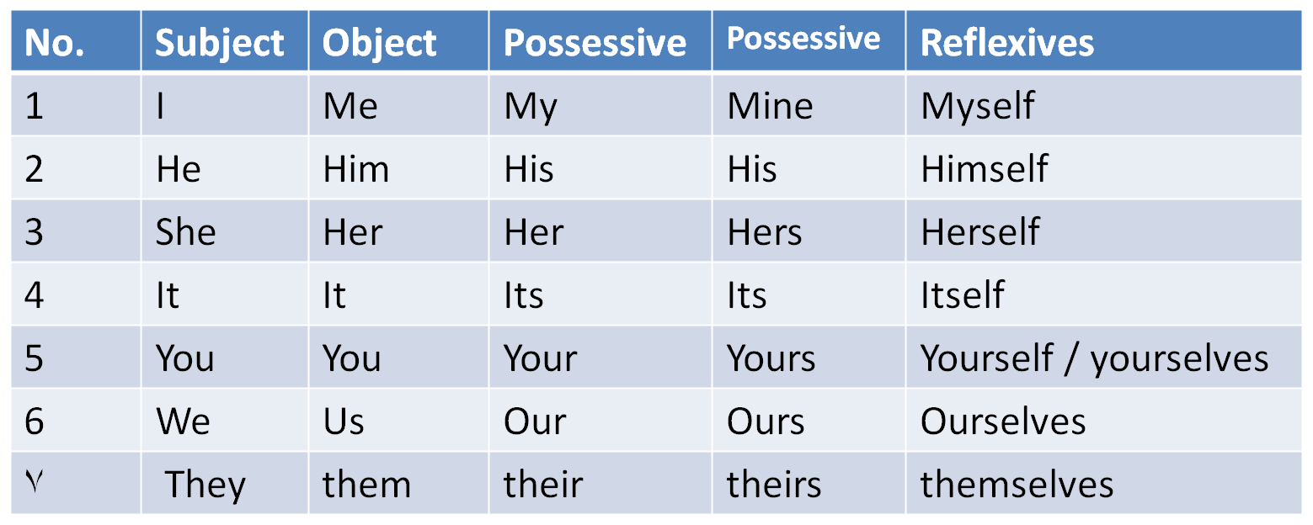
DO NOT use an article when you are speaking about things in general
I like Russian tea.
She likes reading books.

DO NOT use an article when you are speaking about meals, places, and transport
He has breakfast at home.
I go to university.
He comes to work by taxi.

2. Word & Pronoun Reference
A. Personal Pronouns

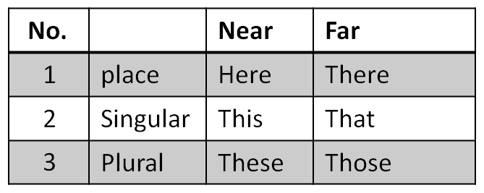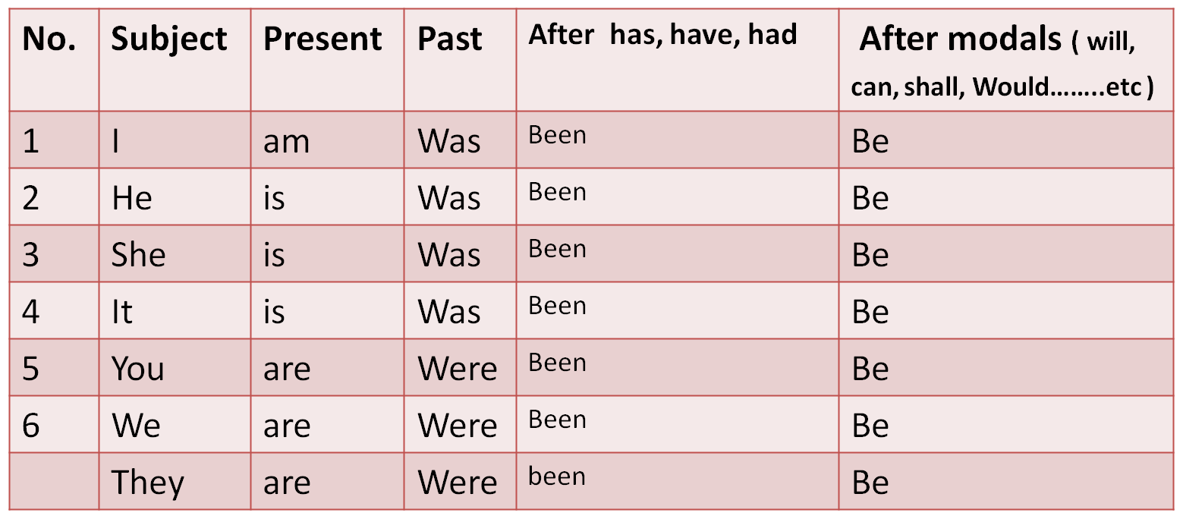
Object Pronouns - me, you, him, her, it, us, you, them serve as the object of a verb.Give me the book.
He told you to come tonight.
She asked him to help.
They visited her when they came to New York.
She bought it at the store.
He picked us up at the airport.
The teacher asked you to finish your homework.
I invited them to a party.

Subject Pronouns - I, you, he, she, it, we, you, they function as the subject of a sentence:I live in New York.
Do you like playing tennis?
He doesn't want to come this evening.
She works in London.
It won't be easy.
We are studying pronouns at the moment.
You went to Paris last year, didn't you?
They bought a new car last month.

Possessive Pronouns - mine, yours, his, hers, its, ours, yours, theirs show that something belongs to someone. Note that the possessive pronouns are similar to possessive adjectives (my, his, her). The difference is that the object follows the possessive adjective but does not follow the possessive pronoun. For example - Possessive Pronoun: That book is mine. - Possessive Adjective:
That is my book.
That house is mine.
This is yours.
I'm sorry, that's his.
Those books are hers.
Those students are ours.
Look over there, those seats are yours.
Theirs will be green.

2. Word & Pronoun Reference
B. Demonstrative Pronouns

Demonstrative Pronouns - this, that, these, those refer to things. 'this' and 'these' refer to something that is near. 'that' and 'those' refer to things that are farther away.

This is my house.
That is our car over there.
These are my colleagues in this room.
Those are beautiful flowers in the next field.

II. Exercise
1. The doctor gave__________ a lecture about pronouns.
a. we
b. us
c. our
d. ours
2. ______ friend sent an email to the doctor regarding the homework.
a. I
b. Me
c. Mine
d. My

II. Exercise
3. Hani visits _______ every week.
a. them
b. they
c. theirs
d. their
4. _______ are the books you told me about.
a. That
b. These
c. You
d. Their

II. Exercise
5. The building you need is ___________.
a. these
b. those
c. there
d. her
6. That car over there is __________.
a. mine
b. me
c. my
d. I

3. Verbs to Be

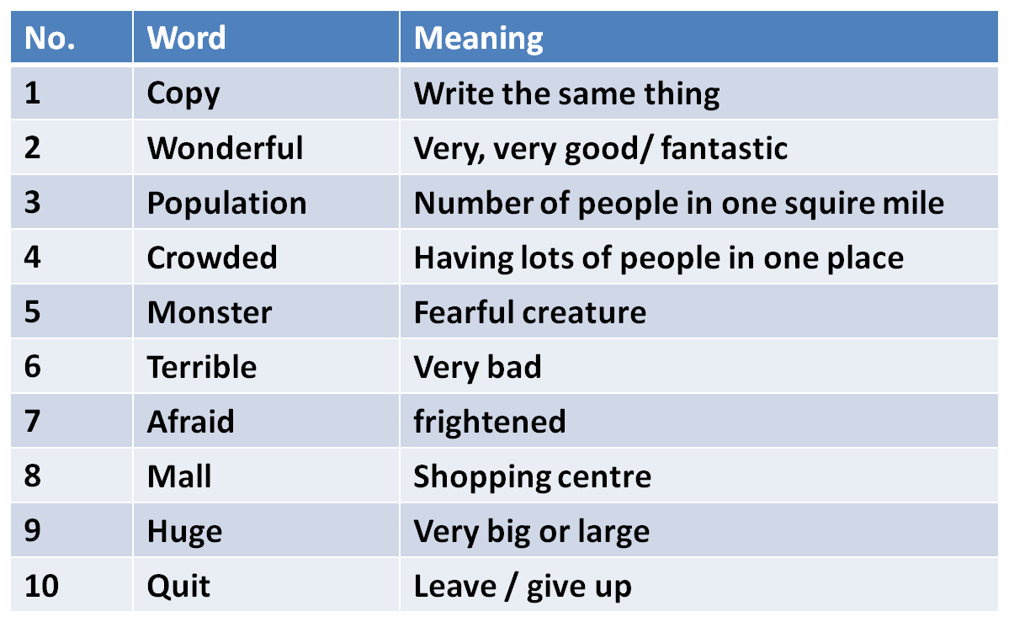
III. Exercise ( verbs to be )
1. She______ at home now.
a. be b. was c. is d. been

2. My friends will_____________ here after 15 minutes.
a. are b. were c. been d. be
3. I ____in Riyadh two weeks ago.
a. was b. am c. be d. were
4. We _________ ready to start now.
a. were b. aren’t c. weren’t d. isn’t
5. ____ Hiba at university yesterday?
a. Is b. Are c. Were d. Was
6. Will Rashed___ at university tomorrow?
a. be b. is c. was d. been

4. Verbs to Have
There are THREE forms of HAVE
A. Have= Present comes after ( I , You, They, We or after plural nouns)
B. Has = Present comes after ( He, she , it or after singular nouns )
C. Had= Past comes after all kinds of nouns plural or singular
******************************************************
Exercise:
1. We _______ a lecture in English yesterday. ( has, have , had, having )
2. My friend________ a new car nowadays. ( has, having, had, have)
3. The students _____ studied English for a month.( has, have, had, having)
4. He has a car. He doesn’t have a car. Does he have a car?
5. He has got a car. He hasn’t got a car. Has he got a car?
Note: 1. ( has, have, had) can be used as main verbs like 1 & 2 & 4 in the
exercise or as helping verbs as 3 & 5.

IV. Exercise ( verbs have )
1. She______ a new car nowadays.
a. had b. have c. has d. hasn’t

2. My friends ___________been here for 15 minutes.
a. has b. have c. hasn’t d. aren’t
3. I ____an English lecture yesterday .
a. had b. have c. has d. haven’t
4. Hind _________ a dictionary now.
a. hasn’t b. doesn’t have c. haven’t d. didn’t have
5. Ahmed and Abdullah _________a mathematics test now?
a. has b. have c. doesn’t have d. had
6. _______ she been here before ?
a. Have b. Has c. Is d. Was

5.Vocabulary Previewing ( pages 5+ 18 )

Exercise
1. You can go to the new ___________ and buy whatever you need.
A. hospital B. school
C. mall D. cinema
2. Doctors always advice smokers to give up smoking. The underlined word give up
has the same meaning as:
A. quit B. Start
C. help D. study
3. The children were afraid when they saw the ________________in the Luna park.
A. food C. monster
C. games D. juice

Exercise
4. The phrase “ write the same thing’ means ________________ .
A. cut B. paste
C. copy D. delete
5. The trip to the sea was very, very good. “ very, very good” means:-
A. wonderful B. dangerous
C. terrible D. easy
3. The men, women and children in Saudi Arabia are kind and generous. The
underlined phrase can be replaced by:
A. visitors C. people
C. soldiers D. vehicles

