انجليزي المحاضرة الثانيه

Lecture 2
المحاضرة الثانية
Reading Skill

- Scanning
- Skimming
- Previewing Vocabulary
- Revising some structures
- Writing : Jumbled sentences

SCANNING
Scanning is a technique you often use when looking up a word in the telephone book or dictionary. You search for key words or ideas. In most cases, you know what you're looking for, so you're concentrating on finding a particular answer. Scanning involves moving your eyes quickly down the page seeking specific words and phrases.
When scanning, look for the author's use of organizers such as numbers, letters, steps, or the words, first, second, or next. Look for words that are bold faced, italics, or in a different font size, style, or color. Sometimes the author will put key ideas in the margin.

Do Let’s Scanning
Pulp Friction
Every second, 1 hectare of the world's rainforest is destroyed. That's equivalent to two football fields. An area the size of New York City is lost every day. In a year, that adds up to 31 million hectares -- more than the land area of Poland. This alarming rate of destruction has serious consequences for the environment; scientists estimate, for example, that 137 species of plant, insect or animal become extinct every day due to logging. In British Columbia, where, since 1990, thirteen rainforest valleys have been clearcut, 142 species of salmon have already become extinct, and the habitats of grizzly bears, wolves and many other creatures are threatened. Logging, however, provides jobs, profits, taxes for the government and cheap products of all kinds for consumers, so the government is reluctant to restrict or control it.
1.How many species of salmon have become extinct in BC?
a. 27
b. 31
c. 137
d. 142

Do Scanning
Much of Canada's forestry production goes towards making pulp and paper. According to the Canadian Pulp and Paper Association, Canada supplies 34% of the world's wood pulp and 49% of its newsprint paper. If these paper products could be produced in some other way, Canadian forests could be preserved. Recently, a possible alternative way of producing paper has been suggested by agriculturalists and environmentalists: a plant called hemp.
2.How much of the world's newsprint paper is supplied by Canada?
a. 31 %
b. 49%
c. 34%
d. 19%
Understanding Pronoun Reference
Because a pronoun REFERS to a noun or TAKES THE PLACE OF that noun, you have to use the correct pronoun so that your reader clearly understands which noun your pronoun is referring to.
Therefore, pronouns should
- Agree in number
If the pronoun takes the place of a singular noun, you have to use a singular pronoun.
If a student parks a car on campus, he or she has to buy a parking sticker.
(NOT: If a student parks a car on campus, they have to buy a parking sticker.)
Hint:
Remember:
The words everybody, anybody, anyone, each,
neither, nobody, someone, a person, etc. are singular and take singular pronouns.
Examples:
Everybody ought to do his or her best. (NOT: their best)
Neither of the girls brought her umbrella. (NOT: their umbrellas)

Understanding Pronoun Reference
2. Agree in person
If you are writing in the "first person" (I), don't confuse your reader by switching to the "second person" (you) or "third person" (he, she, they, it, etc.). Similarly, if you are using the "second person," don't switch to "first" or "third.“
When a person comes to class, he or she should have his or her homework ready.
(NOT: When a person comes to class, you should have your homework ready.)

Choosing the Correct Pronoun
Circle the pronoun that agrees in number with its antecedent in each sentence.
- Each of the girls makes (her, their) own clothes.
- The jury finally made (its, their) decision.
- It often seems that television programmers are not concerned with (its, their) viewers.
- Both Tim and Tony write (his, their) mothers twice a week from camp.

Skimming for the topic Main Idea
Hint: Remember that the topic is just a word or noun phrase – a few words. It is not a sentence.
The main idea is in a sentence or two and can be found at the beginning, middle, or end of a paragraph.
Each Paragraph has a main idea.

¹Do you have a favorite season? ²Winter, fall, and spring have many advantages. ³However, summertime is my favorite season because it offers the tranquility of the beach as well as the exhilaration of outdoor sports. ⁴First, sitting on the other side of a sand dune, hidden by sea oats and sedge, I like looking at the Atlantic Ocean, scanning for dolphins and pelicans. ⁵Looking at something larger than I am gives me a sense of awe and gratitude and provides a backdrop for some deep musings.⁶Second, summertime provides me with the chance to go sailing, surfing, and hiking along the shore. ⁷The exercise enhances my sense of well being and creates a feeling of optimism.
The topic of the paragraph is
a. sailing and surfing.
b. summertime.
c. seasons at the beach.
d. ways to develop optimism.
The main idea of the paragraph is
a. sentence 1. b. sentence 2. c. sentence 3. d. sentence 4.

¹Do you have a favorite season? ²Winter, fall, and spring have many advantages. ³However, summertime is my favorite season because it offers the tranquility of the beach as well as the exhilaration of outdoor sports. ⁴First, sitting on the other side of a sand dune, hidden by sea oats and sedge, I like looking at the Atlantic Ocean, scanning for dolphins and pelicans. ⁵Looking at something larger than I am gives me a sense of awe and gratitude and provides a backdrop for some deep musings.⁶Second, summertime provides me with the chance to go sailing, surfing, and hiking along the shore. ⁷The exercise enhances my sense of well being and creates a feeling of optimism.
The topic of the paragraph is
a. sailing and surfing.
b. summertime.
c. seasons at the beach.
d. ways to develop optimism.
The main idea of the paragraph is
a. sentence 1. b. sentence 2. c. sentence 3. d. sentence 4.

I. Read the following essay ,then answer the questions that follow
My name is Elena Sanchez. I am from Mexico, but now I live in California. I'm a student here in English language classes at a small college.
I live in an apartment building. It's on the corner of Olive Street and Sycamore Avenue. My address is 2201 Olive Street. There's a big olive tree in front of the building. There's a park across the street. There are a lot of oak trees in the park. The trees are beautiful in the summer.
A lot of my neighbors are from different countries. The people next to me are from Indonesia. The family across from the Indonesian family is from Colombia.

The stores in this neighborhood are always busy. There's a Korean drugstore and an Armenian flower shop.
There are three restaurants on Olive Street: One Mexican, one Japanese, and one Moroccan-Italian-American.
I like my neighborhood, but I ask myself one question. Where are the Americans?!!!
Now, Answer the following questions

Part one

1. Where is Elena from?

2. Why does she live now in California?

3. What kinds of trees are in California? [ Mention TWO kinds]

4. When are the trees beautiful?

5. Which country are the people who live next to Elena from?

6. What does a Korean store sell?

7. Who is from Colombia?

8. How many restaurants are there in Olive Street?

9. What is in front of the building?

10. Where does Elena go if she wants to buy flowers?

Part Two
- The underlined word " here" LINE 2 refers California
- The underlined word " one" LINE 11 refers to: restaurant
- The underlined pronoun “ me” refers to: ?????
- A word in the passage which has the same meaning as " shops" is stores
- A word in the passage which has the same meaning as " flat" is apartment
- A word in the passage which has the same meaning as " road" is ?????
- A word in the passage which has the opposite meaning of "behind" is in front of
- A word in the passage which has the opposite meaning of "ugly" is ????
- A word in the passage which has the opposite meaning of " free" is ????
- The simple past form of the verb "am" is was
- The simple past form of the verb " are" is ????

Structure
Part One : Circle the correct response
1.Salma and Fatima -----------------from Riyadh.
a. is
b. was
c. has
d. are
2. ___________ your car new?
a. Are
b. Is
c. Aren't
d. Has
3. London ------------------ a country. It is a city.
- is
- aren't
- isn't
- are
- 4. ----------- ant is ---------------- insect.
- An / an
- An / a
- A / an
- A / a
- 5. Are you a doctor? No, ---------------------.
- I'mn't
- amn't
- Iamn't
- I'm not
- 6. Where is the water? ------------------- inside the refrigerator.
- They're
- It
- It's
- He's
- 7. A teacher usually starts a lesson by writing the date------------------the board.
- in
- under
- over
- on
- 8. My friend is from America.---------- lives in New York city.
- I
- We
- He
- It
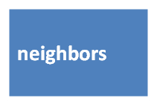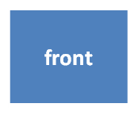
A.Fill in each blank with a word from the box
This store is always ________. There are always lots and lots of people.

2. My_______are from Mexico. They're very nice people.

3. There are two big trees in ________of my house.

4. There is a big apartment_________ on the corner of the street.

5. People in my neighborhood are from ________ countries.

III. Vocabulary
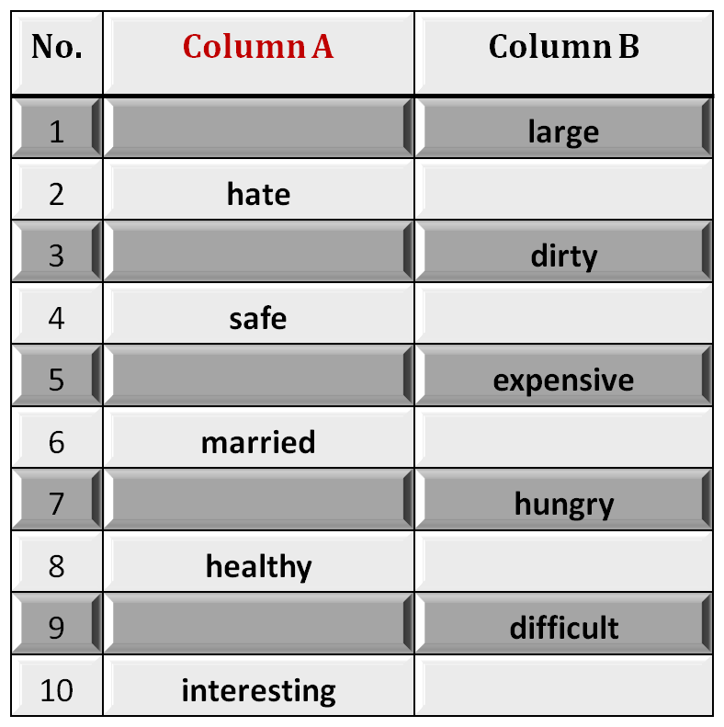
B. Identifying Opposites
Fill in each blank space with the opposite meaning
small
love
clean
dangerous
cheap
single
full
sick
easy
boring

IV. Writing: Jumbled sentences
Rewrite the words in the correct order to make meaningful sentences
weather / very / in / Saudi Arabia / hot / in / The / summer / is.

The weather in Saudi Arabia is very hot in Summer

2. speak / at / The / this / English / university / lecturers.

3. fast / is / Driving / very / your / dangerous / car.

4. red / the / is / book / the / color / of

5. homework / I / my / myself / do / always.

Good **** Luck
End of Lecture 2

