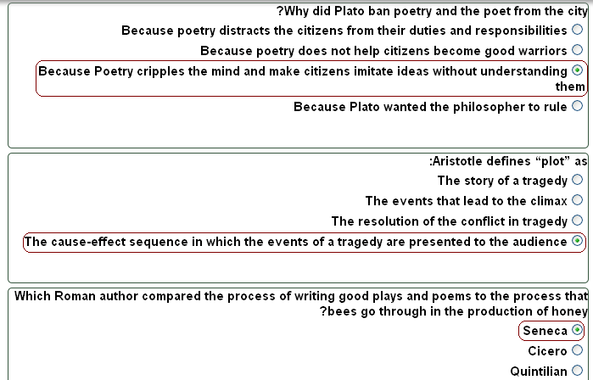
الواجب الأول :.

الواجب الثانـي :..

1.The Formalist school was not interested in the psychology and biography of the author,
or in the politics of literature or the readers’ reactions because:
 | a. | They wanted establish literary scholarship as a distinct and autonomous field of study
 | b. | They wanted to separate psychology from literature
 | c. | They waned to create a new market
 | d. | The psychology and biography of the author was becoming boring

السؤال 2
2. Who said: "The subject of literary scholarship is not literature in its totality but literariness (literaturnost'), i.e., that which makes of a given work a work of literature.”
 | a. | Vladimir Propp
 | b. | Roman Jackobson
 | c. | Viktor Shklovsky
 | d. | Boris Eichenbaum

السؤال 3
3. How many functions did Vladimir Propp establish in the Morphology of the Folktale, and how many types?
 | a. | 7 functions and 31 types
 | b. | 31 functions and 7 types
 | c. | 20 functions and 20 types
 | d. | 10 functions and 10 types

الواجب الثالث .::
Structuralism in literature is a continuation of the work of
Renaissance Humanism
Marxist criticism
Russian Formalism
Traditional criticism
-----------------
Structuralism is not interested in the interpretation of literature, it is interested in
The spirituality of literature
The consumption of literature
The magic of literature
The structures of literature
---------------
Gerard Gennette explains that traditional criticism confuses under “Point of View”:
The question of “who sees?” and the question of “who speaks?
The question of “who writes?” and the question of “who tells?
The question of “who writes?” and the question of “who reads?”
The question of the author with the question of the narrator
----------------
Roland Barthes calls for the “Death of the Author” because:
He hates the author
He wants to liberate the author
He wants the reader to have more freedom to interpret the text
He wants to create competition between the author and the critic

