1
The discipline that studies the nature and use of language is:
Grammar
Applied linguistics
Syntax
Linguistics
2
In that approach, a typical exercise is to translate sentences from the target language into the mother tongue.
Reading approach
Situational approach
Direct approach
Grammar- Translation approach
3
In that approach, Respect is emphasized for the individual.
Reading approach
Grammar- Translation approach
Affective- Humanstic approach
Communicative approach

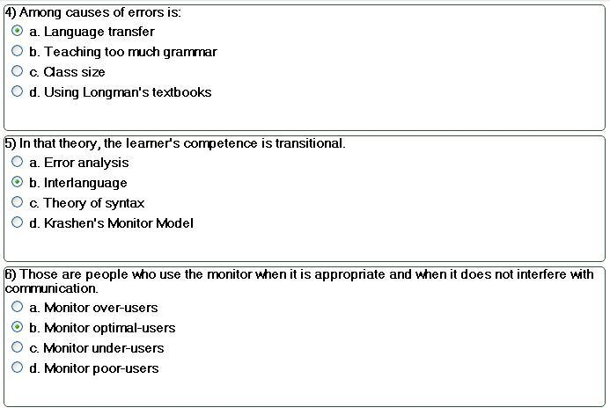

7) The personal judgment of worthiness that is expressed in the attitudes that the individual holds towards himself/herself.
a. Risk-taking
b. Empathy
c. Motivation
d. Self-esteem
2
8) Reading and listening for general understanding is called:
a. Skimming
b. Scanning
c. Planning
d. Socializing
3
9) It offers the possibility of selecting and sequencing different real-life situations rather than different grammatical items, vocabulary topics, or functions.
a. The topic-based syllabus
b. The task –based syllabus
c. The situational syllabus
d. The functional syllabus
4
10) When a test gives consistent results, it is called:
a. Valid
b. Reliable
c. Hard
d. Easy

