CHOOSE THE CORRECT ANSWER

1-If the values of the variable are numbers it is called……

a) - Quantitative variables.
b) - Qualitative Variables.
c) - a + b.
d) - None of the above

2-Measurement that ranks the categories in a certain order

a) – Nominal scale
b) – Ordinal scale
c) – Interval scale
d) – Ratio scale

3-a scale has equal units of measurements but lack stable starting point

a) - Nominal scale
b)-Ordinal scale
c) - Interval scale
d)-ratio scale

4-Consider two persons weight 40 and 80 kg, we can say

a) - the second person is twice as heavy as the first person
b) - the first person is half as heavy as the second person
c) - a + b
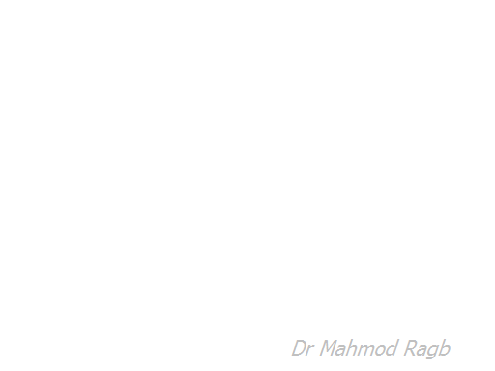
d) - non of the above

5- if a variable has countable values and doesn’t posses any gaps

a) - Discrete variable
b) - cut-off variable
c) - Continuous variable
d) - none of the above

6-(a/ (a + b)) x k is

a) - Rate
b) - proportion
c) - Ratio
d) - a + c

7-if the data values are distinct, separate and countable it is

a) - Discrete data
b) - continuous data
c) - a + b
d) - non of the above

8- if the data values are ranked, counted, order but not measured

a) - Discrete data
b) - Ordinal data
c) - Categorical data
d) - Nominal data

9-a record of how often each value of the variable in question occurs

a) - Frequency table
b) - pie chart
c) - dot plot
d) - non of the above

10-Central Tendency Summarize the data in…………..number

a) – TWO
b) – THREE
b) – ONE
d) – FOUR

11-“Central Tendency Measures” computed from population called

a) – Parameter
b) – rates
c) – Units
d) – none of them

12-The arithmetic mean is

a) – The simplest measure of central tendency
b) – The most obvious measure of central tendency
c) – Summarize the data in one single number
d) – all of the above

13-The difference between the largest and smallest observation in a set of data is

a) – Variance
b) – Range
c) – Central tendency
d) – GPA

14-a Measure that reflect the frequency of sickness producing disease.

a) – Mortality Measure
b) – Morbidity Measure
c) – Disease rate
d) – None of The above

15-Frequency of illness in a society

a) - Morbidity
b) – Disease
c) – Mortality
d) – poor hygiene

16-The Government needs morbidity records to

a) - Establish various public funded programs
b) - make pocket money to sick persons
c) – plan and evaluate the funded programs
d) – a + c

17-Morbidity records needed by insurance companies to

a) – give the insurance policies to sick persons
b) – guide them in the extension of coverage
c) - guide them in the provision of services to their clients
d) – b + c

18-Children disease at school entry age is recorded in

a) School entry data
b) school swimming team data
c) – a + b
d) – none of the above

19-(total cases of a disease at a specific time / number of persons in a population at that specified time) x 1000 is

a) - prevalence rate
b) - Incidence rate
c) – healing rate
d) – a + c

20-prevalence rate has 2 subdivisions

a) - point prevalence + period prevalence
b) – point prevalence + total prevalence
c) – point prevalence + timed prevalence
d) summer prevalence + spring prevalence

21-prevalence rate provides

a) – the total caseload at the time of planning
b) – the rate of new cases added to the initial caseload
c) – a + b
d) – non of the above

22- For a disease of long duration the desirable is

a) - prevalence rate
b) - Incidence rate
c) – a + b
d) – non of the above

23-For investigating causes or etiology

a) – use incidence rate
b) – use prevalence rate
c) –use disease rate
d) - use death rate

24-Prevalence reflect incidence accurately if

a) – the duration of the disease is the same in any two groups compared
b) – the prevalence reflects the total cases added to the disease
c) - a + b
d) – none is true

25-Cause specific mortality reflect incidence accurately if

a) – the disease is underlying cause of death
b) – the incidence reflects the new cases only
c) – the time between onset and death is the same as Bubonic plague
d) – a + c

26-The medical information are located in section….of birth certificate

a) - A
b) – C
c) – B
d) - one

27-Section B of the Birth Certificate is

a) – Confidential
b) – Open public record
c) – Dangerous
d) – a + b

28-“The Physicians required by law to report serious diseases” these are

a) – Epidemiologic diseases
b) – Notifiable diseases
c) – report disease
d) – none is true

29-Enumeration method which allocate persons according to their location at enumeration Time

a) – defacto
b) – dejure
c) – desole
d) – dentist

30-The Current Population Survey(CPS) investigate about

a) – 70,000 households
b) – 50,000 households
c) – 100,000 households
d) – 10,000 households

