-14-

English Thought and Culture Objectives:

- It focuses on the factors, roles, and aspects that have influenced the English thought and culture.
- It presents the foundations of European (Western) thought and culture.

- It highlights the contributions of Arabic and Islamic culture and civilization to the Western thought and culture in general.
- It provides students with tools & skills for cross-cultural communication and dialogue with others.

Foundations and factors influencing the English Thought & Culture

- The contributions of Arabic and Islamic culture and civilization to the Western thought and
culture in general.

- The influence of Islam and Muslims on ETC & Europe.
Spain and Muslims (711 – 1492). Andalusia Al-Andalus became the center or torch of light, knowledge, & sciences for all Europe.

Foundations and factors influencing the English Thought & Culture

Great Muslim Scholars and Scientists:  Ibn Sina (Avicenna)  Ibn Khaldun  Ibn Battuta  Ibn Rushd  Ibn al-Nafis  Ibn al-Haytham  Ibn al-Jazari  Abbas Ibn Firnas | 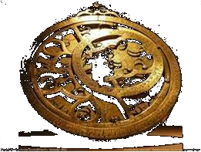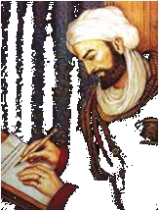
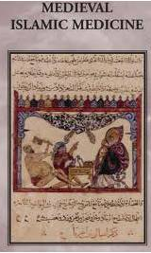
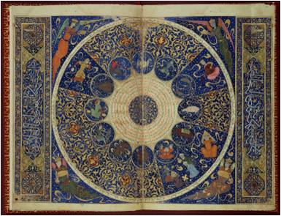
Great Inventions by Muslim Scholars and Scientists:

In Math ( 0 - zero )
In Medicine
In Algebra
In Physics
In Chemistry
In Astronomy
In ……………
Watch this wonderful YouTube clip about
The contributions of Muslims to the West.

https://www.youtube.com/watch?v=Xx2_rVq9QZM

The influence of Islam and Muslims on ETC & Europe.

Spain and Muslims (711 – 1492). Andalusia Al-Andalus became the center or torch of light, knowledge, & sciences for all Europe.

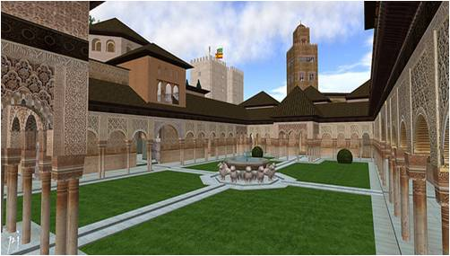 | 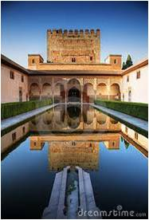



Definitions

English:
Thought:
Culture:

English (From Wikipedia, the free encyclopedia)

- English is a West Germanic language that was first spoken in England and is now the most widely used language in the world.
- It is spoken as a first language by a majority of the inhabitants of several nations, including the United Kingdom, the United States, Canada, Australia, Ireland, New Zealand and a number of Caribbean nations.
- It is widely learned as a second language and is an official language of the European Union, many Commonwealth countries and the United Nations, as well as in many world organizations.
- it has been widely propagated around the world, becoming the leading language internationally.

Thought (From Wikipedia, the free encyclopedia)

- Thought generally refers to any mental or intellectual activity involving an individual's subjective consciousness. It can refer either to the act of thinking or the resulting ideas or arrangements of ideas.
- Thought underlies almost all human actions and interactions.

Culture

Culture is "that complex whole which includes knowledge, belief, art, law, morals, custom, and any other capabilities and habits acquired by man as a member of society."
Edward B. Tylor
Culture = the beliefs, social forms, features, and traits of a racial, religious, or social group.

Foundations and factors influencing the English Thought & Culture

- Invasions (Politics & Economy)
- Roman & Greek teachings and philosophies

- Religions (Judaism & Christianity)
- Theories, Movements, & Revolutions

- Media & Technology
- Geography and location
- Contributions of other nations and cultures (like the Islamic and Arabic contributions)

Foundations and factors influencing the English Thought & Culture

1- Invasions
* Language affects thought and culture.
* Origin and history of English.
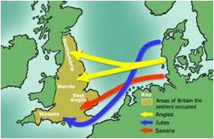

Germanic Invasions
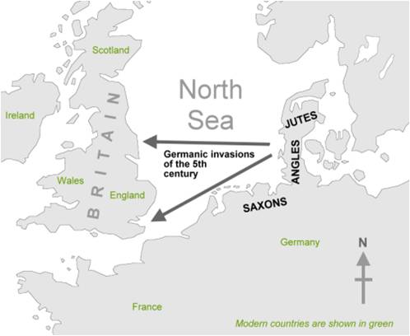

- Germanic invaders entered Britain on the east and south coasts in the 5th century.
- Many cultural, social, economic, military and political events led to the development of English from its Germanic roots.
- English originated as a common language of West Germanic tribes (Angles, Saxons and Jutes) who invaded and populated Britain.

Old English (450-1100 AD)  -The invading Germanic tribes spoke similar languages, which developed into what we now call Old English.  - About half of the most commonly used words in Modern English have Old English roots. The words be, strong and water, for example, derive from Old English. | 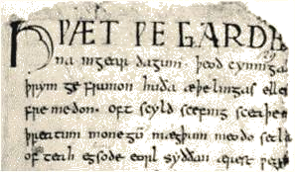

Origin and history of English

Middle English (1100-1500)
- The Normans invaded England. They brought with them a kind of French, which became the language of the Royal Court, and the ruling and business classes.
- For a period there was a kind of linguistic class division:
the lower classes spoke English
the upper classes spoke French
- In the 14th century English became dominant in Britain again, but with many French words added. This language is called Middle English.

- It was the language of the great poet Chaucer (1340-1400).
Origin and history of English

Modern English:
Early Modern English (1500-1800)

- Towards the end of Middle English, a sudden and distinct change in pronunciation (the Great Vowel Shift) started, with vowels being pronounced shorter and shorter.
- From the 16th century the British had contact with many peoples from around the world. This meant that many new words and phrases entered the language.

- The invention of printing also meant that there was now a common language in print. Books became cheaper and more people learned to read. Printing also broughtstandardization to English. Spelling and grammar became fixed, and the dialect of London became the standard.
- In 1604 the first English dictionary was published.

Origin and history of English

Late Modern English (1800-Present)

- The main difference between Early Modern English and Late Modern English is vocabulary.
- Late Modern English has many more words, arising from two principal factors: firstly, the Industrial Revolution and technology created a need for new words; secondly, the British Empire at its height covered one quarter of the earth, and the English language adopted foreign words from many countries.

Varieties of English

There are varieties of English around the world, including:
American English
British English
Australian English
New Zealand English
Canadian English
South African English
Indian English
Caribbean English.
Today, American English is more influential, due to the USA's dominance of cinema,
television, trade and technology (including the Internet).

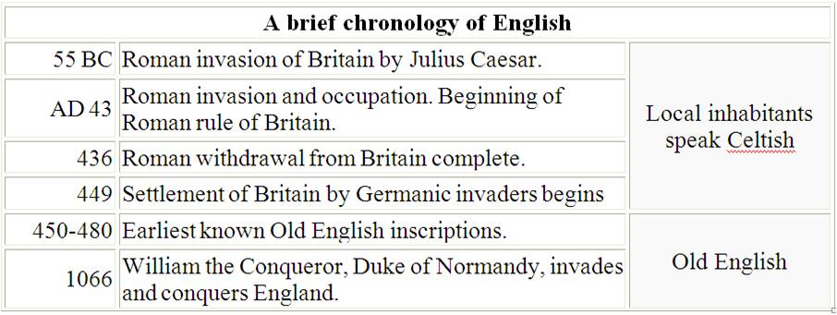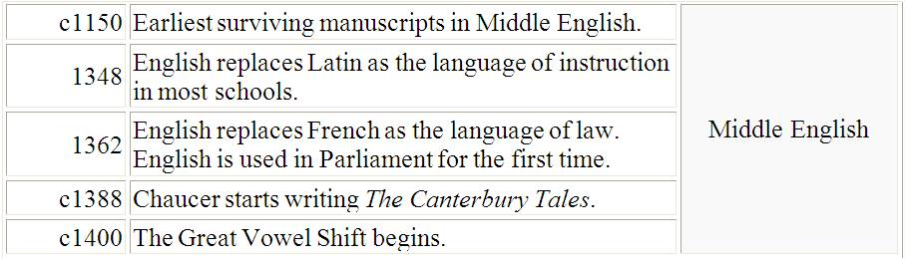
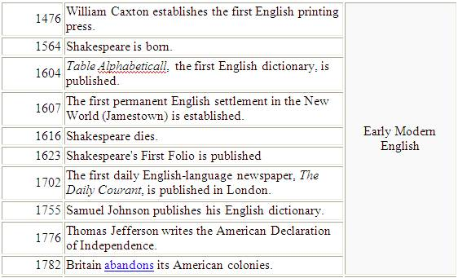

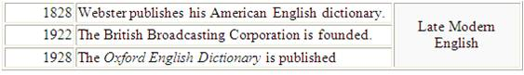

http://www.englishclub.com/english-language-history
http://www.thehistoryofenglish.com

Foundations and factors influencing the English Thought & Culture

Part 2: Greek & Roman effects

English has borrowed many Greek words. This borrowing happened centuries before our current use of English. English is considered a Germanic language, but has been strongly influenced by French.

Ancient Greek philosophy

- Ancient Greek philosophy arose in the 6th century BCE and continued through the Hellenistic period, at which point Ancient Greece was incorporated in the Roman Empire.
- Many philosophers today maintain that Greek philosophy has influenced much of Western thought since its beginning.
- Alfred Whitehead noted: "The safest general characterization of the European philosophical tradition is that it consists of a series of footnotes to Plato." Clear, unbroken lines of influence lead from ancient Greek and Hellenistic philosophers, to the European Renaissance and Enlightenment.

Great Greek philosophers
(recognized as founders of Western philosophy & thought )

- Socrates  - Plato  - Aristotle | 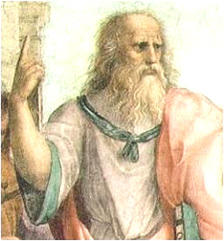
Ancient Greece and Rome and Their Influence on Modern Western Civilization

- “The Greeks had a massive influence on life today. They were the first to develop democracy”. http://wiki.answers.com/Q/How_did_ancient_Greece_influence_modern_civilization
- The American political system, like those of many other Western nations, is deeply influenced by ideas from ancient Greece and Rome.

- Ideas about democracy and republican government come from these ancient governments of ancient Greece and Rome.
- The founders of the United States were learning and absorbing the ideals of ancient Greece and Rome. When they were building the foundations of American government, they looked to ancient Greece and Rome for inspiration”.
http://teachergenius.teachtci.com/ancient-greece-and-rome-and-their-influence-on-modern-western-civilization-2/

The Roman Empire

- The Roman Empire, at its height, included about a fourth of Europe, much of the Middle East, and the entire northern coastal area of Africa.
- The Roman Empire fell apart almost 1500 years ago, but it still influences our lives. More than 300 million persons speak languages directly related to Latin, the Roman tongue.

- Many words in English come from Latin.
- Roman law provided the basis of the law of most European and American nations.
http://terkno.wrytestuff.com/swa134118.htm

The Roman Empire and Christianity

Christianity became the state religion of the Roman Empire in 380 AD.
http://en.wikipedia.org/wiki/Persecution_of_Christians_in_the_Roman_Empire

The Roman Emperor Constantine’s ‘Conversion’
One of the supposed watersheds in history is the ‘conversion’ of the Roman emperor Constantine to Christianity in, or about, 312 AD.

The ‘triumph’ of Christianity
Contemporary Christians treated Constantine’s conversion to Christianity as a decisive moment of victory for Christianity .

http://www.bbc.co.uk/history/ancient/romans/christianityromanempire_article_01.shtml

The Roman Empire and Christianity

The Council of Nicaea 325 AD, (under the Roman Emperor Constantine's influence).
The First Council of Nicaea was the first ecumenical council of the Catholic Church. Most significantly, it resulted in the first, extra-biblical, uniform Christian doctrine, called the Creed of Nicaea.

Effects of the Council

The long-term effects of the Council of Nicaea were significant. For the first time, representatives of many of the bishops of the Church convened to agree on a doctrinal statement. Also for the first time, the Emperor played a role, by calling together the bishops under his authority, and using the power of the state to give the
Council's orders effect.
http://en.wikipedia.org/wiki/First_Council_of_Nicaea

The Roman Empire and Christianity

The Council declared that Jesus the Son was true God, co-eternal with the Father and begotten from His same substance. Under Constantine's influence, this belief was expressed by the bishops in the Nicene Statement. which would form the basis of what has since been known as the Nicene Creed.
Its main accomplishments was settlement of the Trinitarian issue of the nature of The Son and his relationship to God the Father.

http://en.wikipedia.org/wiki/First_Council_of_Nicaea#The Trinity

Trinity:
1- God the Father
2- God the Son
3- God the Holy Spirit

Part 3: Religions

The major religions that have existed in Europe, UK, & USA
and their influences on the English thought & culture (ETC):

- Christianity
Christianity became the state religion of the Roman Empire in 380 AD.
http://en.wikipedia.org/wiki/Persecution_of_Christians_in_the_Roman_Empire
- Judaism
Judaism in Europe has a long history.
Jewish populations had existed in Europe, especially in the area of the former Roman Empire, from very early times.
http://en.wikipedia.org/wiki/Jewish_history#Europe

- Islam
The influence of Islam and Muslims on ETC & Europe in General.
Spain and Muslims (711 – 1492). Andalusia Al-Andalus became the center or torch of light, knowledge, & sciences for all Europe.

Foundations and factors influencing Thought & Culture

Part 3: Religions & Beliefs

Religions and beliefs have tremendous effects on thought & culture:
The world’s major religions, beliefs, and dogmas influencing the
thought & culture of human beings and their lives in general:

- Paganism
- Atheism
- Hinduism
- Buddhism
- Judaism
- Christianity
- Islam

Foundations and factors influencing the English Thought & Culture

Part 4: Theories, Movements, & Revolutions

- Darwin’s Theory of Evolution (natural selection, chance, chimpanzee, atheism ).
- The French Revolution (was a period of radical social, cultural, and political change in France that had a major impact on France and throughout the rest of Europe).
- The Renaissance (a cultural movement - from the 14th to the 17th century, beginning in Italy in the Late Middle Ages and later spreading to the rest of Europe).

- The Enlightenment (or Reason) was a cultural movement of intellectuals in 18th century, first in Europe and later in the American colonies. Its purpose was to reform society using reason (rather than tradition, faith and revelation)
and advance knowledge through science.
- The American Revolution (during the last half of the 18th century in which thirteen colonies in North America joined together to break free from the British Empire, combining to become the United States of America.
Foundations and factors influencing the English Thought & Culture
Part 5: Media & Technology
- Printing & Publication
- Research
- Satellites (BBC & CNN)
- Hollywood
- The Internet
- Telecommunication
- Advanced Technology & Industry

Foundations and factors influencing the English Thought & Culture
Part 6: Geography and location
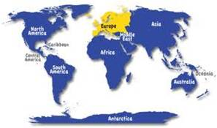

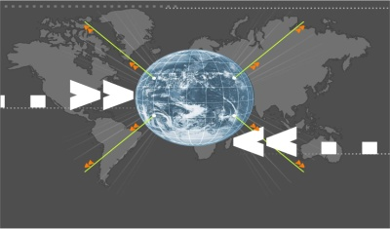
Reaching Out

Effective dialogue & Communication Skills.
Creative methods and approaches on presenting Islam and its civilization & culture to others nicely and wisely!

Foundations and factors influencing the English Thought & Culture
Part 7: The contributions of Arabic and Islamic culture and civilization to the Western thought and culture in general.
The influence of Islam and Muslims on ETC & Europe.
Spain and Muslims (711 – 1492). Andalusia Al-Andalus became the center or torch of light, knowledge, & sciences for all Europe.
والصلاة والسلام على نبينا محمد وعلى آله , وصحبه أجمعين
انتهت المادة , لا تنسوني من دعائكم فدعوة الأخ لأخيه المسلم في ظهر الغيب مجابه
دعواتي وتمنياتي لكم بأعلى الدرجات في الدارين

Contents

Orientation’s Class………………………………………………………………..
Lecture (1)……………………………………………………………………………..
Lecture (2)……………………………………………………………………………..
Lecture (3) …………………………………………………………………………….
Lecture (4) …………………………………………………………………………….
Lecture (5) …………………………………………………………………………….
Lecture (6) …………………………………………………………………………….
Lecture (7) …………………………………………………………………………….
Lecture (8) …………………………………………………………………………….
Review
Lecture (9) …………………………………………………………………………….
Lecture (10) …………………………………………………………………………
Lecture (11) …………………………………………………………………………
Lecture (12) …………………………………………………………………………
Lecture (13) …………………………………………………………………………
Lecture (14) …………………………………………………………………………
Review
Contents…………………………………………………………………..………………

“English Thought and Culture” focuses on the landmarks that have
influenced English, and Anglo-Saxon intellectual life and culture. As such it
starts from the early foundation of European Thought, Plato and Aristotle,
and moves to medieval contributions from Arabic and Islamic culture. The
last part of the course covers Empiricism and contemporary socio-cultural
trends.



http://www.ckfu.org/vb/

