ص11
studying abroad offers students many advantages. First of all, students have the opportunity to learn a new language by interacting with native speakers every day. In addition, the students live in a new culture, so they can learn both in and out of the classroom. Studying abroad also teaches students that there are other ways of looking at the world. This is a very important part of education. In addition, students learn to be flexible because they have to adapt to different ways of living. They experience another culture in a much more significant way than if they simply took a vacation to another country. Also, foreign students are far from home. Therefore, they have to become responsible and self-reliant. When they study abroad, students have an experience they will remember all their lives.
الذين يدرسون في الخارج تقدم للطلاب العديد من المزايا. أولا وقبل كل والطلاب لدينا الفرصة لتعلم لغة جديدة من خلال التفاعل مع الناطقين كل يوم. وبالإضافة إلى ذلك، والطلاب يعيشون في ثقافة جديدة، حتى يتمكنوا من معرفة كل من داخل وخارج الفصول الدراسية. الذين يدرسون في الخارج أيضا يعلم الطلاب أن هناك طرق أخرى للنظر إلى العالم. هذا هو جزء مهم جدا من التعليم. وبالإضافة إلى ذلك، يتعلم الطلاب على التحلي بالمرونة لأن لديهم على التأقلم مع مختلف وسائل المعيشة. كانت تجربة ثقافة أخرى بطريقة أكثر أهمية مما لو أخذت مجرد عطلة إلى بلد آخر. أيضا، للطلاب الأجانب لا تزال بعيدة عن المنزل. لذلك، لديهم لتصبح مسؤولية والاعتماد على الذات. عندما يدرسون في الخارج، والطلاب لديها الخبرة التي سوف نتذكر كل حياتهم.
Studying abroad offers students many advantages. First of all, students have the opportunity to learn a new language by interacting with native speakers every day. In addition, the students live in a new culture, so they can learn both in and out of the classroom. Studying abroad also teaches students that there are other ways of looking at the world. This is a very important part of education. In addition, students learn to be flexible because they have to adapt to different ways of living. They experience another culture in a much more significant way than if they simply took a vacation to another country. Also, Foreign students are far from home. Therefore, they have to become responsible and self-reliant. When they study abroad, students have an experience they will remember all their lives.

My neighborhood is fascinating because people from all over the world live in it. When I walk down the main street of my neighborhood, I can hear the unfamiliar sounds of languages from all over the world. Each ethnic group has its own colorful shop or fascinating restaurant. On a warm evening, I can smell the sweet melons from the Korean produce store and the spicy curries from the Indian restaurant. These smells are free, but for a small price, I can also buy any of 50 kinds of cheeses with strange names from one store, or exotic Asian vegetables and the spices to cook them in from another. The people of the neighborhood take pride in their surroundings. On almost every street , they plant trees and flowers from their native countries to remind them of home and to brighten up the dull gray cement and run-down apartment buildings. One of my neighbors plants delicate Scottish flowers every year in memory of her mother’s garden in Scotland. Another neighbor has a Chinese vegetable garden in window boxes. I don’t need to buy an airplane ticket to experience the world, a walk around my neighborhood can be just as exciting.
حينا هي رائعة لأن الناس من جميع أنحاء العالم يعيشون فيه. عندما أمشي في الشارع الرئيسي من حينا، ويمكنني سماع أصوات غير مألوفة لغات من جميع أنحاء العالم. كل جماعة عرقية لديها متجر لها الملونة الخاصة أو مطعم رائعة. في إحدى الأمسيات الحارة، ويمكنني أن رائحة الشمام الحلو من متجر المنتجات الكورية والكاري حار من المطعم الهندي. هذه الروائح هي حرة، ولكن مقابل ثمن صغير، أستطيع أيضا شراء أي من 50 نوعا من الجبن مع أسماء غريبة من مخزن واحد، أو الخضار والتوابل الآسيوية الغريبة وطبخه في من آخر. شعب حي نفخر في محيطهم. في كل شارع تقريبا، وأنها زراعة الأشجار والزهور من بلدانهم الأصلية لتذكيرهم المنزل وسطع الاسمنت ممل الرمادي ومبان سكنية متداعية. واحد من جيراني أزهار النباتات الاسكتلندي دقيق في كل عام في ذكرى حديقة والدتها في اسكتلندا. جار آخر لديه حديقة الخضروات الصينية في مربعات النافذة.ولست بحاجة لشراء تذكرة طائرة إلى خبرة في العالم، ويمكن المشي حول الحي يكون مجرد إثارة مثل.

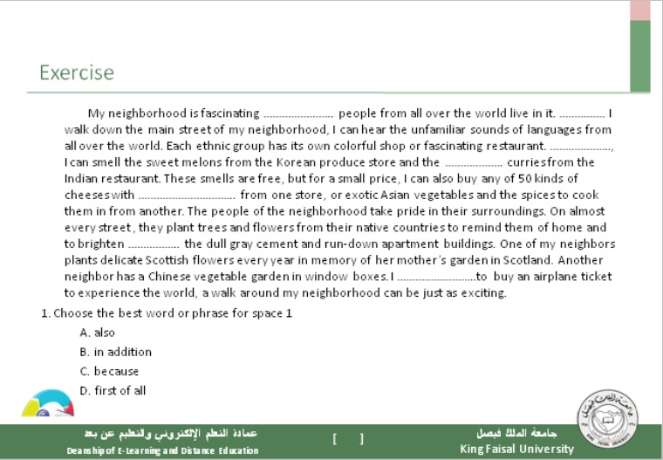

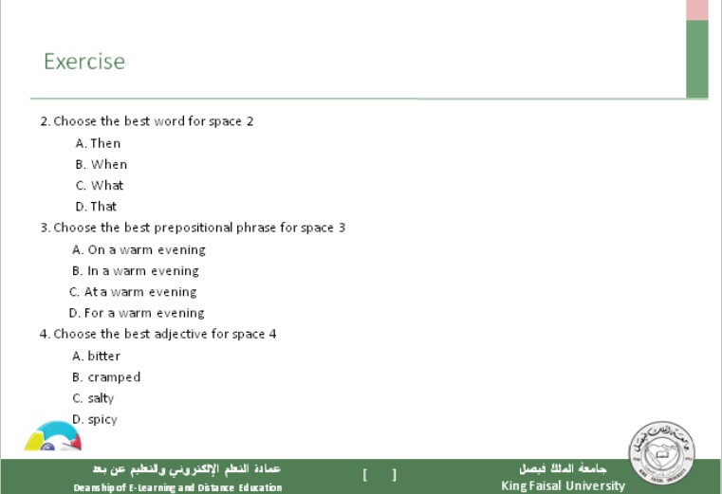

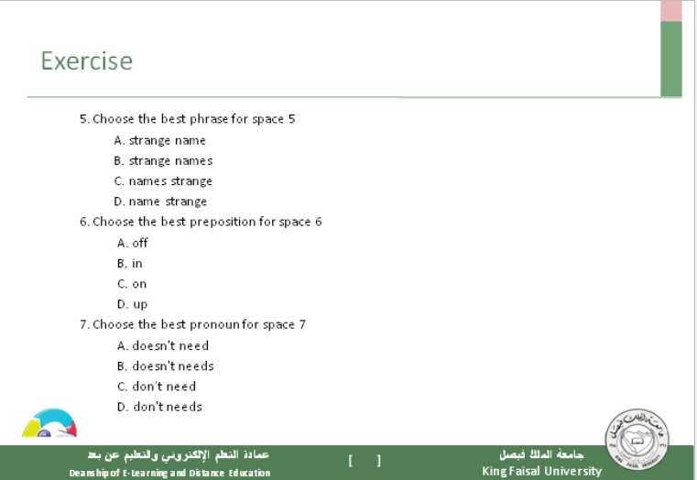

Read paragraphs and complete sentence
My neighborhood is …(1)…because people from all over the world live in it. When I walk down the main street of my neighborhood, I can hear the … (2)…sounds of languages from all over the world. Each ethnic group has its own …( 3)..shop or…(4)… restaurant. On a …(5)…evening, I can smell the …6… melons from the Korean produce store and the …7…curries from the Indian restaurant. These smells are…8…, but for a small price, I can also buy any of 50 kinds of cheeses with …9…names from one store, or …10…Asian vegetables and the spices to cook them in from another. The people of the neighborhood take pride in their surroundings. On almost every street , they plant trees and flowers from their …11…countries to remind them of home and to brighten up the …12…cement and run-down apartment buildings. One of my neighbors plants …13…Scottish flowers every year in memory of her mother’s garden in Scotland. Another neighbor has a Chinese vegetable garden in window boxes. I don’t need to buy an airplane ticket to experience the world, a walk around my neighborhood can be just as…14....

1: which is the best word …?
A: warm B: Colorful C: Unfamiliar D:Fascinating
2: which is the best word …?
A: free B: Fascinating C: Colorful D:Unfamiliar
3: which is the best word …?
A:Colorful B: Fascinating C: StrangeD:exotic
4 : which is the best word …
A: free B: Fascinating C: Colorful D:Unfamiliar
5: which is the best word …
A:WarmB: Colorful C: Unfamiliar D:exotic
6; which is the best word …
A: sweet B: good C:wonderfull D: native
7: which is the best word …?
A:spicy B:sweet B: good D:frees
8: which is the best word …?
A:spicy B:sweet B: good D:frees
9: which is the best word …?
A:Strange B: native C: dull gray D: exciting
10: which is the best word …?
A:Strange B: Colorful C: Exotic D:Unfamiliar
11: which is the best word …?
A: warm B: native C: Unfamiliar D:frees
12: which is the best word …?
A:dull gray B:sweetC: ExoticD:frees
13: which is the best word …?
A: free B: Fascinating C: Exotic D: exciting
Which sentences are correct?
A: Since many people have lived in my neighborhood for years, it is a very friendly place.
B: many people have lived in my neighborhood for years, Since it is a very friendly place.
C: Since Many people have lived in my neighborhood for years. it is a very friendly place.
D: Many people have lived in my neighborhood for years . Since it is a very friendly place.
Which sentences are correct?
A: Since my apartment is very small. I have to keep it very clean.
B: My apartment is very small, since I have to keep it very clean.
C: Since my apartment is very small, I have to keep it very clean.
D: my apartment is very small. Since I have to keep it very clean.
Which sentences are correct?
A: my cousin needed a roommate and is easy to get along with. Since I decided to move
B: my cousin needed a roommate and is easy to get along with, Since I decided to move
C: Since my cousin needed a roommate and is easy to get along with. I decided to move
D: Since my cousin needed a roommate and is easy to get along with, I decided to move
Which sentences are correct?
A: It is easy to get to know everyone in my dormitory since only 40 people live in it.
B: It is easy to get to know everyone in my dormitory, since only 40 people live in it.
C: It is easy to get to know everyone in my dormitory .since only 40 people live in it.
D:Since It is easy to get to know everyone in my dormitory . only 40 people live in it.
Which sentences are correct?
A: Since I have many relatives in the city, I decided not to live in a dormitory.
B: I have many relatives in the city, Since I decided not to live in a dormitory.
C: I have many relatives in the city .Since I decided not to live in a dormitory.
D: Since I have many relatives in the city I decided not to live in a dormitory.
Which sentences are comma splices?
A: My suburban apartment is big and sunny it has a living room with large windows filled with plants.
B: My suburban apartment is big and sunny; it has a living room with large windows filled with plants.
C: My suburban apartment is big and sunny. it has a living room with large windows filled with plants.
D: My suburban apartment is big and sunny. and it has a living room with large windows filled with plants.
Which sentences are comma splices?
A:I have a roommate who is very sloppy .she never washes the dishes, and she leaves her clothes all over the apartment.
B:I have a roommate who is very sloppy. She never washes the dishes, and she leaves her clothes all over the apartment.
C:I have a roommate who is very sloppy ,She never washes the dishes, and she leaves her clothes all over the apartment.
D:I have a roommate who is very sloppy. But She never washes the dishes, and she leaves her clothes all over the apartment.
….
A: I like my street because my neighbors are wonderful .they will help anybody who is having problems.
B: I like my street because my neighbors are wonderful, they will help anybody who is having problems.
C: I like my street because my neighbors are wonderful. So they will help anybody who is having problems.
D: I like my street because my neighbors are wonderful. They will help anybody who is having problems.
…
A: First I painted my room, and later I made new curtains.
B: First I painted my room, And later I made new curtains.
C: First I painted my room. later I made new curtains.
D: First I painted my room. and later I made new curtains.
…
A: My favorite place to relax is the park ,is up the hill from my apartment.
B: My favorite place to relax is the park. that is up the hill from my apartment.
C: My favorite place to relax is the park ,that is up the hill from my apartment.
D: My favorite place to relax is the park that is up the hill from my apartment.
…
A: My Street is dirty and noisy. however it has many good restaurants and my neighbors are friendly.
B: My Street is dirty and noisy, and it has many good restaurants and my neighbors are friendly.
C: My Street is dirty and noisy, it has many good restaurants and my neighbors are friendly.
D: My Street is dirty and noisy. And it has many good restaurants and my neighbors are friendly.

Exercise 1 page 35:
We live in an ordinary house and I think it is terrific! Our house is now 30 years old, but it looks newer. My house is like hundreds of other houses in the suburbs, one story with an attached garage. There is nothing special about the house, and it won’t win any prizes for architecture, but it’s perfect for our family. The kitchen is big and has new appliances, including a beautiful new dishwasher and a microwave oven. I don’t like the heat, but we have air conditioning in the living room and bedrooms, so it is always cool. For the kids there’s a nice yard where they can play. It’s very safe, so my wife and I don’t have to worry. I am very thankful that we can afford this house and live our ordinary lives there.
Choose the best answer to complete the paragraph:
( 1 )………………………………………………………………………………. !Our house is now 30 years old, but it looks newer. My house is like hundreds of ( 2 )…………………… in the suburbs, one story with an attached garage. There is nothing special about the house, and it won’t win any prizes for architecture, but it’s perfect for our family. The kitchen is big and has new appliances, including a beautiful new dishwasher and a microwave oven. I don’t like the heat, but we have air conditioning in the living room and bedrooms, so it is always cool. For the kids there’s a nice yard where they can play. It’s very safe, ( 3 ) …………….. my wife and I don’t have to worry. ( 4 ) …………...................................
نحن نعيش في بيت عادي في شارع عادي في ضاحية عادية, وأعتقد أنه رائع, بيتنا الآن عمره حوالي 30 سنة, لكنة يبدوا أحدث من ذلك. سبق لي أن عشت في شقق, أولها في فلوريدا, ثم في نيو ميكسيكو. لكنني أفضل العيش في بيتنا الخاص. بيتي مثل المئات من البيوت الأخرى في الضواحي, طابق واحد مع مرآب (كراج). ليس هناك شيء مميز في البيت, ولن يفوز بأي جائزة في الهندسة, لكنه ممتاز بالنسبة لعائلتي. المطبخ كبير وبه معدات جديدة, بما فيها غسالة صحون أوتوماتيكية جديدة وفرن مايكرويف. أنا لاأحب الحر, لكن لدينا تكييف هواء في غرفة المعيشة (الصالة) وغرف النوم, لذلك فالبيت بارد دائما. لا أعرف لماذا بعض من أعرفهم لا يحبون الضواحي. بالنسبة للأطفال, هناك حديقة جميلة حيث يمكنهم اللعب. إنها آمنة جدا, لذلك أنا وزوجتي ليس علينا أن قلق. أنا ممتن جدا لأننا استطعنا شراء هذا البيت والعيش حياة عادية فيه.
1. Choose the best topic sentence
A. We live in an ordinary street!
B. We live in an ordinary house, and I think it is terrific!
C. We live in an ordinary house on an ordinary street, and I think it is terrific!
D. We live in an ordinary house on an ordinary street in an ordinary suburb, and I think it is terrific!
2. Choose the best phrase
A. other houses
B. another house
C. other house
D. house other
3. Choose the best word
A. but
B. so
C. also
D. because
4. Choose the best concluding sentence
A. I am very thankful that we can afford this street and live our ordinary lives there.
B. We can afford this street and live our ordinary lives there.
C. I am very thankful that we can afford this house and live our ordinary lives there.
D. We can afford this house and live our ordinary lives there.

Limiting Information
Page 70
I have many qualities that have made me a success as a bike messenger. First of all, I have the ability to persevere when there are difficulties. And bike messengers run into many difficulties. I have had problems with drivers who almost run me over, constant rain for weeks at a time, unreadable addresses, and rude customers. In addition, my dedication to the job has also served me well. I believe that you should do your best at even the most routine jobs. For example, I work hard at finding short cuts around the city. And I'm proud to say that when a package needs to be delivered really quickly, my boss always calls on me. Finally, my success as a bike messenger is partly due to my sense of humor. Many times I have wanted to quit, but I just try to laugh at the situation.
لدي العديد من الصفات التي جعلت لي نجاح رسولا الدراجة. أولا وقبل كل شيء أنا لديها القدرة على المثابرة عندما تكون هناك صعوبات. والمرسلين الدراجة واجهت العديد من الصعوبات. وقد أتيحت لي مشاكل مع السائقين الذين يديرون تقريبا لي أكثر، والمطر المستمر منذ اسابيع في وقت واحد، وعناوين غير قابل للقراءة، والعملاء وقحا. وبالإضافة إلى ذلك، عملت جهدي لتكريس وظيفة لي أيضا بشكل جيد. وأعتقد أنه يجب بذل قصارى جهدكم في وظائف حتى في أكثر روتينية. على سبيل المثال،أنا أعمل بجد على إيجاد طرق مختصرة في جميع أنحاء المدينة. وأنا فخور أن أقول إنه عندما حزمة يجب أن يتم تسليمها بسرعة حقا، مدرب بلدي يدعو دائما على لي. أخيرا، نجاحي رسولا الدراجة ويرجع ذلك جزئيا إلى روح الدعابة. مرات عديدة كنت قد ترغب في الانسحاب، ولكن أنا مجرد محاولة لتضحك على الوضع.

Exercise 6 page 89
One summer weekend, some friends and I decided to walk to a waterfall we had heard about. Since it was too far to walk along the road, we followed a railroad line. We had walked five or six miles when we came to a high rock wall where the tracks entered a tunnel. This tunnel didn’t look very long, but it was very narrow. We knew it would be dangerous if a train came because there would be no safe place for us to go. However, we couldn’t climb the rocks or walk around them, and no one wanted to go back. Finally, we decided to go through the tunnel. I knew it was foolish, but I went because the others did.
As we entered the tunnel, we saw that it was longer and darker than we had thought. Suddenly, everyone was frightened and we all began to run. “ This is crazy!” I thought. As we ran faster, it got lighter in the tunnel. Once we were outside, we fell on the ground gasping. About a minute later, a train came through. That was when I finally realized the importance of thinking for myself.
واحد في مطلع الاسبوع في الصيف، قرر عدد من الأصدقاء وأنا على المشي إلى شلال كنا قد سمعنا عن. نظرا لأنه كان بعيدا جدا على السير على طول الطريق، وتابعنا على خط السكك الحديدية. كنا قد مشى خمسة أو ستة أميال عندما وصلنا إلى الجدار صخرة عالية حيث المسارات دخلت النفق. لم هذا النفق لا تبدو طويلة جدا، لكنها كانت ضيقة جدا. كنا نعرف ان الامر سيكون خطير إذا قطار جاء لانه لن يكون هناك مكان آمن بالنسبة لنا للذهاب. ومع ذلك، لم نتمكن من تسلق الصخور أو المشي من حولهم، ولا أحد يريد العودة الى الوراء. أخيرا، قررنا أن تذهب من خلال نفق. كنت أعرف أنه كان أحمق، ولكن ذهبت لأن فعله الآخرون.
كما دخلنا في نفق، رأينا أنه كان أطول وأكثر قتامة مما كنا نعتقد. فجأة، كان خائفا الجميع وبدأنا كل لتشغيل. "هذا جنون!" فكرت. ونحن ركض أسرع، وانها حصلت على أخف وزنا في النفق. ذات مرة كنا في الخارج، وانخفض نحن على الارض يلهث. حوالي دقيقة واحدة في وقت لاحق، جاء قطار من خلال. وكان ذلك عندما أدركت أخيرا على أهمية التفكير لنفسي.
Exercise 2 page 93:
One summer weekend, some friends and I decided to walk to a waterfall we had heard about. Some people
…………………………… (drive) cars and …………………………. (take) the food, but the rest of us ………………………(want) to walk. Since it was too far to walk along the road, we followed a railroad line. We had walked five or six miles when we came to a high rock wall where the tracks entered a tunnel. We ………………….. (be) surprised. Nobody ……………….......... (tell) us about it. The tunnel didn’t look very long, but it was very narrow. We knew it would be dangerous if a train came. However, we couldn’t climb the rocks or walk around them, and no one wanted to go back. I ……………………………. (have) a good breakfast, but some of the others …………………………………. (not eat). They …………………………………… (want) to get to the waterfall and have lunch. Finally, we decided to go through the tunnel. I knew it was foolish, but I went because the others did.
As we entered the tunnel, we saw that it was longer and darker than we had thought. Earlier we ………………………….
(decide) to walk and to stay together, but suddenly everyone was frightened and we all began to run. “ This is crazy!” I thought. “ Why didn’t I go back?” As we ran faster, it got lighter in the tunnel. Once we were outside, we fell on the ground gasping. No one …………………………… (fall) in the tunnel. We ……………………………………(be) all safe. About a minute later, a train came through. We ……………………(be) upset because we ……………………...... (come) so close to death. We ………………………(be) also angry with ourselves for being so foolish. Later we ………………………..
( hear) that two boys ……………………………… (die) in that tunnel before. That was when I finally realized the importance of thinking for myself.

Exercise 2 page 93:
1- had driven 11- were
2- taken 12- were
3- wanted 13- had come
4- were 14- were
5- had told 15- heard
6- had had 16- had died
7- hadn’t eaten
8 wanted
9- had decided
10- had fallen

