Vocabulary
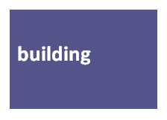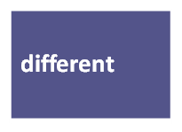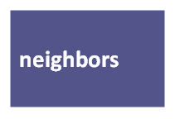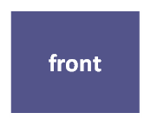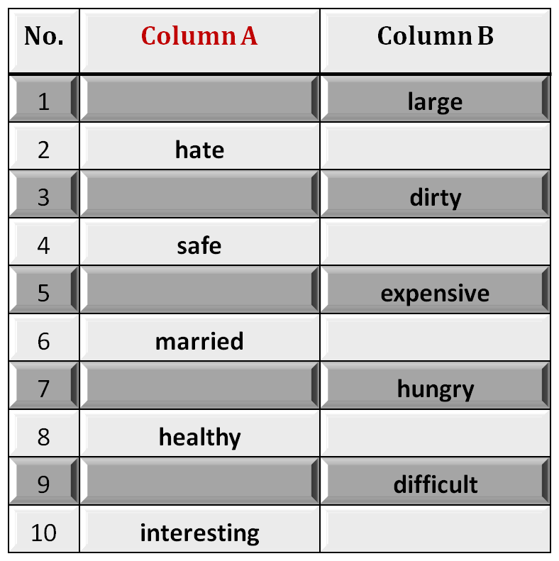 I. Exercise:
A.Fill in each blank with a word from the box
This store is always ________. There are always lots and lots of people.

2. My_______are from Mexico. They're very nice people.

3. There are two big trees in ________of my house.

4. There is a big apartment_________ on the corner of the street.

5. People in my neighborhood are from ________ countries.

III. Vocabulary
B. Identifying Opposites
Fill in each blank space with the opposite meaning
small
love
clean
dangerous
cheap
single
full
sick
easy
boring
Exercise
1. You can go to the new ___________ and buy whatever you need.
A. hospital B. school
C. mall D. cinema
2. Doctors always advice smokers to give up smoking. The underlined word give up
has the same meaning as:
A. quit B. Start
C. help D. study
3. The children were afraid when they saw the ________________in the Luna park.
A. food C. monster
C. games D. juice

4. The phrase “ write the same thing’ means ________________ .
A. cut B. paste
C. copy D. delete
5. The trip to the sea was very, very good. “ very, very good” means:-
A. wonderful B. dangerous
C. terrible D. easy
3. The men, women and children in Saudi Arabia are kind and generous. The
underlined phrase can be replaced by:
A. visitors C. people
C. soldiers D. vehicles

Exercise
1. Where is the car? It’s in the___________
A. library B. bog
C. garage D. kitchen
2. If you didn’t find the book, you can look for it in the other room. the underlined
word look for means:
A. buy B. search
C. read D. eat
3. English language is_________________. It is not difficult.
A. beautiful C. boring
C. safe D. easy

4. The word “ classifications’ means ________________ .
A. entertainments B. eatables
C. categories D. customers
5. The word “gourmet means__________________.
A. a policeman B. Food specialist
C. mechanic D. who works at hospital
6. “separated from others” . The underlined phrase means:
A. happy C. sick
C. alone D. busy

1. I speaks speak English fluently and Reem does, ___________
a. either b. too c. so d. neither
2. My ________ in this term is 84.3 %.
a. marriage b. package c. garage d. average
3. All members in __________ families were living in one house.
a. traditional b. nuclear c. rich d. bad
4. We went for a picnic by the sea and had a ___________.It was a very
delicious meal.
a. problem b. barbecue c. test d. camera
5. My uncle and my aunt are called my _______________.
a. relatives b. brothers c. friends d. neighbors
6. Group of people/ playing a sport is called a ________________.
a. family b. friend c. team d. match

Vocabulary Exercise:
1. The word ‘ ___________” means lines on one’s skin
a. stress b. wrinkles c. beverages d. toes
2. “________” means that a person is unable to sleep.
a. sleep- deprived b. sleep too much
c. relaxed d. healthy
3. The word that has the same meaning as sickness is __________ .
a. wealth b. disease c. health d. earth
4. My friend suffers from ___________.He has become too fat.
a. overweight b. poorness c. English d. hard work
5. “ __________________” means worry.
a. Relaxation b. Stress c. Health d. highness
6. The opposite meaning of sick is ________________.
a. rich b. happy c. healthy d. tired
7. The phrase “ get older” means ___________.
a. age b. to be young c. fat d. strong
8. “________” means not even once.
a. Always b. never c. sometimes d. rarely
9. The word that has the same meaning as “ drinks of all kinds” is___ .
a. water b. food c. vegetables d. beverages
10. “ Unhealthy things to eat” means__________________.
a. overweight b. junk food c. honey d. milk
11. “ __________________” means find an answer.
a. solve b. shake c. draw d. watch
12. The opposite meaning of “Physical” is ________________.
a. successful b. happy c. healthy d. mental
Vocabulary Exercise:
1. The word ‘ ___________” means a group of words but not a sentence
a. phrase b. hierarchy c. beverage d. meal
2. “________” is the opposite of hate.
a. Eat b. Love c. relax d. watch
3. The word that has the same meaning as “moving around doing
many things, is __________ .
a. wealthy b. sick c. active d. fond of
4. We enjoyed ___________ last Thursday. We bought new clothes.
a. swimming b. shopping c. playing d. driving
5. “ __________________” is the opposite meaning of private.
a. Relaxed b. serious c. public d. high
. The phrase “ get older” means ___________.
a. age b. to be young c. fat d. strong
8. “________” means not even once.
a. Always b. never c. sometimes d. rarely
9. The word that has the same meaning as “ drinks of all kinds” is___
a. water b. food c. vegetables d. beverages
10. “ Unhealthy things to eat” means__________________.
a. overweight b. junk food c. honey d. milk
11. “ __________________” means find an answer.
a. solve b. shake c. draw d. watch
12. The opposite meaning of “Physical” is ________________.
a. successful b. happy c. healthy d. mental
13. He doesn’t like anyone. He has a cold hear . A cold heart means___________
a. very sad b. mean c. in the middle of d. a new feeling

Vocabulary Exercise:
Fill in the following blank space with the most appropriate answer a, b, c or d:-
1. To ask oneself and think means:_____________________
a. prefer b. wonder c. repair d. enjoy
2. “________” has the same meaning as “ proof”.
a. essence b. similarity c. evidence d. reference
3. The word that has the same meaning as “ a chemical that helps us to grow” is______ .
a. germs b. sugar c. bacteria d. hormone
4. “ __________________” the same meaning as “ nevertheless”.
a. however b. because c. since d. as
5. something we use to refer to another thing is a ____________
a. book b. pen c. symbol d. sheet
6. __________ is the opposite of sleeping.
a. Dreaming b. Awake c. Running d. Active
7. Wishes means:_____________________
a. wonders b. desires c. dreams d. studies
8. “________” has the same meaning as “ repair”.
a. fix b. damage c. prepare d. concern
9. The word that has the same meaning as “ reason” is___________ .
a. question b. purpose c. basic d. season
10. The word that means “period of time” is___________ .
a. areas b. project c. stage d. sense
11. “ __________________” the same meaning as “ happens”.
a. occurs b. finishes c. starts d. enjoys
12. The word that means “go places” is _____________________
a. swim b. leave c. travel d. look

13. “__________” is the opposite of easy.
a. make sense b. complicated c. normal d. expensive
Exercise:
I. The word “ __________” means work for free.
A. employ B. volunteer
C. prepare D. watch
2. The phrase “ a big or strong difference” means ______________.
A. contract B. difficulty
B. contrast D. similarity
3. You are________________ because every body knows about you.
A. sick B. a driver
C. a player D. famous
4. A person between 13 and 19 years old is a _____________________
A. teenager B. worker
C. volunteer D. pilot
5. In our society, a mother usually____________ her children and prepares food.
A. kills B. goes for
C. Takes care of D. sets out
6. The word “ ________________” is closest in meaning to the word “ a picture”.
A. mission B. vision
B. revision D. television
7. The box is ________________ . It is not easy to break it.
A. heavy B. rough
C. tough D. red
8. Some examples of ____________ are love, feelings and joy.
A. invitation B. emotions
C. tourism D. sickness
Previewing Vocabulary:
1. The word” _____________” is closest in meaning to the phrase “ not cooked”.
A. boiled B. raw
C. fried D. ugly
2. Some people lose weight fast, but they usually _____________ it back again.
A. gain B. eat
C. help D. give
3. The word “ ___________” is closest in meaning to the phrase “ very beautiful”.
A. interesting B. attractive
C. difficult D. thin
4. She looks very ______________ because of the diet she follows.
A. slim B. ugly
C. dangerous tall
5. I remembered the meanings of all words ____________the word” except”.
A. expect B. accept
C. except D. receipt
6. My friend suffers from being _____________. He is now too fat.
A. thin B. overweight
C. light D. happy
7. “ _________” is closest in meaning to the phrase “ old, smelly and very bad”.
A. interesting B. attractive
C. disgusting D. delicious
8. Dieting often doesn’t work. People usually gain back the weight.
The word “Work” means:___________________
A. have a job B. succeed
C. fail D. be active and try

Previewing Vocabulary
1. The word” __________” is closest in meaning to the phrase “ a way of acting”.
A. difficulty B. behavior
C. entertainment D. character
2. Most of the students feel _____________ because of the final tests.
A. worried B. thirsty
C. sleepy D. hungry
3. The word “ ___________” is closest in meaning to the phrase “ very clever”.
A. interesting B. intelligent
C. easy D. enjoyable
4. Every one felt ______________ because of the bad movie.
A. bored B. happy
C. dangerous D. tall
5. “____________” is closest in meaning to the phrase“ kinds of living things”.
A. islands B. beaches
C. species D. insects
6. All children _____________ watching cartoon movies.
A. dislike B. enjoy
C. are afraid of D. avoid
7. “ _________” is closest in meaning to the word “ like”.
A. hate B. attract
C. prefer D. avoid
8. When the sun rises, the fog ___________________ quickly .
A. disappears B. succeeds
C. returns D. fails

