Grammer
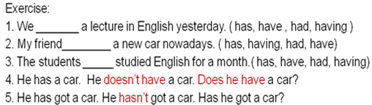
II:

Structure

1.Salma and Fatima -----------------from Riyadh.

a. is
b. was
c. has
d. are

2. ___________ your car new?

a. Are
b. Is
c. Aren't
d. Has
Part One : Circle the correct response
II.
Structure
3. London ------------------ a country. It is a city.

is
aren't
isn't
are
4. ----------- ant is ---------------- insect.

An / an
An / a
A / an
A / a
Part One:
Structure
5. Are you a doctor? No, ---------------------.

I'mn't
amn't
Iamn't
I'm not
6. Where is the water? ------------------- inside the refrigerator.

They're
It
It's
He's
Part Two:
Structure
7. A teacher usually starts a lesson by writing the date------------------the board.

in
under
over
on
8. My friend is from America.---------- lives in New York city.

I
We
He
It

Part Two:
Structure
9. ------------ in the house now.

We're
Wer'e
Were
We re

10. Are you ready? - -------------------------------.
No, I'm not
Yes, Im
No, Iamn't
Yes, You're

I. Exercise ( an & a )
1. Could you please give me _____ piece of cake?
a. an b. two c. a d. many

2. ___ dog is ____ animal.
a. An/a b. An/an c. A/an d. A/a
3. I visited ____Ahmed last week.
a. an b. the c. a d. Nothing
4. The capital of Saudi Arabia is ____ Riyadh.
a. Nothing b. an c. a d. the
5. I finished ____ unit in English language course.
a. an b. a c. three d. few
6. I take___ umbrella when it rains.
a. a b. an c. two d. several

II. Exercise
1. The doctor gave__________ a lecture about pronouns.
a. we
b. us
c. our
d. ours
2. ______ friend sent an email to the doctor regarding the homework.
a. I
b. Me
c. Mine
d. My

3. Hani visits _______ every week.
a. them
b. they
c. theirs
d. their
4. _______ are the books you told me about.
a. That
b. These
c. You
d. Their

5. The building you need is ___________.
a. these
b. those
c. there
d. her
6. That car over there is __________.
a. mine
b. me
c. my
d. I

III. Exercise ( verbs to be )
1. She______ at home now.
a. be b. was c. is d. been

2. My friends will_____________ here after 15 minutes.
a. are b. were c. been d. be
3. I ____in Riyadh two weeks ago.
a. was b. am c. be d. were
4. We _________ ready to start now.
a. were b. aren’t c. weren’t d. isn’t
5. ____ Hiba at university yesterday?
a. Is b. Are c. Were d. Was
6. Will Rashed___ at university tomorrow?
a. be b. is c. was d. been

Exercise
IV. Exercise ( verbs have )
1. She______ a new car nowadays.
a. had b. have c. has d. hasn’t

2. My friends ___________been here for 15 minutes.
a. has b. have c. hasn’t d. aren’t
3. I ____an English lecture yesterday .
a. had b. have c. has d. haven’t
4. Hind _________ a dictionary now.
a. hasn’t b. doesn’t have c. haven’t d. didn’t have
5. Ahmed and Abdullah _________a mathematics test now?
a. has b. have c. doesn’t have d. had
6. _______ she been here before ?
a. Have b. Has c. Is d. Was

1. Exercise
1. Sultan __________ his best to get full mark in the last homework.
a. do b. does c. did d. done
2. Fatin has _________ the homework perfectly.
a. done b. did c. do d. does
3. You will _______ me favor if you tell me the answer
a. doing b. do c. doing d. did
4. He always __________ the right thing.
a. do b. doing c. does d. done
5. The students are _________ the exercises now.
a. do b. doing c. done d. did
6. _______________ the homework yesterday?
a. Have you do b. Can you doing c. Do you d. Did you do
Exercise:
1. He goes to work____________ seven o’clock
a. in b. on c. at d. for
2. She was born_______ October.
a. at b. in c. on d. with
3. The weather is hot______ summer.
a. in b. on c. At d. From
4. Students don’t go to university_______ Friday.
a. in b. At c. Over d. on

1. She _______________ her mother in the house.
a. help b. doesn’t help c. don’t help d. doesn’t helps
2. The men __________ their work in the best way.
a. don’t do b. does c. doesn’t do d. don’t
3. _______________ doesn’t smoke nowadays .
a. My brothers b. You c. My father d. I
4. ____ they play football every week?
a. Do b. Does c. Are d. Done
5. Why ____ he always come late?
a. is b. do c. does d. was
Put in : do/don't/does/doesn't
1.Excuse me, _____________ you speak English?
. .Where's Ann? I _____________ know.2
George is a good tennis player but he ___________ play very often.3

Write the questions for the following answers. (Present Simple)
. ?__________________________________1.
I work in a bank.
?_____________________________________2.
My brother is an engineer.
3.___________________________________?
He lives in an apartment building.

Exercise
1. My uncle _________ us every week.
a. visit b. visits c. visiting d. has visited
2. Water __________ at 100 degree centigrade.
a. boiled b. boiling c. boil d. boils
3. They _______________ the work at 7 every morning.
a. begins b. have begun c. begin d. beginning
4. ____ drinks milk before sleeping.
a. The child b. The children c. The boys d. You
5. I usually ____ carefully when it rains.
a. drove b. drives c. driving d. drive
6. My mother cooks rice and meat _____________________.
a. now b. yesterday c. once a week d. last month
Exercise
1. The underlined letter /s/ in the word ‘ leaks” has the same
pronunciation of the letter /s/ in the word: ____________ .
a. hats b. toys c. windows d. rains
Sample Questions:
1. The men ____________ in the building now.
a. worked b. works c. are working d. working
2. ___________________ waiting me at the moment? – near the pharmacy.
a. Where he is b. Where does he
c. Where did he d. Where is he
3. The boys __________________________ football now .
a. are play b. play
c. is playing d. aren’t playing
4. Listen! The baby ________________ in the next room.
a. will cry b. crying
b. are crying d. is crying
5. I can’t go with you. I ______________ my homework now.
a. did b. have don c. am doing d. do
6. She ____________ meat with rice now.
a. isn’t liking b. doesn’t like c. is liking d. like

7. She___________________ meat with rice at the moment.
a. eats b. doesn’t eats c. is eating d. eat
8. The boys __________________________ football now .
a. are play b. play
c. is playing d. aren’t playing
9. look! The car________________ coming toward us.
a. will come b. coming
b. are coming d. is coming
10. My mother is in the kitchen. She ______________ now.
a. cooked b. have cooked c. is cooking d. cook
Exercise:
1. The students ___________ the homework last week.
a. do b. did c. will do d. are doing
2. We ________ to the new shopping mall yesterday.
a. go b. are going c. didn’t go d. didn’t went
3. ________ he _________ the accident two days ago?
a. Does/ see b. Does/ saw c. Did / saw d. Did/ see
4. The doctor________________ busy when I phoned him.
a. was b. is c. did d. are
5. She___________ a meeting with the doctor at university last Monday.
a. has b. doesn’t have c. had d. hadn’t
6. When he came, I __________ here.
a. didn’t was b. wasn’t c. am not d. didn’t do
Sample Questions ( Wh- Questions):
Circle the most suitable answer a, b, c or d for each of the following
1. __________ was the reason of the car accident? – It was the very high speed.
A. Why B. Where C. What D. How
2. Could you please tell me __________ will be the final test ? - Next Monday.
A. Where B. When C. How D. Who
3. _____________ do you eat a day? - Only twice.
A. How far B. How long C. How often D. How
4. How long did it take you to finish doing the homework? - __________________
A. Three kilometers B. Two hours C. Four children D. Yesterday
5. ____________ is knocking at the door? __ It is Rami
A. How B. When C. Why D. Who
6. I really don’t know_________ the football match begins.
A. when b. who C. what D. whose
7. How _________ is the hospital from the police station? _ Three kms.
A. long B. often C. much D. far
8. ____________ did she say? – Nothing
A. Who B. Why C. What D. When
9. I need your help please. I don’t know__________ to start this machine.
A. who B. how C. what D. whose
10. _______________ house is that beautiful one? – Its mine
A. Who B. What C. Whose D. Where
11. _________ colour do you prefer Aysha ? – The red one
A. Which B. Who C. When D. how
12. How ____________ are you Abdullah? _ 178 cm
A. long B. tall C. far D. old
a little / a few
1. Have you got any money? Yes, I have got ________.
2. Have you got many envelopes? No, I’ve got just ________.
3. Does your friend speak English? Yes, he speaks ________.
4. Do you want sugar in your coffee? Yes, I would like ________.
5. We are going away for ________ days.

very little / very few

1. Your English is very good. You make ______________.
2. I drink ______________. I don’t like it.
3. Hurry up. We’ve got _______________.
4. I am sad and lonely. I’ve got _______________.
5. I’m afraid I won’t be able to buy that, I’ve got _________________.

much / many

1. Do you drink _______ coffee?
2. I stay at home most of the time. I don’t go out ________.
3. I’ve seen _______ films with Brad Pitt.
4. How _________ photos did you take?
5. Do you eat ________ chocolate?
Sample Questions
( many/much/ a few/ a little, some, several…etc ) page 195
1. I was very hungry. I ate ______________ food .
a. many b. little c. much d. a few
2. _________ students will pass the test. It is vey easy.
a. Few b. Some c. A few d. Many
3. Fortunately, _______________ people died in the terrible accident.
a. Many b. Some c. Few d. A few
4. He was very happy . He won ____________ money in the project.
a. many b. much c. little d. a few
5. _______ student should have the textbooks.
a. many b Some c. Every d. All
6. I didn’t like the food. I ate ______________
a. much b. many c. little d. few
7. I read ______________books about English literature.
a. a little b. several c. much d. every
8. I haven’t seen ________students at university on Friday.
a, many b. some c. any d. a few
Exercise:
- Sami______________ his friends.1
A. respects always B. respects never
C. always respects D. respects sometimes

2- The students ________________ afraid of the final tests.
A. usually are B. are usually
C. is usually D. usually is
3- Our doctor ______________ his mobile.
A. has switched off rarely B. has rarely switched off
C. rarely has switched off D. never has switched off
Exercise:
1. My friend is very clever. He _________ passes the tests.
A. sometimes B. always
C. never D. seldom
2. My friend is very clever. He _________ fails the tests.
A. always B. sometimes
C. never D. seldom
3. ______________ a snake? – No, I haven’t.
A. Have you seen ever B. Have you ever seen
C. Have you seen never D. Have you never seen

Exercise : Past Progressive
I. We saw an accident while we ____________ to university.
A. go B. have gone
C. were going D. was going

2. When he ________, it was raining heavily.
A. was arriving B. arrived
B. arrives D. is arriving
3. As the children ________________ in the park, someone fell down.
A. were playing B. played
C. play D. are playing
Exercise : Adverbs of Frequency:
1. Hind is very punctual. She _________ comes late to her work.
A. always B. never
C. sometimes D. often
2. Rami plays football three times a week. He ______ plays football.
A. always B. sometimes
C. never D. seldom
3. ______________ the homework alone?
A. Do you do usually B. Do you never do
C. Do usually you do D. Do you usually do

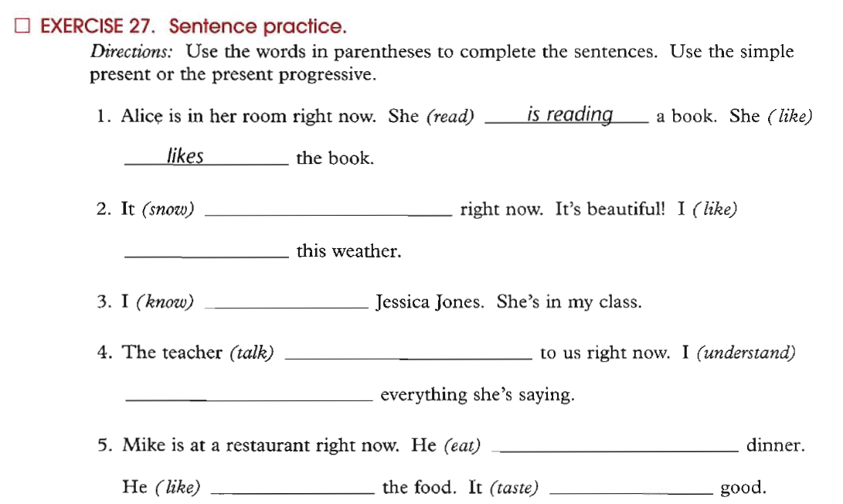

2. The underlined letter /es/ in the word ‘ fixes” has the same
pronunciation of the letter /s/ in the word: ____________ .
a. employs b. rooms c. matches d. helps

3. The underlined letter /s/ in the word ‘ goes” has the same
pronunciation of the letter /s/ in the word: ____________ .
a. heats b. repairs c. breaks d. catches

Exercise:
Circle the most suitable answer a, b, c or d for each of the following
- The final test will be similar to the questions in the lectures exercises.
1. The part speech of “ final” is __________
A. a verb B. an adverb
C. a noun D. an adjective
2. The part speech of “ questions ” is ________________
A. a verb B. an adverb
C. a noun D. an adjective
3. The part speech of “ will” is __________________
A. a main verb B. a verb to be
C. a modal D. a preposition
4. The part speech of “ in” is _________________
A. a verb B. a preposition
C. a noun D. an adjective
The doctor gave us the first homework last week.
5. The part speech of “ us” is ___________________pronoun
A. a possessive B. an object
C. a subject D. a reflexive
6. The part speech of “ gave ” is _____________________
A. a present verb B. an auxiliary
C. a future verb D. a past verb
7. The part speech of “ last” is _____________________
A. an adjective B. a verb to be
C. an article D. a preposition
8. The part speech of “ doctor” is __________________
A. a verb B. a subject noun
C. an object noun D. an adjective

Exercis
1. People in Saudi Arabia are as ______________ as people in Jordan .
A. more generous B. generous
C. most generous D. the most generous
2. The weather in winter is _____________ than it is in summer.
A. colder B. cold
C. coldest D. the coldest
3. I have ___________ money than you do.
A. much B. more
C. most D. least
4. Abdullah is ______________ of all boys.
in
A. the fastest B. the most fastest
C. fast D. faster

Do More Exercises
- What is the comparative of "sad"?
  - sader
  - sadder
  - sadier
  - saddier
- What is the comparative of "destructive"?
  - destructiver
  - more destructive
  - destructivier
  - more destructiver
- What is the superlative of "soft"?
  - softest
  - softiest
  - softtest
  - most soft
- What is the comparative of "hot"?
  - hoter
  - hotter
  - hotest
  - hottest
- What is the comparative of "heat"?
  - heater
  - heatter
  - heatier
  - hetter
  - none of these
- What is the superlative of "ugly"?
  - uglier
  - uggliest
  - uglyest
  - ugliest
- What is the superlative of "unpleasant"?
  - unpleasant
  - most unpleasant
  - more unpleasant
  - unpleasantest
- What is the superlative of "small"?
  - smallier
  - smaller
  - smalliest
  - smallest
- What is the comparative of "lively"?
  - livelyer
  - more livelyer
  - livelier
  - more livelier
- What is the superlative of "deep"?
  - deeper
  - deepper
  - deepest
  - deeppest
Choose the correct alternative for each sentence. (Comparatives or Superlatives)
1. I think that’s _____ film I’ve ever seen
- the funnier than b) the funny
- c) the funniest d) the funnier
2. Is football the _____ sport in Chile?
- popular b) more popular
- c) popularest d) most popular
3. Vegetables are _____ last week
- expensiver than b)more expensiver tham
- c) more expensive than d) most expensive

4. I think Vladimir is _____ intelligent person in the class
- more than b) the most
c) most d) the more
5. Don’t you think there are _____ things to do on hokidays than watching tv all day?
a) best b) bestest c) better d) better than
6. Summer is _____ season in our country
a) the hottest b) hotter than c) the hot d) hot
7. Groenland has the _____ weather of the world. It’s always raining and snowing
a) bad b) worse than c) worst d) worsest
8. The Everest is _____ the Aconcagua
a) the highest b) highest than c) the higher than d) higher than

9. Last week we had _____ day in Santiago, the temperature was –18ºC
a) the colder b) the coldest c) the cold d) colder than

10. To fall from a motorcycle is _____ to fall from a bicycle.
- more painful b) more painful than c) painfuller than d) the painfullest
11. If you suffer asthma, don’t go to Mexico City. It is one of the _____ cities in the world
- pollutest b) more polluted c) polluter than d) most polluted
12. The _____ place from Chile is Australia. It’s on the other side of the world.
- farther b) farthest c) farther than d) farthest than
13. I don’t think your bike is _____ mine.
- fastest than b) faster c) fastest d) faster than
14. Michael was _____ basketball player in the world
- taller b) tallest c) the taller d) the tallest
15. Speaking Japanese is _____writing it.
a) the easiest b) easy c) easier than d) easyer than

Write the following sentences using the correct form of the adjective (comparative or superlative)
- Clare is _______older than_____________________ Mike. (old)
- Jane is ________ of the four. She eats very well and does a lot of sports, (healthy)
- The coach thinks that Peter is the __________________ player of the team, (fast)
- The Sahara desert is one of the ___________________deserts in the world. (hot)
- The climate in the North of Chile is _______________________ in the South, (dry)
- Asia is _________________________________________________ Europe. (big)
- A Rolls-Royce is one of _______________________ cars in the world. (expensive)
- ____________________________ hurricanes are developed over México, (violent)
- Diamonds are ______________________________ jewels in the world. (precious)
- History classes are _________________________ chemistry classes. (interesting)
- In each of the sentences below, you will see a blank. Please choose one of the following articles for each sentence – a, an, the or leave it blank.
1. My father’s car is considered to be ______ piece of art.
- 2. _______ (B/b)eauty is fleeting.
- 3. _______ (A/a)ir in the room was stifling.
- 4. The doctor told me that I needed ______ operation tomorrow.
- 5. ______ (I/i)nformation I received was extremely important.
- 6. ______ (A/a)ir is made up of millions of atoms.
- 7. My parents could not believe that their dog had peed on ______ carpet.
- 8. ______ (A/a)pple a day keeps the doctor away.
- 9. In some cultures ______ dogs are considered man’s best friend.
- 10. My sister decided to cut her hair with ______ scissors.
- 11. I was bitten by _______ mosquito in the Caribbean.
- 12. When the horn honked, it scared me and I dropped ______ glass on the floor.
- 13. In ancient Egypt _______ cat was considered sacred.
- 14. Is _______ water in Lake Erie safe to drink?

- A, An, The, Zero Article
- 1. Could you please give me _____ piece of cake?
- a. an b. two c. a d. many

- 2._____ dog is ______ animal.
- a. An/a b. An/an c. A/an d. A/a
- 3. I visited ________ Ahmed last week.
- a. an b. the c. a d. Zero Article
- 4. The capital of Saudi Arabia is_______ Riyadh.
- a. Zero Article b. an c. a d. the
- 5. I finished _______ unit in English language course.
- a. an b. a c. three d. few
- 6. I take ______ umbrella when it rains.
- a. a b. an c. two d. several

