Lecture 27
Unit 9
Unit Objectives

Things happen
In Unit 9, you learn how to . . .
* use the past continuous for events in progress in the past.
* use myself, yourself, himself, etc.
* talk about accidents and things that went wrong.
* react to other people's stories.
* use the expression I bet. . . .

2) forget something | 1) broke something
4) damaged something | 3) lost something

Are you having a bad week?
Robert Moreno  “Yeah a kind of. A couple of days ago, a friend and I were waving to a friend at the mall. We weren’t looking, and we walked right into a glass door. I was so embarrassed.” | Sean Davis  " Actually, yes. I was going to  Work on the train Monday morning and I wasn't paying attention, and I missed my stop. I was half an hour late for a meeting with my new boss. "
Julia Chen
" Oh, definitely! A friend of mine
accidentally deleted all my music
files yesterday when she was using
my computer. I tried for hours to
find them, but nothing worked.
I lost everything! "

Can you choose the correct verb forms in these sentences?
1. Sean talked / was talking to a women on the train, and missed / was missing hid stop.
2. Julia's friend deleted / was deleting her files when used / was using Julia's computer.
3. Roberto and his friend tried / were trying to look cool when walked / were walking. Into a glass door.

Past Continuous
The past continuous is used to talk about actions and events in progress in the past.

Form
• Affirmative Statements
subject + was / were + present participle
I was talking.
They were watching TV.
• Negative Statements
subject + wasn’t / weren’t + present participle
I wasn’t paying attention.
We weren’t looking.

Past Continuous Forms
Question | negative | positive
Was I working?  Were you working?  Were we working?  Were they working?  Was he working?  Was she working?  Was it working? | I was not working.  You were not working.  We were not working.  They were not working.  He was not working.  She was not working.  It was not working. | I was working.  You were working.  We were working.  They were working.  He was working.  She was working.  It was working.

Past Continuous
Use
1. To talk about actions and evens in progress in the past
These may be temporary or unfinished.
Helen was using my computer last night.
Last year, I was living in Riyadh.

2.To set the background for a story, telling about longer actions
I was going to work, and I was talking to my friend.

Past Continuous with Simple Past
The Past Continuous is often used when one action in progress is interrupted by another action in the past.
The Past simple is used in such sentences.
A friend of mine deleted all my files (short action)
when she was using my computer (background, longer action)
She was studying when the phone rang.

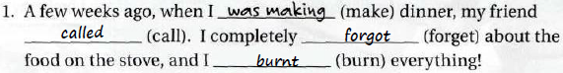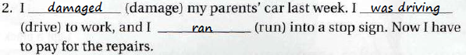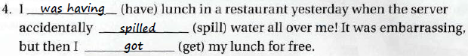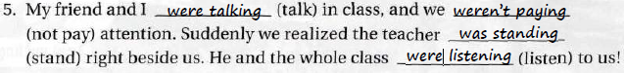

By: samiyah al-zahrani..

