آلوآجب آلآول :
1\ Psycholinguistics studies
A. how language is represented and processed in the mind
B. how language affects your psychological well being
C. how different languages can be learned
D. how words are organized in a dictionary
2\ A (intended) You have wasted the whole term.
B (said) You have tasted the whole worm.
Sentence B is an example of:
A. a slip of a tongue
B. a syntactic error
C. a parsing problem
D. a priming effect
3\ Lexical Decision is
A. a method used to understand how words are represented in the mind
B. a method used to organize words in a dictionary
C. a method used to analyze words using a computer
D. a method used to measure how many word are in the brain
آلوآجب آلثآني :
1\ Event-related potentials (ERPs) is an experiment that:
A. measures electrical activity in the brain
B. measures the potential to learn a language
C. measures the speed of someone's speech
D. measures the time of a learning event
2\ Bottom-up processing is:
A. a phonetic analysis used to relate sounds to items in the mental lexicon
B. a morphological analysis used to relate sounds to items in the mental lexicon
C. a syntactic analysis used to relate sounds to items in the mental lexicon
D. a semantic analysis used to relate sounds to items in the mental lexicon
3\ The psycholinguistic study of morphological processing:
A. seeks to understand how morphological principles play a role in the representation of words in the mind
B. seeks to create a computer programs that work as word processors
C. seeks to analyze words and phrases in the sentences with speech errors
D. seeks to understand how computer word processors can be used to enhance language acquisition
آلوآجب آلثآلث :
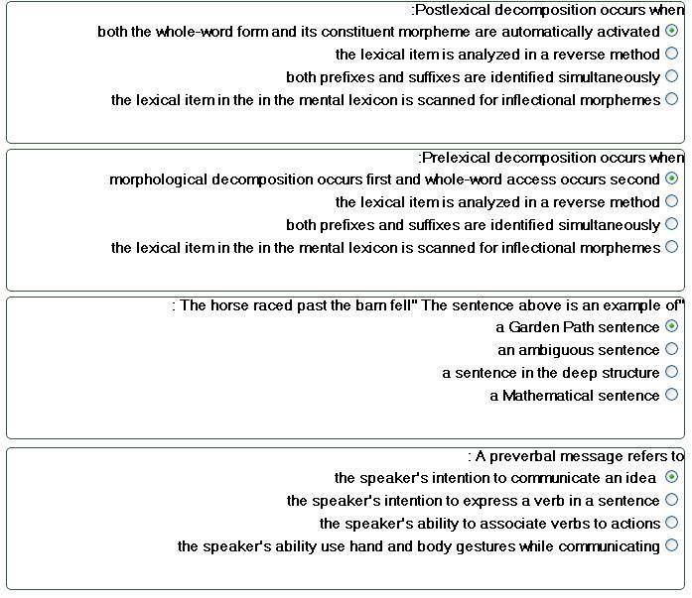

بَ آلتوفيقَ لكُم .. Susan

