الفصل الخامس عشر
إدارة نماذج وأدوات ويندوز أثناء تشغيل البرنامج
التمرين الأول :-
- أرسمي الشكل التالي حيث أن الإحداثياتي هي :
100, 20, 100, 90 الرأس
150, 110, 150, 250 الجسم
150, 150, 100, 170 اليدين
150, 150, 200, 170
150, 250, 100, 300 الرجلين
150, 250, 200, 300
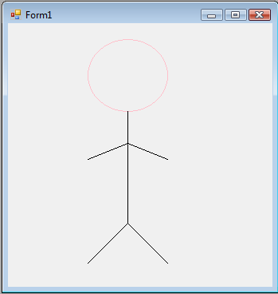
Public Class Form1
Private Sub Form1_Paint(ByVal sender As Object, ByVal e As System.Windows.Forms.PaintEventArgs) Handles Me.Paint
Dim G As Graphics
G = Me.CreateGraphics
Dim Pen As New Pen(Color.Pink)
Dim Brush As New SolidBrush(Color.Blue)
'الراس
G.DrawEllipse(Pen, 100, 20, 100, 90)
'الجسم
G.DrawLine(Pens.Black, 150, 110, 150, 250)
'اليدين
G.DrawLine(Pens.Black, 150, 150, 100, 170)
G.DrawLine(Pens.Black, 150, 150, 200, 170)
'الرجلين
G.DrawLine(Pens.Black, 150, 250, 100, 300)
G.DrawLine(Pens.Black, 150, 250, 200, 300)

'G.FillRectangle(Brushes.SkyBlue, 70, 20, 20, 40)
'G.FillEllipse(Brushes.Yellow, 300, 10, 50, 50)
End Sub
End Class
التمرين الثاني :-
اكتبي برنامج يسمح للمستخدم باختيار الشكل من قائمة (List box) ثم يختار اللون من Radio Button كما يسمح له باختيار رسم شكل معبأ :-
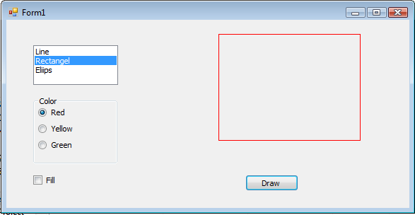

Public Class Form1
Dim G As Graphics
Dim P As Pen
Dim B As SolidBrush
Private Sub RadioButton1_CheckedChanged(ByVal sender As System.Object, ByVal e As System.EventArgs) Handles RadioButton1.CheckedChanged
P = New Pen(Color.Red)
B = New SolidBrush(Color.Red)
End Sub

Private Sub RadioButton2_CheckedChanged(ByVal sender As System.Object, ByVal e As System.EventArgs) Handles RadioButton2.CheckedChanged
P = New Pen(Color.Yellow)
B = New SolidBrush(Color.Yellow)
End Sub

Private Sub RadioButton3_CheckedChanged(ByVal sender As System.Object, ByVal e As System.EventArgs) Handles RadioButton3.CheckedChanged
P = New Pen(Color.Green)
B = New SolidBrush(Color.Green)
End Sub

Private Sub Button1_Click(ByVal sender As System.Object, ByVal e As System.EventArgs) Handles Button1.Click
G = Me.CreateGraphics
'fill
If CheckBox1.Checked = True Then
If ListBox1.SelectedIndex = 1 Then
G.FillRectangle(B, 300, 20, 200, 150)
ElseIf ListBox1.SelectedIndex = 2 Then
G.FillEllipse(B, 300, 20, 200, 150)
End If
End If
'not fill
If CheckBox1.Checked = False Then
If ListBox1.SelectedIndex = 0 Then
G.DrawLine(P, 300, 20, 200, 150)
ElseIf ListBox1.SelectedIndex = 1 Then
G.DrawRectangle(P, 300, 20, 200, 150)
ElseIf ListBox1.SelectedIndex = 2 Then
G.DrawEllipse(P, 300, 20, 200, 150)
End If
End If
End Sub
End Class

