Gold, God and Glory محاضر ه2
Trade routes, Missionary work and Fame
- Crusades tried to dislodge Muslims from control of trade routes to the East

- Crusades were a big loss, but Europe learnt to draw maps and sail seas.
- Fall of Islamic Spain, al-Andalus, put a huge reservoir of wealth and scientific knowledge in the hands of Europe
- Notice the dates: Fall of Grenada January 1492, Columbus sails in July 1492.
- Explorations Begin
- Portugal, Spain, England, and France led the exploration and colonization movement and built individual empires across the Americas, Africa, Asia, and Australia.
- Portugal led the way. A land of experienced sailors who had traveled the seas in search of trade for centuries. Portuguese monarchs like Prince Henry the Navigator understood their country’s dependence on the sea and eagerly finance exploration ventures.
- Portugal
- 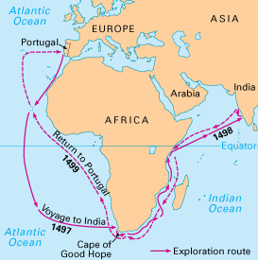
- Portugal led the way. A land of experienced sailors who had traveled the seas in search of trade for centuries. Portuguese monarchs like Prince Henry the Navigator understood their country’s dependence on the sea and eagerly finance exploration ventures.
- The Portuguese, first, explored
the west coast of Africa and established
trade in gold and slaves
- . 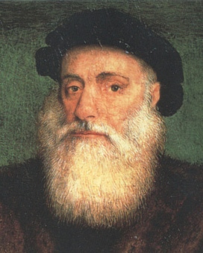
- 1497, Vasco da Gama sailed around the Cape of
Good Hope at the southern tip of Africa and
Continued to India. He and his crew were the
first Europeans to reach India by sea.
- Then the Portuguese established settlements
in Brazil in South America.
- Brazil provided Portugal gold and sugar.
- Portugal was more interested in trade
than in taking over a land and its people. By the 1600s, Portugal
had established trading posts in important coastal areas of Africa
The Spanish Empire
- The Spanish Empire Spain’s exploration and colonization were led by the Italian explorer Christopher Columbus. in 1492, Columbus reached the Caribbean Islands. His aim was to find a new route to Asia.
- Accidentally found America while looking for a westward route to Asia
- His voyages considered a turning point in history
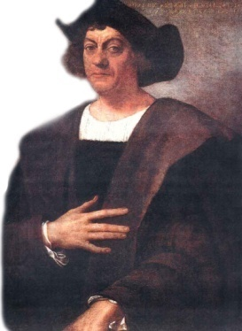
The Spanish Empire

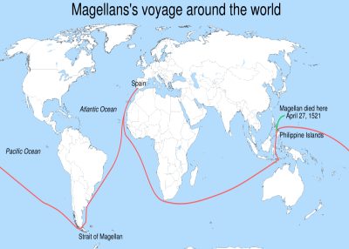
- In 1510, Spain financed the voyage of Portuguese explorer Ferdinand Magellan, who headed south and west, rounding the tip of South America and finally reaching the Philippine Islands after 18 months at sea.
- Magellan died there, but his crew returned home after circumnavigating the entire world and proving that the earth was round!
- The Spanish Empire
- Spanish explorers soon conquered the powerful Inca and Aztec empires in what is now Peru and Mexico. They established colonies that destroyed the native’s civilization and its population. The Spanish empire eventually became the largest and strongest of the colonial empires.
- The Spaniards used the gold and silver of the Americas to finance military wars and to take over Asian trades in spices, silk and cloth.
Spreading the Catholic religion was also an important part of the Spanish colonization

- The English EmpireEngland started by conquering Ireland in the 1500s.
- In the 1600s and 1700s, the English established tobacco plantations in the Caribbean Island and colonies along the Atlantic coast of North America.
The colonists were a mix of religious puritans and pirates and mercenaries
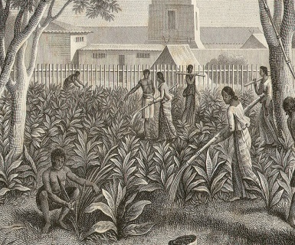
- In 1600, England chartered the East India Company to trade in the East Indies (India and Southeast Asia) and soon established a colonial presence in India. India eventually came under British rule in 1858.
- England first explored Australia in the late 1600s and established a strong colonial presence there in the late 1700s after the American colonies became independent. The French
- The French
- The French settled in North America once French explorer Samuel de Champlain founded the colony of Quebec as a trading post in 1608. Then they moved down the Mississippi River and claimed the central part of what is now the United States.
- Rise of Mercantilism
- Governments sponsored most early ventures
- Private sponsorship begins with Joint-Stock Companies
- Money pooled together = Limited liability
- World trade shifts from Mediterranean to Atlantic
- Mercantilism begins:
- Nations base wealth on gold and silver, gained only through mining or trade.
- Gov’ts begin forcing colonies to trade ONLY with parent country
- All raw materials go to parent country, and colonies must buy finished goods from parent country
- All wealth then stays with parent country

- Social Impact
- Massive population growth in Europe between 1450-1650 (55 mil to 100 mil)
- Columbian Exchange- new crops, animals, diseases exchanged
- Items only in Europe/Asia before 1492: Beet, Carrot, Cherry, Cinnamon, Coffee, Grape, Lettuce, Melon, Oat, Olive, Orange, Rice, Spinach, Wheat, Cattle, Goat, Pig, Sheep, Cotton, Rat
- Items only in America before 1492: Avocado, Cacao Bean (Chocolate), Chile Pepper, Corn, Peanut, Pineapple, Potato, Pumpkin, Sweet Potato, Tomato, Turkey, Tobacco
- People begin to migrate to New World colonies for new opportunities
- Scientific Revolution
- Nicolas Copernicus
- Studied in Poland; questioned old beliefs
- Thought Earth was round, it rotated in axis, & revolved around the sun
- Wouldn’t publish beliefs until near death (afraid of the Church)
- Johannes Kepler
- Used math to prove Earth revolved around sun
- Also discovered planets move in ellipses & at different speeds
- Galileo Galilei
- Built telescope & observed several moons
- Proved theories of Copernicus
- Church forced him to recant his beliefs
- Also worked with physics and motion
- Scientific Revolution
- Francis Bacon
- Founded the scientific method (truth through evidence)
- Rene Descartes
- Questioned everything; father of analytical geometry
- “I think therefore I am”
- Isaac Newton
- 1st European to recognize concept of gravity (apple)
- Wrote of laws of universe (Principia)
- Developed calculus to study changes in forces or quantities
- Andreas Vesalius
- Recorded information on human anatomy (The Structure of the Human Body)
- Robert Hooke
- Used microscope to study the body
- Discovered cells
- Conclusions
- Of course, Renaissance did not usher only an age of exploration and travels and literature.
- It also ushered an age of exploitation and destruction
- Many nations were destroyed in the areas that came under European control.
- Some like the Mayas and Incas were very sophisticated
- The Renaissance also ushered the age of the International Slave Trade, and millions of Africans were kidnapped and taken to plantations in the Americas where they were forced into bondage and servitude.
- Conclusions
- Not to forget that mercantilism builds the foundations of the modern Capitalist system
- New methods of warfare that are far more devastating than anything humanity has ever seen.
- The literature of the Renaissance did not appear simply because some writers of genius appeared, but because the new socio-economic realities brought with it new cultures and new ways to look at the world and new ways to think and organize and communicate.

