-12-
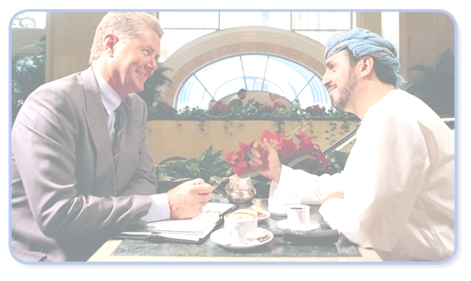
Effective dialogue & Communication Skills. (Part 2)
Creative methods and approaches on presenting Islam and its civilization & culture to others nicely and wisely!

Second:
Defining Names and Terms
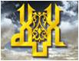
God

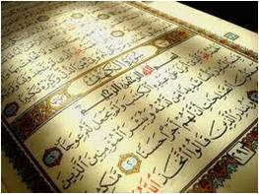  The Qur’an  Muslim | 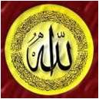  Allah | 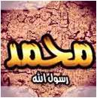Muhammad  Islam

 | In a survey questionnaire that I conducted during my Ph.D.  study at Michigan State University, one of the questions asked:  According to you,  ‘GOD’ refers to WHO?
These are the participants’ responses! Thus, people generally view “God”
Differently based on their religious & cultural backgrounds!

- God refers to The Creator.
- God refers to Krishna.
- God refers to Buddha.
- God refers to Allah.
- God refers to Brahma.
- God refers to Jesus.
- God refers to nothing. There is no god.
- God refers to god the Father, god the Son, and god the Holy Spirit.
Third:
Showing
the Beauty of Islam

Monotheism
(A Pure Creed )

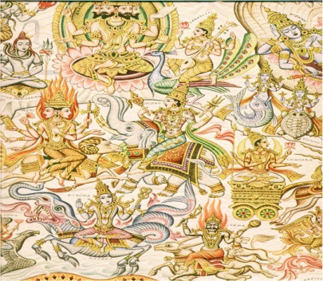 | Hinduism  Brahma, the Creator  Vishnu, the Preserver  Shiva, the Destroyer  + 33 million gods

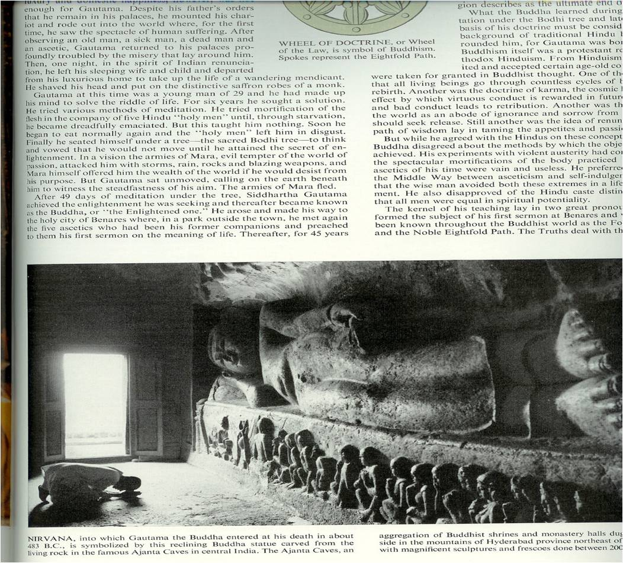
Buddhism:
Buddha

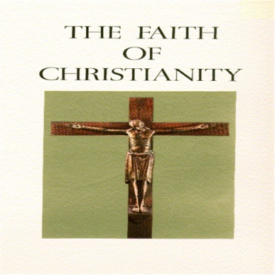 | Christianity  Trinity  - God the Father  - God the Son  - God the Holy Spirit

Monotheism/ Tawheed
) A Pure Creed and belief in the One True God, Allah alone )
- Peace of Mind

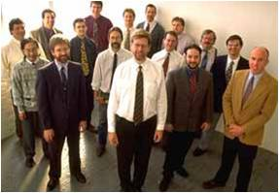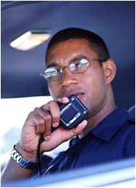
- Equality

- Moderation


- Brotherhood

- Justice

- Good
Manners


Islam clearly answers important and critical questions like:

- Who is The true God?
- Who created us?
- Why were we created?
- Whom must we worship?
- What is after death?
- How to get Eternal life?

Fourth:
Introducing
The ABCs Of Islam

Teach the ABCs of Islam:

- Explain the articles of faith briefly.
- Explain the pillars of Islam briefly.

- Focus on:
- The Testimony (Ashahada)
- Prayer (Salat)

Notes:______________________________________________________________________________________________________________________________________________________________________________________________________________________________________________________________________________________________________________________________________________________________________________________________________________________________________________________________________________________________________________________________________________________________________________________________________________________________________________________________________________________________________________________________________________________________________________________________________________________________________________________________________________________________________________________________________________________________________________________________________________________________________________________________________________________________________________________________________________________________________________________________________________________________________________________________________________________________________________________________________________________________________________________________________________________________________________________________________________________________________________________________________________________________________________________________________________________________________________________________________________________________________________________________________________________________________________________________________________________________________________________________________________________________________________________________________________ _____________________________________________________________________________________________________________________________________________________________________________________________________________________________________________________________________________________________________________________________________________________________________________________________________________________________________________________________________________________________________________________________________________

