-11-
What’s Parallelism?
Conjunctions

Parallelism

What is parallelism in grammar?

The best way to understand the idea of parallelism is to look at examples.
For example:
(Not parallel)
We wanted to cook and to go swimming.
(Parallel)
We wanted to cook and to swim.

What is parallelism?

- Parallelism means using similar structures to express similar ideas.
- Parallel structures make sentences clearer and easier to read.
- Editing for parallel structure helps you avoid awkward sentences and keeps you from breaking your promise to the reader.

Using parallel structure in your writing will help with

1) economy 2) clarity
3) equality 4) delight.

Example:

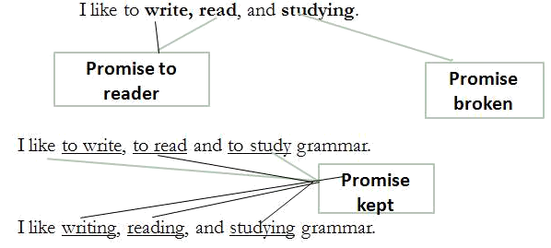

Now you try. Which sentence is parallel?

- This semester I’m studying art, music, and taking a math course.

- This semester I’m studying art, music, and math.

Use parallel structure with elements in lists or in a series.

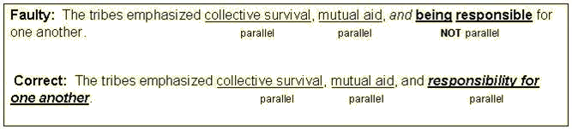

How Can we make a paralleled structure?

Use parallel structure with elements joined by coordinating conjunctions.

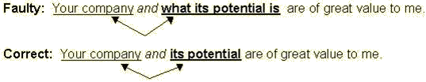

What is a Conjunction?

A conjunction is like glue. It helps things to stick together.
A conjunction joins words, phrases, and sentences, which are called clauses.

What is a Conjunction?

Conjunctions join two or more words.
Example: I went to the store to buy eggs, milk, and bread.

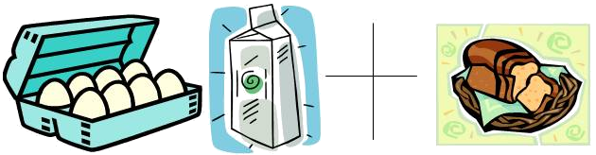

What is a Conjunction?

Conjunctions can join two prepositional phrases.
Ex. I went skiing down the hill and past the trees.

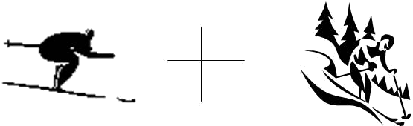

What is a Conjunction?

Conjunctions can connect two clauses or sentences.
When two sentences are joined, a comma MUST be placed before the conjunction.
Ex. I played cards for awhile, but then I played chess.

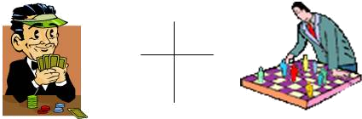

Types of Conjunctions

One type of conjunction is the coordinating conjunction.
They connect words, phrases, and clauses, which are sentences.
They connect things of equal value.
(This means that they would connect a noun with another noun or
a prepositional phrase with another prepositional phrase.)

CONJUNCTIONS
Conjunctions are words used as joiners.
Different kinds of conjunctions join different kinds of grammatical structures.

“AND”

Coordinating conjunctions affect the meaning of your sentence.
“And” connects things that are alike or joined together.
Ex. I want popcorn and pizza.
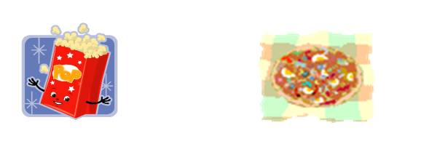

“BUT”

Coordinating conjunctions affect the meaning of your sentence.
“But” is used to connect things that are different or separated.
Ex. I want popcorn but not pizza.

“OR”

Coordinating conjunctions affect the meaning of your sentence.
“Or” is used to offer a choice.
Ex. Do I want popcorn or pizza?

“NOR”

Coordinating conjunctions affect the meaning of your sentence.
“Nor” is used to offer a negative choice.
Ex. I do not want popcorn nor pizza.
“YET”

Coordinating conjunctions affect the meaning of your sentence.
“Yet” is used to show a change. When it is used to combine two sentences, you must put a comma before it.
Ex. I want popcorn, yet I also want pizza.

“SO”

Coordinating conjunctions affect the meaning of your sentence.
“So” is used to show a relationship between things. When it is used to combine two sentences, you must put a comma before it.
Ex. I want popcorn, so I made some.

“FOR”

Coordinating conjunctions affect the meaning of your sentence.
“For” is also used to show a relationship between things. When it is used to combine two sentences, you must put a comma before it.
Ex. I ordered a pizza, for I was hungry.

Coordinating conjunctions

join equals to one another:
words to words,
phrases to phrases,
clauses to clauses.

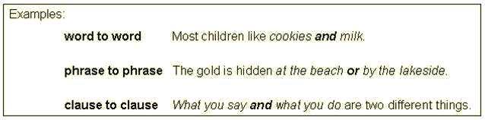

Coordinating conjunctions go in between items joined, not at the beginning or end.

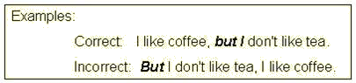

Punctuation with coordinating conjunctions:

When a coordinating conjunction joins two words, phrases, or subordinate clauses, no comma should be placed before the conjunction.

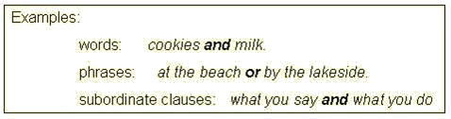

A coordinating conjunction joining three or more words, phrases, or subordinate clauses creates a series and requires commas between the elements.

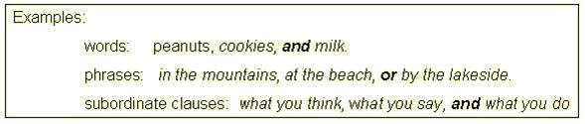

A coordinating conjunction joining two independent clauses creates a compound sentence and requires a comma before the coordinating conjunction.

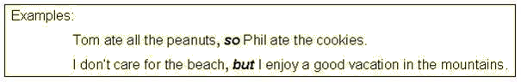

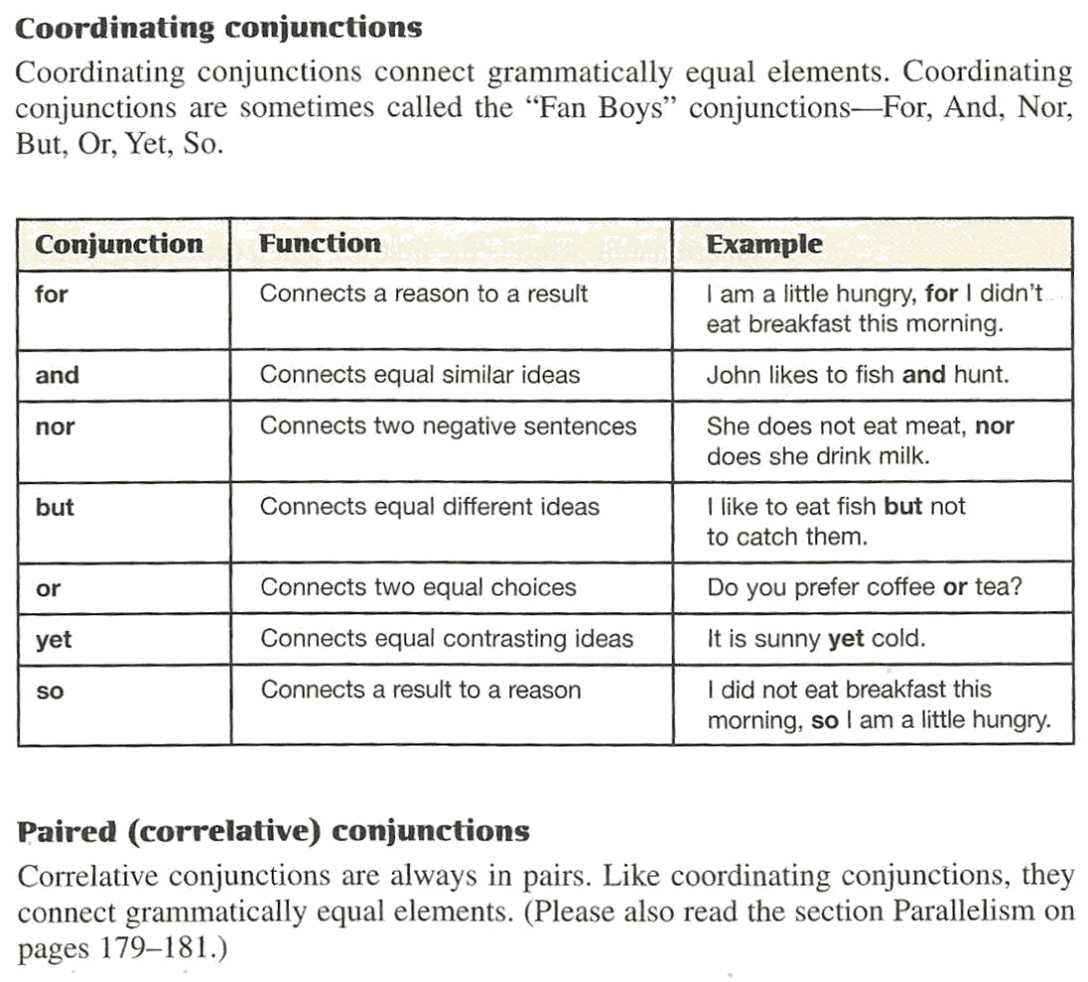

PAIRED CONJUNCTION

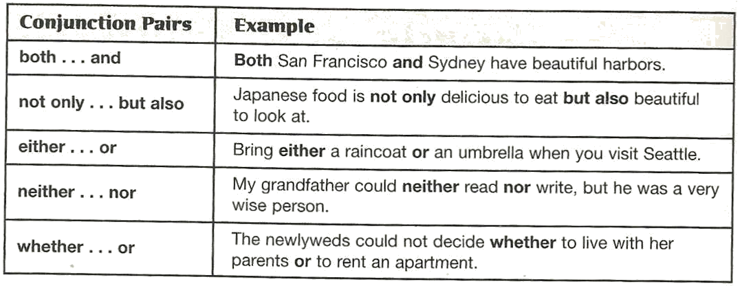

These pairs of conjunctions require equal (parallel) structures after each one.

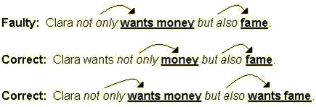

Exercises

- The curtains were pulled shut. The school was empty.
- Alvin has always lived in the city. His parents bought a home in the suburbs.

- Biggie Molar has a toothache. He will see the dentist, Dr. I. Yankum.
- Carmelo received a new Mini Cooper. He passed all his subjects with A’s.

- Rod Ketchum worked in the city sewer system. He attended night school.
- I may take a trip to Mt. Rushmore. I may stay home.

Answers

- The curtains were pulled shut, and the school was empty.
- Alvin has always lived in the city, yet his parents bought a home in the suburbs.
- Biggie Molar has a toothache, so he will see the dentist, Dr. I. Yankum.

More Exercises

- The boys were given five detentions each. They had cut Mr. Atom’s science class.
- I had a chance to buy a ten speed racer. I decided on buying an ATV instead.

- Bike riding enables me to see the sights of the city. It allows me to lose weight.
- The canoe was old and leaky. We won the race.

- The girls had never played on the team before. They won the first game of the season.
- He was bigger and stronger than I. I let him kick sand in my face.
- Girls are weaker than boys. Boys are putty in their hands.

Answers

- The boys were given five detentions, for they had cut Mr. Atom’s science class.
- I had a chance to buy a ten speed racer, but I decided on buying an ATV instead.

- Bike riding enables me to see the sights of the city, and it allows me to lose weight.
- The canoe was old and leaky, yet we won the race.

- The girls had never played on the same team before, but they won the first game of the season.

- He was bigger and stronger than I, so I let him kick sand in my face.
- Girls are weaker than boys, yet boys are putty in their hands.

To Be Continued…

Notes:___________________________________________________________________________________________________________________________________________________________________________________________________________________________________________________________________________________________________________________________________________________________________________________________________________________________________________________________________________________________________________________________________________________________________________________________________________________________________________________________________ _________________________________________________________________________________________________________________________________________________________________________________________________________________________________________________________________________________________________________________________________________________________________________________________________________________________________________________________________________________________________________________________________________________________________________________________________________________________________________________________________________________________________________________________________________________________________________________________________________________________________________________________________________________________________________________________________________________________________________________________________________________________________________________________________________________________________________________________________________________________________________________________________________________________________________________________________________________________________________________________________________________________________________________________________________________________________

