-10-

Elements of the Class

- Complex Sentences
- With adverb clause
- With adjective clause
- With noun Clasus

Complex Sentences

A complex sentence contains at least one independent clause and one dependent clause.

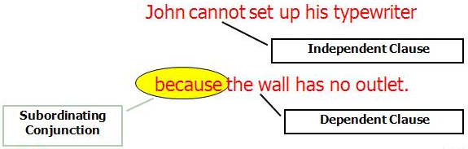

Example- Complex Sentence

A complex sentence contains at least one independent clause and one dependent clause.

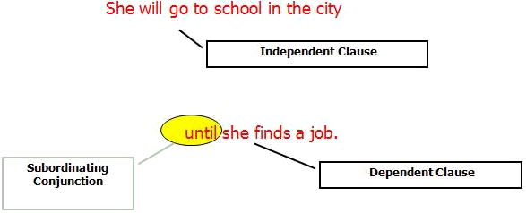

Complex Sentences

Use a comma after a dependent clause if it begins the sentence.

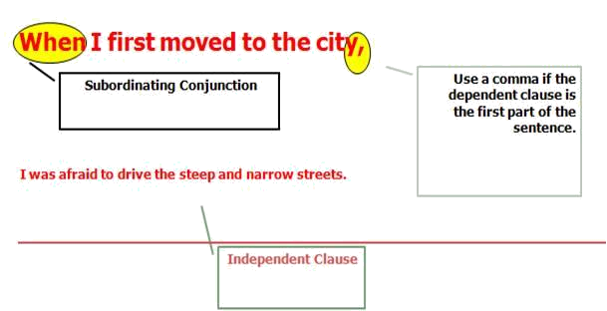

Correct! 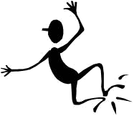

Excellent! This sentence reads more smoothly
because it has more sentence structure variety.

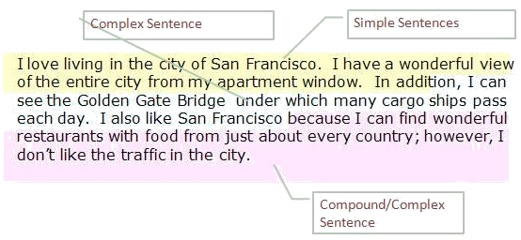


I’m Sorry!

These sentence do not read as smoothly.
These sentences contain no sentence variety.

I love living in the city. I have a wonderful view of the entire city. I have an apartment. I can see the Golden Gate Bridge. I can see many cargo ships pass under the bridge each day. I like the restaurants in San Francisco. I can find wonderful food from just about every country. I don’t like the traffic in the city.
Simple Sentences

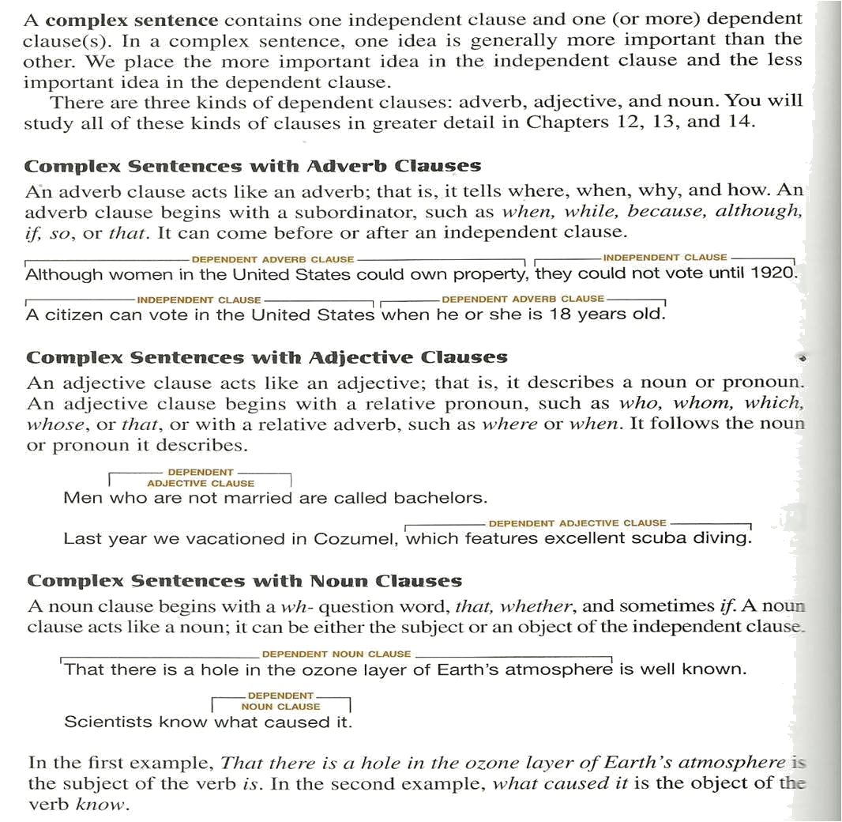
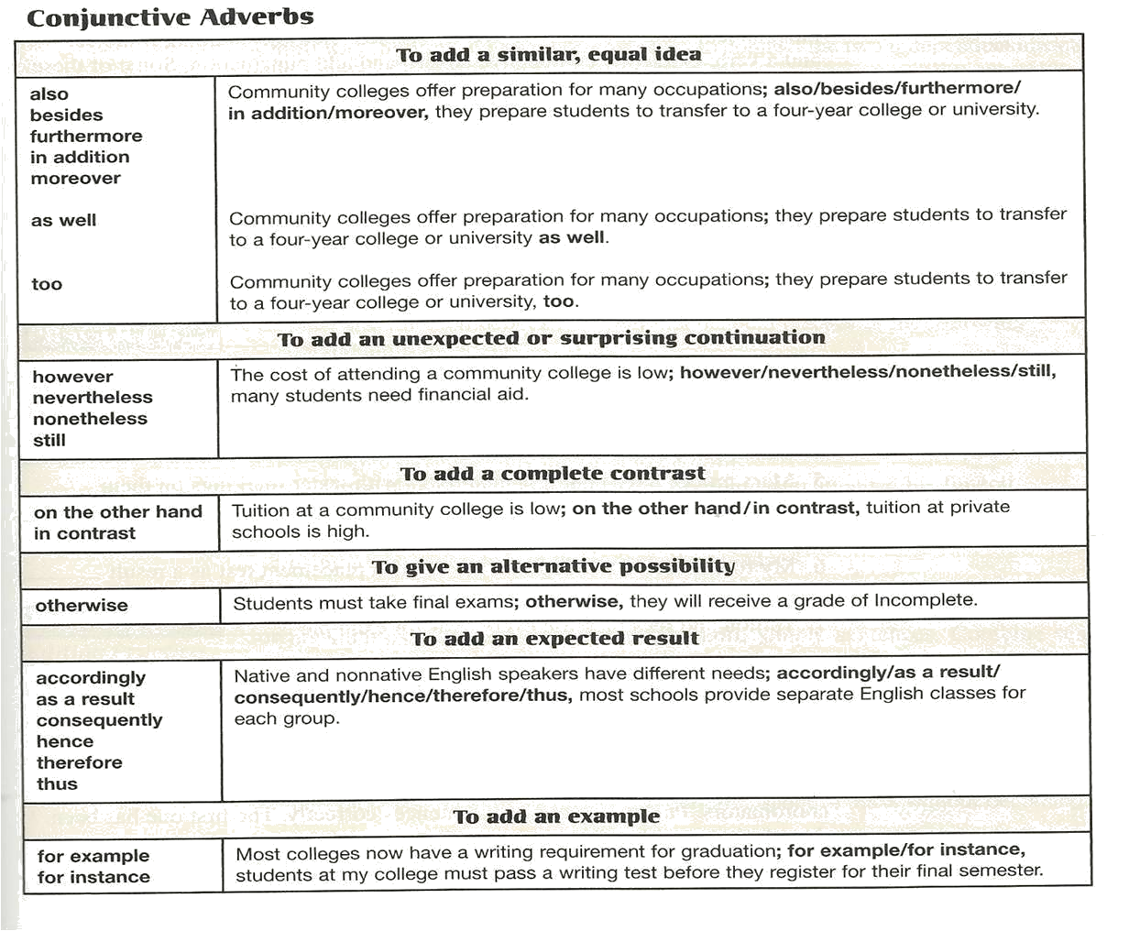

Relationship | Transition
Addition | Moreover  Furthermore  In addition  besides
Contrast | However On the contrary  In contrast On the other hand
Result or Effect | Consequently Accordingly  Thus Hence  Therefore As a result
Reinforcement/Emphasis | Indeed  In fact

Relationship | Transition
Exemplification | For example  For instance  In particular
Time | Meanwhile (at the same time)  Subsequently (after)  Thereafter (after)
Reinforcement/Emphasis | Indeed  In fact
Exemplification | For example  For instance  In particular

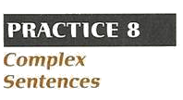
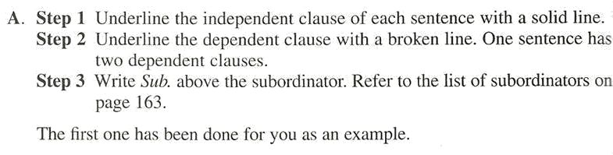
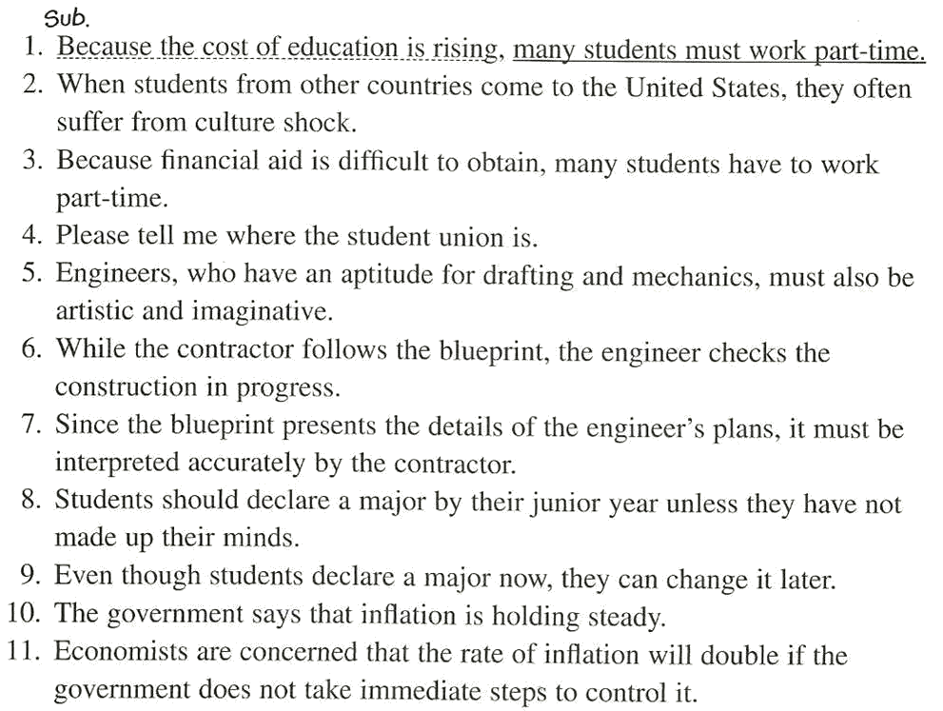
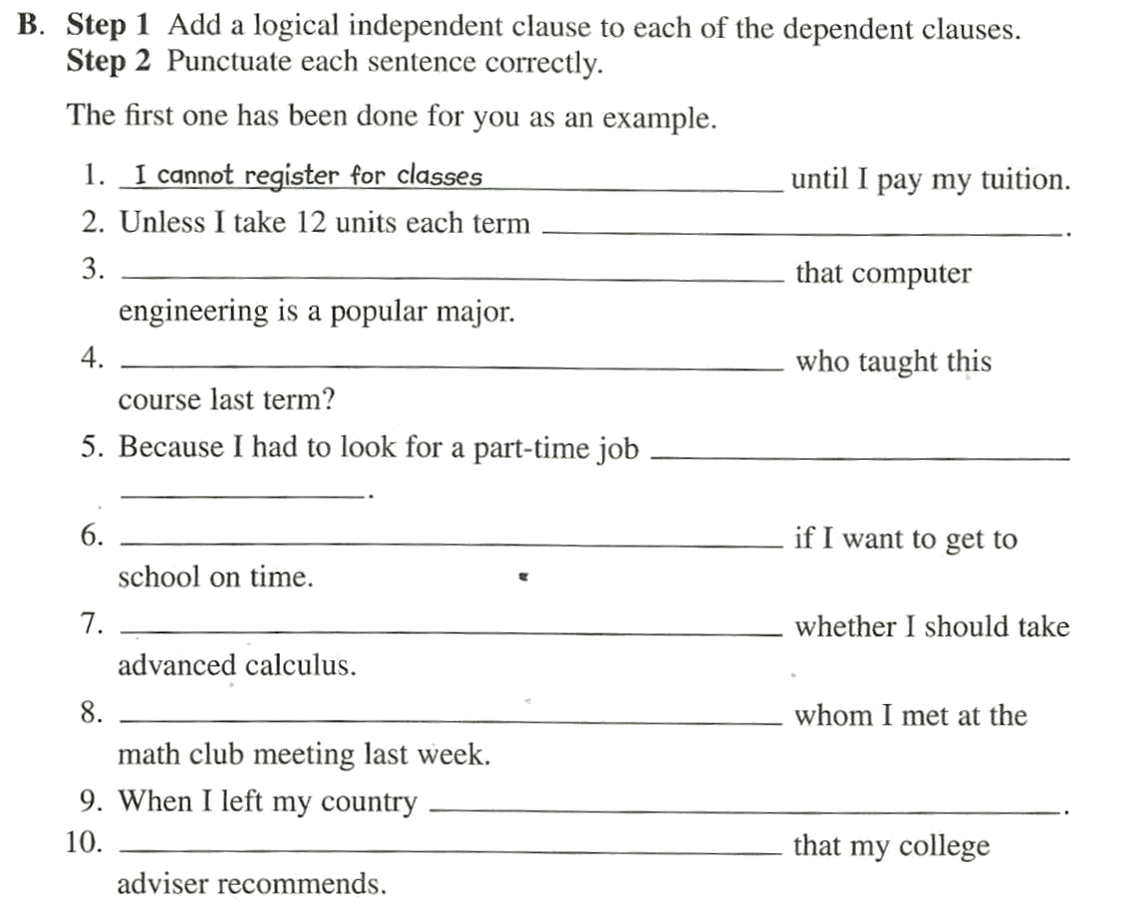

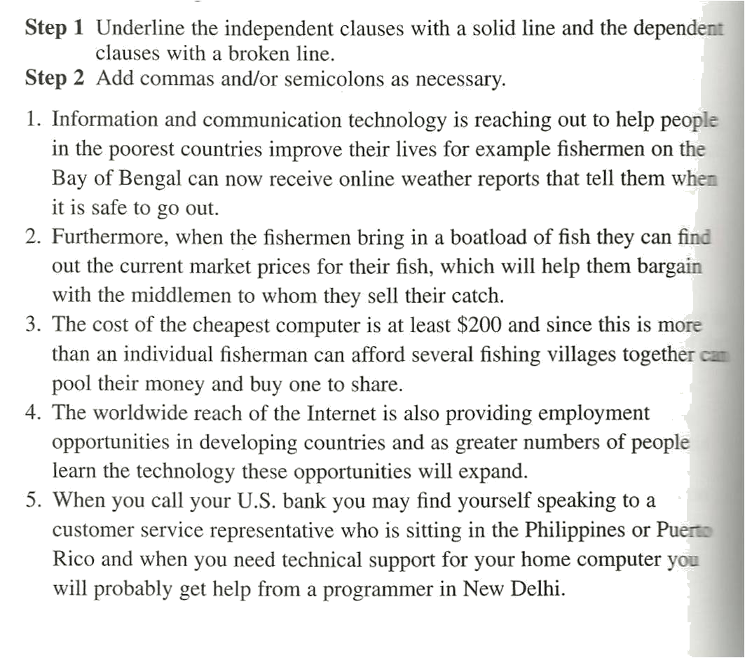

Notes:___________________________________________________________________________________________________________________________________________________________________________________________________________________________________________________________________________________________________________________________________________________________________________________________________________________________________________________________________________________________________________________________________________________________________________________________________________________________________________________________________ ________________________________________________________________________________________________________________________________________________________________________________________________________________________________________________________________________________________________________________________________________________________________________________________________________________________________________________________________________________________________________________________________________________________________________________________________________________________________________________________________________

