-14-
Review: Exercises

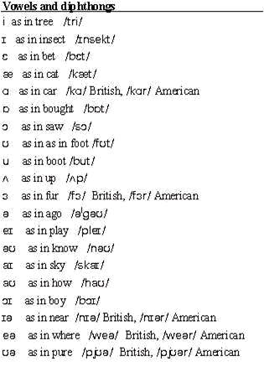

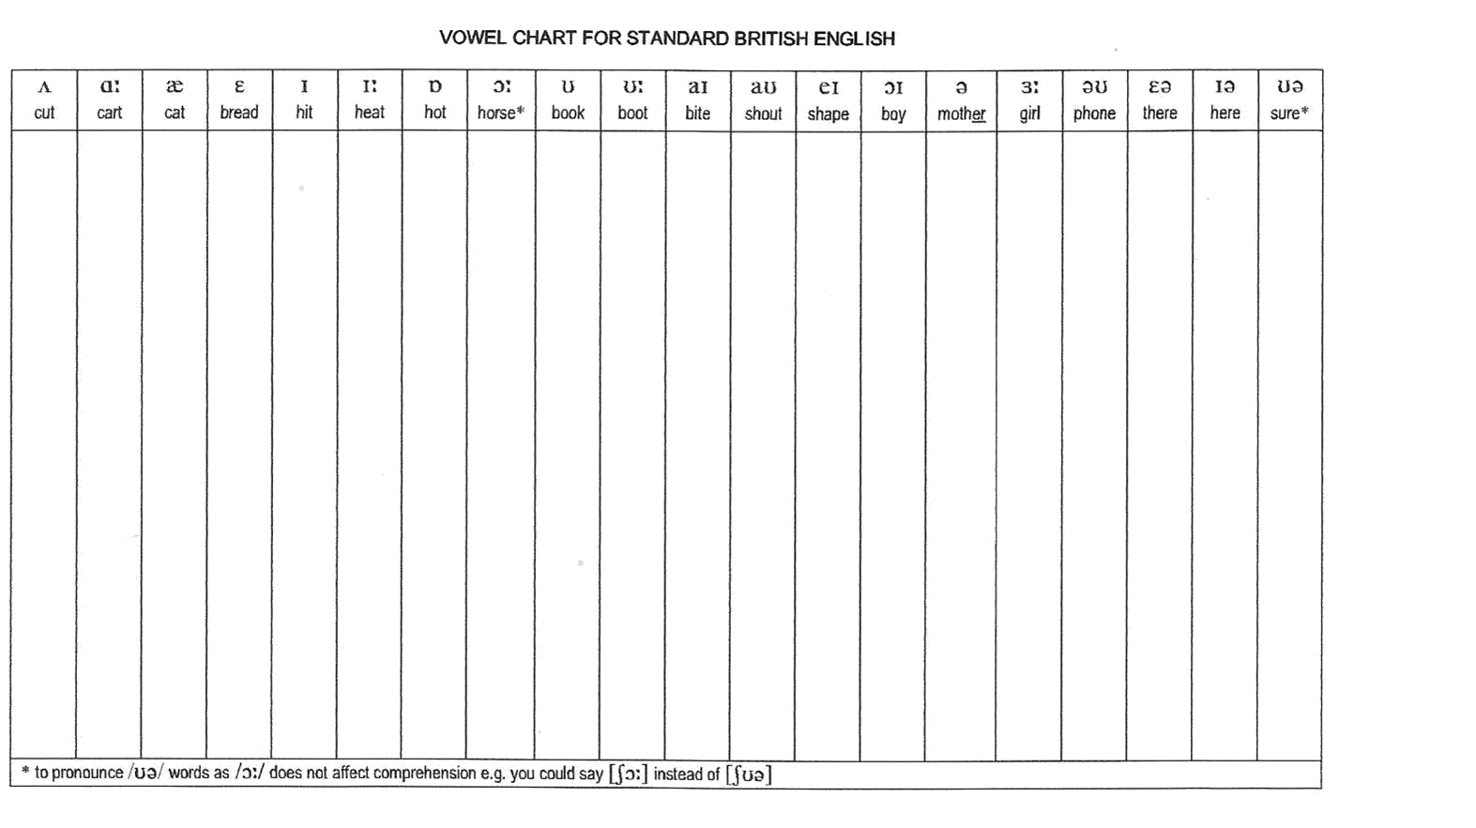

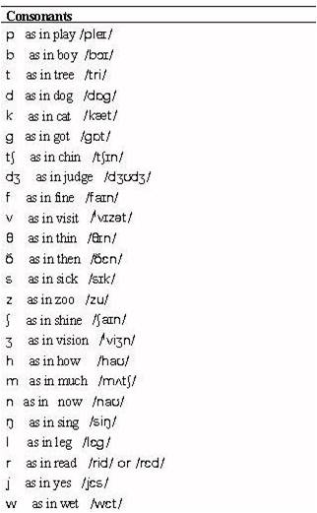

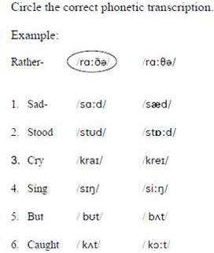

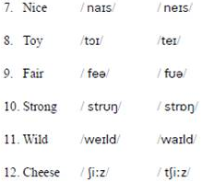

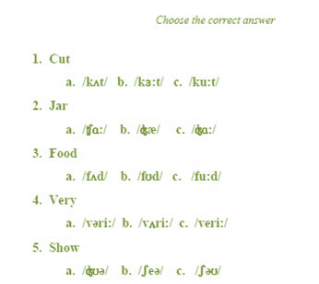
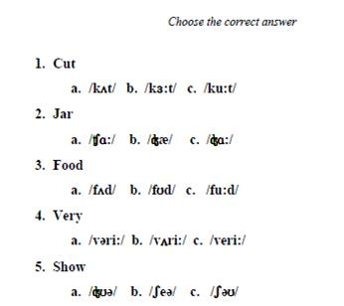

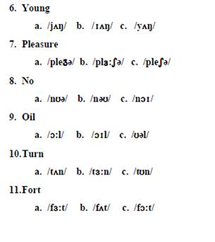

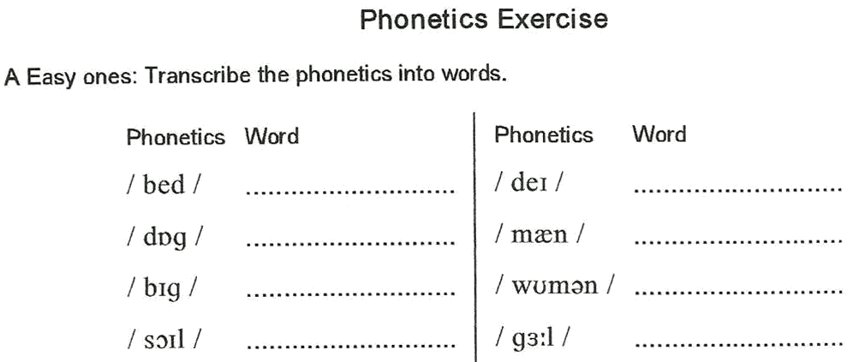

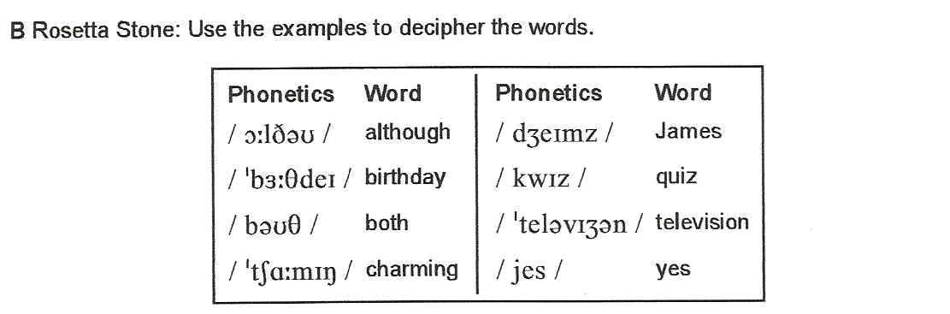

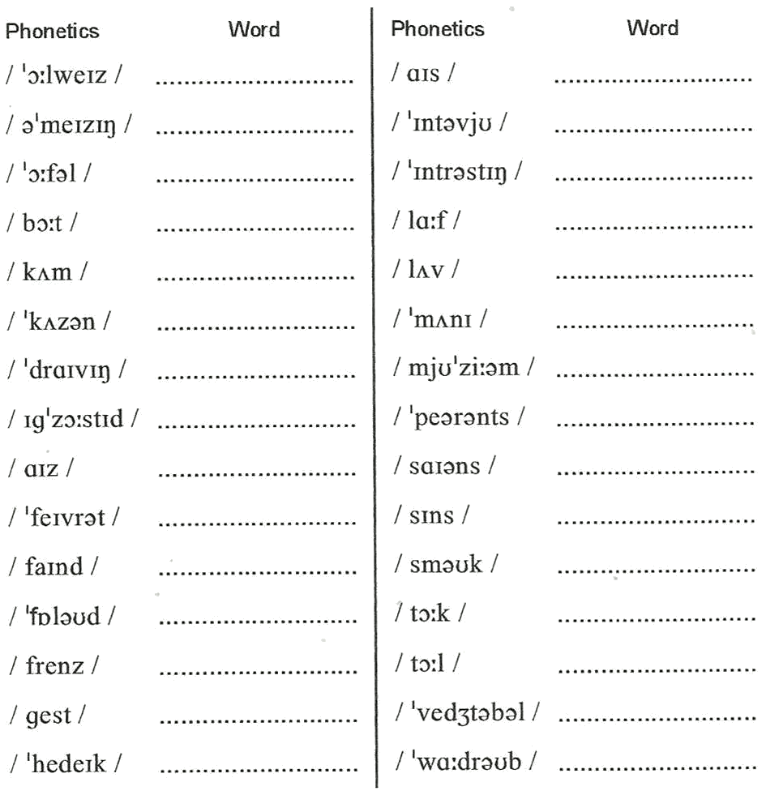

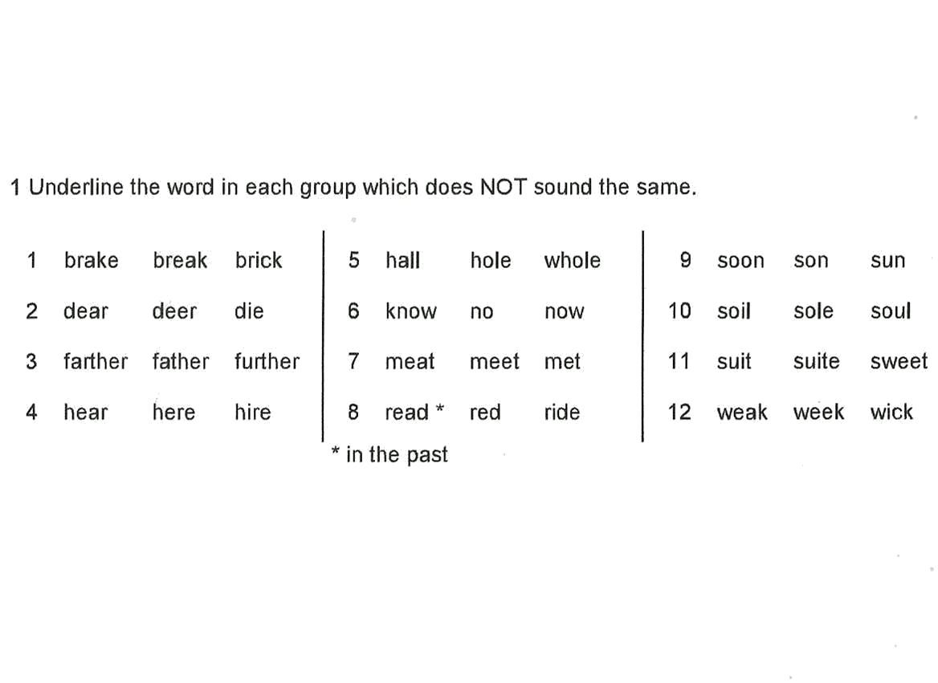

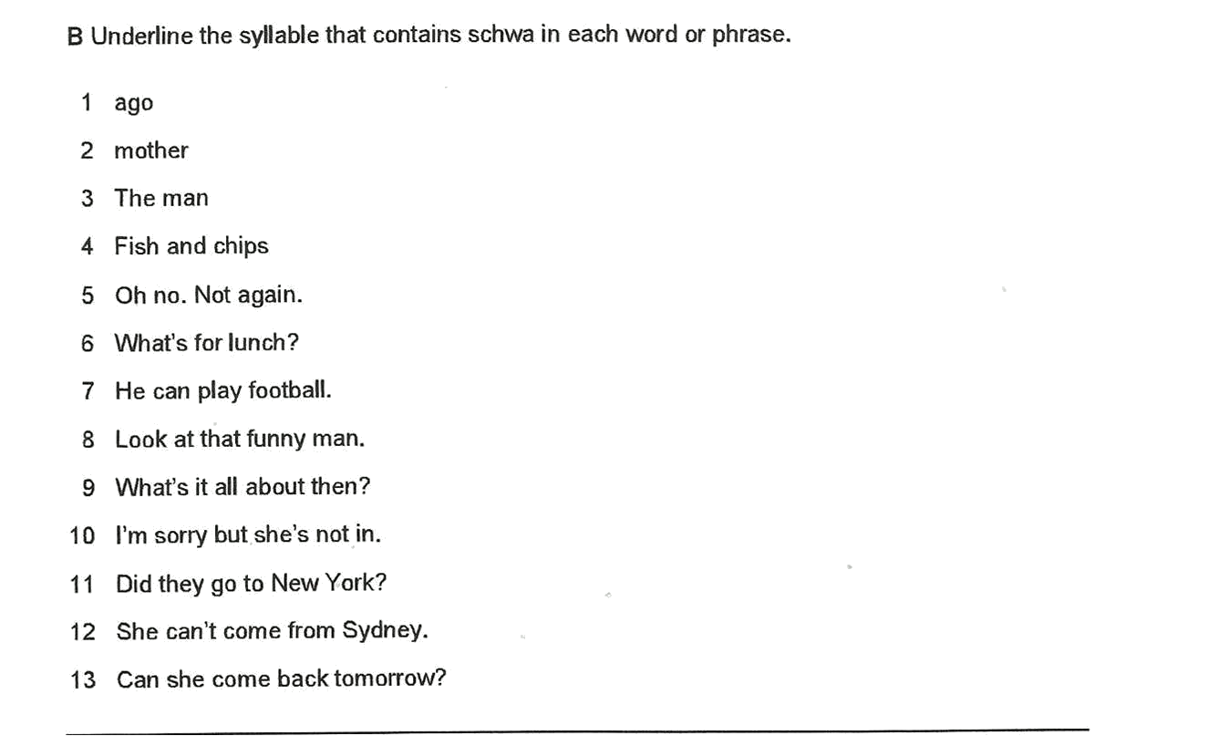

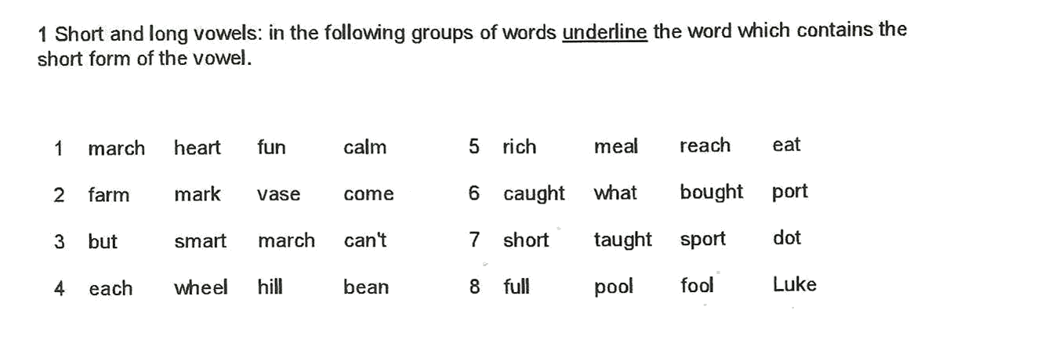

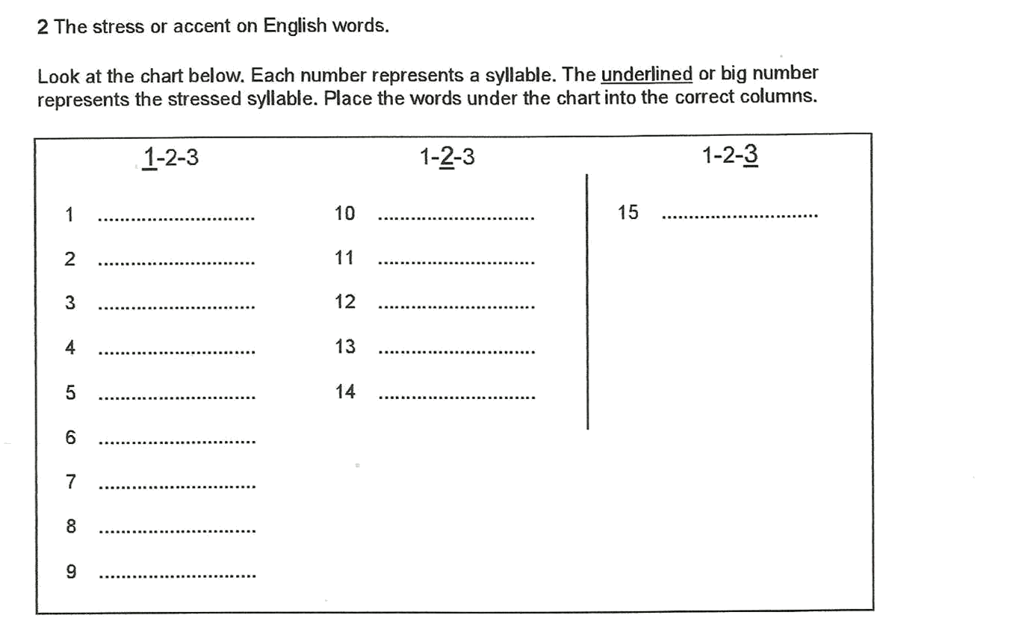

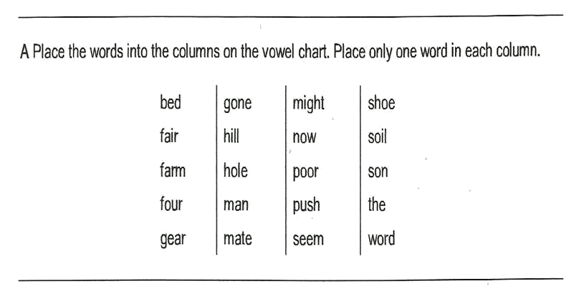

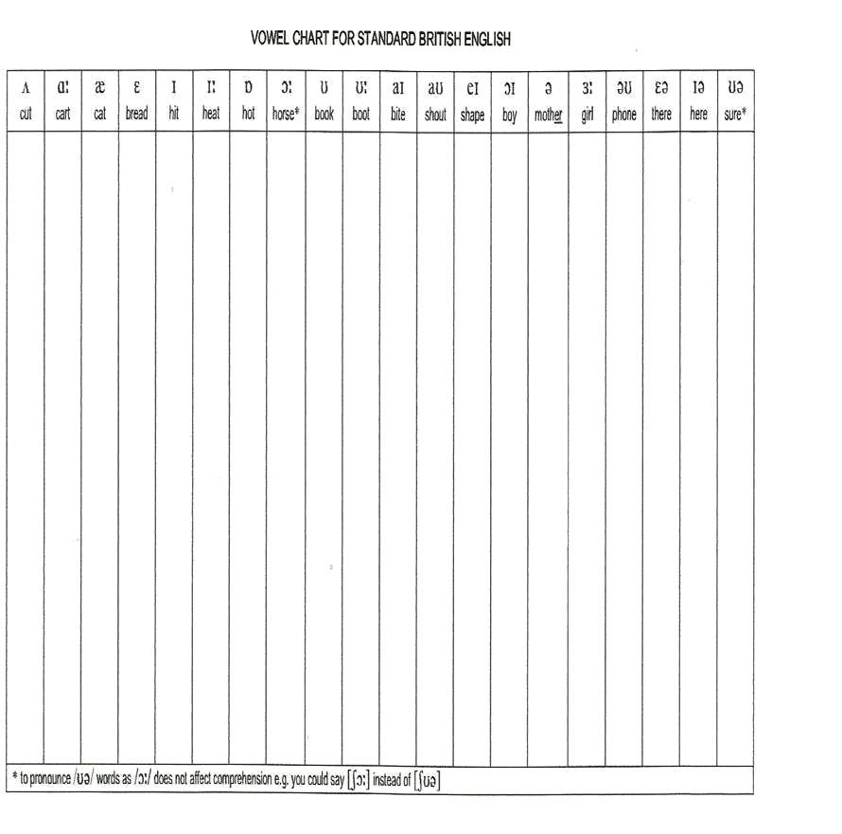

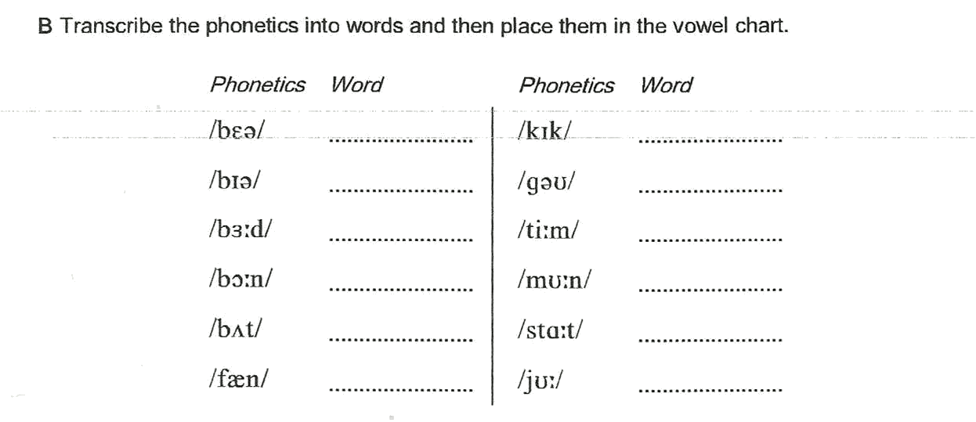

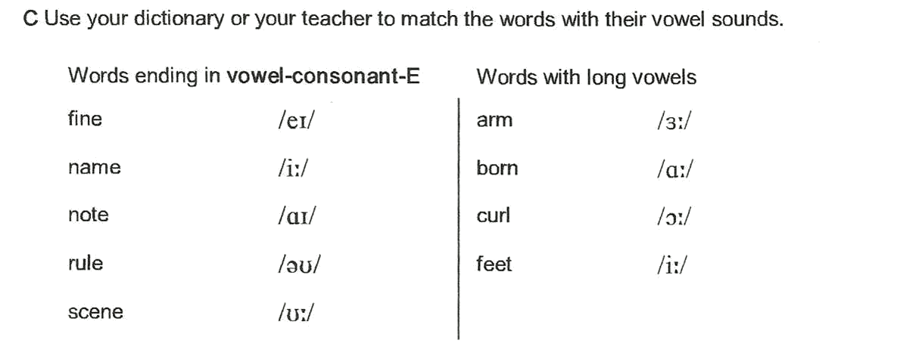

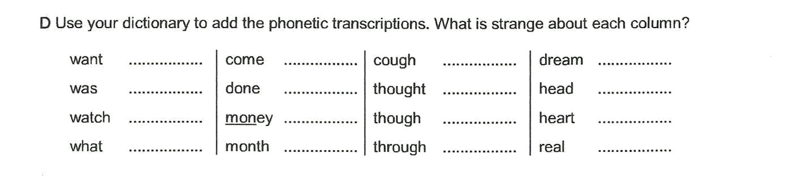

والصلاة والسلام على نبينا محمد وعلى آله , وصحبه أجمعين
انتهت المادة , لا تنسوني من دعائكم فدعوة الأخ لأخيه المسلم في ظهر الغيب مجابه
دعواتي وتمنياتي لكم بأعلى الدرجات في الدارين

Contents

Orientation’s Class………………………………………………………………...
First Class………………………………………………………………………………
Phonetics and Phonology and their types
What Phonological knowledge permits a speaker to...
Organs of Speech : The Vocal Tract, Parts of the Mouth, Glottis, Vocal Cords, Diagram of Human Head.
The Concept of Phoneme

SOUNDS OF ENGLISH:Consonants………………………………………….
The Place Of Articulation
Manner of Articulation
IPA Chart
Terms: Phonemes, Allophones,
minimal pairs, Complementary Distribution, Free variation.
Third Class Exercise ……………………………………………………………….
Fourth Class Vowels………………………………………………………………
5th Class………………………………………………………………….
Short & Long Vowels with Diagrams
Diphthongs,
Triphthongs & Glides
^{6th} Class Phonetic Transcription……………………………………….
^{7th} Class Syllable Structure in English Lets study it………………………
8th Class Syllables Practice………………………………………………………..
9th Class…………………………………………………………………
Strong and Weak Syllables
Ths Shwa
Close front and close back vowels.
The Nature of Stress
Word stress rule
Sentence stress in English
10th Class Stress …………………………………………………………………….
11th Class Stress & suffixes……………………………………………………
12th Class Intonation & Sound Linking……………………………………..
13th Class Linking Sounds…………………………………………………………
14th Class Review: Exercises…………………………………………………….
Contents…………………………………………………………………..

“Phonetics and Phonology” introduces the main areas in the study of sounds
in human language. It covers the main areas of articulatory Phonetics of
English. It focuses on the phonology of English starting from the units of the
phoneme and the syllable. It also includes the prosodic features of stress and intonation.

http://www.ckfu.org/vb/

