-3-

Foundations and factors influencing the English Thought & Culture

- Invasions (Politics & Economy)
- Roman & Greek teachings and philosophies

- Religions (Judaism & Christianity)
- Theories, Movements, & Revolutions

- Media & Technology
- Geography and location
- Contributions of other nations and cultures (like the Islamic and Arabic contributions)

Foundations and factors influencing the English Thought & Culture

1- Invasions
* Language affects thought and culture.
* Origin and history of English.
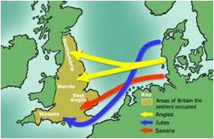

Germanic Invasions
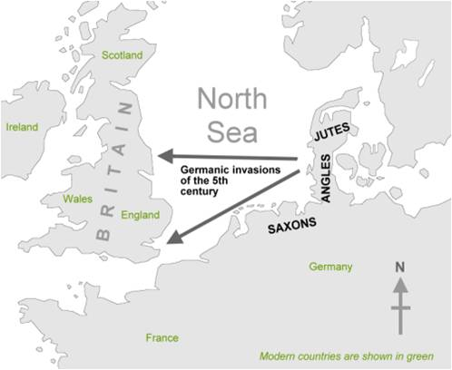

- Germanic invaders entered Britain on the east and south coasts in the 5th century.
- Many cultural, social, economic, military and political events led to the development of English from its Germanic roots.
- English originated as a common language of West Germanic tribes (Angles, Saxons and Jutes) who invaded and populated Britain.
Origin and history of English

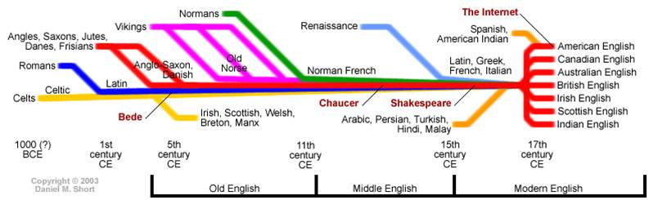

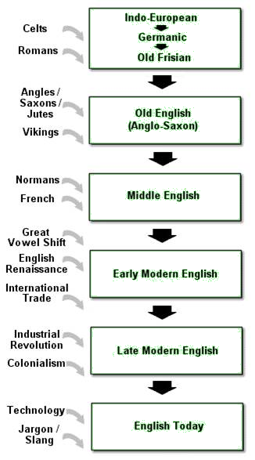

Origin and history of English

Old English (450-1100 AD)  The invading Germanic tribes spoke similar languages, which in Britain developed into what we now call Old English. Old English did not sound or look like English today. Native English speakers now would have great difficulty understanding Old English. Nevertheless, about half of the most commonly used words in Modern English have Old English roots. The words be, strong and water, for example, derive from Old English. Old English was spoken until around 1100. | 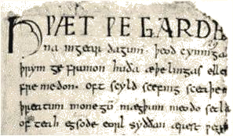

Notes:______________________________________________________________________________________________________________________________________________________________________________________________________________________________________________________________________________________________________________________________________________________________________________________________________________________________________________________________________________________________________________________________________________________________________________________________________________________________________________________________________________________________________________________________________________________________________________________________________________________________________________________________________________________________________________________________________________________________________________________________________________________________________________________________________________________________________________________________________________________________________________________________________________________________________________________________________________________________________________________________________________________________________________________________________________________________________________________________________________________________________________________________________________________________________________________________________________________________________________________________________________________________________________________________________________________________________________________________________________________________________________________________________________________________________________________________________________

