Lecture 6
Sense Relations
Part 2
Hyponymy
Hyponymy is a sense relation between words in which the meaning of one word is included in the meaning of the other. Hyponymy involves the notion of inclusion in the sense that the meaning of “tulip” and “rose” is included in the meaning “flower”, and the meaning of “lion” and “cow” is included in “animal” or “mammal”. 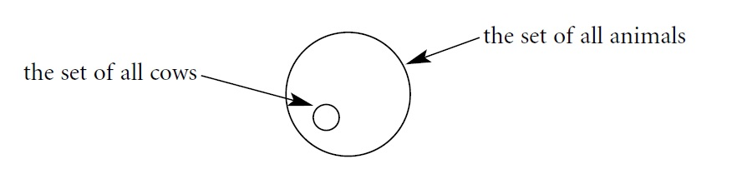
Hyponymy
The upper term is called the superordinate and the “lower” term is called the hyponym.
E.g. The meaning of “scarlet” is included in the meaning of “red”. “Red” in this example is the superordinate, and “scarlet” is a hyponym of “red”.
Hyponymy
If a superordinate term has more than one hyponym, we call them co-hyponyms.
E.g. The superordinate “emotion” has the hyponyms “fear”, “anger”, “happiness”, “sadness”.. etc. We say that “fear” is a co-hyponym of “anger” and “sadness” is a co-hyponym of “fear”.. etc.
Hyponymy
A hyponym can itself be a superordinate of another term included in its meaning. For example, “tulip” is a hyponym of “flower” and “flower” is a hyponym of “plant”.
In a case like this, we say that “flower” is an immediate hyponym of “plant” and “tulip” is an immediate hyponym of “flower”. “Tulip” is also a hyponym of “plant” but it is not an immediate hyponym.
Hyponymy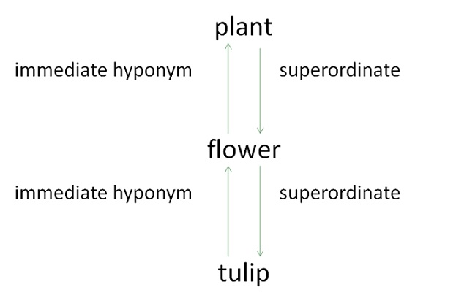

Hyponymy
There is not always a superordinate term for hyponyms in a language. For instance, there is no superordinate term in English to cover a variety of professions and crafts like “carpenter”, “doctor”, “flute player”.. etc. The nearest possible term is “craftsman”, but that would not include “doctor” or “flute player”. However, hyponymy relations vary from language to language. Greek, for example, has a superordinate term to include a variety of occupations.
Hyponymy
Synonymy can be seen as a special case of hyponymy. For example, if we look at two synonyms, such as “mercury” and “quicksilver”, we notice that these also illustrate the hyponymy relationship because the meaning of one of them is included in the other and vice versa. We call this special case of hyponymy: “symmetrical hyponymy”. The rule here is that if X is a hyponym of Y and Y is a hyponym of X, then X and Y are synonymous.
Polysemy and Homonymy
Polysemy is a sense relation in which the same word has several very closely related meanings (senses).
E.g. “Earth/earth” (our planet vs. soil). The two senses are clearly related by the concepts of land (earth as land not sky or water).
In the case of polysemy, a native speaker of the language has clear intuitions that the different senses are related to each other in some way.
Polysemy and Homonymy
Homonymy is a sense relation in which several words have the same shape, but different meanings that are far apart from each other.
E.g. “Bank” (financial institution vs. the side of a river) is a case of homonymy in English.
In the case of homonymy, the senses of the word are not obviously related to each other in any way that is clear from a native speaker’s intuition.
Polysemy and Homonymy
Dictionary-makers have to decide whether a particular item is to be handled in terms of polysemy or homonymy, because a polysemic item will be treated as a single entry in the dictionary, while a homonymous one will have a separate entry for each of the homonyms.
Polysemy and Homonymy
It is important to note that there are cases where homonyms differ in either writing or speech.
E.g. “Lead” (metal) and “lead” (dog's lead) have the same spelling, but pronounced differently. On the other hand, “site” and “sight”, “rite” and “right” are spelled differently but pronounced in the same way. For the former, the term homography (words spelled the same) may be used, and for the latter we use homophony (words pronounced the same).

