Lecture 12
Unit 3

Look at the picture. Then answer the questions with the correct form of the verbs in the box:

do karate eat fruit play tennis
drink water exercise try to lose weight

1.What is Bryan doing now to stay healthy?
a._________________________________
b._________________________________
c._________________________________
2.What else does he do to stay healthy?
a._________________________________
b._________________________________
c._________________________________

A Complete the conversations with the simple present or present continuous. Then practice whit a partner:

1) A How ________ you ________ (cope) with stress?
B Well, I_____________ (take) a course in flower arranging right now, and I _____________ (enjoy) it. But everybody in my family is pretty relaxed. We _____________ (not get) stressed very often.

2) A What kind of exercise ___________ you usually ___________ (do)?
B I _____________ (like) swimming. My brother and I usually ___________ (go) to the pool every day in the summer.
Right now it's cold, so I _______________ (not swim) at all. But my brother ___________ (go) very day, even when it's cold.

3) A __________ you ___________ (eat) a lot of fast food these days?
B Well, I ____________ (love) it, but right now I ______________ (try) to eat a balanced diet. It's hard because my husband _____________ (not like) fruit and vegetables.

ACHES AND PAINS

Fever: an illness or a medical condition in which you have a very high temperature.
( I have a fever. I think )

The flu: a common illness that makes you feel very tired and weak, gives you a sore throat, and makes you cough and have to clear your nose a lot [influenza].
( I'm getting the flu ).

Cough : to suddenly push air out of your throat with a short sound, often repeatedly.
( I have a bad cough )
( I'm coughing a lo )

Stomachache : pain in your stomach or near your stomach.
( I have a stomachache )
( I often get stomachaches )

toothache : a pain in a tooth
( I have a toothache )

headache: a pain in the head .
( I hardly ever get headaches , but I have one now )

A cold: a common illness that makes it difficult to breathe through your nose and often makes your throat hurt.
Sore throat: a pain in the front of your neck.
( I have a cold and a store throat. I get a lot of colds )

sick : suffering from a disease or illness. if you are sick, the food in your stomach comes up through your mouth [vomit, throw up]
( I feel sick. I often get sick when I eat shellfish )

allergy: a medical condition in which you become ill or in which your skin becomes red and painful because you have eaten or touched a particular substance.
sneeze: if you sneeze, air suddenly comes from your nose, making a noise.
( I have allergies and I sneeze all the time )

Pain , Ache , Sore..
Pain: for a short time.
After the accident I felt a pain in my knee.

ache: for a long time.
I have a bad headache.

sore: a pain to the move, touch or swallow.
I have sore eyes.
His elbow is sore.

Adverbs of Frequency..
Never: at no time.
I never get colds. I always feel healthy.

Hardly ever: almost never.
I hardly ever have a stomachache.

Sometimes: from time to time, now and then.
Sam sometimes gets a toothache. He eats a lot of candies.

Often: many times, frequently.
They often feel sick after having seafood.

always: all the time.
I love chocolate. I always eat it

Joining Clauses with If and when:

What is a clause?
A clause is a group of words that contains a verb (and usually other components too). A clause may form part of a sentence or it may be a complete sentence in itself. For example:

He loves sports, and he plays football on weekends.
I am driving the car that I bought last week.

When: for usual situations.
If: for unusual situations.

I watch TV when I have free time.
When I feel tired, I get some rest.

I’ll visit Eiffel Tower if I go to Paris.
If it rains tomorrow, I’ll stay at home.

Joining Clauses with If and when:

What do you take When you have a cold?
I don't take anything when I have a cold.
When I have a cold, I don't take anything.
What do you do if you get a really bad cold?
If I get a really bad cold, I drink hot vinegar with honey.
I drink hot vinegar with honey if I get a really bad cold.

Exercise 1: Join the phrases with when and if to make true sentences about yourself:
1. Have a fever/ take medicine.
When I have a fever, I usually take medicine.
2. Get a stomachache / stay in bed
I hardly ever stay in bed when I get a stomachache.
3. Have a cough / go to the doctor
Sometimes I go to the doctor when I have a cough.
4.Feel sick / lie down for a while
When I feel sick, I usually lie down for a while.
5. Have a sore throat / drink hot tea with honey
When I have a sore throat, I always drink hot tea with honey.
6. Have a headache / take aspirin
When I have a headache, I never take aspirin.
Look at the picture. Write questions and answer: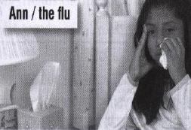 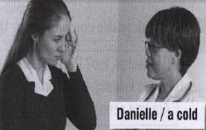
1._________________________________? 2.________________________________?
When__________________________. If_______________________________.
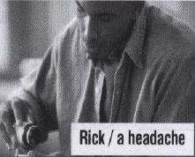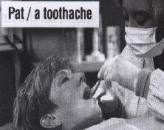
3._________________________________? 4.________________________________?
______________when_____________. _______________if_______________.
By : Samiyah al-zahrani..

