Lecture 13
Unit 3

Adverbs of Frequency;
Never: at no time.
I never get colds. I always feel healthy.
It is never snowy in Saudi Arabia.

Hardly ever: almost never.
I hardly ever have a stomachache.
The weather is hardly ever cold in Dammam.

Sometimes: from time to time, now and then.
Sometimes Sam gets a toothache.
It is sometimes difficult to wake up early.

Often : many times, frequently.
They often feel sick after having seafood.
They are often late.

Usually: most of the time .
I usually drink coffee in the morning.
Usually the sky is clear.

always: all the time.
I love chocolate. I always eat it.
His room is always messy.

Lesson C ,

How come you're tired?
1 Conversation strategy Encouraging people to talk
A Which are the best responses to keep the conversation going?
Check ( √ ) the boxes.
A I'm so tired B Yeah, I know Oh! Why is that?
Yeah, me too. Oh, I'm sorry.
Really? How come? You look tired. Are you busy at work?

Paulo: I'm so tired.
Matt: Really? How come?
Paulo: Well, I'm working lwo jobs this semester.
So I'm getting up at. Like 5:30 to study .
Matt: You're kidding! Two jobs? Wow.
Paulo: yeah. Just for a couple of months.
I'm working in the supermarket
after class, and then I have my
regular job at the restaurant till 11:00.
Matt: Oh, that's late. So, what time do you go to bed?
Paulo: About 1:00 . . . 1:30.
Matt: Gosh, So you're only getting about
four hours' sleep? That's not much.

Notice how matt encourages Paulo to continue talking.
Matt comments on what Paulo says and asks follow-up question.
Find examples in the conversation.

B Match each sentence with an appropriate reply. Then practice with a partner.
1.I need a lot of sleep.________
2.I can't sleep if there's light in my room._______
3.I usually go to bed early during the week._______
4.If I can't fall asleep, I usually read._______
5.I often take a nap after lunch._______
6.I only sleep about five hours a night._______

a. I can't either. Do your windows have blinds?
b. That's not much. Are you getting enough sleep?
c. At the office? How long do you sleep?
d. Really? How much sleep do you need?
e. That's good. Do you wake up early, too?
f. That's a good idea. What do you read?

Showing Surprise;

Use expressions like these to show A: I’m working two jobs
surprise in informal conversations: B: You’re kidding me!
Oh! Gosh!
Really? Oh, my gosh!
Wow! You're kidding! A: I had an accident
Oh, wow Are you serious? B: Oh, my gosh!
No way! No!

In formal conversations, use Oh! Or Really?

A: His mother died yesterday.
B: Really!

Circle the best response to show surprise:
1.My brother talks in his sleep.
a. My brothers does too.
b. Wow! What does he say?

2.I love getting up early on weekends.
a. I always get up early.
b. Early? I like to sleep late.

3.I take two or three naps every day.
a. Oh! Are you sleeping enough at night?
b. I know. And you snore. Too.

4.I eat a lot of chocolate when I can't sleep.
a. Me too. I love to eat chocolate at night.
b. You're kidding! I can't sleep when I eat
chocolate.

5.My grandfather goes running six days a week.
a. No way! How old is he?
b. I see. He's very healthy, right?

6.I often dream about food.
a. I do too. I always dream about ice cream.
b. food? Are you hungry when you go to bed?

7.I have three part-time jobs.
a. It's important to work hard.
b. Really? Aren't you tired a lot?

8.If I can't sleep, I always read a history book.
a. Me too, I also read a novel.
b. Gosh! Why not a novel or a crime story?

COMMON QUESTION ABOUT STRESS
Am I stressed?
If you can't sleep well or can't concentrate, . . .
If you feel depressed or want to cry a lot, . . .
If you have a headache or an upset stomach, . . .
If you can't relax and you feel irritable, . . .
If you are extremely tired, . . .
. . . then it's possible you are stressed.

Is stress bad for me?
Occasional stress is common and can be good for you.
However, if you feel stressed for a long time, it can be
serious. Stress can make you sick. It can also affect your
memory or concentration, so work or study is difficult.

What can I do?
Fortunately, there's a lot you can do, Try some of these
relaxation techniques. If you still feel stressed, make an
appointment to see your doctor.

RELAXATION TECHNIQUES
1) Breathe Take a breath, hold it for four
seconds, and then breathe out very slowly.
Feel your body relax.
2) Exercise Walk or exercise for just 30 minutes
each day and feel better.
3) Talk Call a friend. Talk about your problems.
4) Meditate Close your eyes and focus on
something clam. Feel relaxed.
5) Pamper yourself Take a hot bath, or have a massage.
6) Do something you enjoy Listen to music.
Sing. Watch TV . Meet a friend.
Department of Health _ "take care of yourself".

Learning tip Learning words together
When you learn a new word or expression, write down
other words you can use with it.

1 Complete these expressions. Use the words in the box.
a break better home in bed medicine sick

feel stay take
Better

Home

A break
Sick

In bed
medicine

2 Which of these verbs can you use with the words and expressions in the chart?
Complete the chart. You can use some verbs more than once:

be do feel get go(to) have see stay take

a vacation | allergies | sick
a cough | a headache | exercise
healthy | home | a checkup
a doctor | In shape | stressed

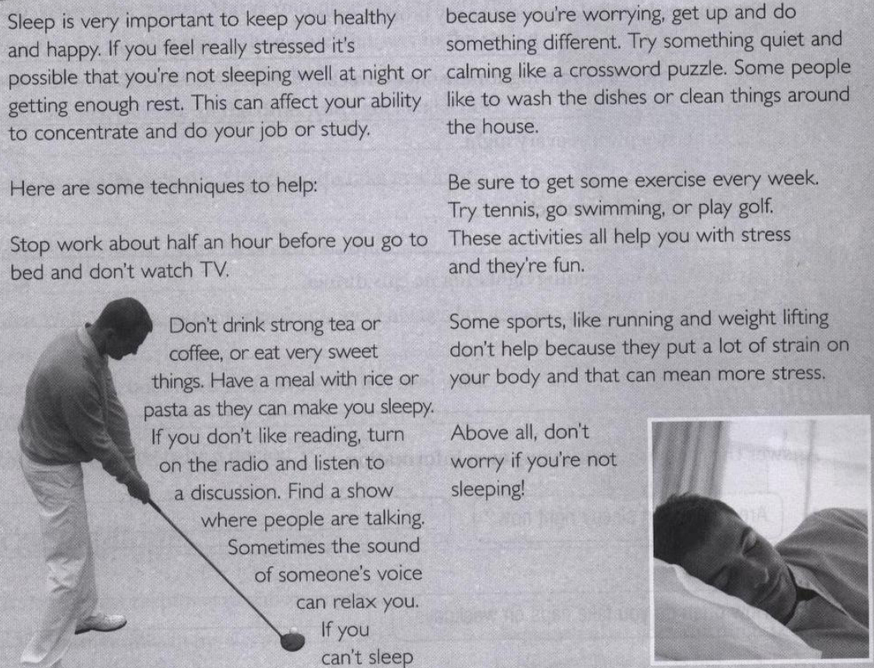Reading Questions;
1.If you feel really stressed :
a. it keeps you healthy and happy.
b. sleep is not important .
c. you need to eat before sleep.
d. it means you’re not getting enough sleep.
2.Before you go to sleep you should:
a. Don’t watch TV.
b. Watch TV.
c. stop work before half an hour.
d. a & c.
3.Before you go to sleep you should have:
a. rice or pasta .
b. strong tea and coffee .
c. very sweet things .
d. chicken.
4.If you can’t sleep because you’re worrying:
a. stay in bed.
b. watch TV .
c. do something different.
d. listen to loud music.

5.Some sports don’t help, for example:
a. tennis.
b. playing golf.
c. swimming .
d. running .
6.Which of the following would be the best title for the article:
a. Tiring Job .
b. Sports and Health.
c. Sleep and Stress .
d. Playing Golf.

Present Simple :

Use Present Simple to talk about “all the time” and routines.
(Facts and habits)

How do you stay in shape?
I walk everywhere.

Do you exercise regularly?
Yes, I do. I exercise six days a week.
No, we don’t. We don’t exercise at all.

USE 1:
Use Present continuous to talk about “now”

• I am sitting.
• I am not standing.
• You are learning English now.
• What sports are you playing these days?
I am doing karate. It’s getting me in shape.

USE 2:
Use Present continuous to talk about temporary events.
Longer Actions in Progress Now .

• I am studying to become a doctor.
• I am not studying to become a dentist.
• I am reading the book Tom Sawyer.
• Is she trying to lose weight?
Yes, she is. She’s drinking diet drinks.
No, she’s not. She’s not trying to lose weight.

USE 3:
Near Future
I am visiting my grandparents next Friday.
I am not working next week.
Are you playing football this weekend?

Non-Continuous Verbs

Abstract Verbs
to be, to want, to cost, to seem, to need, to care, to contain, to owe, to exist...

Possession Verbs
to possess, to own, to belong, to have...

Emotion Verbs
to like, to love, to hate, to dislike, to fear, to envy, to mind...

Examples:
He is needing help now. Not Correct
He needs help now. Correct
He is wanting a drink now. Not Correct
He wants a drink now. Correct

In general or right now?
Simple Present
in general (regularly, often, never)
Colin plays football every Tuesday.
present actions happening one after another .
First Colin plays football, then he watches TV.

Present Continuous
right now
Look! Colin is playing football now.
also for several actions happening at the same time .
Colin is playing football and Jim is watching.

Signal words

Always these days
every ... this month
often this year
normally at the moment
usually at this moment
sometimes today
seldom now
hardly ever right now
never Listen!
once …. / twice … Look!

Complete the conversations with the correct form of the verb:

1. Sam: You _________(look) great, Andrew. How________ you_________(stay) in shape?
Andrew: Well, I_____________(not eat) any junk food these day. And I usually_________(exercise) three or four times a week.
Sam: That's great. What kind of exercise________ you usually __________(do)? I mean, _________ you __________(take) an aerobics class?
Andrew: No, but I just started a soccer class at Soccer World.
I really__________(love) it. Actually, I___________(walk) there now.________ you ________(want) to come?
Sam: Uh, thanks, but I'm kind of busy right now.
Andrew: Really? Where________ you __________(go)
Sam: I _________(go) to The Good Life.
It's my favorite place to eat.
Andrew: Oh, is that a health-food restaurant?
Sam: Actually, no, . . . it's an ice-cream store.

2. Doctor: You're not in very good shape, Ken. Are you eating right?
Ken: Well, I_________(want) to give up meat, and I________(try) to eat a balanced diet, but it's hard.
Doctor: _________ you _________(eat) a lot of vegetables these days?
Ken: Oh, yes. I__________(eat) vegetables every day.
I_________(love) French fries.
Doctor: Oh. __________ you __________(get) enough exercise these days?
Ken: To be honest, not really. I'm really busy.
I__________(take) a class three days a week.
I__________(learn) to bake cakes.
Doctor: But what about exercise? _________ you _______(do) any exercise these days?
Ken: Well, I__________(walk) to the supermarket every other day. And I_________(play) pool twice a week.

Complete the following conversation using the words between parenthesis:
1. A: __________________________________________________ (when / are sick) B: When I’m sick, I stay home and watch TV all day.
2. A: ____________________________________________ (if / have a bad cough) B: I chat on the internet with my friends instead of on the phone if I have a bad cough.
3. A: ___________________________________________ (if / get a stomachache) B: If I get a stomachache, I drink water. I don’t eat a lot.
4. A: _____________________________________________ (when / have a fever) B: When I have a fever, I take aspirin. I don’t go out.
Complete the conversation. Use the sentences in the box.
Headaches too? Do you take anything?
You're kidding! How come?
Are you serious? You can't study?
Oh, no! Do you sneeze a lot?
Gosh, that's terrible! So, what are you studying?
Really? But how can you study when you feel sick?

Unit Vocabulary

Junk food Allergy
Meat sneeze
Karate Fever
Weight Flu
Diet Cough
Honest Stomachache
Snack Toothache
Hiking Headache
Ache Cold
Pain Throat
Sore Sick
Fever Allergy
Flu sneeze
Cough Stress
Stomachache Concentrate
Toothache Depressed
Headache Upset
Cold Relax
Throat Irritable
Sick

By: Samiyah al-zahrani ..

