-9-

Foundations and factors influencing the English Thought & Culture

- Invasions
- Roman & Greek effects (teachings, philosophies, & laws)
- Religions & Beliefs
- Theories, Movements, & Revolutions
- Media & Technology
- Geography and location
- Contributions of other nations and cultures (like the Islamic and Arabic contributions)

Foundations and factors influencing Thought & Culture

Part 3: Religions & Beliefs

Religions and beliefs have tremendous effects on thought & culture:
The world’s major religions, beliefs, and dogmas influencing the
thought & culture of human beings and their lives in general:

- Paganism
- Atheism
- Hinduism
- Buddhism
- Judaism
- Christianity
- Islam

Foundations and factors influencing Thought & Culture

Part 3: Religions & Beliefs
The world’s major religions, beliefs, and dogmas influencing the thought & culture of human beings and their lives in general:

-Paganism  Believing in or worshipping  idols, statues, plants, rocks,  mountains, rivers, animals,  or other objects | 

Foundations and factors influencing Thought & Culture

Part 3: Religions & Beliefs
The world’s major religions, beliefs, and dogmas influencing the
thought & culture of human beings and their lives in general:

- Atheism
Atheism is the rejection of belief in the
existence of deities. In a narrower sense,
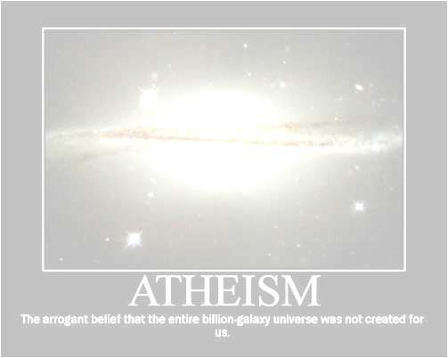
atheism is specifically the position that
there are no deities (gods).

(It means denying the existence of God).

* Before the 18th century, the existence of God was
so universally accepted in the western world.
* Darwin’s Theory of Evolution

(natural selection, chance, human evolution from ape).

http://en.wikipedia.org/wiki/Atheism

Foundations and factors influencing Thought & Culture

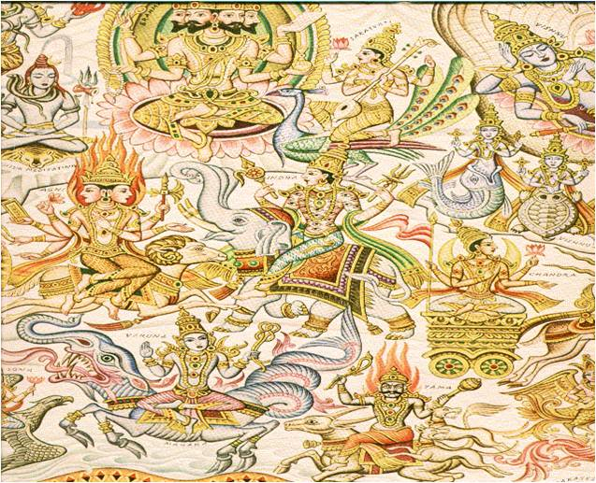
Part 3: Religions & Beliefs
The world’s major religions, beliefs,
and dogmas influencing the
thought & culture of human beings and
their lives in general:

- Hinduism
- Brahma, the Creator
- Vishnu, the Preserver
- Shiva, the Destroyer
+ 33 million gods

Foundations and factors influencing Thought & Culture
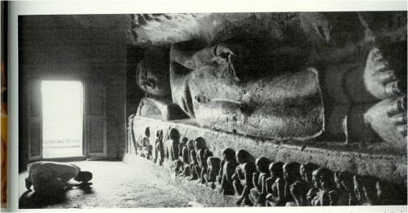
Part 3: Religions & Beliefs

- Buddhism
Buddha was taken as god.

Foundations and factors influencing Thought & Culture

Part 3: Religions & Beliefs
The world’s major religions, beliefs, and dogmas influencing the
thought & culture of human beings and their lives in general:

- Judaism
Belief in one God for the Jews only!

Foundations and factors influencing Thought & Culture

Part 3: Religions & Beliefs

The world’s major religions, beliefs, and dogmas influencing the
thought & culture of human beings and their lives in general:

- Christianity
Trinity
God the Father
God the Son
God the Holy Spirit

Foundations and factors influencing Thought & Culture

Part 3: Religions & Beliefs
The world’s major religions, beliefs, and dogmas influencing the
thought & culture of human beings and their lives in general:

- Islam
Belief in one true God (Allah) for all

Notes:__________________________________________________________________________________________________________________________________________________________________________________________________________________________________________________________________________________________________________________________________________________________________________________

