Writing Project ( UNIT 6 )
A. Pen Pal Letter
Pen pal letter is also called friendly or informal letter.
1. Read the following writing Sample of a letter to keep in touch and compare it with the following tips of writing a pen pal letter.
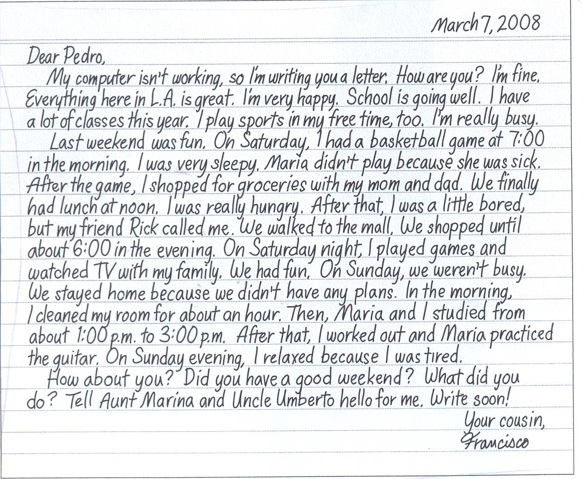

pen pal letter
Writing Tips:
1. Language:
Be friendly, but not too friendly .*
Use friendly and informal language.*
*Avoid questions that are too personal to ask a stranger.
Eg. -Do you have any pets? ( friendly ) - What is your religion? -How much many do you earn? ( too personal
Know your reader as: *

Name: _______________________________________________ Age:_________________________________________________
School:_______________________________________________
Major/course __________________________________________
Home ( city/suburb/small town):___________________________
Other information: ______________________________________

2. Organization :
Look at the form of a pen pal letter below.
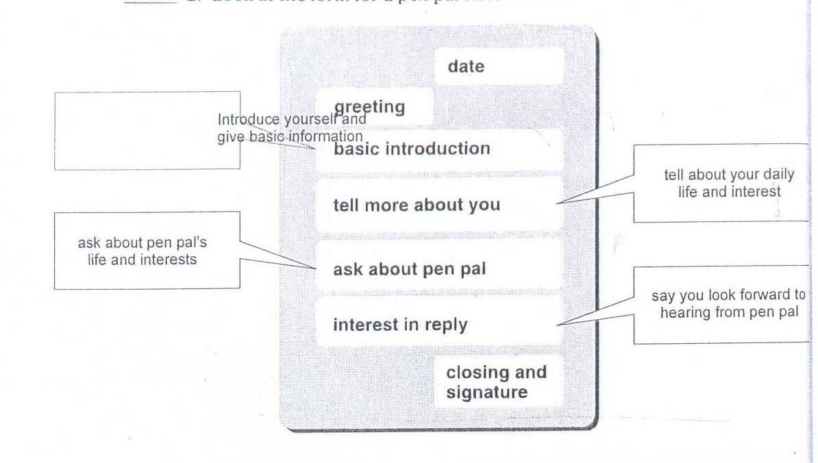

REMEMBER:
When you write remember the 5 parts of a friendly letter.
 | 20/10/2012 | 1. Date
 | Dear Ayesha, | 2. Greeting
 | It is in 4 paragraph form | 3. Body of the pen pal letter
Introduce yourself and give basic information . | Basic introduction | A.
Tell more about daily life and interest. | Tell more about you | B.
Ask about pen pal's life and interest. | Ask about pen pal | C.
Say you are looking forward to hearing from pen pal | Interest in reply | D.
 | Say good bye to the receiver | 4. The closing
 | Is the signed name under the closing. | 5. Signature

B. Information Letter
Information letter is also called formal letter or official letter.
2. Read the following writing Sample.

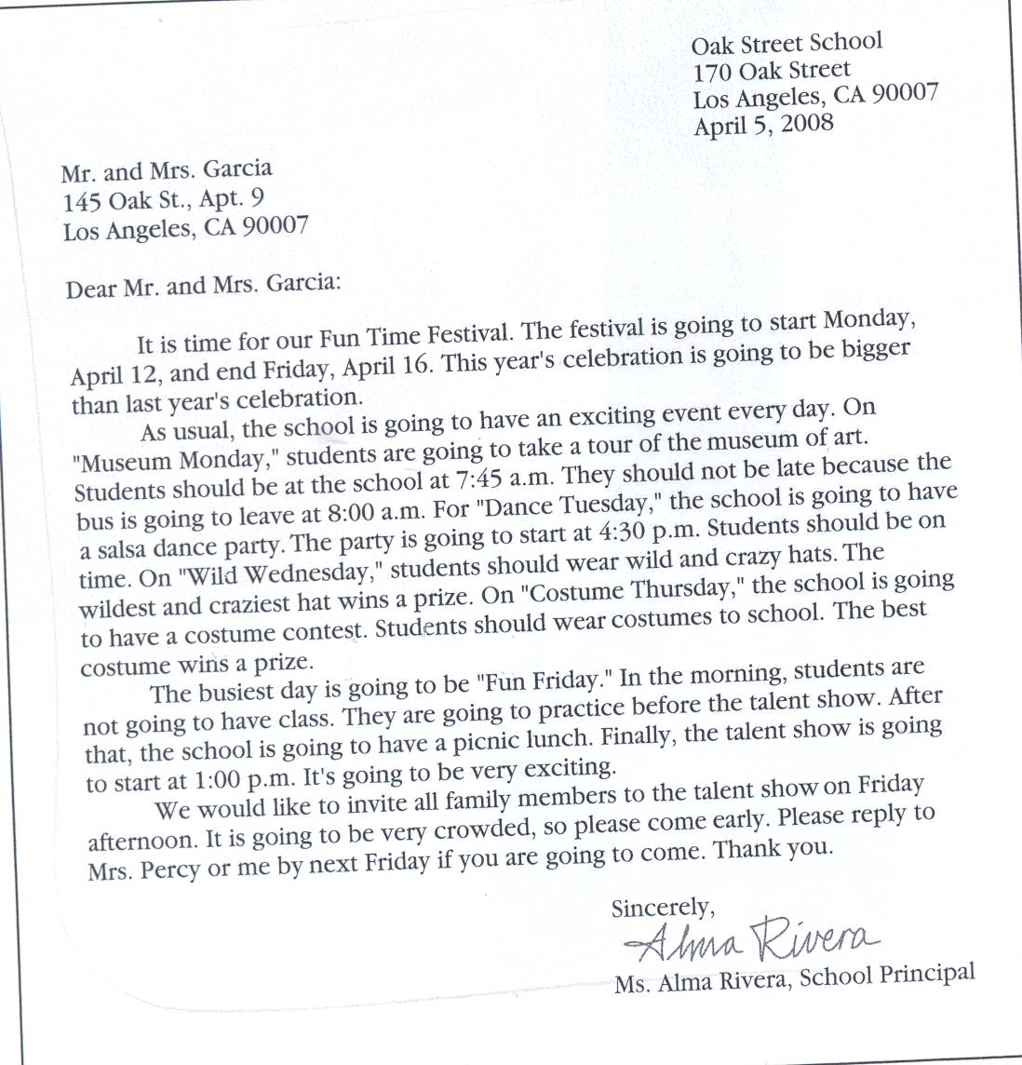
Writing Tips:
1. Language:
Use formal expressions.*
*Find places to ask for information.
Find their address. *
* What information do you need?
( eg. About English courses/levels/duration/time/books/fees/certificate/lecturers ……..etc)
2. Organization :
Look at the form of information letter below.
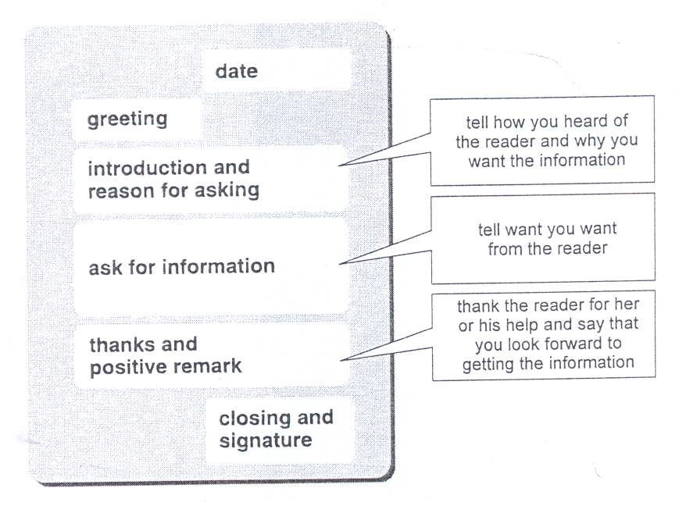

Page for practice:
Discussion :
1- What are differences between a pen pal letter and an information letter.
2- What are differences between a pen pal letter and a letter to keep in touch with a friend.

Group work :
2- write( a reply letter ) to get more information about talent show on Friday afternoon.
Follow the format of writing information letter.*
* be sure to explain what you want and why you are interested in the information.
Write a draft of your letter*
*Trade your writings
Write your final draft .*
*Show your final draft to your teacher.

