Lecture ONE Eng 220
Interactions: Reading
Chapter ONE
Elements of the Lecture :
I- Vocabulary Preview
2- Vocabulary Definitions
3- Guessing meaning from context.
4-Organizing Words: Using a T-Chart
5. Recognizing Word Meaning
1. Previewing Vocabulary:
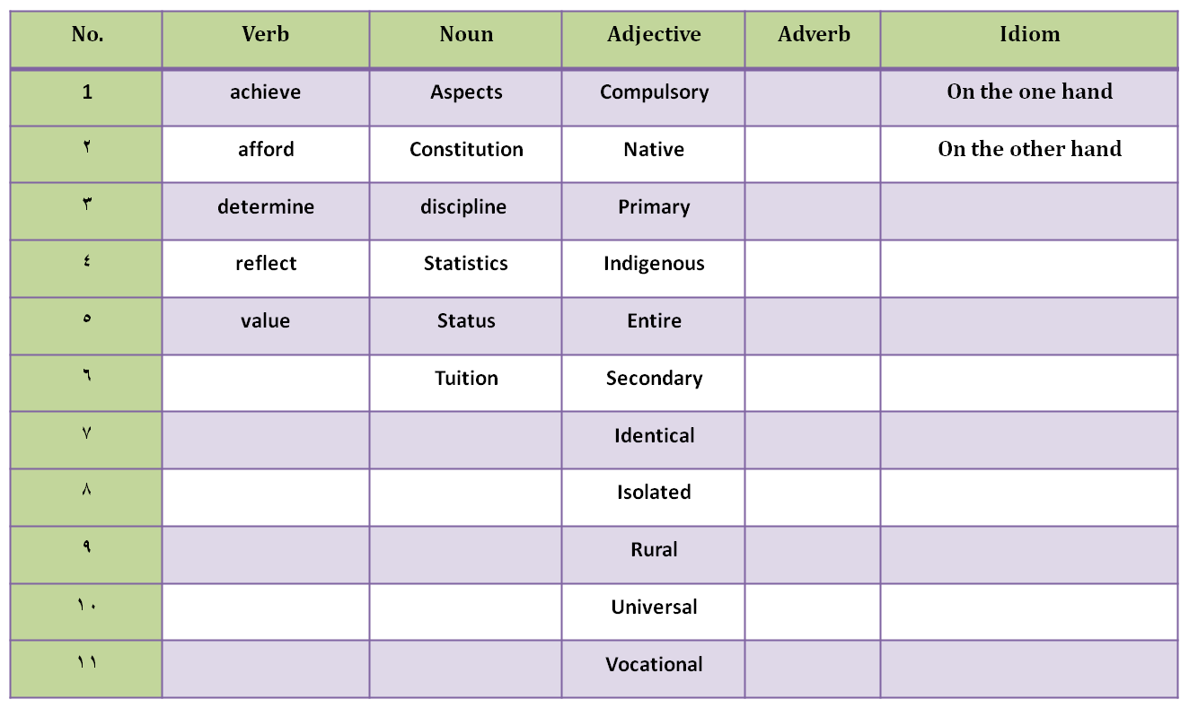

2. Vocabulary Definitions:
Read the definitions below and write words or expressions that fit these definitions :-
1. A paper containing the laws that a country is based on = [-------------------------------]
2. Calculations =[ --------------------------------------------------]
3. Fees (money) for education= [ --------------------------------------- ]
4. Far away from cities or towns= [ ---------------------------------------- ]
5. a school for job training= [ ------------------------------------------------- ]
6. To have enough money for something= [ --------------------------------------------]
7. Sides, parts, characteristics, features= [ -------------------------------------------------- ]
8. To decide on something= [ ----------------------------------- ]
9. Another idea or point of view= [ ------------------------------------------]
10. Covering all countries or global [ -----------------------------------------------]
3. Guessing meaning from context :
*We all know that translation is the easiest way that most foreign language learners prefer when they want to get the meaning of a word. Also using (synonym & antonym)helps to identify the exact meaning of any word .
A. indigenous= أصلي ( translation)
B. indigenous= real or first ( synonym )
c. indigenous= the opposite foreign / unreal (antonym )
* Contextualization ( using the target words in context to guess/ get the meaning):-
1. There is a drawback, a disadvantage, to that idea. (Punctuation)
2. A school system in one country is not identical to the system in any other country. It cannot be exactly the same because each culture is different. (Another sentence)
3. The educational system is a mirror that reflects the culture. (Logic)
4. The rekotal is flying in the sky. The underlined word logically means:_________________
A. a camel C. a building
B. a kind of birds D. An apple
5. I am very hungry. I want to eat some ___________________.
A. books C. zamoad
B. water D. questions

6. The _____________ moves faster than a car.
A. hotel C. table
B. university D. ogali
Now, figure out the meanings of the underlined words from the content
and write them on the Line provided:
7. On the one hand, there are many advantages to this system. On the other hand, there are also several drawbacks.
On the one hand= ---------------------------------------------------------------------------------------------
On the other hand= -------------------------------------------------------------------------------------------
8. In a number of countries, education is both compulsory- required- and universal, available to everyone, at least in primary school( elementary school).
Compulsory= ------------------------------------------------------------------------------------------------------
Universal = --------------------------------------------------------------------------------------------------------
Primary= ------------------------------------------------------------------------------------------------------------
9. There are many more schools in cities than in rural areas.
Rural -----------------------------------------------------------------------------------------------------------------
10. Public schools are all both free and egalitarian; No money to pay and students are considered equal and learn the same material.
Free =------------------------------------------------------------
Egalitarian=-----------------------------------------------------
11. College students need great discipline; in order to make time for their studies, they need
the Self-control to give up hobbies, sports, and social.
Discipline= ----------------------------------------------------
12. Results on these exams affect the entire family because there is high status, or social
position , for a whole in which children have high tests scores.
Entire= ---------------------------------------------------------
Status= ---------------------------------------------------------
13. Students themselves decide if they want college-preparatory or vocational classes in high
school; no national exam determines this for them.
Determines= ----------------------------------------------------
4. Organizing Words: Using a T-Chart :
Reorganize the following words by filling each one of them in the T-Chart:
eat – story – father – go – write – fill – school – read – restaurant – woman – cat – come food –
tell – bring – house – sit – bed – mountain – city
No. | Verb | Noun
1
2
3
4
5
6
7
8
9
10

5. Recognizing Word Meaning :
Rmatch the words with their meanings by writing the letters on the line:
No. | Word | Meaning
1_______ | determine | a. unusual
2_______ | afford | b. disadvantage
3_______ | reflect | c. side, part, or characteristic
4_______ | nontraditional | d. developing new ideas
5_______ | drawback | e. Fact in the form of a number
6_______ | statistic | f. control
7_______ | discipline | g. whole
8_______ | aspect | h. decide on
9_______ | involve | i . Have enough money for
10______ | tuition | j. show
11______ | entire | Fees ( money) for school
12______ | creative | includes

