-7-

- Where we Stand

,In the Previous Lecture  - Individualism  - Materialism  - Serialisation  - Patronage  - Prefaces | In this lecture  - Long titles  - Sentimentalism  - Repetition  - Colonialism  - Contradiction  - The omniscient narrator

Some more Disadvantages of Robinson Crusoe: Long Titles and Chapter Headings

Full title:

- Like all other novels in the 18th century, the title page is so long.
- It is long because the writer wants to

- Make the novel interesting to readers.
- Prove that it is not “a novel” but just a history or some adventures.
- Make sure thee reader will buy the book using illustrations and explanations

Full Title
- The Life and Strange Surprising Adventures of Robinson Crusoe of York. Mariner; who lived Eight and Twenty Years, all alone in an uninhabited Island on the coast of America, near the Mouth of the Great River of Oroonoque; Having been cast on Shore by Shipwreck, wherein all the Men perished but himself. With An Account how he was at last as strangely deliver'd by Pirates. Written by Himself.

Titles of Chapters are Also Lengthy
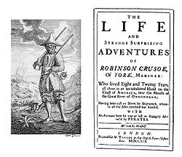
That of course is a demerit in the 18th century novel

Titles and Subtitles
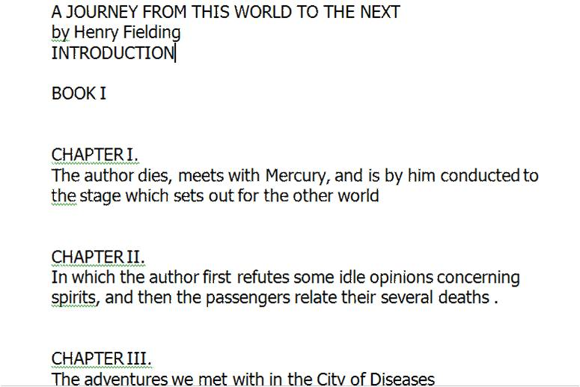

Sentimentalism
- It means a lot of crying and tears on any occasion. It is affected, not real. Men and women are described as shedding tears.
- It is against verisimilitude.
- It is one of the common features of the novel in the 18th century.
- This is not touching all the time. It could be insincere. An example is Robinson's parents early in the novel
Repetition

The reasons behind repetition are:
- the novel was published in journals and the writer had to remind readers every time of what has been said before.
- The writer had no experience of novel-writing before and that is why he could not avoid repetition.

Repetition
Robinson Crusoe is full of redundancy:
- It is full of fun
- It is full of irony
- It is full of repetition

Redundancy is…… in Robinson Crusoe .
- An advantage
- A disadvantage
- Vague
Colonialism

- The colonizer and the colonized.
- The ruler and the ruled.

- England XX Africa (vulgar) .
- Robinson feels very important as a British citizen. For him Africans and Arabs and even Muslims are lower classes of people. He is the superior one. For him they are inferior.

Colonialism

- Robinson is a representative of powerful rich individuals from England the Empire over which the sun never set.

- It would be meaningless and contradictory of course if the writer portrayed him as a slave. That is why in the novel we do not read at all about this period in his life.

Colonialism

Servant (Africa) | Master (England)
Colonized | Colonizer
Ruled | Ruler
Inferior | Superior
Lower | Upper
Savage Eastern  (Arabs, Muslims, Moors | Noble, western  (Christians)
Black, colored | White
Bad | Good
Ignorant | Has a lot of learning
Innocent | Has a lot of experience
Good-for-nothing | Has a lot of cleverness

Contradiction

- No experience in novel-writing led writers to contradict themselves without noticing it.

- The novel is full of contradiction which is understandable in the light of the things explained above

Contradiction

Examples:

- promising to obey God and parents then obeying only himself,
- saying that he has close friends then getting rid of them so soon,

- visiting Africa to know more about it but considering it to be inferior and referring to it in a vulgar way.
- Describing the voyage as the most successful one while we know that it is not.

The Omniscient Narrator

Why is Defoe called an omniscient narrator?

- First of all, the word omniscient means a narrator who knows everything about characters and events.
- He is the one through whose eyes the whole novel is narrated.

- In the novel, no character speaks for himself or herself. All are given to us from the point of view of that narrator. We are just told about them.

- The same thing with events which are narrated only from the point of view of the narrator.
- This is of course a demerit in novel writing as it detracts from the reader’s right to free judgement.

Question

True or false:

The word omniscient means a narrator who knows
everything about characters and events √

Best Answer?

Using the omniscient narrator is (an advantage- a disadvantage- needed) in the 18th century novel.
Notes:________________________________________________________________________________________________________________________________________________________________________________________________________________________________________________________________________________________________________________________________________________________________________________________________________________

