-5-

Foundations and factors influencing the English Thought & Culture

- Invasions
- Roman & Greek effects

- Religions (Judaism & Christianity)
- Theories, Movements, & Revolutions
- Media & Technology

- Geography and location
- Contributions of other nations and cultures (like the Islamic and Arabic contributions)

Foundations and factors influencing the English Thought & Culture

Part 1: Invasions
* Language affects thought and culture.
* Origin and history of English.
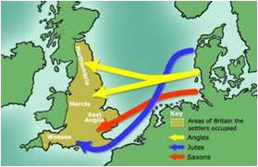

Germanic Invasions

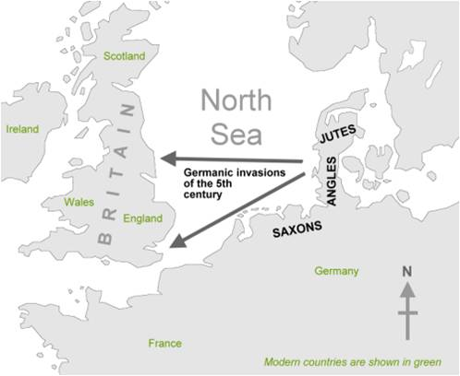

Foundations and factors influencing the English Thought & Culture

Part 2: Greek & Roman effects

English has borrowed many Greek words. This borrowing happened centuries before our current use of English. English is considered a Germanic language, but has been strongly influenced by French. French is a Romance language (from Rome, which had much geographical cross over with Greece).

Ancient Greek philosophy

Ancient Greek philosophy arose in the 6th century BCE and continued through the Hellenistic period, at which point Ancient Greece was incorporated in the Roman Empire. It dealt with a wide variety of subjects, including political philosophy, ethics, metaphysics, logic, biology, etc.

Many philosophers today maintain that Greek philosophy has influenced much of Western thought since its inception. Alfred Whitehead once noted: "The safest general characterization of the European philosophical tradition is that it consists of a series of footnotes to Plato." Clear, unbroken lines of influence lead from ancient Greek and Hellenistic philosophers, to the European Renaissance and Enlightenment.

Socrates

Socrates (469 BC – 399 BC) was a classical Greek Athenian philosopher. Credited as one of the founders of Western philosophy, he is an enigmatic figure known chiefly through the accounts of later classical writers, especially the writings of his students Plato and Xenophon, and the plays of his contemporary Aristophanes. Many would claim that Plato's dialogues are the most comprehensive accounts of Socrates to survive from antiquity.

Through his portrayal in Plato's dialogues, Socrates has become renowned for his contribution to the field of ethics, and it is this Platonic Socrates who also lends his name to the concepts of Socratic irony and the Socratic method, or elenchus. The latter remains a commonly used tool in a wide range of discussions, and is a type of pedagogy in which a series of questions are asked not only to draw individual answers, but also to encourage fundamental insight into the issue at hand. It is Plato's Socrates that also made important and lasting contributions to the fields of epistemology and logic, and the influence of his ideas and approach remains strong in providing a foundation for much western philosophy that followed.

Plato:

Plato (424/423 BC – 348/347 BC) was a Classical Greek philosopher, mathematician, student of Socrates, writer of philosophical dialogues, and founder of the Academy in Athens, the first institution of higher learning in the Western world. Along with his mentor, Socrates, and his student, Aristotle, Plato helped to lay the foundations of Western philosophy and science.^{[3]} In the words of A. N. Whitehead:

The safest general characterization of the European philosophical tradition is that it consists of a series of footnotes to Plato. I do not mean the systematic scheme of thought which scholars have doubtfully extracted from his writings. I allude to the wealth of general ideas scattered through them.^{[4]}

Plato's sophistication as a writer is evident in his Socratic dialogues; thirty-six dialogues and thirteen letters have been ascribed to him. Plato's writings have been published in several fashions; this has led to several conventions regarding the naming and referencing of Plato's texts.^{[5]} Plato's dialogues have been used to teach a range of subjects, including philosophy, logic, ethics, rhetoric, and mathematics. Plato is one of the most important founding figures in Western philosophy.

Aristotle

Aristotle (384 BC – 322 BC) was a Greek philosopher, a student of Plato and teacher of Alexander the Great. His writings cover many subjects, including physics, metaphysics, poetry, theater, music, logic,

linguistics, politics,government, ethics, biology, and zoology. Together with Plato and Socrates (Plato's teacher), Aristotle is one of the most important founding figures in Western philosophy. Aristotle's writings were the first to create a comprehensive system of Western philosophy, encompassing morality,aesthetics, logic, science, politics, and metaphysics.

Aristotle's views on the physical sciences profoundly shaped medieval scholarship, and their influence extended well into the Renaissance. In the zoological sciences, some of his observations were confirmed to be accurate only in the 19th century. His works contain the earliest known formal study of logic, which was incorporated in the late 19th century into modern formal logic. In metaphysics, Aristotelianism had a profound influence on Christian theology. All aspects of Aristotle's philosophy continue to be the object of active academic study today.

Ancient Greece and Rome and Their Influence
on Modern Western Civilization
“The Greeks had a massive influence on life today. They were the first to develop democracy”. http://wiki.answers.com/Q/How_did_ancient_Greece_influence_modern_civilization

“The American political system, like those of many other Western nations, is profoundly influenced by ideas from ancient Greece and Rome. Our ideas about democracy and republican government come from these ancient governments. Our values of citizen
participation and limited government originate in these ancient societies.

The founders of the United States had all received a classical education. As they were forming their own ideas about the world, they were learning about and absorbing the ideals of ancient Greece and Rome. It is no wonder that when they were building the foundations of American government, they looked to ancient
Greece and Rome for inspiration”.
http://teachergenius.teachtci.com/ancient-greece-and-rome-and-their-influence-on-modern-western-civilization-2/

The Roman Empire

- The Roman Empire, at its height, included about a fourth of Europe, much of the Middle East, and the entire northern coastal area of Africa. Its millions of people spoke many languages and worshipped different gods, but they were united by the military power and government of the Romans. The city of Rome grew from a farming village in central Italy to become the capital of the huge empire.
- The Roman Empire fell apart almost 1500 years ago, but it still influences our lives. More than 300 million persons speak languages directly related to Latin, the Roman tongue. Many words in English and in other languages come from Latin. Roman law provided the basis of the law of most European and American nations.
http://terkno.wrytestuff.com/swa134118.htm

The Roman Empire and Christianity
Christianity became the state religion of the Roman Empire in 380 AD.
http://en.wikipedia.org/wiki/Persecution_of_Christians_in_the_Roman_Empire
The Roman Emperor Constantine’s ‘Conversion’
One of the supposed watersheds in history is the ‘conversion’ of the Roman emperor Constantine to Christianity in, or about, 312 AD.
The ‘triumph’ of Christianity
Contemporary Christians treated Constantine’s conversion as a decisive
moment of victory for Christianity .
http://www.bbc.co.uk/history/ancient/romans/christianityromanempire_article_01.shtml Notes:________________________________________________________________________________________________________________________________________________

