-10-

Stress

Stress (within a word)

The nature of stress
Levels of stress
Placement of stress within a word

- suffixes
- prefixes
- compound words
- variable stress
- word-class pairs

The nature of stress

Stress – a sound or syllable which is stressed is one upon which there is expended in the articulation relatively great breath effort and muscular energy: in voiced sounds, greater amplitude of vibration of the vocal folds, together with the reinforcing resonation of the supraglottal cavities, results in the physical terms in relatively great intensity of the sound or syllable, such intensity being perceived by the listener as greater loudness associated with the sound or syllable.

The nature of stress

Production

- generally defined as the speaker using more muscular energy than is used for the unstressed syllables.

- the muscles used to expel air is more active, producing higher superglottal pressure.
Prominence – stressed syllable are recognised because they are more prominent than the unstressed syllable.

What makes a syllable prominent?

There are certain factors that make a syllable more prominent and these factors often co exist to give considerable perceptual effect.

- stressed syllables are often louder.
- stressed syllables are made more prominent by its length.

- the pitch of the stressed syllable is noticeably different from the other syllables. (movement of pitch e.g. rising or falling)

- contains a vowel which is of different quality from the other vowels. (refer to “WEAK FORMS” in Roach pg 112)

Levels of stress

Many levels of stress depending on the length of the word. (not just confined to two or three levels)

- the word ‘around’ – on the second syllable the pitch of the voice does not remain level but falls from a higher to a lower pitch (trans 1)

- the prominence from this pitch transition is called primary stress (Roach) primary accentuation (Gimson)

- secondary stress – weaker than primary stress but stronger than than an unstressed syllable.
‘examination’ , ‘photographic’,

Placement of stress

How can we know the correct syllable to stress? Example ‘camera, ca’mera or came’ra?

- the word is morphologically complex or simple? I.e does it have one or more affixes or is it a compound word?
What part of speech? Noun? Verb?

The total number of syllables
Phonological structure of the syllables.

Word stress/accentual patterns

2 syllables –

if verbs – basic rule, the second syllable is accented.
Examples: in’vent, re’form.

If the final syllable is weak then the first syllable is accented
Examples: ‘open, ‘enter
Adjectives – ‘lovely, ‘yellow

Nouns – if the second syllable contains a short vowel, then the stress will go to the first syllable. If not, it will fall on the second syllable
Examples: ‘husband, ‘placard, ‘window, ‘money, bal’loon, Chi’nese, can’teen

Word stress patterns

3 syllables

Verbs – is the final syllable is strong then it will be stressed
Examples : under’stand, enter’tain

If the last syllable is weak, stress will be on the preceding syllable if it is strong.
Examples: en’counter, de’termine

If both the second and third syllable are weak, the the stress will go to the first syllable.
Examples: ‘parody

Word stress pattern

3 syllables

Nouns – if the final syllable is weak or ends with {}, then it is unstressed. If the syllable preceding this is strong, the the stress will go to the middle syllable. Examples: re’lation, po’tato, e’leven, sy’nopsis
Is the second and third syllable are both weak, the the stress will go to the first syllable.

Examples: ‘yesterday, ‘innocence, ‘bachelor, ‘wanderer
To think: last syllables which are prominent, do they take a the secondary stress? (Roach pg. 100)

Word stress patterns

Complex words

- words made from a basic word form (stem) + an affix
- compound words – words composed of separable root morphemes. (football)

Affixes – prefixes (comes before the stem, example: impossible) and suffixes (comes after the stem, example: happiness)

Suffixes

Suffixes carrying primary stress – the primary stress is on the first syllable of the suffix. If the stem consists of more than one syllable then its first syllable will take a secondary stress

Ja’pan -> ,Japa’nese
‘-ee’ -> ,refu’gee
‘-eer’ -> ,mountai’neer
‘-ese’ -> ‘portu’guese’
‘-ette’ -> ,ciga’rette
‘-esque’ -> ,pictur’esque
Suffixes

Suffixes that do not affect stress placement

“-able” ‘comfortable
“-age” ‘anchorage
“-al” ‘refusal, ‘rebuttal
“-en” ‘widen
“-ful” ‘wonderful
“-ing” ‘amazing
“-ish” ‘devilish

For verbs with stems containing more than 1 syllable, the stress is always on the syllable immediately preceding “-ish” e.g. re’plenish

Suffixes

Suffixes that influence stress in the stem
In these examples primary stress is on the last syllable of the stem.

“-eous” ,advan’tageous
“-graphy” pho’tography
“-ial” de’nial
“-ic” cli’matic
“-ion” per’fection
“-ious” in’jurious
“-ty” tran’quility
“-ive” re’flexive

Prefixes

Effects on stress do not have comparative regularity, thus ~ safe to say governed by the same rules as those for words without prefixes.

Compound words

Stms with hyphen “air-raid”, smts as one word “strawberry”, smts as two words “desk lamps”

- Compounds with an adjectival first element and the –ed morpheme at the end
Examples: Bad-’tempered, half-’timbered,
heavy-’handed

- Compounds in which the first element is a number in some form also tend to have final stress
Examples: three-’wheeler
second-’class

Compound words

- Compounds functioning as adverbs are usually final-stressed
Examples: head-’first, North-’East, down-’stream

- Compounds functioning as verbs and have an adverbial first element take the final stress
Examples: down-’grade, back-’pedal, ill-’treat

Variable stress

Stress patterns change
Stress position may vary due to:

- the stress on other words occurring next to the word in question. Example: stress on the final stress compound tends to move to a preceding syllable if the following word begins with a strongly stressed syllable.
- Bad-’tempered -----> a ‘bad-tempered ‘teacher
- Not all speakers agree on the placement of the word. Example ‘controversy vs. con’troversy

Word-class pairs

- Two syllable words identical in spelling, differ from each other in their word class. Most of them are prefix+stem

- Their stress placement is also different. I.e. stress should be on the second syllable for the verbs but on the first syllable for the nouns and adjectives.

Examples: ‘permit (n) per’mit (v)
‘present (n,adj) pre’sent (v)
‘produce (n) pro’duce (v)

Word Stress Rule
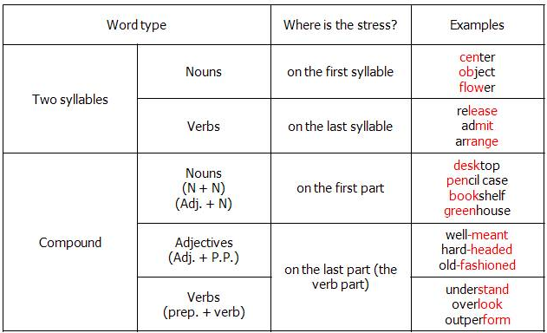

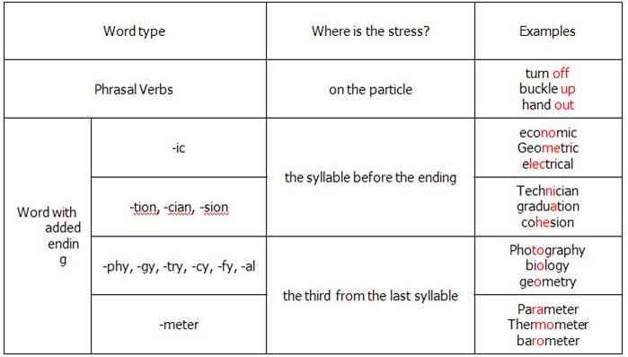

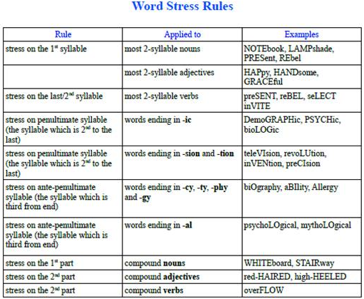

Sentence Stress in English

- Sentence stress is the music of spoken English. Like word stress, sentence stress can help you to understand spoken English, especially when spoken fast.

- Sentence stress is what gives English its rhythm or "beat". You remember that word stress is accent on one syllable within a word. Sentence stress is accent on certain words within a sentence.

Most sentences have two types of word:

content words
structure words

Content words are the key words of a sentence. They are the important words that carry the meaning or sense.

Structure words are not very important words. They are small, simple words that make the sentence correct grammatically.
If you remove the structure words from a sentence, you will probably still understand the sentence.

Imagine that you receive this telegram message:

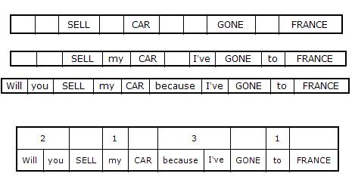

Rules for Sentence Stress in English

The basic rules of sentence stress are:

- content words are stressed
- structure words are unstressed
- the time between stressed words is always the same

Content words - stressed

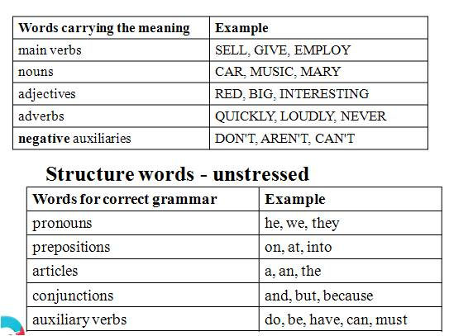

Structure words – unstressed

Notes:________________________________________________________________________________________________________________________________________________________________________________________________________________________________________________________________________________________________________________________________________________________________________________________________________________ ___________________________________________________________________________________________________________________________________________________________________________________________________________________________________________________________________________________________________________________________________________________________________________________________________________________________________________________________________________________________________________________________________________________________________________________________________________________________________________________________________________________________________________________________________________________________________________________________________________________________________________________________________________________________________________________________________________________________________________________________________________________________________________________________________________________________________________________________________________________________________________________________________________________________________________________________________________________________________________________________________________________________________________________________________________________________________________________________________________________________________________________________________________________________________________________________________

