-9-

Elements of the Class

- Strong and Weak Syllables
- Ths Shwa
- Close front and close back vowels.
- The Nature of Stress
- Word stress rule
- Sentence stress in English

Syllable structure

The general structure of a syllable consists of the following segments:
Onset (obligatory in some languages, optional or even restricted in others)
Rime
Nucleus (obligatory in all languages)
Coda (optional in some languages, highly restricted or prohibited in others)
tree representation of a CVC syllable.

Strong and weak syllables

A close observation of English phonology will reveal that many syllables are weak; this is true of many other languages ,but their constant occurrence and their importance makes it imperative to study them closely.
So it is necessary to study how these weak syllables are pronounced and where they occur in English..

What does “stress” mean?

stress is the relative emphasis that may be given to certain syllables in a word, or to certain words in a phrase or sentence.
The term is also used for similar patterns of phonetic prominence inside syllables. The word accent is sometimes also used with this sense.

What do we mean by :strong: and :weak:?

In the present context, we are using these terms to refer to phonetic characteristics of syllables. We could describe them partly in terms of stress (by saying, for example, that strong syllables are stressed and weak syllables unstressed),but until we describe what " stress" means such a description would be very useful.

Rule

The more important thing to note at present is that any strong syllable will have as its centre one of the vowel phonemes(or possibly a triphthong )but not Shwa.

Rule

While comparing the weak syllables containing vowels with strong syllables, it is obeserved that vowel in a weak syllable tends to be shorter, of lower intensity and different in quality.

For example, in the other word " father /f ɑ: ə the second syllable , which is weak is shorter than the first, is less loud and has a vowel that cannot occur in strong vowels.In a word like " bottle" /bɒtl/ the weak second syllable contains no vowel at all, but consists entirely of the consonant.We call this a syllabic consonant.

The vowel ( " shwa" ) ə

The most frequently occuring vowel in English language is shwa ə , which is always associated with weak syllables.In quality it is mid( that is, half-way between close and open) and central ( that is, half way between front and back).It is generally described as lax, that is , not articulated with much force and energy.

Rule

Most of the weak syllables in English have shwa but it does not mean that all weak syllables have shwa . Learners of English will have to know about the proper placement of the shwa.

Here are some examples in which spellings
act as guide to predict the weak syllable.

- Spelt with " a '; strong pronuciation would be æ
attend / ətend / character /kærəktə/
barracks / bærəks /
- Adjectival endings spelt " ate" ; strong pronunciation would be eI
intimate / IntImət / accurate/ækjərət /
desolate/desələt/

Close front and close back vowels

Two other vowels are commonly found in weak syllables, one close front ( in the general area of i: and i) and the other close back rounded ( in the general region of u: and ʊ ) .
In strong syllables it is easy to distinguish i: from ,u: from ʊ , but in weak syllables the difference is not so clear.For example, although it is easy enough to decide which vowel one hears in " beat " or " bit" , it is much less easy to decide which vowel one hears in the second syllable of words such as, " easy" or " busy".

What is the weak form?

English is a stress-timed language, which means that stressed syllables are equal in timing. In order to fit our words into this pattern, we tend to "squash" or compress other syllables or words occurring between stresses, in order to keep up with the more or less regular rhythm. Therefore, compressing or "weakening" some sounds is necessary to keep the rhythm of English.

A weak form is the pronunciation of a word or syllable in an unstressed manner. Of course, the difference between the strong form (stressed) and the weak form (unstressed) of a word is not apparent in writing, but in speech these two variations in pronunciation can be drastically different. If spoken in isolation, the weak form of a word would probably be unintelligible. The difference between the two forms can affect meaning.
See à à à à à à à à à à à

- Here is an example to show how strong and weak forms of a single word (that) can change the entire meaning of a sentence:

- John thinks that man is evil. /ð ə t/
This version of the sentence, with the weak (unstressed) form of that, means "John thinks all humans are evil." ə

- John thinks that man is evil. / æt/
This version of the sentence, with the strong (stressed) form of that, means "John thinks a specific (male) individual is evil."

- As indicated by this example, if a speaker unknowingly uses the strong form instead of the weak form, misunderstandings can occur.

There are two good reasons why weak and strong syllables ought to be learnt

First, teaching weak forms can help students improve their production of spoken English. Because of the influence of their first language, foreign students tend to pronounce every word very clearly. As a result, their speech always sounds foreign, sometimes unintelligible, because enunciating each word in a sentence can disrupt the natural rhythm of spoken English. Second, not knowing the weak form may inhibit students' comprehension of the English spoken by fluent speakers. Therefore, acquiring weak forms is important not only for students' production of spoken English but also for their listening comprehension.

The nature of stress

- All stressed syllables (or strong syllables) are more prominent than unstressed syllables (or weak syllables) . Four different factors are important:

- Stressed ayllables are louder than unstressed syllables; (loudness)
- The length of syllables; If one syllable is longer than the others there is quite a strong tendency to hear it as stressed;

- The pitch of the syllable: pitch in speech is realted to the frequency of vibration of the vocal cords and to the musical notion of low and high pitched notes;
- A syllable will tend to be more prominent if it contains a vowel that is different in quality from neighbouring vowels (i.e look at vowels against vowels encountered in weak syllables)

How do you say teacher?

Longer | teeeeeeeeeeee cher
Higher | tea
Higher |  | cher
Louder | TEA cher
All three combined | TEEEEEEEEEEE
All three combined |  |  | cher

Word Stress Rule

Word type |  | Where is the stress? | Examples
Two syllables | Nouns | on the first syllable | center  object  flower
Two syllables | Verbs | on the last syllable | release  admit  arrange
Compound | Nouns  (N + N)  (Adj. + N) | on the first part | desktop  pencil case  bookshelf  greenhouse
Compound | Adjectives  (Adj. + P.P.) | on the last part (the verb part) | well-meant  hard-headed  old-fashioned
Compound | Verbs  (prep. + verb) |  | understand  overlook  outperform

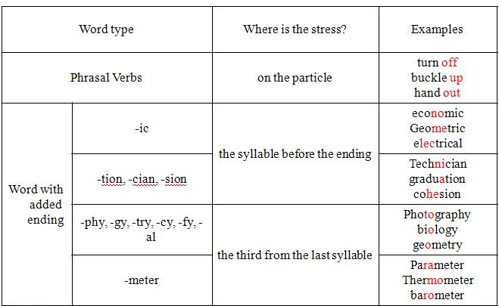

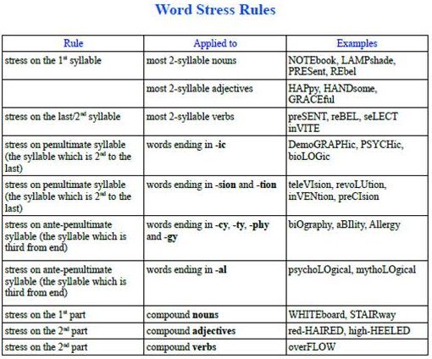

Sentence Stress in English

- Sentence stress is the music of spoken English. Like word stress, sentence stress can help you to understand spoken English, especially when spoken fast.

- Sentence stress is what gives English its rhythm or "beat". You remember that word stress is accent on one syllable within a word. Sentence stress is accent on certain words within a sentence.

Most sentences have two types of word:

content words
structure words
Content words are the key words of a sentence. They are the important words that carry the meaning or sense.
Structure words are not very important words. They are small, simple words that make the sentence correct grammatically.
If you remove the structure words from a sentence, you will probably still understand the sentence.

Imagine that you receive this telegram message:

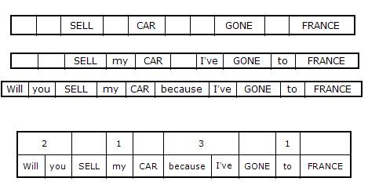

Rules for Sentence Stress in English

The basic rules of sentence stress are:
- content words are stressed
- structure words are unstressed
- the time between stressed words is always the same

Content words - stressed

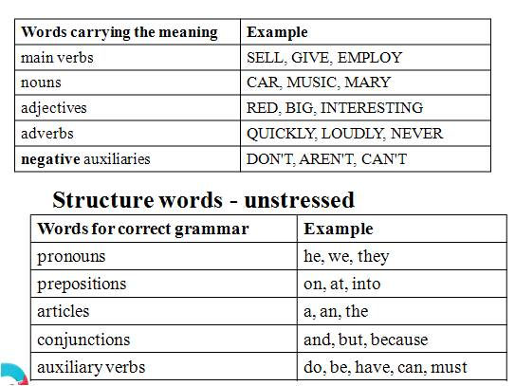

Structure words – unstressed

Notes:____________________________________________________________________________________________________________________________________________________________________________________________________________________________ ___________________________________________________________________________________________________________________________________________________________________________________________________________________________________________________________________________________________________________________________________________________________________________________________________________________________________________________________________________________________________________________________________________________________________________________________________________________________________________________________________________________________________________________________________________________________________________________________________________________________________________________________________________________________________________________________________________________________________________________________________________________________________________________________________________________________________________________________________________________________________________________________________________________________________________________________________________________________________________________________

