Lecture 3
Lexical Decision
and
Priming

Lexical Decision
A lexical decision experiment is conducted by asking a native speaker to sit in front of a computer screen where he/she is asked to judge as quickly as possible if the word that appears on the screen is a real word. If the word is real the participant clicks “yes”; if not, the participant clicks “no”.

What are we looking for?
Usually what we are looking for in this task is:
Response latency: and that is the time it takes for the a participant to respond “yes/no”.
Response accuracy: and that is whether or not the participant responded accurately.
Details
When designing this task the participants are usually tested on one set of stimuli against another set of stimuli. For example:
“Nouns” compared to “Verbs”. “concrete words” compared to “abstract words”
This test measures the speed and accuracy in which the mental lexicon is accessed.
Interesting findings
It has been found that it usually takes participants about a half a second to press “yes” for word they know or frequently used words. However, it takes three-quarters of a second to press “yes” for less common words. This is commonly known as the frequency effect.
What we can infer from this is that our mental lexicons are probably organized in a way that words we use often are more easy to access.
Priming
Priming can be considered as an extension of lexical decision task. However, in this task before the participant is asked to choose “yes” or “no” the target word is preceded by another stimulus (called the prime). What is measured is the extent the prime influences the participant’s lexical decision on the target stimuli.
When the target is preceded by a related word the response is usually quicker.
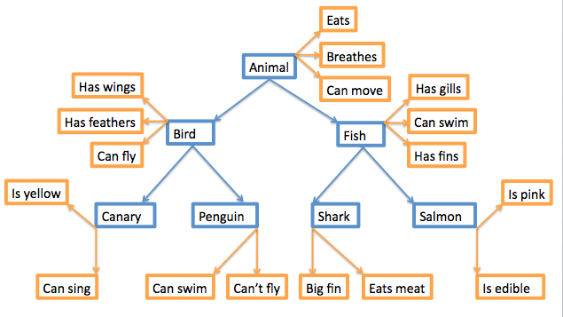

** وكآلعآده اخر شريحهه مرجع مآفيهه حآققهه .. درررن <☺>
The End

