-6-
Reviewing the Main Speaking Skills

Exercise : Start Short Conversation With Strangers.

at the bus stop?  - At the post office  - At a wedding  - In a supermarket  - On a bus  - Anywhere  - In a museum | It’s hot today, isn’t it?  - This line is really slow, isn’t it?  - It’s nice to have a chance to celebrate, isn’t it?  - These tomatoes look terrible, don’t they?  - What country are you from?  - Can you lend me some money?  - This is a wonderful painting, isn’t it?

Say the Following Correctly.

Unsure of the Answer (Real Questions)  - The food is awful, isn’t it?  - You don’t see any fresh fruit, do you?  - There isn’t any yogurt, is there? | Sure of the Answer (small talk)  - The food is awful, isn’t it?  - You don’t see any fresh fruit, do you  - There isn’t any yogurt, is there?

Introduce Someone  - -I’d like you to meet…  - This is… a friend of mine (my brother, sister, etc.)  - Have you met..? | Response  - Nice (Glad, Pleased) to meet you

- Well, I’ve got to run.
- Good-bye.
- See you later (Friday, etc.).
- Have a good day. Have a good weekend

Expressing Thanks  - Thanks.  - Thank you very much (so much)  - That was very kind of you,  - How thoughtful!  - I appreciate it. I’m very grateful. | Response  - You’re welcome.  - Don’t mention it.

Giving an Apology  - I’m very sorry.  - Excuse me.  - Forgive me.  - It was my fault. | Responses  - No problem.,  - That’s ok. That’s all right.  - Don’t worry about it. a

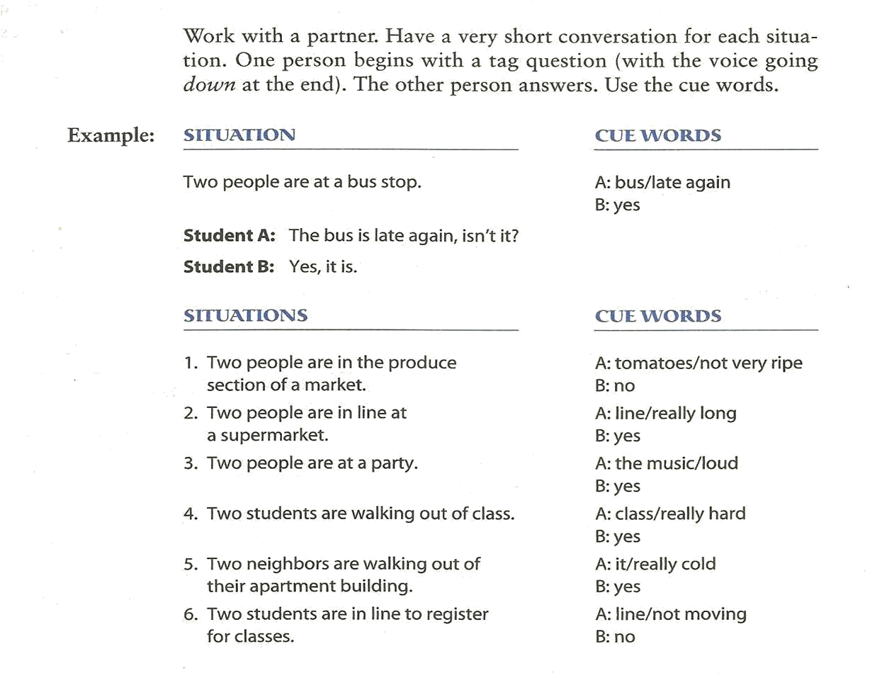
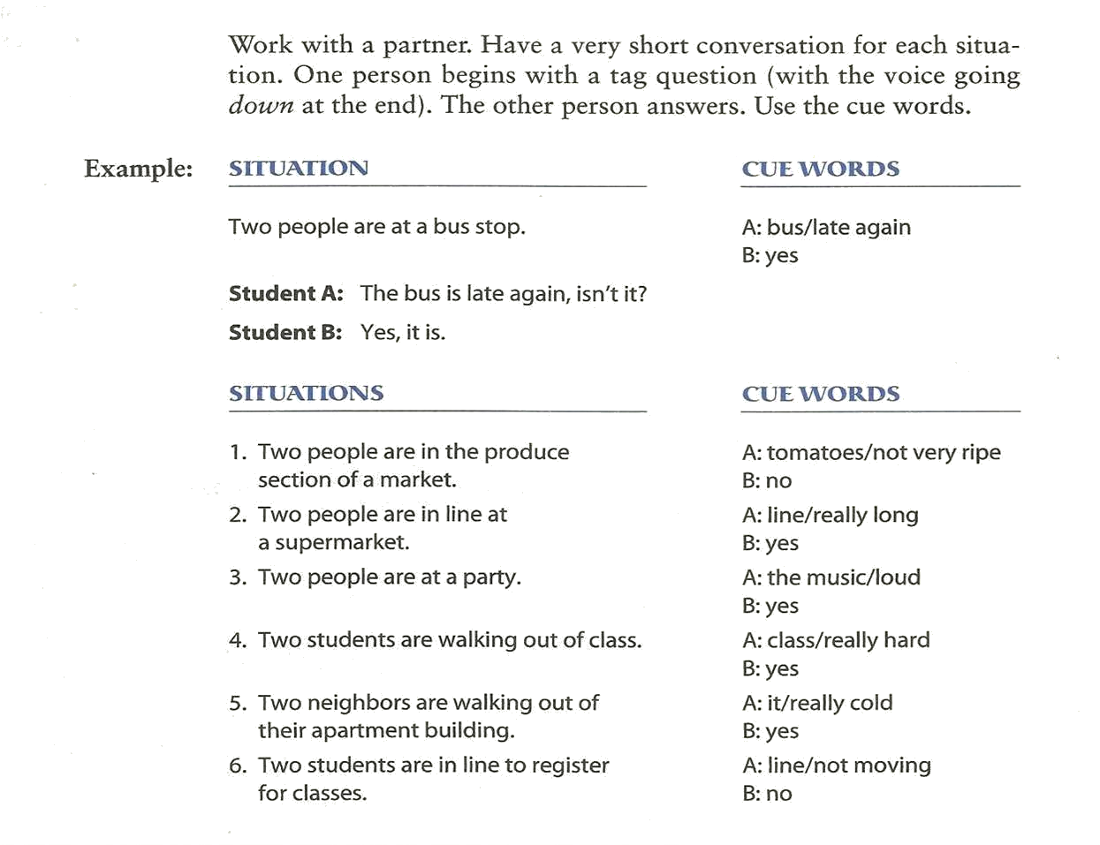

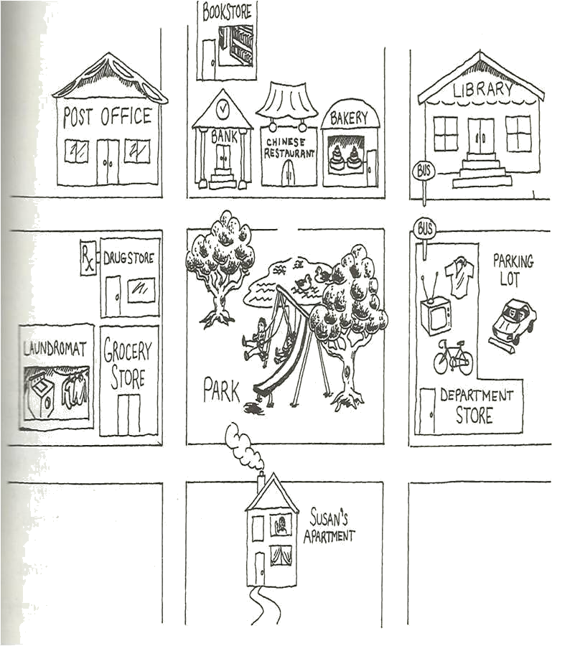 | How can I get to  Could you tell me where … is?  Is….. Far from here?  I’m looking for ….  In what direction is …?  - The post office is across the street from the bank.  - The bakery is down the street from the post office.  - The Laundromat is next to (beside) the grocery store.  - The drugstore is around the corner from the laundermat

Creating a Conversation

Work with a partner. Student A wants to take the bus. Student B is a bus driver. Have a conversation. Follow this model.

A: Excuse me. Does this bus go to …?
B: No, … you need bus number …..
A: where do I get ….?
B:…..
A: How much …..?
B:…..
A: Thanks.
B:……

Reduction

Long Form  - Do you have any pets?  - What’s your name?  - Does this bus go to Geary Street?  - Do you want to see the kitchen?  - You have to have exact change. | REDUCTION  SHORT FORM  - You à ya  Do ya have any pets?  - What’s you à watcher  Watcher name?  - Go to à goda  Does this bus goda Geary Street?  - Want to à wanna  Do you wanna see the kitchen?  - Have to à hafta  You hafta have exact change
Study this situation J

Situation : your class colleague is talking about a topic that you are unfamiliar with. You want to ask him or her for clarification. What should you say? | Excuse me, What was that again?  Or  Could you repeat that?  Or  How do you spell that?

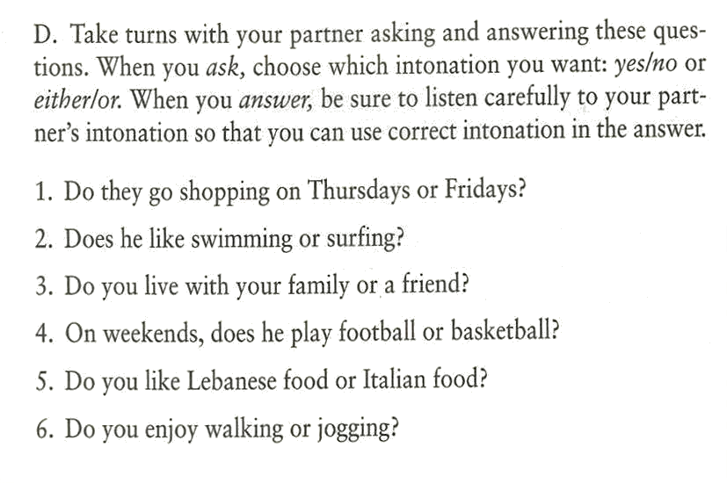 | Remember: In yes, No questions, the answer is “yes” or “no” The speaker’s voice goes up two times.  Also Remember: in either/or questions, the answer is one of the two items from the question. The speaker’s voice goes up on the first item and down on the second item.

Study this situation

Situation: one of your colleagues has got average grade in his/her first exam. However, he/she is looking for a higher grade. Your role is to encourage him/her. What should you say. | 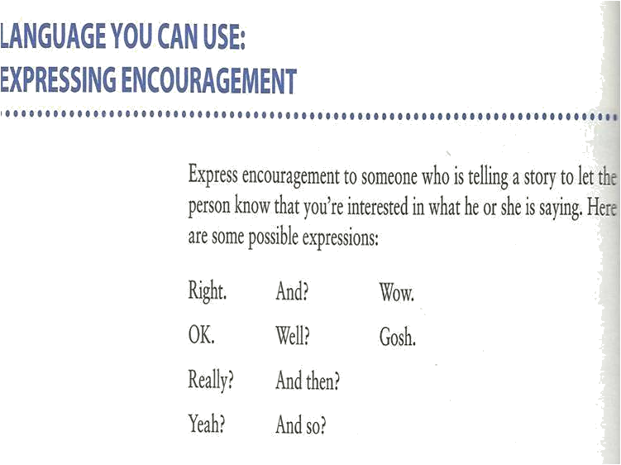  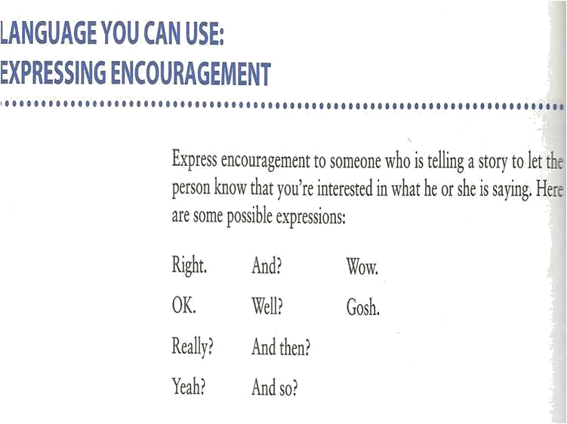

Stressed Words

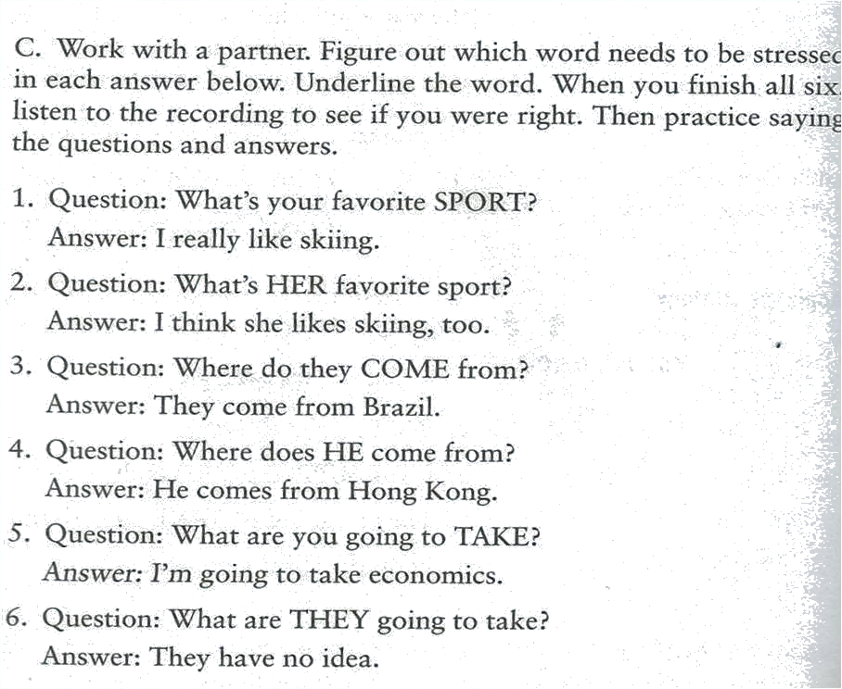

Long Form  - What do you do?  - What are you doing?  - What kind of childhood was it?  - What did you do?  - What did he do?  - They used to live here.  - I’m going to buy a house. | Short Form, Reduction  - What do you do – whadaya  whadaya do?  - What are you – whatcha  whatcha doing?  - Kind of – kinda  What kinda childhood was it?  - Did you – didja  what didja do?  - Did he- didee  what didee do?  - Used to –yoosta  They Yoosta live here.  - Going to – gonna  I’m gonna buy a house

Study this Situation

- Situation: your professor is asking you a question about your future plans. “What’s your future plane?” he is saying. What should you say? | - I am going to go to Georgetown University. I have already got an admission.  - I will pursue my higher education. But I don’t know where yet.

Give Advice:

We should wash our hands  with liquid soap | 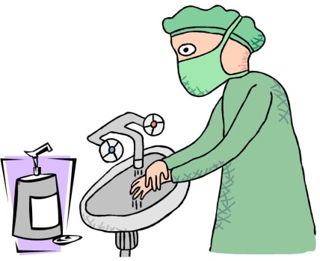
We should prevent disease. | 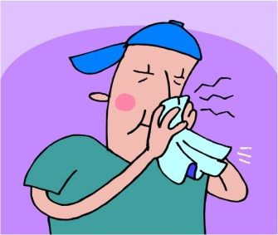
We shouldn't litter. | 
We should see a doctor  promptly if we feel unwell. | 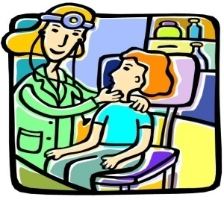

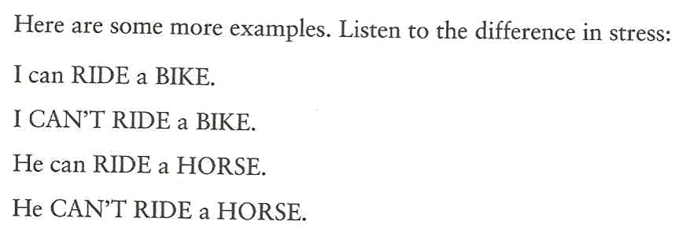

Notes:_______________________________________________________________________________________________________________________________________________________________________________________________________________________________________________________________________________________________________________________________

