Sociolinguistics (1,2,3,4,5) level 7
بسم الله الرحمن الرحيم
Lecture 1
In this lecture, we will discuss the following:

1- Why do we study language?
2- Characteristics of Language.
A- Language is a system.
B- Language has the potential to create new meanings
C- Language can have multiple functions:
a. Language used referentially.
b. Language used affectively
c. Language used aesthetically
d. Language used phatically.
D- Language is diverse

When we study language we discover more about different fields of knowledge:

language

Sociolinguistics Psycholinguistics
Artificial intelligence Applied linguistics

.

.

Why do we study language?

Psycholinguistics

Definition:
Psycholinguistics: is the study of how a listener recognize words and utterances, or how damage to our brains results in certain kind of language disorders.

Applied Linguistics
A branch of linguistics where we study how to learn and to teach different languages.

Artificial intelligence:
The study of how to make computers more sophisticated

Sociolinguistics
The study of the relation between language and society and the different varieties of language people use
Who is interested in Language?
-Language related issues are discussed in newspapers, television, lectures, etc.
-e.g. complaining about jargon used in classroom
-e.g. coining new words.
-e.g. importance of political speeches, etc.

What is language?
Characteristics of Language.
1- Language is a system.
2- Language has the potential to create new meanings
3- Language can have multiple functions.
4- Language is diverse

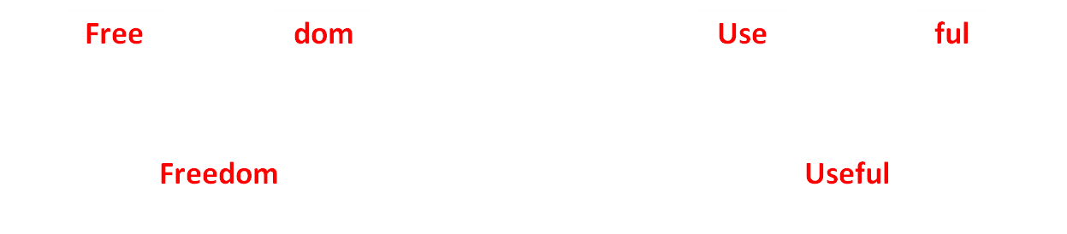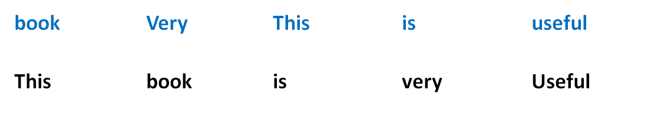
Language is a system.
Language is a systematic way of combining smaller units into larger units for the purpose of communication:
Ex. syntax
Ex. unit + unit = lexical items. phoneme + phonemes = lexical items
Phonemes, Lexical items, Syntax
Phonemes: the sounds of our language. E.g. /k/, /t/, etc.
Lexical items: the words of our language. E.g. Help, homework, etc.
Syntax: grammatical rules which determine how words can be combined into phrases and sentences:
E.g. The nice book *book the nice
Jane is happy *Is happy Jane
The use of a star * means that the sentence is ungrammatical.

Language has the potential to create new meanings

E.g.
Arabic: أتمتة يؤتمت

English: Importantunimportant
BossBossy
We can easily understand what these new words mean:
-Unimportant = not important
-Bossy = to order people around.

This characteristics distinguishes human language from other languages:

E.g. Birds have very limited range of messages.

Language can have multiple functions:
Language can be used in different ways:
Language used referentially.
Language used affectively.
Language used aesthetically.
Language used phatically.

A. Language used referentially.

Referential use of language can be found in examples giving information or instructions the speaker wants the hearer to do. The purpose is to transmit accurate or non-ambiguous information.

Eg.
-Put those papers on the table.
-Open this door.
Your instruction is referential because it gives information about what you want placed (the papers) and where you want them placed (on the table).

B. Language used affectively:

When language is used affectively , the speaker/writer expresses his/her feelings or attitudes.
Eg. Wow, she is very beautiful.
Oh, he is coming!
The affective function of language expresses the speakers’ or writers’ feelings and attitudes.
C. Language used aesthetically

Aesthetic language is usually used in poetry not in science.
Aesthetic language can hold people's interest.

-Language performing aesthetic function is designed to please the senses through actual or imagined sounds and through metaphor.

Ex.
Speech is silver silence is gold.

D. Language used phatically

The phatic function is used to keep communication lines open and also keep social relationships well. It helps in maintaining cohesion within social groups.

-Refers to the everyday usage of language
-Refers to the small talk between people to share feelings or establish a mood of sociability; phatic language is for the sake of interaction that opens up a social channel.
Ex.
Greetings:How are you today?
Discussions of the weather:It is very warm today.

D. Language is Diverse

-There is more than one variety of English: English varies between countries. Eg.
Indian English, American English, etc.

-Language use varies within a country.
Eg.
Classical Arabic and Modern Arabic
Formal Arabic and informal Arabic.

Lecture 2
In this Lecture, we will discuss the following:

1- Power and language.
-Definition of power
-How can language impose power?
2- Saussure’s theory of language.
3- Sample exam questions for lectures (1+2)

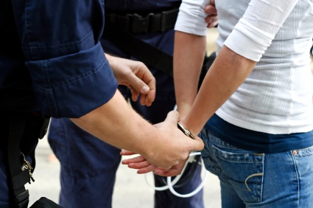
Power is The ability of its holders to force compliance or obedience of other people to their will.

Eg. A police office can use power to stop criminals or thieves and make them comply with the law.

Definition of power
Statistics published by the State of the World Forum (September 2000):

● Number of pages on the World Wide Web: 320,000,000
This means that:
-The English language has the power to dominate the the Web. It has become so widespread.

● Percentage of all websites in English: 80
This means that:
If you do not speak a certain language you are excluded from some kind of power.

How can language impose power?
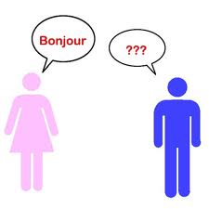
How can language impose power?

Which language we speak can be pathway to power

Knowing a language is power.

E.g. People who have knowledge (language or an skill) have the power to make you feel ignorant or confused because they have knowledge that you do not have.
E.g. An average person vs. an expert

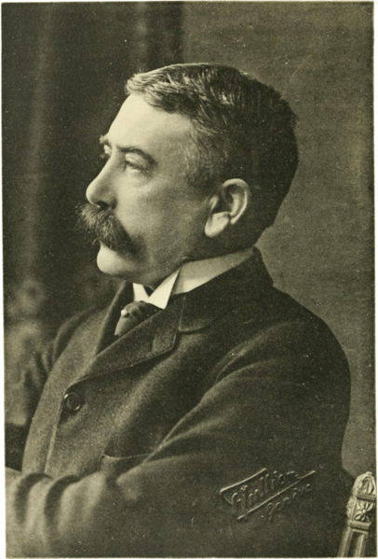
Saussure’ theory of language

Ferdinand de Saussure (1857-1913) was a Swiss linguist whose ideas laid a foundation for many significant developments in linguistics in the 20th century.

Theory: Language as a Representational System

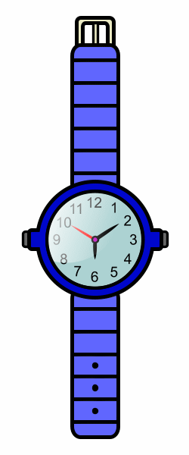

As soon as you hear or read a word, you know what concepts it refers to.

Ex. Tree
watch

Principles of Saussure’ theory of language
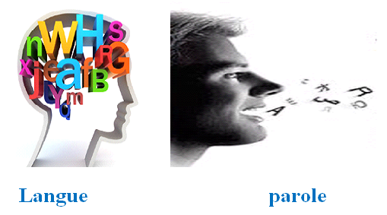
Saussure divided language into two parts.
1- Langue is ‘our [innate] knowledge of the systematic correspondences between sound and meaning which make up our language (including the knowledge of what utterances are possible . . . and what utterances are not).

E.g. * see tomorrow I will
I will see you tomorrow.
2- Parole: is the actual use of language in both speech and writing

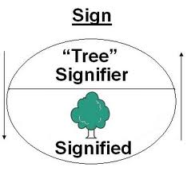
Principles of Saussure’ theory of language
Signifier and signified
Signifier: the sound sequence which makes up a label
Signified: is the meaning or concept associated with the signified.
Sign: is the correspondence between signifier and the signified. It is the association that binds the signifier and the signified together.

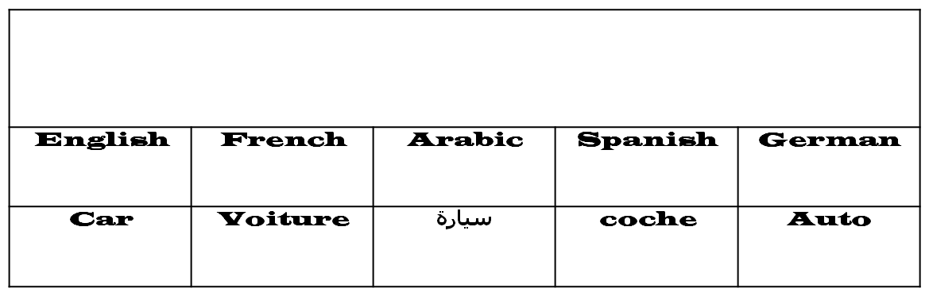
The link between the signified and the signifier is arbitrary
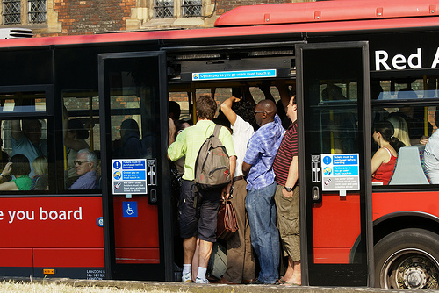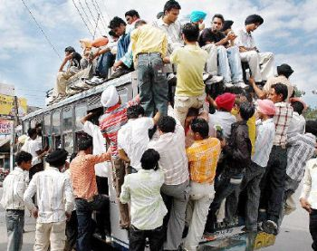
Sign partially derive meaning from their relationship with other associated signs.
Crowded overcrowded

Crowded
We know the meaning of overcrowded through its relation with crowded

Signs do not exist in isolation, but in systems of associative relationship.
White TulipRed Tulip
We know the meaning of white tulip through its association with red tulip.
Sample exam questions: lectures (1 and 2).
Lecture 1
…………….. is the study of how a listener recognize words and utterances.
a. Psychosis
b. Psychotherapy
c. Psychology
d. Psycholinguistics

Psycholinguistics is the study of………………………
a. How to describe the sounds of a language.
b. How to learn languages.
c. How to teach languages
d. how a listener recognizes words and utterances.

………… refers grammatical rules which determine how words can be combined into phrases and sentences:
a. Morpheme
b. philosophy
c. Syntax.
d. Morphology

The ………..is used to keep communication lines open and also keep social relationships well
a. aesthetic function
b. phatic function
c. Referential function
d. Affective function

There is more than one ……………of English, eg. Indian English, American English
variety
verb
Language
Terminology

Aesthetic language is usually used in …………..not in science
Mathematics
Physics
Poetry
Morphology

Choose the example that expresses the affective use of language:
a. It is very hot to day.
b. Wow, she is very beautiful
c. Go to the end of the road.
d. Put those books on the table.

Lecture 2
Ferdinand de Saussure (1857-1913) was a ……..linguist
Syrian
Swiss
British
American
Saussure divided language into two parts: langue and ………
a. paradox
b. Pardon
c. Parole
d. grammar
………is the actual use of language in both speech and writing
linguistics
B. language
Competence
Parole

The link between the signifier and the signified is ………..
Regular
Systematic
Arbitrary
Logical

…….is The ability of its holders to force compliance or obedience of other people to their will.
Parole
Language
Power
signifier

Lecture 3
In this Lecture, we will discuss the following:

1- The Sapir-Whorf hypothesis. The hypothesis refers to two parts:
A. Linguistic relativity
B. Linguistic determinism

Chapter 3
1- Language and Politics
2- Ideology
3- Role of Language in establishing ideology
4- Political discourse.
Presupposition
Implicatur
Persuasive language.
Rhetorical devices


The Sapir-Whorf hypothesis
The Sapir-Whorf hypothesis
- There is a causative link between culture and language.
- A community’s cultural experience shapes their language.
Eg. Coffee

EnglishJapanese (ambiguous)
hot coffee: hot/iced??

Hot Hoticed
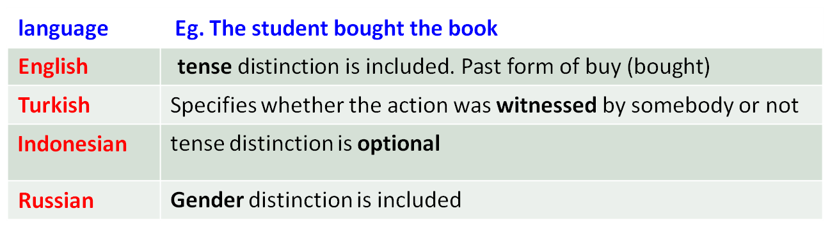
2-The hypothesis refers to two parts:
A. Linguistic relativity
B. Linguistic determinism
Linguistic relativity
Languages of different cultures involve distinct systems of representation which are not necessarily equivalent.

Speakers of different languages refer to different aspects of the world. That is their language affect the way they think.
Linguistic relativity
Languages of different cultures involve distinct systems of representation which are not necessarily equivalent.
Eg. Arabic: زارت ناديا صديقتها
English: Nadia visited her friend.

Speakers of different languages refer to different aspects of the world. That is their language affect the way they think.
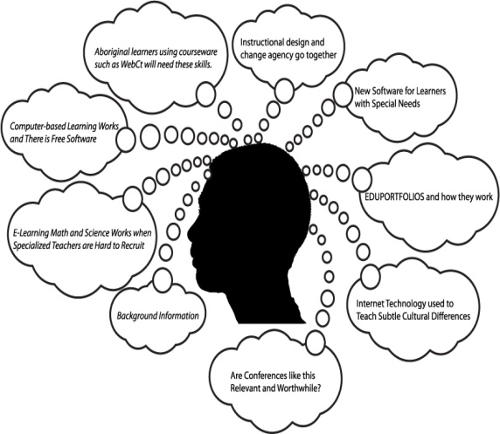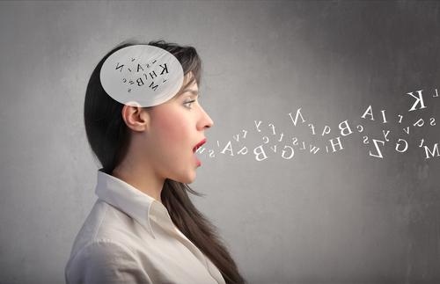
B. Linguistic determinism: language affects the thought processes of its speakers.

-the language you speak determines the way that you will interpret the world around you.
-Our language determines how we see the world (we can’t see things another way)
language and its structures limit and determine human knowledge or thought
-individuals experience the world based on the grammatical structures they habitually use

Chapter 3 Language and Politics
What is meant by politics:
Politics is concerned with power: the power to make decisions, to control resources, to control other people’s behaviour and values.

There is no keeping out of politics. Politics can involve most aspects of life.
Everyday’s decisions and politics.
Eg.
In a supermarket:
-Buying some brand of coffee rather than another:
When you choose specific brand you make a small contribution to the continued existence of a particular company.
Eg.
-Recycled paper goods or non-recycled paper goods
-Organically grown vegetable or genetically modified vegetables.
-Imported food or food produced in your country.

Politics and Ideology
How to achieve political beliefs.
1- Physical coercion
Associated with dictatorial regimes
2- Legal laws
Associated with democratic regimes
Eg. Laws for car parking, places where you can drink alcohol, etc.
3- Persuasion and consent.
Persuade people to act voluntarily in the way you want
-what you want is what your people want.
To achieve this we need ideology
Ideology
Ideology:
Any set of beliefs which, to people who hold them, appear to be logical and natural.

Questioning the ideology:
- difficult
- challenging
-appears not to make sense
- a price to be paid.
Political Discourse
1- Presupposition
2- Implicature
These are two main tools that can lead the hearer to make assumptions about the existence of information that is not made explicit in what is actually said.
Eg.
-Why did you kill your wife?
This sentence presupposes that the listener has really killed his wife.
Presupposition
Presupposition is the background assumption embedded within a sentence or a phrase.
Eg.
We want to set people free. (British conservative politician).

This example presupposes that people are not currently free.
How to use presupposition in a sentence?
1- Adjectives, especially comparative adjectives.
Eg. Goodbetter
We need a better teacher. (presupposes that the current teacher is not good)
-Fairfairer
The government will introduce a fairer funding for schools.
(presupposes that the current funding is not fair).

2- Possessives
Eg. We will not talk about Sally’s problems any more.
(Presupposes that we have talked before and that Sally has problems.)
3- Questions instead of statements
Eg. Is it not now time to study hard?
Presupposes that the listener did not study hard.

Eg. Do not you think that we should make use of our time?
Presupposes that we have wasted our time?
Implicature.
Implicature leads the listener to infer something that was not explicitly asserted by the speaker.
Characteristics.
-Implicature operates over more than one sentence.
-Implicature depends on shared knowledge between the speaker and the hearer.
-Implicature depends on the surrounding context of the discourse.
Eg.
A: Will Sally be at the meeting this afternoon?
B. Her car broke down.
Implicature: Sally won't be at the meeting.
Lecture 4
In this Lecture, we will discuss the following:
Persuasive language.
The power of Rhetoric
Rhetorical Devices used by Politicians:
Metaphor
Simile
Personification
Euphemism
The Rule of Three
Parallelism
Pronouns
Language and the media
Potential power of the media
Media Language and Power.
Sources of news
Commonsense Discourse
The Power of Change

Persuasive language- the power of rhetoric.
Rhetoric: is the art of using language so as to persuade or to influence others” Oxford English Dictionary.

Rhetoric : is group of rules that speakers/writers adhere to so that they express themselves with eloquence (using language to best effect).
Rhetorical Devices used by Politicians:
a. Metaphor: is a way of comparing two different concepts:
e.g. Sally is an angel.
their house is a palace.
b. Simile: asserts that something is similar something else.
e.g. Sally is like an angel.
their house is similar to a palace.
Simile and Metaphor
Simile
The room was like an oven
Her hair is golden silk.
The sun was like a diamond in the sky
He was like a lion in the battle

Her smile was as bright as the sun.
The night was as black as tar

Metaphor

This room is an Oven
Her hair was golden silk
The sun was a diamond in the sky
He was a lion in battle
While a metaphor asserts that something is something else, a simile asserts that something is similar to something else.
Examples showing the use of metaphor/simile in politics
That vast wealth producing engine of the West began to splutter
Margaret Thatcher. 1983
Thatcher talks about the Western economy which she says is an engine.

The airport is already acknowledged as the economic motor of the region’ Graham Stringer, 1997
Personification is a rhetoric device that entails giving human characteristics to inanimate objects or abstract ideas
Eg.
a. Once again the heart of America is heavy. (Us President Lyndon Johnson).
The use of personification in (a) can give the speech a poetic effect.

b. Germany is the bully in the playground. (British TV news 1990s)

The use of personification in (b) has an ideological effect: indicating Germany’s strong and influential position in the European Union or its dominance in Europe
Further examples:

c. Germany is the conductor of the orchestra.
d. Germany is the captain of the ship.`
.
E.g. Sex or Death
Make lovesexual intercourse
Die pass away

E.g. Military matters
Clean strikesdeadly strikes

Positive effect through the connotation of clean which means healthy

Decommissioningdisarming
Put weapons beyond usesurrender

Ethnic cleansingforcible removal of civilians
The term is used to hide the fact of forcing civilians to move out of their homes because they belong to specific ethnic group.

E.g. diplomatic meetings
Free and frank exchange of viewsflaming row

Euphemism is a rhetorical device which uses mild or inoffensive language to make something seem more positive than it actually appears
E.g.
That government of the people, by the people and for the people shall not perish from this earth. (Abraham Lincoln)
The cry of the French Revolution (liberty, equality, brotherhood).
Tony Blair claimed that three main commitments of the labour party were education, education , education.
The rule of Three: a rhetorical device where a statement is divided into three parts or points.
Parallelism.
Parallelism: A rhetorical device which expresses several ideas in a series of similar structures.

Politicians use parallel structures when they want to draw attention to a particular part of their message:

E.g.
“we shall fight on the beaches, we shall fight on the landing grounds, we shall fight in the fields and in the streets. Winston Churchill1940

This can serve to emphasize that
the ideas are equal in importance
and add a sense of symmetry and rhythm,
make the speech more memorable.
Pronouns is a device which can be used by either to emphasize or to obscure responsibility and agency.
E.g.
‘We have no choice but to consider retreating combat units as a threat
[. . . ] Nearly six weeks ago, I said that our efforts are on course’
US President George Bush

Why do you think George Bush change from we to I?

Answer:
He uses we when the focus of his speech is relatively controversial, as it is unclear whom we refers to. He uses I when he is on safer ground and where he claims responsibility for positive achievements.
Language and the media
Media

the press radio television broadcastingworld wide web
Importance:
We get our knowledge of the world through media
Potential power of the media
Media can represent a powerful source in society:
The media can select what counts as news.
The media can who gets on the television, radio or newspaper.
Media plays important role in the ways through which information is told or presented
The media has become an integral part of most people's lives
Linguistic representation is a level of language use which is concerned with the relation between how a story is told and how this can lead to different view or versions of the same story or event.

Journalist (1)
narrates the event as they appeared
gives informative facts,
states official sources from police and hospitals, etc.
Reports facts objectively

Journalist (2)
openly refers to the ethnic community the involved individuals belong to.
Gives expected incidents.
Uses unofficial sources. E.g. Friends and personal experience
Reports facts subjectively
Media, Language and Power.
Sources of news
The factuality level of a source is very important.

Examples of unreliable sources:

- A friend of Mr. Carling is reported as saying ….
-He told me later that ……

These are examples of third- or fourth-hand source of information because the reported information is difficult to retrieve or verify

Commonsense Discourse
Discourse is used in linguistics with a range of meanings. It can refer to
Any piece of connected language which contains more than one sentence.
It refers to conversations.

Commonsense Discourse
The prevailing way that a culture talks about or represents something is called the dominant discourse
Ex.
a. I want to go to the forest and try to understand what the plants are saying
b. I want to go to the forest to be inspired by nature.

The Power of Change
Media can lead to different changes in the society:

1- The use of non-sexist language
Eg. The use of grammatical forms which are neutral such as the third person pronoun being a non-specific-gender pronoun

Eg: Gender-specific nouns: fireman, chairman
Gender-neutral nouns: firefighter, chairperson

Example of sexist language
The athlete should get the appropriate amount of rest before his match.

Correction:
The athlete should get the appropriate amount of rest before his/her match.

Most job titles that were gender-specific in the past have an equivalent gender-neutral synonym today
mail carrier, postal worker
server
Sales representative, sales clerk
police officer
congressional representative
chair, chairperson,

mailman
waitress/waiter
saleswoman/salesman
policewoman/policeman
congressman
chairman

Examples:
Lecture 5
In this Lecture, we will discuss the following:

Media Voices: accent and Register
variation in register
Public participation in the Media
Language, society and virtual power.
social identity
Netiquette Netiquette
Cyberspace: a socially powerful community?\

Language and gender
How is English sexist?
Characteristics of Sexist language
Symmetry and asymmetry

Media Voices.
What accent is used in the media?
Received Pronunciation (advanced RP)BBC Englishmainstream (RP)
Received Pronunciation (advanced RP):
refers to the accent used by the educated and the wealthy. It gave no indication of what part of the country the speaker came from
BBC English:
A pronunciation of British English based on the speech of the upper class of southeastern England
Mainstream (RP):
An accent which sounds less formal than advanced RP and is the one that most people in Britain generally hear when they listen to newsreaders on national television.
Variation in Register.
What is Register?
Register is the way that language can systematically vary according to the situation in which it is used.

Variation in Register can be in
Sentence structure,
Pronunciation
Vocabulary

Three factors that determine variation in register.
Field: refers to the subject matter of the discourse
Tenor: refers to the role being played by the speaker
Mode: refers to the medium of communication, e.g. speech or writing.

E.G
the weather forecast contains technical vocabulary relating to temperature, high and low pressure, cyclones, etc.,
Field= weather forecast
Tenor = weather reported
Mode = technical vocabulary (temperature, high and low pressure)
a small sun to represent sunshine
arrows for the direction of the wind, etc.
Public participation in the media
What are the reasons for allowing the public to participate in the media. (TV shows)

1-This provides the opportunity for democratic debate in the media.

2- This can depoliticize some important issues by presenting them for public debate.

3-This opens up access to an important public domain for people whose voices and opinions are not usually heard on television.

4- This provides a powerful space for the voices of ordinary people to be privileged over the voices of institutional representatives whose opinions and views usually predominate in the media.

Computer mediated communication (CMC)
This includes different forms of interactions ranging from email to newsgroup
Social identity
In the early days of CMC it was thought that this new medium would result in more democratic communication, because a person’s social identity (their gender, ethnicity, age) can be hidden in the virtual world. However, this is not the case as stereotypical interpretations of gendered behaviour still prevail:
So you can disguise your identity on the net, the people you interact with will still make assumptions about who you are based on what you say and how you say it.
Language, society and virtual power
Netiquette (short for network etiquette)
Netiquette refers to the rules that attempt to control social interaction in the virtual world (cyberspace).

E.g. There are rules and codes of behavior which have developed in order to control the way members of a community behave as in chat rooms.

Many newsgroups have a FAQ (frequently asked questions) file which sets out what these rules are,

Inappropriate behavior can get you sanctioned, and possibly excluded from, a group.
E.g.
Flaming (aggressive verbal behavior)
spamming (sending unwanted long messages)

Cyberspace: a socially powerful community?
Diverse groups of people who participate in protests and campaigns via the internet, can be socially and politically powerful.

Example
In case a database such as (Marketplace Households) (listing details of people and the items they bought) are released.

-This can result in intense debate about privacy
-The debate is not only in newspapers but across internet newsgroups and bulletin boards.

Language and gender
We will discuss:
a. asymmetrical representations of women and men
b. Why language can be considered sexist ?
c. Whether women and men use language in different ways

Sex and Gender
Sex refers to biological category, which is usually fixed before birth.
Gender refers to social category, which is associated with certain
Behaviour.
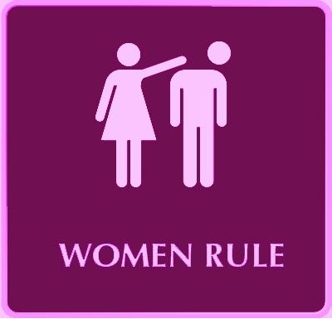
Sexist language represents women and men unequally, as if members of one sex were somehow less completely human, or had fewer rights than members of the other sex.
Examples of sexist language

Characteristics of Sexist language
Sexist language presents stereotypes of women and men sometimes to the disadvantage of men, but more often to the disadvantage of women.
E.g.
The most common stereotype about women’s speech is that women talk a lot

Men are strong and do all the work.
husband works, wife stays home

-Men still hold more ‘high-status’ occupations in this society than women do.
E,g.
Most presidents around the world are men.

-Men still own more property and earn more than women.

How is English sexist?
Sexist language can be discussed in two points:
1- English language system is inherently sexist
2- Some ways of using language are sexist

Point (1)
to what extent English is inherently a sexist language:
Answer:
We look for symmetry versus asymmetry in the vocabulary or lexis.

Symmetry and asymmetry
generic Man
female woman
male man
young child
young female girl
young male boy
woman Miss / Mrs / Ms
man Mr

Symmetry asymmetry
adult male = Mr
adult female = Miss, Mrs or Ms

Any woman who gives her preferred title on a form is revealing far more information about herself than a man does.
E.g.
Miss reveals that she is unmarried
Mrs indicates that she is married
Ms. does not reveal marital status, in line with title for men
Ms
Divorced feminist; information about your political opinions
Men do not face this situation as the term Mr does not indicate all the
information we find in women
For next lecture, we will discuss the following topic
Some ways of using language are sexist

سبحان الله وبحمده سبحان الله العظيم السالفة مليون

