-5-

In this lecture:

- Censorship  - How writers escaped from censorship  - Individualism  - Sentimentalism  - Demerits of the English novel in the 18th century  - Journalism  - Coincidence | - Elements of the novels  - Summary of weaknesses  - Merits of the English novel in the 18th century  - Censorship  - Patronage  - Serialisation

Characteristics of the 18th Century Novel: Censorship

- A Novelty means something that is strange, unfamiliar, unacceptable.
- The novel was considered to be a novelty.
- It could not be published easily.
- This had to do with the nature of the novel at that time as it was a new genre and was considered by many to be a novelty, something which not many people were proud of. Robinson Crusoe for example was not published as a novel but a s a history or journalistic repertoire.

- What did writers do to escape from censorship?
- Writing prefaces to justify the writing of novels
- Changing the setting like solitary islands or remote places and past times
- The setting is the (time- place- time and place) of the novel.
- Seeking patronage
- Calling the novel history or tale or adventure or just giving it any other name in order to avoid censorship.

- Was this good for the rising novel?
True or False?
Censorship was good for the rising novel
- Of course not
- Unnecessary prefaces
- Exaggeration
- Not giving the novel its proper name

Individualism

- Individualism means the interest in one's own problems, desires, hopes, ambitions, and dilemma.
It is a tendency that began in the modern ages especially the eighteenth century.

- Most works of art written in that age talked about individuals rather than about groups of people. Examples are Robinson Crusoe, Gulliver's Travels, Emma, Rasselas, Hamlet, King Lear, Macbeth, Othello, Romeo and Juliet, Silas Marner, and Oliver Twist.
- All features of the age (geographical expansion, scientific discoveries, the clash between science and religion) led to individualism.

- In Robinson Crusoe, the writer focuses entirely on the character of Robinson as if no one else exists.
- When Robinson deals with anyone even his parents and friends, we understand that his own good and desires come first.
- That is why he does not listen to the advice of his parents or even know what happened to his friend.

Sentimentalism

Tendency to shed tears over any occasion
It is affected and not sincere
It is a demerit
Verisimilitude

A French term
Verite
Smili
Tude
= realism= probable= possible= can happen
Things as they can be not things as they are

Features of the novel

- Title expressive (remote-exotic)
- Prefaces
- No dialogue
- Illustrations
- repetition
- All places very queer
- Setting
- Sharp but indirect criticism
Demerits

- Titles of novels and chapters
- Subtitles
- Coincidence
- Language
- Illustrations

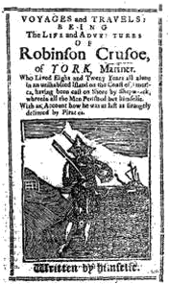

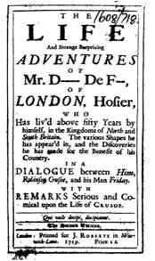

Robinson Crusoe by Daniel Defoe
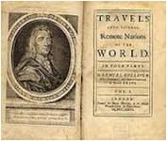
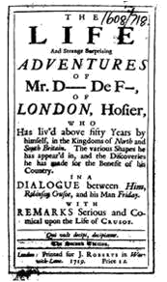

Gulliver’s Travels by J Swift
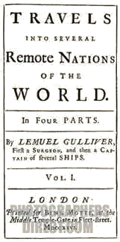

Joseph Andrews by henry fielding
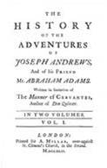

Elements of the Novel

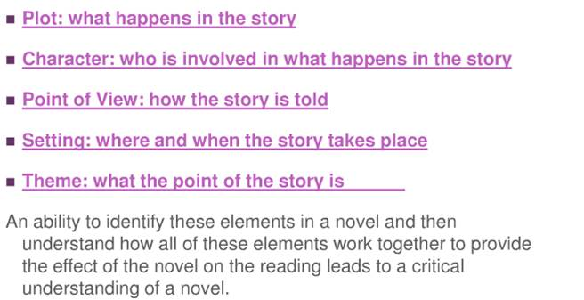

Summary of Weaknesses

- Titles of novels and chapter headings:  - sentences  - Repetition  - Structure  - plots  - story-telling  - Coincidence  - Sentimentalism | - long and detailed  - Long and complex  - Repetition  - Weak  - Weak  - Loose, multiple  - Crude and abrupt  - Overrated and revolting

Notes:_____________________________________________________________________________________________________________________________________________________________________________________________________________________________________________________________________________________________________________________________________________________________________________________________________________________________________________________________________________________________________________________________________________________________________________________________________________________________________________________________________________________________________________________________________________________________________________________________________________________________________________________________________________________________________________________________________________________________________________________________________________________________________________________________________________________ _________________________________________________________________________________________________________________________________________________________________________________________________________________________________

