-5-
Elements of the Elements

- Practical things about ordering in English
- Giving an Advice (should, shouldn’t)
- Can / Can’t
- Talking about Fitness

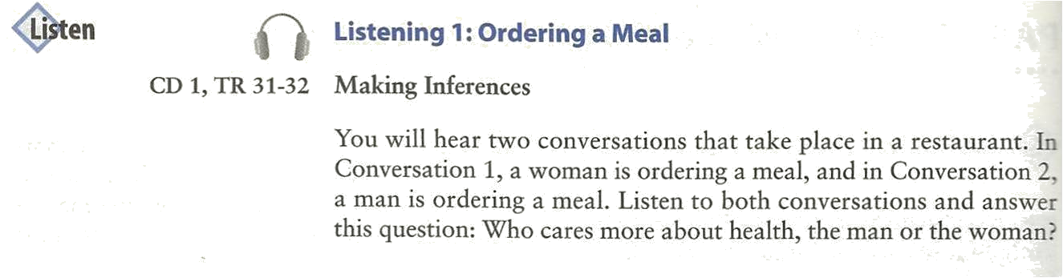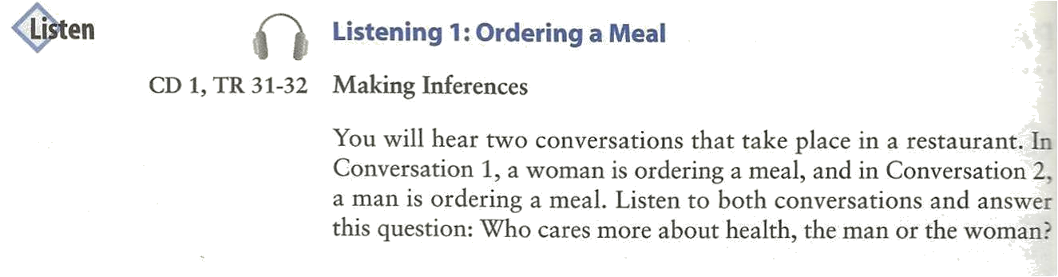

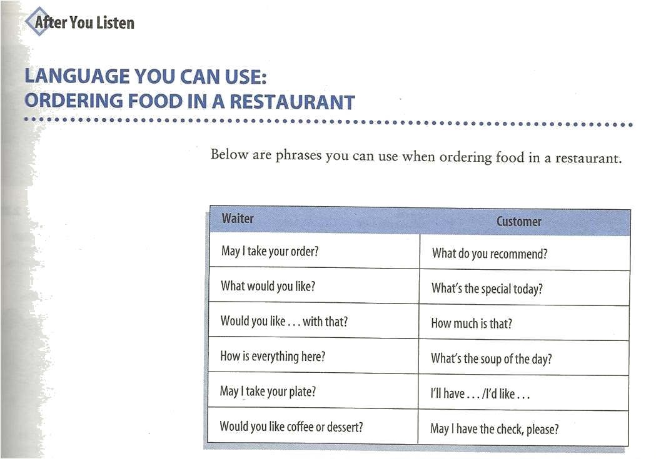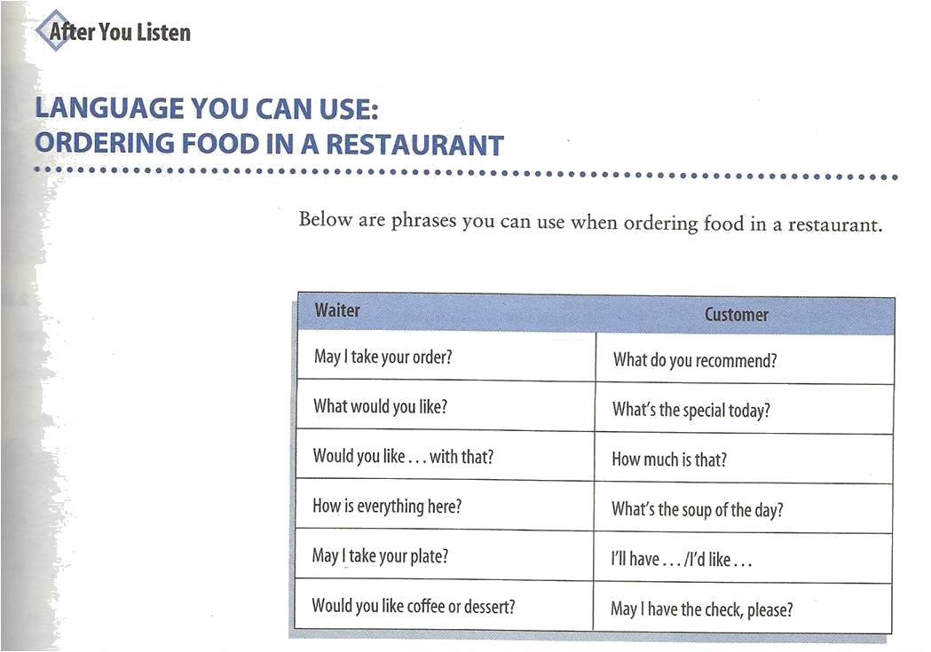
Dialogue:

C. May we see the menu, please?
W. Sure, here it is.
W. Can I take your order?
C. Yes, I'd like a hamburger and a milkshake.
W. How about you?
C. I'd like a ham sandwich.
W. (Would you like) anything to drink?
C. No, thank you. Just water.
Practice 1: Vocabulary Expansion

May we see the menu, please?
have more coffee?
have the check?

Practice 2: Vocabulary Expansion

- I'd like a hamburger.
    - ham sandwich.
    - taco.
    - milk shake.

- I'd like(a glass of) milk.
- (a cup of) hot chocolate.
- (a piece of) pie.
- (a bowl of) soup.

Practice 3: Vocabulary Expansion

- Would you like anything to drink?
- to eat?
- for desert?
- Else?
Practice 4: Role Play
Teacher:Can I take your order?
Student:Yes, I'd like __________.
Teacher:Thank you. How about you?
Student:I'd like __________.
Teacher:Would you like anything t drink?
Student:Yes. I'd like __________.
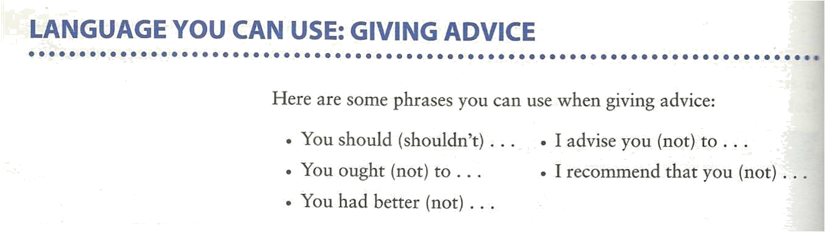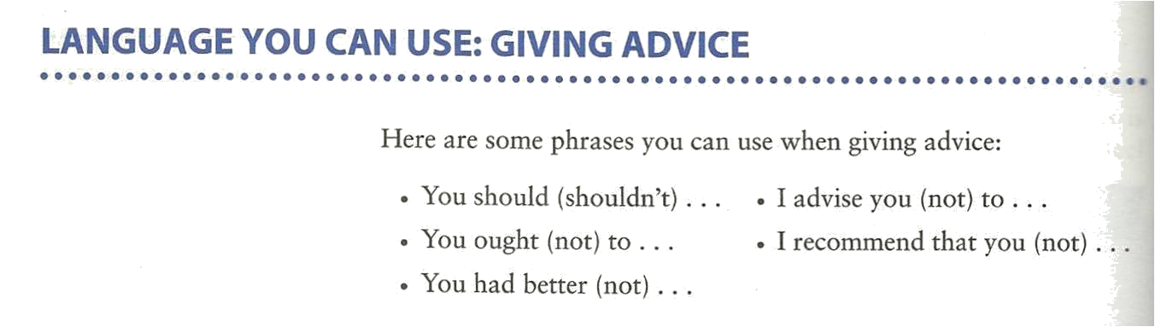

We should wash our hands  with liquid soap | 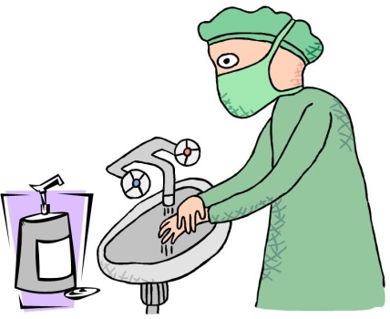
We should prevent disease. | 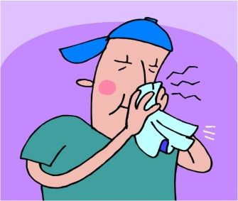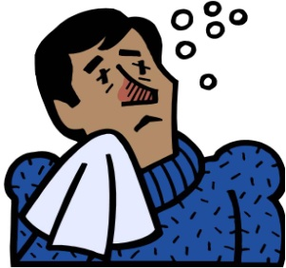
We shouldn't litter. | 
We should see a doctor  promptly if we feel unwell. | 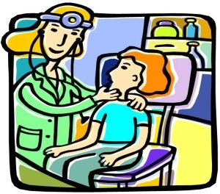

Let’s do some exercises
You __________ eat too many sweets. They are not good for you. | 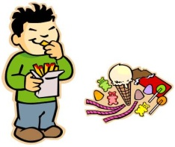
You __________ sleep early. | 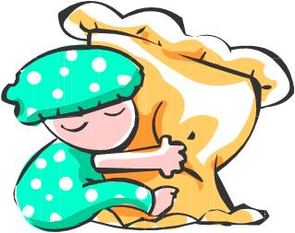
We _______ be friendly to our friends. | 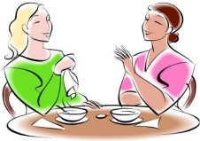
Lily’s dress is dirty. She __________ clean it. | 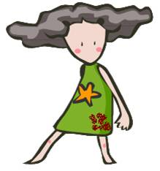

You _________ play on the road. | 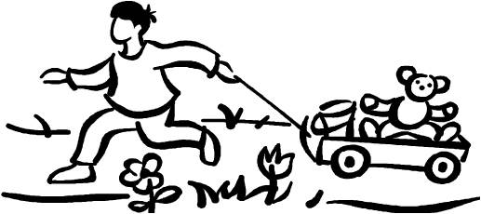
Your brother is weak in Maths. You ______help him. | 

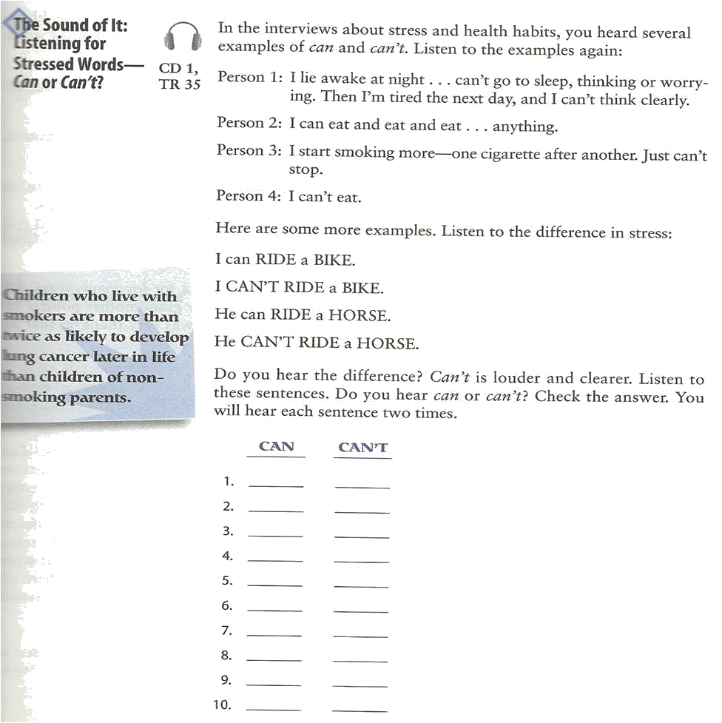

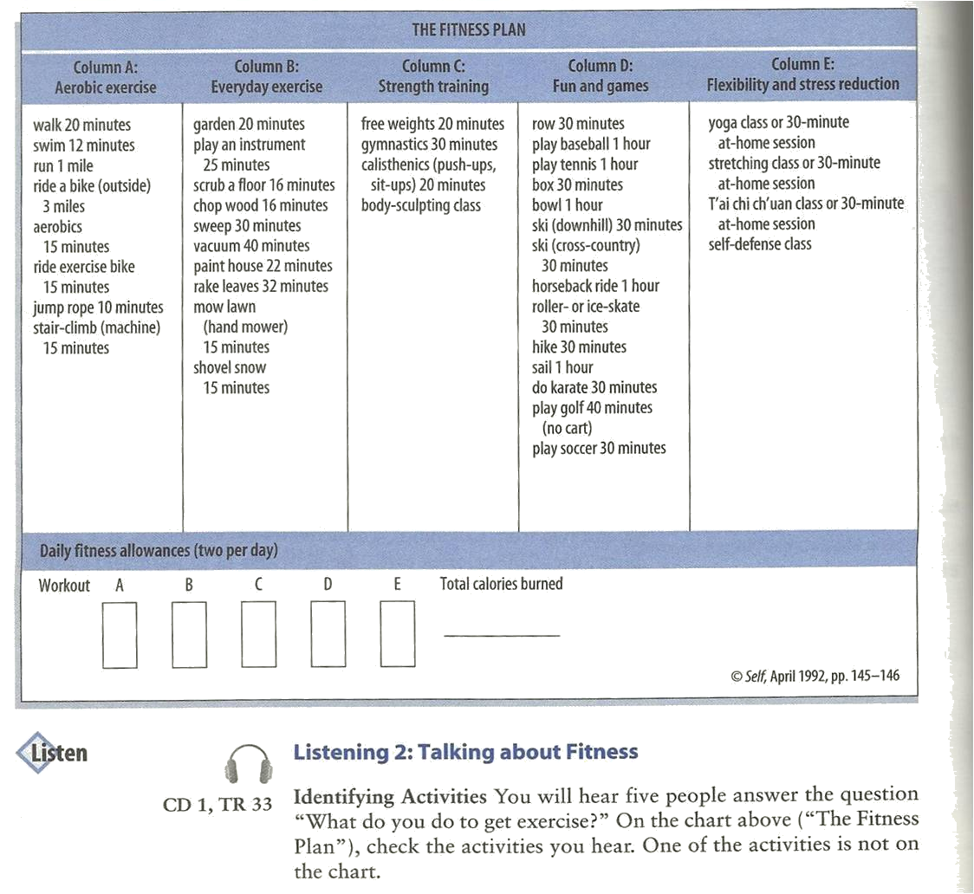

Write a Role Play . J

“What do you do to get exercise?
Notes:_____________________________________________________________________________________________________________________________________________________________________________________________________________________________________________________________________________________________________________________________________________________________________________________________________________________________________________________________________________________________________________________________________________________________________________________________________________________________________________________________________________________________________________________________________________________________________________________________________________________________________________________________________________________________________________________________________________

