-4-
Elements of the Lecture
- Talking about Goals
- Talking about future plans
- The Sound of it: Understanding Reductions
CD1 TR 24-27
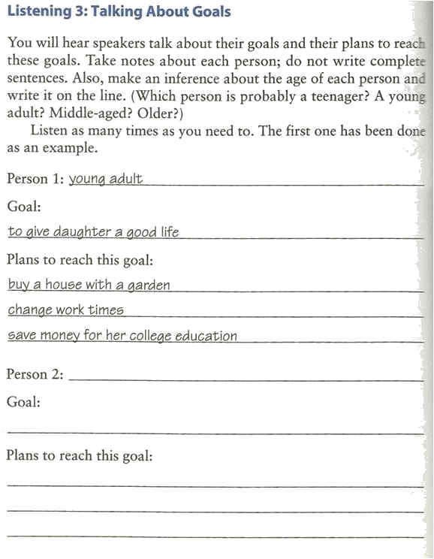
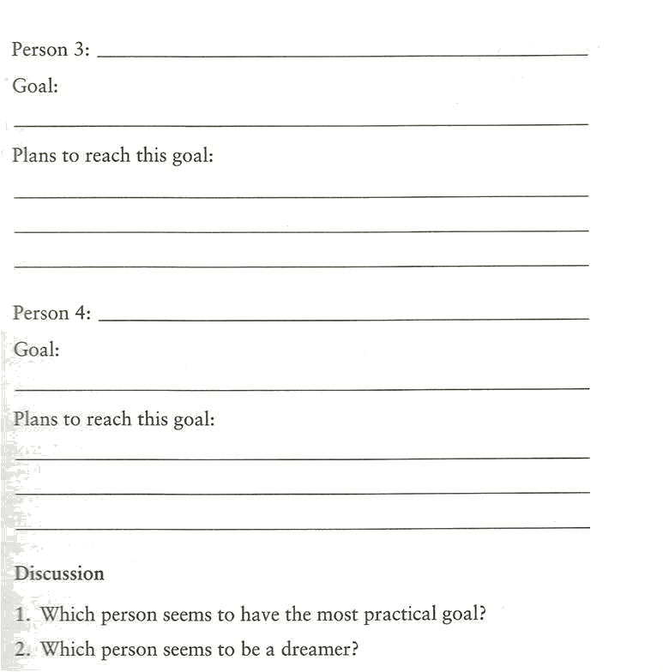

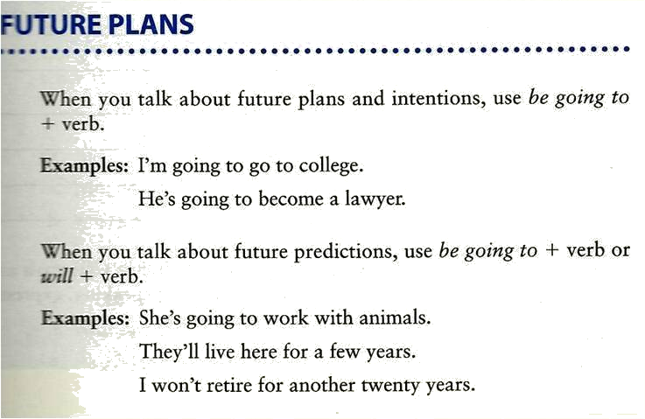

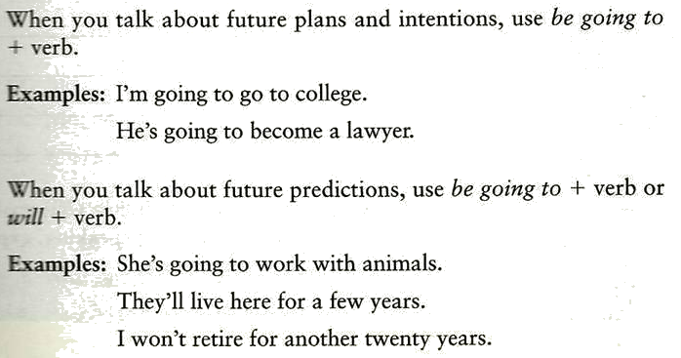

‘will’ ‘going to’
Kate: ‘Anna’s in hospital.’  Ben. ‘Is she?  I’ll visit her tomorrow.’ | - I’ll visit her tomorrow.
Kate: ‘Anna’s in hospital.’  Ben: ‘I know.  I’m going to visit her tomorrow.’ | - I’m going to visit her tomorrow.

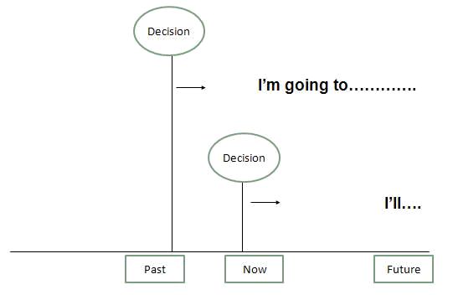

‘going to’ ‘will’
We use ‘going to’ when we have a plan.  We have decided to do something. | We use ‘will’ when decide to do something now --- at the time of speaking.
- ‘My bag is so heavy.’ ‘I’ll carry / I’m going to carry it for you.’
- I bought some warm boot because I’ll go / I’m going skiing.
- ‘Tony’s back from holiday.’
’Is he? I’ll give / I’m going to give him a ring.’
- ‘What are you doing tonight?’
‘We’ll see / We’re going to see a play at the theatre.’
- You can tell me your secret. I won’t tell / I’m not going to tell anyone.
- Congratulations! I hear you’ll get married / you’re going to get married.
- ‘I need to post these letters.’
‘I’ll go/ I’m going shopping soon. I’ll post / I’m going to post them for you.’

‘will’ ‘going to’
- A Why are you turning on the television?
B _________________ the news. (I/watch)
I’m going to watch

- A Why are you filling that bucket with water?
B ________________ the car. (I/wash)
I’m going to wash

- A What would you like to eat?
B ________ a sandwich, please. (I/ have)
I’ll have

- A Hello. Can I speak to Jim, please?
B Just a minute. _______ him. (I / get)
I’ll get

- A I don’t know how to use this camera.
B It’s easy. ________ you (I / show)
I’ll show

Do it by Yourself J : Share it with us on Blackboard Forums
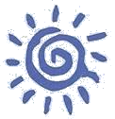
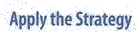
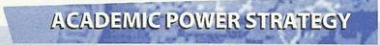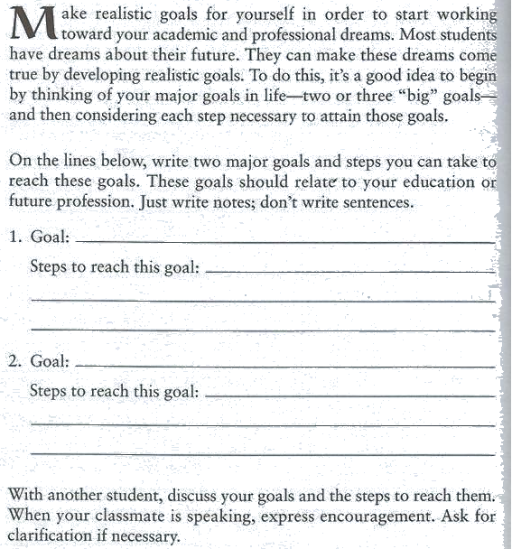

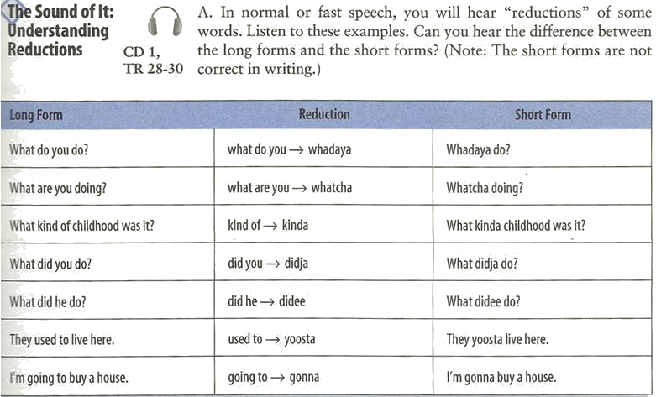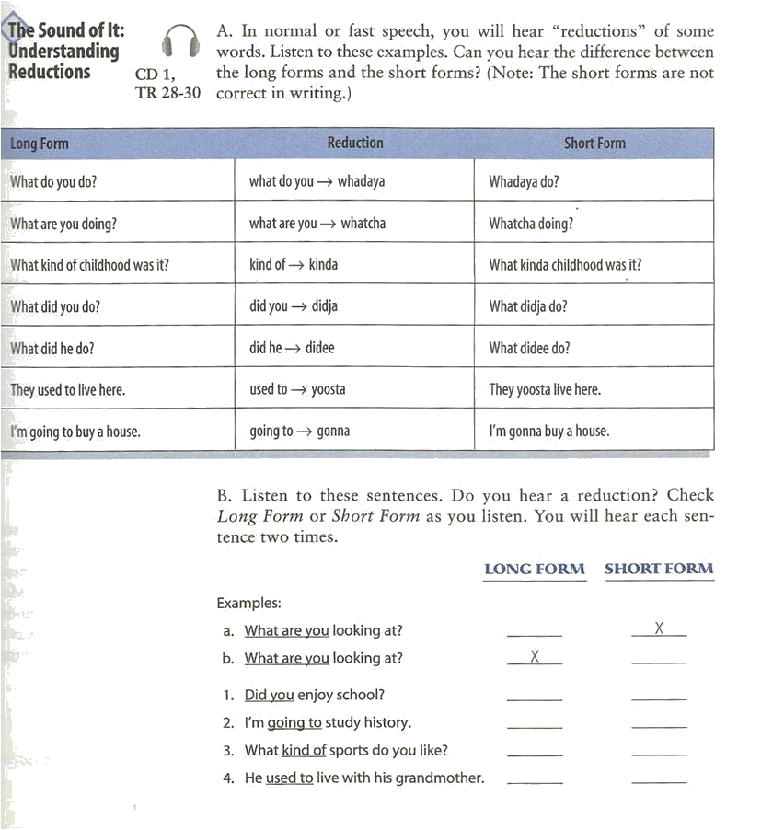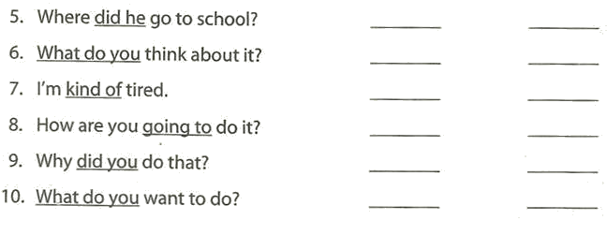

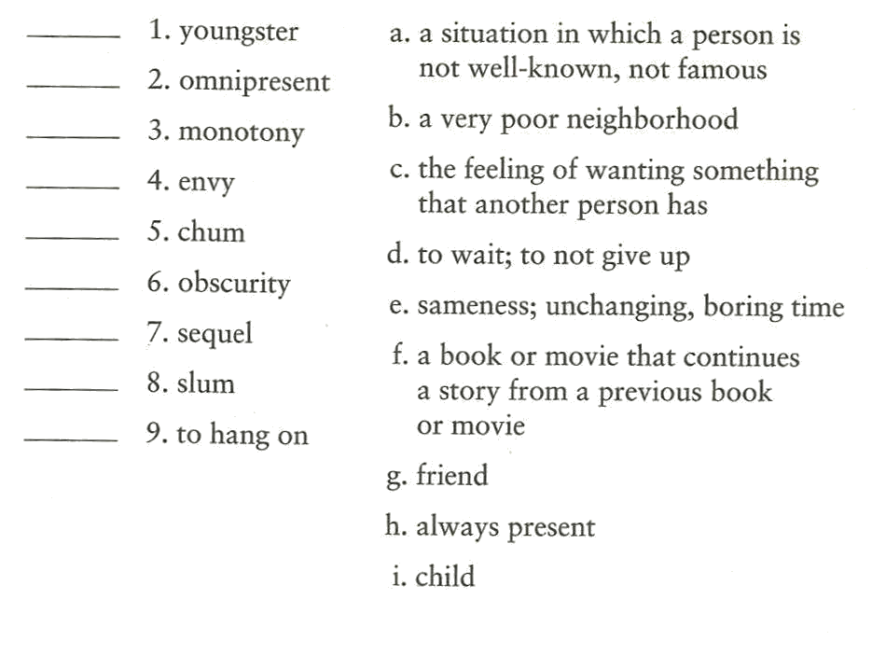

Notes:__________________________________________________________________________________________________________________________________________________________________________________________________________________________________________________________________________________________________________________________________________________________________________________________________________________________________________________________________________________________________________________________________________________________________________________________________________________________________________________________________________________________________________________________________________________________________________________________________________________________________________________________________________________________________________________________________________________________________________________________________________________________________________________________________________________________________________________________________________________________________________________________________________________________________________________________________________________________________________________________________________________________________________________________________________________________________________________________________________________________________________________________________________________________________________________________________________________________________ ________________________________________________________________________________________________________________________________________________________________________________________________________________________________________________________________________________________________________________________________________________________________________________________________________________________________________________________________________________________________________________________________________________________________________________________________________________________________________________________________________________________________________________________________________________________________________________________________________________________________________________________

