-3-

Names given to the period of time before 18th Century

So people felt calm, happy, and content.
They also felt stagnant as there was no movement, no change.
It was the age of stagnation
The age of negativity.
The age of reason.
The classical age.
The age of propriety (this is good, this is bad).

England in the eighteenth century

It is an age that witnessed a rebellion against the values that were prevalent in the age of Pope (1688-1744).
A new generation of writers reacted against the self-complacency, the chilliness, and the aridity of the preceding age.
They found themselves unhappy with the way in which their fathers looked at life, with their formalism, their narrowness of sympathy, and their controlling ideals.
They dreamed of becoming more natural and spontaneous in expressing themselves in literature.

The New Age

The new age was different
It was the age of change
The age of science
The age of the industrial revolution
Lots of machines, lots of production.
Factories, boats, trains, hospitals, telegrams, printing, transportation, communication,-education, health, etc.

The Industrial Revolution

The industrial revolution and its impact on health (pollution, smoke);
family (women going to work, family disintegration work of children);
lack of interest in education and the false or dogmatic ideas spread in educational institutions; reason versus imagination;
clash between science and religion and the weakening of the influence of the church over people (secularism).

Materialism as people lost all trust in religion and began to seek fulfillment of their desires and needs.

What are some of the passive effects of the IR?

The industrial revolution also had its demerits:
Environmental Pollution
Poor health conditions at the start of the century
Materialism
Lack of interest in education
Work of women and children
The weakness of the family structure
Poverty of some classes of people
Hunger, diseases, deaths.

The Empire

On the international level, England became a huge super power.
It occupied many countries all over the world.
It became the Empire over which the sun never sets
There was huge expansion and geographical discoveries all the time.
People from England felt very important and very powerful.

Individualism

Every man and woman felt the desire to roam the globe, to travel everywhere and explore new lands.
Individuals preferred their own good. They wanted to satisfy their desires for more money, more knowledge, more pleasure.
Every individual wanted to achieve himself and lost interest gradually in every other individual.

Individualism is the moral stance, political philosophy, ideology, or social outlook that stresses "the moral worth of the individual". Individualists promote the exercise of one's goals and desires and so value independence and self-reliance while opposing most external interference upon one's own interests, whether by society, family or any other group or institution.

Definition

A fictional prose narrative of considerable length, typically having a plot that is unfolded by the actions, speech, and thoughts of the characters.
It is about 250 pages in length.

More definitions

The novel is a worldwide cultural instrument which helped redifne:
The time and space where we live
The way we speak and talk
How we feel
What we do
Hybrid genre

The novel encompassed many different sub-genres
Is always in search of a definition
Battled with other genres from the very beginning

Another definition

A novel (from French nouvelle and Italian novella) is an extended, generally fictional narratuive in prose. Untill the 18th century the novel referred specifically to short fictions of love and intrigue as opposed to romances, which were epic-length works about love and adventure. During the 18th century the novel adopted features of the old romance and became one of the major literary genres.

“The Novel is a picture of real life and manners, and of the time in which it is written. The Romance, in lofty and elevated language, describes what never happened nor is likely to happen.”  Clara Reeve, The Progress of Romance, 1785 | 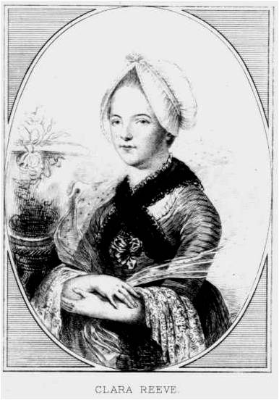

Goal of the Novel

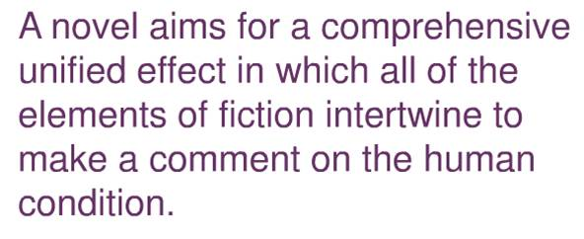

Novel: various Meanings of the Term

Novel = m(adj): new
Unfamiliar
Unacceptable
Novelty (a noun) = something that is not welcome

Why the “rise of the novel”

Restoration of monarchy (post-Puritan)
Appearance of periodicals
Rise of middle class
Leisure time for middle class
Growing audience of literate women

Title Count in the 18th Century

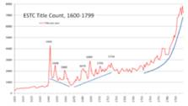

When and where?

1st half of the 18th century in England. Prototypes of the novel date back to the Elizabethan literature. Sir Philip Sidney’s arcadia, Aphra Behn’s Oronooko or the royal slave (1688), and John Bunyan’s the Pilgrims Progress (1678)

Notes:__________________________________________________________________________________________________________________________________________________________________________________________________________________________________________________________________________________________________________________________________________________________________________________________________________________________________________________________________________________________________________________________________________________________________________________________________________________________________________________________________________________________________________________________________________________________________________________________________________________________________________________________________________________________________________________________________________________________________________________________________________ ___________________________________________________________________________

