 | type | nationalty | century | name
Belief no limits to what man could accomplish | humanists | Italian  Lived in florence | 14 | Giovanni pico della
1- studying the works of Cicero and Virgil  2- attempting to imitate Cicero's style  3- Petrarch works led to the rise of people known as civic humanists or those individuals who were civic minded and looked to the governments of the ancient worlds for inspiration | humanists | Dutch  Lived in Tuscany  Milan  venice | 13 | Francesco Petrarca
1-wrote abiography of Cicero  2- encouraged people to become active in the political and cultural life of their cities  3-he was a historian who today is most famous for the History of the Florentine peoples  4- was also the Chancellor of Florence | humanists | florence | 13-14 | Leonardo Bruni
1-wrote Decameron  2- boccaccios work is considered to the best prose of the Renaissance | humanists | Italian | 13 | Giovanni Boccaccio
- The Courtier  (which set forth the criteria on how to be the ideal Renaissance man |  | Italian | 14-15 | Baldassare Castiglione
العلماء الانسانيوون .. عشان نحفظهم .. اربطوهم مع الصور
هذه صور العلماء اربطوهم بالجدول

Giovanni Pico della Mirandola
عجبنى اسمه ميرندولااا
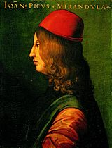
Francesco Petrarca
هذا ابو المصايب اللي بكل صفحت ناقز لنا .. هو والزرع اللي على راسه
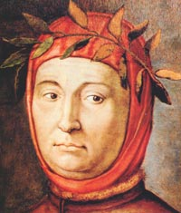
Leonardo Bruni

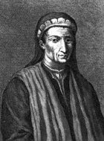
Giovanni Boccaccio
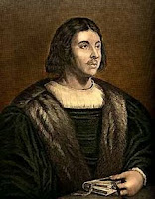
Baldassare Castiglione
