المحاضرة الخامسة
....................Lecture No. Five
Synonym, antonym and hyponym
Synonym and Antonym are forms of Greek nouns which mean,respectively,same name and opposed or different name. We may find synonyms which have an identical reference meaning, but since they have different connotations. They can never be truly synonymous.Ths is particularly the case when words acquire strong connotations of approval or disapproval. We can see this by comparing terrorist with freedom fighter or agnostic.
Synonym, antonym and hyponym.
Some speakers will not be aware of synonyms, so cannot make a choice. But those with a wide lexicon will often choose between two or among many, possible synonyms. This is an area of interest to semanticists. What are the differences of meaning in toilet,lavatory,WC,closet,privy ,bog,dunny and so on? Intillegent reflection on lexicon will show that most words do not have antonyms.
Synonym, antonym and hyponym
Hyponymy s an inclusive relationship where some lexemes are co-hyponyms of another that includes them. As cutlery includes knife,fork,spoon these are co-hyponyms of the parent or superordinating term. This traditional term denotes a grouping similar to a semantic field. So cod,guppy ,salmon,and trout are hyponyms for fish, while fleet has the hyponyms battleship, aircraft carrier,cruiser,destroyer and frigate.
Synonym, antonym and hyponym
David crystal points out that this is a linguistic, not a real-world, relationship-so it varies from one language to another. In English potato is a hyponym of vegetable but in German the lexemeGemuse doesn’t include Kartoffel=potato.
Collocation, Fixed Expression and Idiom
Some words are most commonly found paired with other words, to create a semantic unit or lexeme.
Thus false is often found together with passport, teeth or promise. These pairs are known as collocations. They are very helpful in establishing the meanings of the words in the pair. Porn s likely to be followed by customer, operative or minister. After estate you expect agent. How often have you seen whole new as collocation?
Synonym, antonym and hyponym
Think of collocations including these words: American,British,coffee,dirty,mad.millennium,native,Ninja,prime,police,rotten,spee,surf.
When words become grouped in almost predictable ways these are fixed expressions. Examples include jewel in the crown, desirable residence, criminal mastermind, world of work, address the issues,I put it to you. Sometimes ,the group is so well rooted in the language that the meanings of
Synonym, antonym and hyponym
The component words are ignored, or metaphorical meanings are never visualized. Such a group has a meaning that is not to be found in analysis of its parts,and is an idiom. Examples include :keep your nose clean, stick your nose in beneath your station bed of roses, load of crap not my cup of tea, a piece of cake etc..
Semantic change &Etymology
Over time lexemes may change their meaning. This kind of change is semantic change. Perhaps a connotation will take the place of the original denotation. More often a second or a third meaning will develop side by side with the original. In time, this may come to be the primary reference meaning. Gay has both the sense of happy and homosexual. In spoken British English-today the primary meaning s more likely to be the second of these.
Semantic change &Etymology
Etymology is the systematic study and classification of word origins, especially as regards forms and meanings-it s therefore an important concept both for semantics and the study of language change. The etymology of a given lexeme denotes an account of its historical –linguistic origin.
We can illustrate semantic change through the etymology of gentle. In the 14h century gentile had the meaning of noble, referring both to social class
Semantic change &Etymology
and to character. Because a noble person was supposed to be kind and considerate, the adjective today has the sense of tender ,careful or delicate. The older meaning is preserved in gentleman ,genteel and gentilty.Until recently public toilets in the UK were designated Gentlemen or ladies-where now we usually see a male or female picture representation. See the picture
Semantic change &Etymology

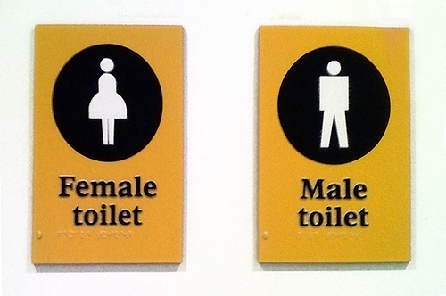

Polysemy
Polysemy refers to a word that has two or more similar meanings:
The house is at the foot of the mountains
One of his shoes felt too tight for his foot
'Foot' here refers to the bottom part of the mountains in the first sentence and the bottom part of the leg in the second.
Homonymy.
homonymy the state or quality of a given word’s having the same spelling and the same sound or pronunciation as another word, but with a different meaning, as race ’tribe’ and race ’running contest.’ Cf. heteronymy. — homonym, n. — homonymous,adj.
Homographs:
Homographs are words of like spelling but with more than one meaning. A homograph that is also pronounced differently is a heteronym.
Some words are nouns or adjectives when the accent is on the first syllable and verbs when it is on the second. When the prefix "re-" is pretended to a monosyllabic word, and the word gains currency both as a noun and as a verb, it will probably fit into this pattern, although, as the list below makes clear, most words fitting this pattern do not match that description. End of lecture five

