1 - What is translation ?
- The simple Definitions of translation
- Meaning of translation as a noun or a verb
- Advanced definitions of translation
- How can we achieve equivalence in translation ?
- Using the six wh – questions in looking for equivalence in translating a text
- What is a good translation ?
- Three laws of good translation
2- what is a translator ?
- Communication versus translation
- What is the difference between a normal communicator and a translator?
- How important are memory, meaning and language to another in the course of translation ?
- What does the translator’s knowledge-base contain ?
- What does the translator’s communicative competence consist of
- What are the primary characteristics of a good translator ?
3 – what is translation theory ?
- The meaning of the term ‘theory’
- The definition of a theory
- The definition of a model
- Main characteristics of a useful model
- Main characteristics of a theory
- What is translation theory ?
4 – Elements of Translation ?
- The six elements of translation
- The Source Language
- The Source Text
- The Translator
- The Translated Text
- The Language of Translation
- The Target Language
The interaction of the six elements of translation
5 - The Process of Translation
- What is the Process of Translation
- What are the stages recognised in the process of translation?
- Editing the source text
- Interpretation of the source text
- Interpretation in a new language
- Formulating the translated text
- Editing the formulation
6- Methods of Translation
- -
Dichotomy of Translation Emphasis
- Source Language Emphasis
- Word-for-word translation
- Literal Translation
- Faithful Translation
- Semantic Translation
- Target Language Emphasis
- Adaptation
- Free Translation
- Idiomatic Translation
- Communicative Translation
7- Translation & Culture
- Definitions
- Cultural Categories
- Ecology : flora, fauna, winds, plains, hills; ‘honeysuckles’, ‘downs’, ‘plateau’
- Material culture: (artefacts) (food, clothes, houses and towns, transport.
- Social culture: work and leisure
- Organisations, customs, activities, procedures and concepts:
- Political and administrative
- Religious
- Artistic
- Gestures and Habits : as in ‘spitting’
8- A Short Introduction to Arabic/English Translation
- Islam Emphasis on Learning Foreign Languages
- Translation in the early days of Islam
- Translation during the Abbasid Age (811-1331).
- Methods of Translation in the Abbasid Age
- Translation during the French Invasion of Egypt in 1789
- Translation during Muhammad Ali’s rule in Egypt (1805
- The effect of Arab Translators on European Movement of Translation – 1848)
9- Translation Versus Interpretation
- Translation Domains
- Translators’ tools and aids
- What is interpretation/interpreting
- Conference interpreting
- The Definition of a conference interpreter
- Types and Modes of Interpreting
- Differences between Translation and Interpreting
10- Computer-Aided Translation & Machine Translation
- What is the term ‘computer-aided translation’ (CAT)
- The importance of CAT
- CAT Tools
- What is Translation Memory Technology
- Types of segment matches in TM
- What is Machine Translation?
- Types of Machine Translation
- Most popular MT systems of today
11- Linguistic Problems in Arabic/English Translation
Part 1 \ Lexical Problems
- Main Categories of Translation Problems
- Translation Problems at Morpheme Level
- Translation Problems at Word Level
- Translation Problems above Word Level
12- Linguistic Problems in Arabic/English Translation
Part 2 Grammatical Problems
- Definition of Grammar
- Grammatical Translation Problems
A – number
B – gender
C – person
D – tense and aspect
E – voice
- Translation Problems & Word order
13- Cultural Problems in Arabic/English Translation
- The Concept of Culture
- Culture and Translation
- Examples of Cultural Problems in Arabic /English Translation
A - Political and Administrative
B – Religious
C – literary
D – Ecological

Examples of final Exam questions

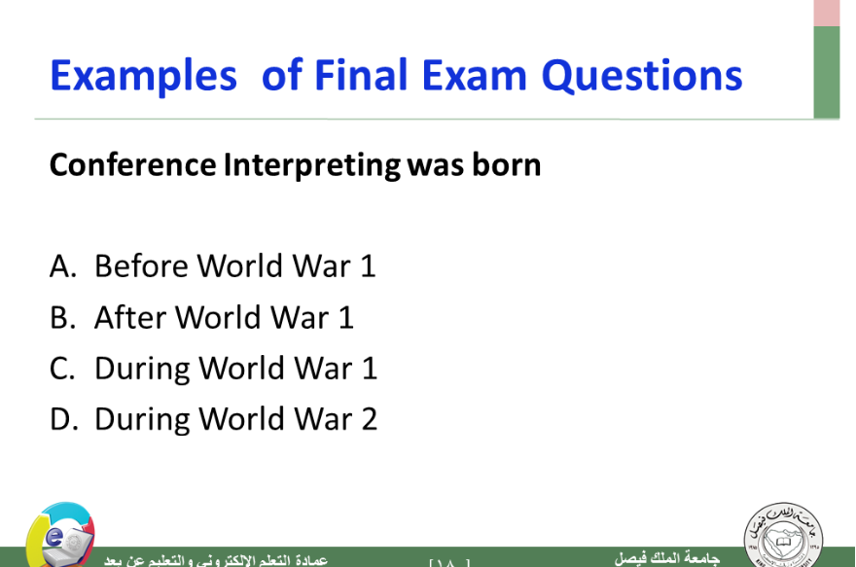

-

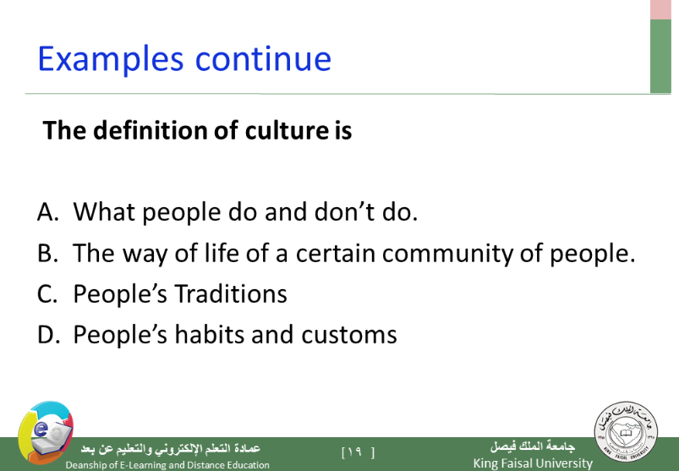
-
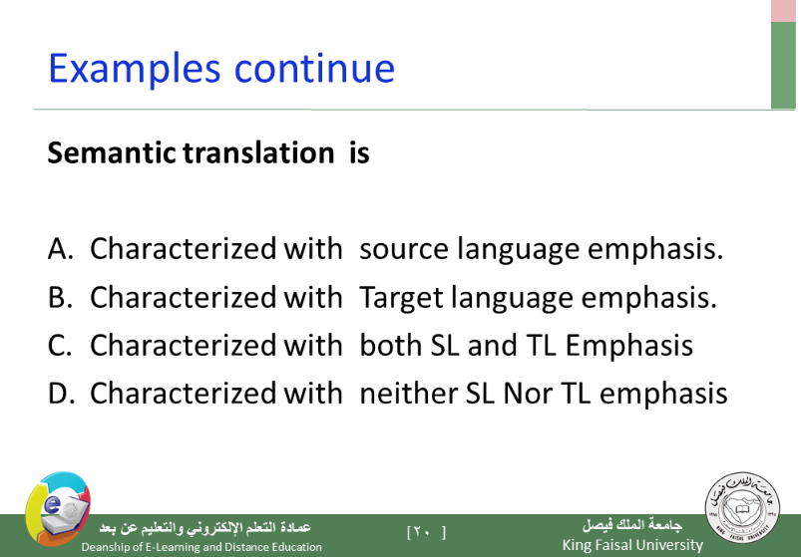

By ; DodE ~

