Be a Better Leader, Have a Richer Life

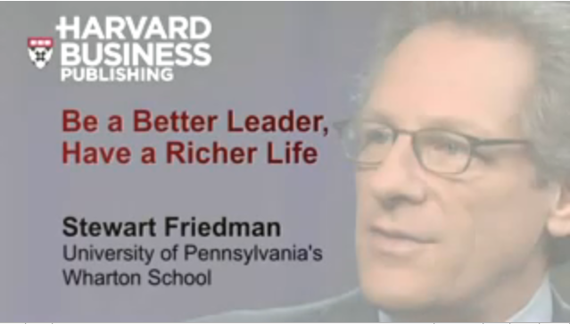

http://www.youtube.com/watch?v=doHNHxD0_DU

To become a successful leader you must focus on 4 areas of this life which are (work- home “family”- community “society”- self “privet self”). The reasons these let us care on home, community and self are:
- Other parts of your life affect your work and affect your performance at work. He found that “the more you can bring the whole person in, the more energy, productivity and focus on work”.
- Understanding the needs and interest (the performance expirations of the keys stakeholders the most important people in tour life).
- Be innovative.
Work life balance becomes a very present issue in mane sector in the society. Balance is wrong concept because it implies that give up part of your life to succeed in the other part. He encourages people to see the possibility of 4 ways wins requires that you use leadership to better integrate the different parts of your life.

Being real by understanding what really matter to you by looking at your values, your futures and what is the most important thing of your life today in terms of work, home, community and self.

Teamwork and Collaboration


http://www.youtube.com/watch?v=9WX7BNnYTf8

First, he defined the problem of the Cisco company which is the company moving too slowly. This problem let them reconsider their management style and they decide to do the biggest change in the management style of the company. They started applying “collaboration and teamwork” style which helped them to innovate more quickly. As result of the “collaboration and teamwork” style they changed every functional group in Cisco to use the capability of the internet. So, everything will be served online. According to this change, 85% of their customers when they had an issue the internet will solve the form without people. That will increase their productivity 3 times more.

Fluevog's Open-Source Footwear



http://www.youtube.com/user/HarvardBusiness#p/u/25/BhCD4eZzfjY

From this speech I noticed some recommendations. First, let the customers share their ideas and their creativity with your company. Then, Gather the ideas. After that, look for the best and most repeated ideas. Afterward, rotate these best ideas to products. Finally, have a big profit and satisfied customers.

