
المملكة العربية السعودية
وزارة التعليم العالي
جامعة الدمام
كلية التربية بالجبيل

Data structure

Group.7

ندى محمد القحطاني

زينب حبيب المرهون

زهراء ابراهيم امحيميد

غدير ابو علوى

خلود بشير العتيبي

Date:9\6\1433

D.Eman Ahmed Abdel Ghaffar.

Task 1:
Code for Program of traversing a binary tree in inorder iteratively in C++ Programming ...

Task 2:
- Fibonacci numbers
The mathematical definition of the Fibonacci number is:
fib(0) = 1
fib(1) = 2
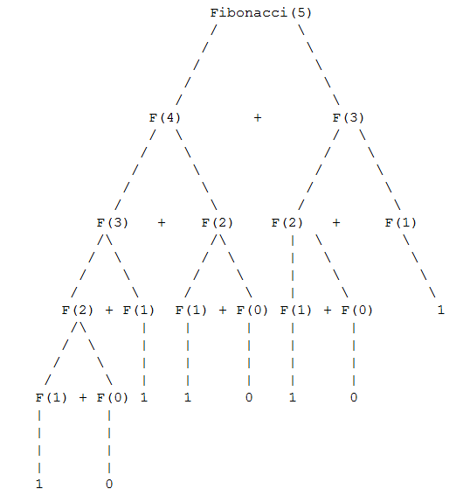
fib(n) = fib(n-1) + fib(n-2)

Reference:

1- http://pages.cs.wisc.edu/~calvin/cs110/RECURSION.html

2- http://www.syntax-example.com/Code/traversing-binary-tree-inorder-979.aspx

program:
# include <iostream.h>
# include <conio.h>
int Recursive(int n) {
cout << n << endl;
if (n == 0) return 1;
if (n == 1) return 2;
return (Recursive(n - 1) * Recursive(n - 2));
}

int no,key,level=0,flag=1;
struct bstree
{
int no;
struct bstree *left;
struct bstree *right;
}*list,*head;

class bst
{
struct bstree *list;
public:
struct bstree *root;
bst()
{
list=NULL;
root=NULL;
}
void create_bstree(struct bstree *list);
void display_bstree(struct bstree *list);
void search_bstree(struct bstree *list);
};

void bst :: search_bstree(struct bstree *list)
{
if(list!=NULL)
{

if(key == list->no)
{
cout<<"Key Found at Level :" <<level;
flag=0;
return;
}

if(key < list->no)
{
level++;
search_bstree(list->left);
}

if(key > list->no)
{
level++;
search_bstree(list->right);
}
}
else
{
return;
}
}

void bst :: display_bstree(struct bstree *list)
{

if(list->left!=NULL)
{
display_bstree(list->left);
}

cout<<list->no<<"\t";

if(list->right!=NULL)
{
display_bstree(list->right);
}
return;
}

void bst :: create_bstree(struct bstree *list)
{
if(root==NULL)
{
cout<<endl<<"Enter -1 to Stop ..."<<endl;
cout<<"Enter Number :";
cin>>no;
if(no==-1)
{
return;
}
else
{
list=new bstree;
list->left=NULL;
list->right=NULL;
root=list;
list->no=no;
}
}
else
{
if(no==-1)
{
return;
}
if(no < list->no)
{
if(list->left!=NULL)
{
create_bstree(list->left);

}
else
{
list->left=new bstree;
list=list->left;
list->left=NULL;
list->right=NULL;
list->no=no;
}
if(no==-1)
return;

}

if(no>list->no)
{
if(list->right!=NULL)
{
create_bstree(list->right);
}
else
{
list->right=new bstree;
list=list->right;
list->left=NULL;
list->right=NULL;
list->no=no;
}
if(no==-1)
return;
}
}
cout<<endl<<"Enter -1 to Stop ..."<<endl;
cout<<"Enter Number :";
cin>>no;
if(no==-1)
{
return;
}
else
{
create_bstree(root);
}
}
void main()
{
clrscr();
bst bst1;
bst1.create_bstree(bst1.root);
cout<<endl;
cout<<"Inorder"<<endl;
bst1.display_bstree(bst1.root);
cout<<endl<<"Enter Number to search :";
cin>>key;
bst1.search_bstree(bst1.root);
if(flag==1)
{
cout<<endl<<"Search key not Found in the tree"<<endl;
}
int num;
cout<<endl<<"Enter Number to fibonacci :";
cin >> num;

cout << "Result: " << Recursive(num) << endl;
getch();
}

Out-Put

