Lecture 10

Sorting algorithms
In computer science, a sorting algorithm is an algorithm that puts elements of a list in a certain order. Efficient sorting is important for optimizing the use of other algorithms (such as search and merge algorithms) that require sorted lists to work correctly.There are various sorting algorithm, for example, one of the earliest was the bubble sort it was analyzed as early as 1956 , and one of the latest is the library sort was published in 2004.

Bubble sort
Bubble sort, is a simple sorting algorithm that works by repeatedly stepping through the list to be sorted, comparing each pair of adjacent items and swapping them if they are in the wrong order. The pass through the list is repeated until no swaps are needed, which indicates that the list is sorted. The algorithm gets its name from the way smaller elements "bubble" to the top of the list. Bubble sort is not efficient for sorting large lists.

Algorithm
- Compare each pair of adjacent elements from the beginning of an array and, if they are in reversed order, swap them.
- If at least one swap has been done, repeat step 1.

Example 1:
Let us take the array of numbers "5 1 4 2 8", and sort the array from lowest number to greatest number using bubble sort algorithm. In each step, elements written in bold are being compared. Three passes will be required.
First Pass:
( 5 1 4 2 8 ) ( 1 5 4 2 8 ), Swap since 5 >1
( 1 5 4 2 8 ) ( 1 4 5 2 8 ), Swap since 5 > 4
( 1 4 5 2 8 ) ( 1 4 2 5 8 ), Swap since 5 > 2
( 1 4 2 5 8 ) ( 1 4 2 5 8 ), Now, since (8 > 5), no swap
Second Pass:
( 1 4 2 5 8 ) ( 1 4 2 5 8 )
( 1 4 2 5 8 ) ( 1 2 4 5 8 ), Swap since 4 > 2
( 1 2 4 5 8 ) ( 1 2 4 5 8 )
( 1 2 4 5 8 ) ( 1 2 4 5 8 )
Now, the array is already sorted, but our algorithm does not know if it is completed. The algorithm needs one whole pass without any swap to know it is sorted.
Third Pass:
( 1 2 4 5 8 ) ( 1 2 4 5 8 )
( 1 2 4 5 8 ) ( 1 2 4 5 8 )
( 1 2 4 5 8 ) ( 1 2 4 5 8 )
( 1 2 4 5 8 ) ( 1 2 4 5 8 )

Example 2: Sort {5, 1, 12, -5, 16} using bubble sort.
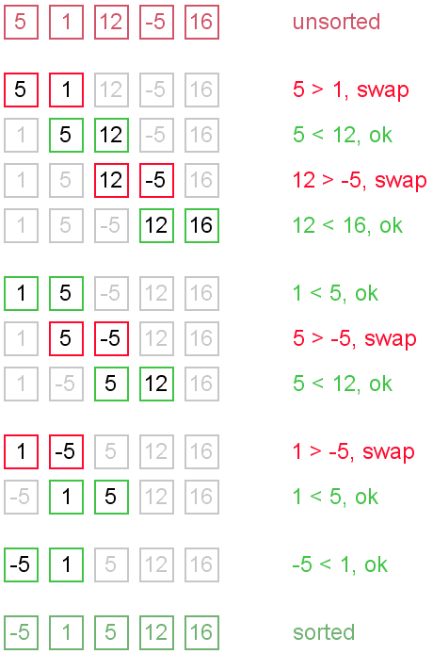

Complexity analysis
In the best case scenario where the list is already sorted, nothing is swapped and the running time is simply (n). In the worst case however the list could be sorted backwards, which means that the algorithm would have to perform n swaps per iteration for n iterations. This equals a complexity of n².
There is a chance of improvement. After each iteration, the largest element will always be the n^{th} element. Therefore this element can be ignored at the next pass. This will shrink the list by one after each pass and quicken the algorithm.

Implementation
for(int x=0; x<n; x++)

{

for(int y=0; y<n-1; y++)

{

if(array[y]>array[y+1])

{

int temp = array[y+1];

array[y+1] = array[y];

array[y] = temp;

}

}

}

Quick sort
From power point presentation

Heap Sort
Heaps are based on the notion of a complete tree.
A binary tree is completely full if it is of height, h, and has max 2^{h+1}-1 nodes.
Heap: a full binary tree, where the values in each node is greater than or equal to the value of both of its children. The largest value in such a tree must be in the root.
66
64 54
17 37 35 46
2 16 12 22 19
Note:
- There is no ordering between left and right nodes.
- A node may have zero, one or two children.
- If there is only one children it must be to the left. Why??
The reason is that we may store the binary tree in an array so we don’t want to waste any space
66 64 54 17 37 35 46 2 16 12 22 19
- The children of node I is found at locations 2I and 2I+1.
- Building a heap
Construct the Heap from the following tree elements
19 2 46 16 12 54 64 22 17 66 37 35
- Place first element 19 as the root
- Add 2 to right
19
2 is this a heap? Yes

- Add 46
19
2 46 is this a heap? No
Restore the heap;
46
2 19

- Add 16
46
2 19 is this a heap? No
16

Restore the heap;
46
16 19
2
- Add 12
46
16 19 is this a heap? yes
2 12
- Add 54
46
16 19 is this a heap? no
2 12 54
Restore the heap (two steps);
46
16 54
2 12 19
54
16 46
2 12 19
- Add 64
54
16 46 is this a heap? no
2 12 19 64
Restore the heap (two steps);
54
16 64
2 12 19 46
64
16 54
2 12 19 46
- Add 22
64
16 54
2 12 19 46 is this a heap? no
22

Restore the heap (two steps);

64
16 54
22 12 19 46
2
64
22 54
16 12 19 46
2
- Add 17
64
22 54
16 12 19 46 is this a heap? no
2 17

Restore the heap;
64
22 54
17 12 19 46
2 16

- Add 66
64
22 54
17 12 19 46 is this a heap? no
2 16 66
Restore the heap (three steps);
64
22 54
17 66 19 46
2 16 12
64
66 54
17 22 19 46
2 16 12
66
64 54
17 22 19 46
2 16 12

- Add 37
66
64 54
17 22 19 46 is this a heap? no
2 16 12 37
Restore the heap;
66
64 54
17 37 19 46
2 16 12 22
Add 35
66
64 54
17 37 19 46 is this a heap? no
2 16 12 22 35
Restore the heap;
66
64 54
17 37 35 46
2 16 12 22 19
Which is the final heap.
2-Deleting the root from a heap
Let's start with this heap.  A deletion will remove the T  at the root. | 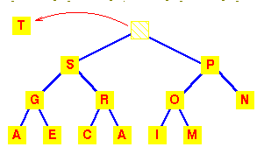

To work out how we're going to maintain the heap property, use the fact that a complete tree is filled from the left. So that the position which must become empty is the one occupied by the M.  Put it in the vacant root position. | 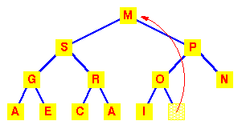

This has violated the condition that the root must be greater than each of its children.  So interchange the M with the larger of its children. | 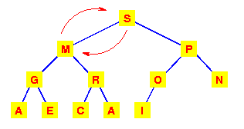

The left subtree has now lost the heap property.  So again interchange the M with the larger of its children. | 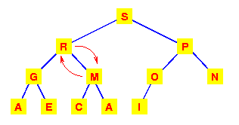
This tree is now a heap again, so we're finished.
We need to make at most h interchanges of a root of a subtree with one of its children to fully restore the heap property.

3-Adding an element to a heap
To add an item to a heap, we follow the reverse procedure.  Place it in the next leaf position and move it up. | 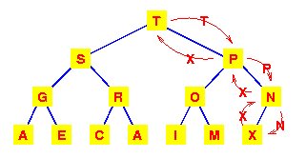

Storage of complete trees in an array:
The properties of a complete tree lead to a very efficient storage mechanism using n sequential locations in an array.
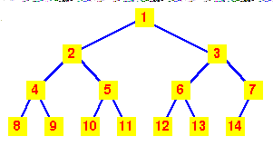 | If we number the nodes from 1 at the root and place:  - the left child of node k at position 2k  - the right child of node k at position 2k+1  Then the 'fill from the left' nature of the complete tree ensures that the heap can be stored in consecutive locations in an array.

Viewed as an array, we can see that the nth node is always in index position n. | 