الدوال والاجراءات
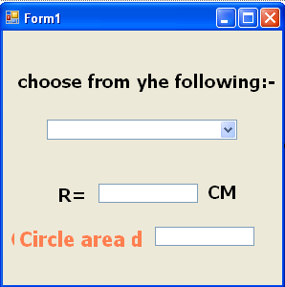
Public Class Form1
Dim r, a As Single
Private Function area() As Single
r = TextBox1.Text
area = 3.14 * r ^ 2
Label5.Visible = True
TextBox2.Visible = True

End Function
Private Function around(ByVal r As Single) As Single
Dim x As Single
' r = TextBox1.Text
x = 3.14 * 2 * r
Return x

End Function
Private Sub go()
Dim form2 As New Form2
Me.Hide()
form2.Show()

End Sub

Private Sub finish()
Dim result3 As DialogResult
result3 = MessageBox.Show("are you sure that you want to exit?", _
"The Question", _
MessageBoxButtons.YesNoCancel, _
MessageBoxIcon.Question, _
MessageBoxDefaultButton.Button2)
If result3 = Windows.Forms.DialogResult.Yes Then End

End Sub

Private Sub ComboBox1_SelectedIndexChanged(ByVal sender As System.Object, ByVal e As System.EventArgs) Handles ComboBox1.SelectedIndexChanged
If ComboBox1.SelectedIndex = 1 Then
TextBox2.Text = area()
End If

If ComboBox1.SelectedIndex = 2 Then
Dim m As Single
r = TextBox1.Text
m = around(r)
Label4.Visible = True
TextBox2.Visible = True
TextBox2.Text = m
End If

If ComboBox1.SelectedIndex = 3 Then
Call go()
End If

If ComboBox1.SelectedIndex = 4 Then
finish()
End If
End Sub

Private Sub Form1_Load(ByVal sender As System.Object, ByVal e As System.EventArgs) Handles MyBase.Load

End Sub
End Class

