المحاضرة الحادية عشر
Liberty and Justice for All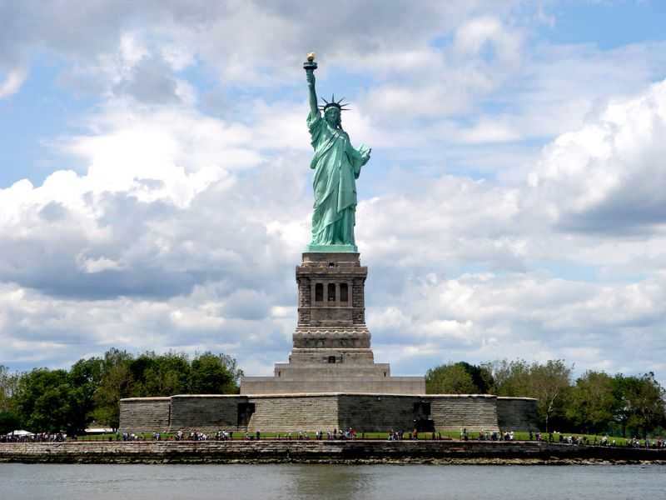
Give me your tired, your poor, Your huddled masses, yearning to breathe free, The wretched refuse of your teeming shore, Send these, the homeless, tempest tossed, I lift my lamp beside the golden door.
John Locke – “The liberty of man in society is to be under no other legislative power but that
Established by consent in the commonwealth; nor under the dominion of any will or
restraint of any law, but what that legislative power shall enact according to the trust put in it.”
Jean Jacques Rousseau – “I prefer liberty with danger to peace with slavery.” "No one has
The right to kill and enemy except when he cannot make him a slave, and the right to enslave
him cannot therefore be derived from the right to kill him"
Patrick Henry – “Give me liberty, or give me death.” (at the second Virginia Convention,
on March 23, 1775)
The Declaration of Independence - We hold these truths to be self-evident, that all men are
created equal, that they are endowed by their Creator with certain unalienable Rights, that
among these are Life, Liberty and the pursuit of Happiness.
Slavery, Abolition, and Emancipation

“The case of the oppressed blacks commands our attention to move in endeavors for
their relief as opportunities are favorable…” - James Pemberton (1723-1808)
“That some desperate wretches should be willing to steal and enslave men by violence
and murder for gain is rather lamentable than strange. But that many civilized, nay,
Christianized people should approve, and be concerned in the savage practice, is surprising.”
-Thomas Paine
Slavery had existed in America from the discovery and exploration period, and America’s
economy had become dependent upon it. It is important to note that slavery existed throughout
the colonies, without restraint, prior to the Revolution. In the north, the antislavery movement
began to gain momentum as early as 1773.
- In 1774 Reverend Hopkins and the Congregational Church accomplished their objective and abolished slavery in Rhode Island.
- In 1777, Pennsylvania passed its first law for the gradual emancipation and made appropriation for full emancipation by 1780. Both of these colonies dealt with slavery before the Revolutionary War had even been decided.
- After the conclusion of the war, during the 1780’s Connecticut outlawed slavery with New York abolishing it in 1799 and New Jersey in 1804.
- Though the U.S. Congress outlawed the African slave trade in 1808, the domestic trade flourished, and the slave population in the U.S. nearly tripled over the next 50 years. By 1860 it had reached nearly 4 million, with more than half living in the cotton-producing states of the South.
- The Abolitionist Movement
- From the 1830s until 1870, the abolitionist movement attempted to achieve immediate emancipation of all slaves and the ending of racial segregation and discrimination.
- Although abolitionist feelings had been strong during the American Revolution and in the Upper South during the 1820s, the abolitionist movement did not coalesce into a militant crusade until the 1830s.
- In early 1831, William Lloyd Garrison, in Boston, began publishing his famous newspaper, the Liberator.
- In December 1833, Garrison and sixty other delegates of both races and genders met in Philadelphia to found the American Anti-Slavery Society.
- Free States and Slave States
- In 1820, Missouri's application for statehood ended in a compromise: Missouri was admitted to the Union as a slave state, Maine as a free state and all western territories north of Missouri's southern border were to be free soil.
- In 1850, The Kansas-Nebraska Act opened all new territories to slavery by asserting the rule of popular sovereignty over congressional edict, leading pro- and anti-slavery forces to battle it out (with much bloodshed) in the new state of Kansas
- In 1857, the Supreme Court's ruling in the Dred Scott case effectively repealed the Missouri Compromise by ruling that all territories were open to slavery. The abolitionist John Brown's raid at Harper's Ferry, Virginia, in 1859 aroused sectional tensions even further: Executed for his crimes, Brown was hailed as a martyred hero by northern abolitionists and a vile murderer in the South.
- Dred Scott Case
- In March 1857, in one of the most controversial events preceding the American Civil War (1861-65), the U.S. Supreme Court issued its decision in the case of Dred Scott v. Sanford.
- The case had been brought before the court by Dred Scott, a slave who had lived with his owner in a free state before returning to the slave state of Missouri. Scott argued that his time spent in these locations entitled him to emancipation.
- In his decision, Chief Justice Roger B. Taney, a staunch supporter of slavery, disagreed: The court found that no black, free or slave, could claim U.S. citizenship, and therefore blacks were unable to petition the court for their freedom.
- The Dred Scott decision incensed abolitionists and heightened North-South tensions, which would erupt in war just three years later
Civil War
In the spring of 1861, decades of simmering tensions between the northern and southern United States over issues including states' rights versus federal authority, westward expansion and slavery exploded into the American Civil War (1861-65).
The election of the anti-slavery Republican Abraham Lincoln as president in 1860 caused seven southern states to secede from the Union to form the Confederate States of America; four more joined them after the first shots of the Civil War were fired.
The War Between the States, as the Civil War was also known, pitted neighbor against neighbor and in some cases, brother against brother. By the time it ended in Confederate surrender in 1865, the Civil War proved to be the costliest war ever fought on American soil, with some 620,000 of 2.4 million soldiers killed, millions more injured and the population and territory of the South devastated.
The Emancipation Proclamation
During the Civil War US President Abraham Lincoln issued the Emancipation Proclamation.
Whereas, on the twenty-second day of September, in the year of our Lord one thousand eight hundred and sixty-two, a proclamation was issued by the President of the United States, containing, among other things, the following, to wit:
"That on the first day of January, in the year of our Lord one thousand eight hundred and sixty-three, all persons held as slaves within any State or designated part of a State, the people whereof shall then be in rebellion against the United States, shall be then, thenceforward, and forever free; and the Executive Government of the United States, including the military and naval authority thereof, will recognize and maintain the freedom of such persons, and will do no act or acts to repress such persons, or any of them, in any efforts they may make for their actual freedom.”
The Thirteenth Amendment
The Emancipation Proclamation, although it’s wording freed the slaves, was a
Wartime proclamation and Lincoln feared it would have no standing after the end of
The war.
Therefore, on December 18, 1865, congress ratified the 13th Amendment to the
Constitution, which ensured that forever after “neither slavery nor involuntary servitude
... Shall exist within the United States.”

