Sem 311 SCI 051 Chemistry WEEKS 2,3,4 Hand-out

Sec. 12.5 Physical and Conceptual Models
Models – help us imagine invisible things like atoms

Two Types of Models
Physical model – is used to picture a very small or a very large object that can only be
seen with microscopes and telescopes
Conceptual model – a model that helps to explain the connections among the parts of
a system
Example: atomic models

Atomic models - conceptual models that describe and explain the behavior of the
invisible atom

Sec. 12.6 Identifying Atoms Using the Spectroscope
Atomic spectrum – the pattern of frequencies formed by a given element when the light
from the element’s glowing atoms is viewed through a spectroscope
- can be used to identify an element
Spectroscope – an instrument used to see the color components of any light source

Sec. 12.7 The Quantum Hypothesis
Max Planck – Light energy is quantized or consists of some number of fundamental units
- Light energy is contained in discrete packets called quanta
(singular: quantum – a small, discrete packet of light energy)
- Each quantum of light is called a photon
- Distinct frequencies of light appears in an atomic spectrum when the atom
absorbs and then emits a photon of light

The Bohr Model of the Atom
- the "planetary model" of the atom.
- in the model, the neutrons and protons occupy a dense central region called the
nucleus, and the electrons orbit the nucleus much like planets orbiting the Sun.
A. An electron moves around the nucleus  at fixed distances or at permitted energy  levels.  B. Each energy level is assigned a principal  quantum number, n, where n is always  some integer .  C. n =1 for the lowest energy level and an  electron in an n =1 level is closest to the  nucleus  D. As n increases, the farther is the electron  from the nucleus | 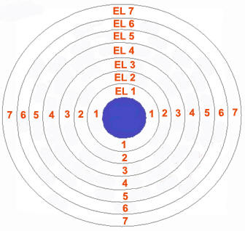
Sec. 12. 8 Electron Waves
> the fast moving electrons of an atom have wave properties
> the wave nature of electrons suggests that each electron orbit is like a self-
reinforcing wave and will not allow the electron to spiral closer and closer to the
positive nucleus

Sec. 12.9 The Shell Model
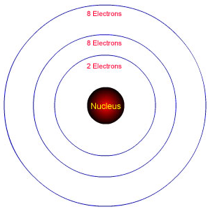 | A. The positively charged nucleus is encircled  by clouds of negatively charged electrons  arranged in a series of concentric shells  B. Shell - a region in space around the nucleus  in which electrons of similar energy levels  in an atom have a 90% chance of being found  C. Each e shell can only hold a fixed number of  electrons
 | Value of n  # of electrons | 1  2 | 2  8 | 3  8 | 4  18 | 5  18 | 6  32 | 7  32

The Shell Model and the Periodic Table
Seven shells in the atom ⇒ seven periods of the periodic table  The # of electrons in the shell ⇒ the # of elements in each period | Valence Electrons  Electrons in the outermost occupied shell  Electrons that take part in chemical bonding  The valence electrons of elements that belong to the  same group are similarly organized
 | 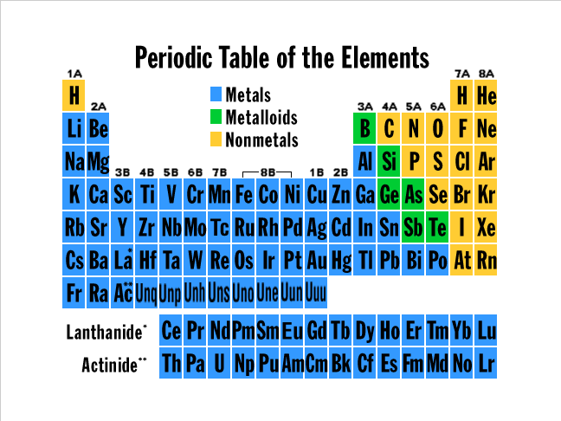
  Value of n | # of electrons
  1 | 2
  2 | 8
  3 | 8
  4 | 18
  5 | 18
  6 | 32
  7 | 32

CHAPTER 14. ELEMENTS OF CHEMISTRY

Sec. 14.1 Chemistry: The Central Science
Research – an activity
- systematic discovery of new knowledge
- interpretation of new knowledge

Two types of research
Basic research – activity that leads to a greater understanding of the natural world
Applied research – activity that develops applications of the results of basic research
Examples:
Research on the chemistry of dyes or coloring materials – basic or applied?
Research on cosmetics or make-up – basic or applied?

Sec. 14.2 The Submicroscopic World
Different Levels of Magnification of Matter
1. Macroscopic – when matter is large enough; it can be seen, it can be measured, it can be handled
2. Microscopic – when matter can only be seen using a microscope
3. Submicroscopic – when matter cannot be seen even with a microscope

Examples of submicroscopic matter: atoms and molecules

Atoms – the particles that make up an element
Molecules – the particles that form when 2 or more different atoms link together
- the particles that make up a compound
Example:
Two hydrogen atoms and one oxygen atom link together to form a
molecule of water: 2 H atoms + 1 O atom = H₂O molecule

Three Phases or States of Matter
1. Solid
- definite shape and definite volume
- the attraction between the atoms or molecules is very strong
2. Liquid
- definite volume but no definite shape
- the attraction between the atoms or molecules is weak; the particles can move
fast and the liquid can flow
3. Gas
- no definite shape and no definite volume
- no attraction between the atoms or molecules

Sec. 14.3 Physical and Chemical Properties
1. Physical Properties
- properties that describe the look or feel of a substance
Examples: color, hardness, density, texture (rough or smooth?),
state or phase (solid or liquid or gas?)
Some physical properties of gold: solid, yellow color, density = 19.3 g/ml
2. Chemical Properties
- properties that allow a substance to change into another substance
- how something reacts or changes into another substance
Example: iron can change into rust in the presence of oxygen and water
iron + oxygen → rust

Types of Changes that Matter Goes Through
1. Physical change – a change in phase or any physical property
- no new substance is formed; no change in the composition of matter
Examples: breaking or tearing a piece of paper; mixing sand and water;
Ice changing into water or H₂O(s) → H₂O(l)
2. Chemical change – any change in a substance that results to a rearrangement of the
way atoms are chemically bonded
- a change in the composition of the substance
- new substance or substances are formed
- also known as chemical reaction; represented by a chemical equation
Examples: Rusting of iron: iron + oxygen → rust
Chemical equation: 4 Fe + 3 O₂ → 2 Fe₂O₃
iron oxygen iron(III) oxide
Combustion of methane: methane + oxygen → carbon dioxide + water
Chemical equation: CH₄(g) + 2 O₂(g) → CO₂(g) + 2 H₂O(l)

What is a chemical bond?
A chemical bond is the force of attraction between two atoms that holds them together
The electrical force that holds atoms together

Sec. 14. 4 Determining Physical and Chemical Changes
1. In a physical change, a change in appearance is due to a change in conditions.
When the original condition is put back, the original appearance returns.
Example: When the temperature is above zero: Ice → Water
When the temperature is below zero: Water → Ice
2. In a chemical change, a change in appearance is due to the formation of a new material.
The new material has its own set of distinct properties.
Example: Sodium and chlorine react to form sodium chloride
Chemical equation: 2 Na + Cl₂ → 2 NaCl
The distinct properties suggest a chemical change:
Sodium Chlorine Sodium chloride
• shiny metal • green gas • white solid
• soft, can be cut • poisonous • not poisonous

Sec. 14.5 Elements to Compounds
Pure Substances
Elements Compounds
– the simplest type of pure substance  - is made up of only one kind of atom  Remember: Atomic symbols are used  for elements  Example: Au – gold  C – carbon  Cl - chlorine  Elemental formula – the fundamental  unit of an element that has  more than 1atom  Examples: O₂ and O₃, N₂ | – pure substances in which atoms of  different elements are bonded to one another  Molecule – the particle that is made up of  the group of atoms that make up a  compound  Chemical formula – a designation for a  compound or a molecule  Examples:  Compound Chemical Formula  Sucrose C₁₂H₂₂O₁₁  Sodium chloride NaCl
Chemical formula
- a designation for a compound or a molecule
• the symbols for the elements that make up the compound are written together
• numerical subscripts indicate the ratio in which the atoms combine
Examples: The chemical formula of sugar or sucrose is C₁₂H₂₂O₁₁
The atoms combine in the ratio 12 C atoms is to 22 H atoms is to 11 O atoms
NaCl 1 Na atom is to 1 Cl atom H₂O 2 H atoms is to 1 O atom

Sec. 14. 6 Naming Compounds
Guideline 1. The name of the element farther to the left in the PT is followed by the name of the
element farther to the right, with the ending –ide added to the name of the second
element.
NaCl sodium chloride CaF₂ calcium fluoride
Li₂O lithium oxide
Guideline 2. When two or more compounds have different numbers of the same elements,
prefixes are added to prevent confusion.
mono- one di- two tri- three tetra- four
CO - carbon monoxide CO₂ - carbon dioxide
Guideline 3. Some compounds have traditional or common names.
H₂O - water NH₃ - ammonia CH₄ - methane

PRACTICE EXERCISES:

1. Give the chemical names of the following compounds:
a. KF b. Ba₃N₂ c. NO d. N₂O
2. What is the chemical formula for the compound dihydrogen sulfide?

☺☺☺☺☺☺☺☺☺☺☺☺☺☺☺☺☺☺☺☺☺☺☺☺☺☺☺☺☺☺☺☺☺☺☺☺

Try the following assessment questions on Chap. 14

- Tell whether the change is physical or chemical change:

- You cut an apple into 4 so you can share it with your friends.

- The piece of ice that you put in your orange juice became smaller.

- The plant in your garden has become bigger.

- A piece of bread is burnt in the toaster.

2. How many kinds of atoms are there in one molecule of H3PO$?

3. How may atoms of each element are there in one molecule of H3PO4?

4. Draw the arrangement of particles in the solid, liquid and gaseous states.

5. If you study what happens when red and green colors are mixed, will that be a basic or applied
research? Explain.

Love all….
Trust a few……
Do harm to none.

