Lecture 5
Describe a favorite place(2)
Adverb
An adverb adds more to the meaning of a verb, an adjective or another ad verb.
I called you last night.
Verb
Adverb

You dress is very beautiful.
Adjective
Adverb

The rain stopped quite suddenly.
Adverb
Adverb

She's watching them carefully.
Verb
Adverb

I sometimes go shopping with my parents.
verb
Adverb

Types of adverbs
1) Adverb of time- this shows when an action or something is done or happens.
It answers the question "when?"
It is either placed at the beginning or the end of a sentence.
Examples:
I phoned you yesterday.
I saw her walking along the river last week.
2) Adverb of place-this shows where an action or something done or happens.

It answers the question "where?"
It is placed after the verb.
Examples:
I live here.
He fell down.
3) Adverb of manner- this shows an action or something is done.
It answers the question "how?"
It's usually placed just after the verb.
Examples:
She sleeps soundly.
He drives quickly.
4) Adverb of quantity- this answers the questions "to what degree?" or "how much?"
It is usually placed before the adjective and the adverb.
Examples:
It is too dark for us to see anything.
Last night it rained very heavily.
5) Adverb of frequency- this answers the question "how often?"
Examples:
He will never finish in time.
We always go to school by bus.

Exercise C page 70
1. it's not sunny. It's really sunny.
2. People in the park are walking slowly.
People in the park are walking quickly.
3. A man is painting very carelessly.
A man is painting very carefully.
4. An old man and a tall woman are talking and laughing quietly.
An old man and a tall woman are talking and laughing loudly.
5. A brother and sister are playing sadly in the park.
A brother and sister are playing happily in the park.

Practice
Find the adjective in the first sentence and fill the gap with adverb.
1. Joanne is happy. She smiles happily.
2. The boy is loud. He shouts loudly.
3. Her English is fluent. She speaks English fluently.
4. Our mom was angry. She spoke to us angrily.
5. My neighbor is a careless driver. He drives carelessly.
6. The painter is awful. He paints awfully.
7. Jim is a wonderful piano player. He plays the piano wonderfully.
8. This girl is very quite. She often sneaks out of the house quietly.
9. She is a good dancer. She dances really well.
10. The exercise is simple. You have to put one word in each space simply.

Organization :general to specific

When you write, you can start with general information and then give specific details.
In the reading on page 66 Francisco first describes the general setting (place and time) and he tells what he is doing. Then he adds specific details about the characters (people). Then he describes the action (what is happening).
1) General information:
A- setting: place and time.
B- What is he doing.

There are many interesting places in my neighborhood. One place is Oak Street Park. I am at Oak Street Park right now. It’s my favorite place. It’s 1:00 on Saturday afternoon. I am sitting on a bench and writing in my journal. Today is a beautiful day. It’s really sunny and hot. The sky is clear and bright. The air smells fresh and sweet.

2. specific information:
a- characters: (people)

The park is very crowded. Some people are young, and some people are old. Some people are tall, and some are short. Some people have long, straight hair. Some people have short, curly hair. One old man has no hair! He is sitting in front of the park gate. A tall woman is standing beside him. She has blonde hair and blue eyes. They are talking and laughing loudly.

b- action: (what is happening)
There are a lot of things happening around me. Many people are exercising. They’re walking quickly or riding their bikes. There is a food stand to the right of the entrance. A few people are eating lunch next to it. There is a handsome man to the left of the entrance. He is painting a picture very carefully. Across from me, a young girl is playing under a tree. Her brother is playing with her, too. They’re running and jumping happily. Their mother is sitting behind them. She is watching them quietly. Everyone is having fun.

Practice
Number the sentences in order from general to specific:
Group 1
----2----- I'm staying home and watching a movie.
----1----- It's cold, wet Saturday in Washington D.C.
----4----- They are singing and dancing.
----3----- There are many people in the movie.
Group 2
----4----- Some people are playing football.
Some are relaxing.
----2----- Carson beach is very popular. It has water sports, a picnic area, and food stands.
----1----- Carson City is very beautiful in the summer. It is a great place for a vacation.
----3----- The beach is always very crowded. Many people are at Carson beach right now.
Descriptive writing
Descriptive writing tells how something looks, tastes, smells, sounds, feels, or makes a person feel.
A detailed description makes the sitting, characters, and action seem reel.
Example:
I am at my favorite place, Brocato’s Café. It’s 4:00 in the afternoon. I’m sitting at a table and studying. Brocato’s is a nice café. There are many small, round tables. There are many Italian flags on the walls. Brocato’s is very crowded today.
:
Some people are old, and some people are young. Some people are eating quietly. Some people are talking loudly. There is a long, clean counter to the right of me. A tall, older woman is standing behind the counter. She has gray hair and blue eyes. A young boy is standing in front of the counter. He is smiling happily. He is giving the woman some money. The woman is giving him a large ice cream cone. I want some ice cream, too.
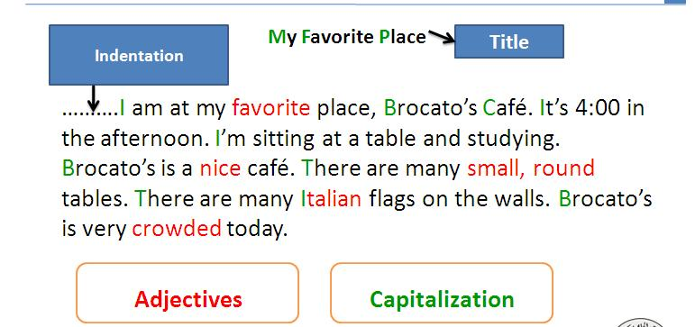

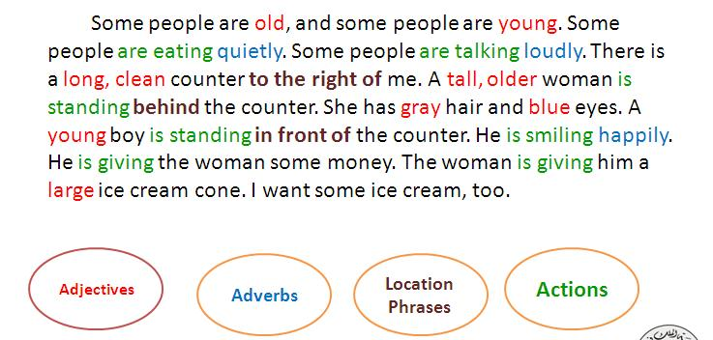

Imagine you are sitting at a café right now. Write a paragraph to describe the café.
Start with a general description about the place and time . say what you are doing.
Then describe the people.
Finally, describe what they are doing.
Use adjective, adverbs, location phrases.

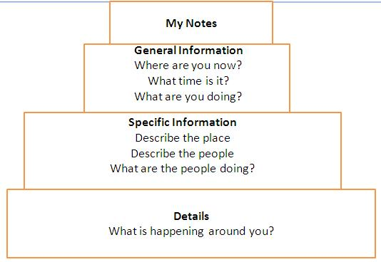
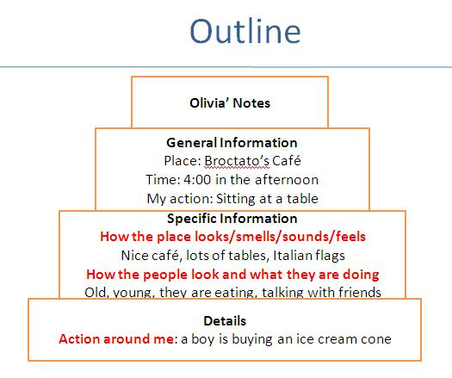

1. When you describe a favorite place, you start with:
- Specific Information
- Details (what’s happening around you)

Find the irrelevant sentence:
- (1)I am at my favorite place, Brocato’s Café. (2) It’s 4:00 in the afternoon. (3) I’m sitting at a table and studying. (4) Brocato’s is a nice café. (5) Some people are old, and some people are young. (6) There are many small, round tables. (7) There are many Italian flags on the walls. (8) Brocato’s is very crowded today.
- Sentence 2
- Sentence 4
- Sentence 5
- Sentence 8

