Lecture 1

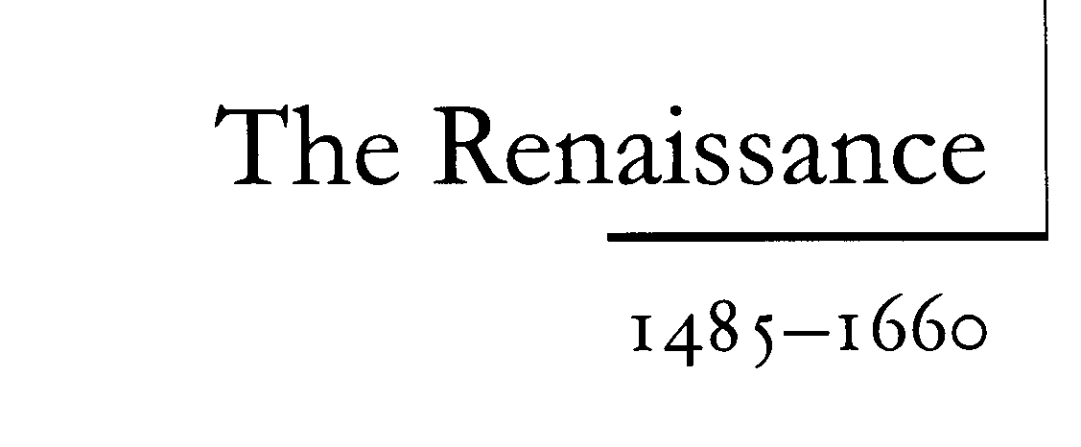

This course provides a concise introduction to the literature of Elizabethan and Stuart England (1558–1649). It is aimed chiefly at undergraduate students taking courses on sixteenth and seventeenth-century English literature, but will hopefully be useful, too, for taught postgraduates looking to refresh or consolidate their knowledge of the period’s literature, and lecturers preparing or teaching Renaissance courses.

The Renaissance (meaning ‘rebirth’) is defined as the period in European history that marked the end of the Middle Ages and the beginning of the modern world which came about under the influence of Greek and Roman models. In broad terms, it is usually seen as spanning the fourteenth, fifteenth and sixteenth centuries, although it did not reach Great Britain, for example, until the 1480s or so. It began in Italy in the late 14th cent., culminated in the High Renaissance in the early 16th cent, (the period of *Michelangelo and *Machiavelli), and spread to the rest of Europe in the 15th century, and afterwards.
The Renaissance saw an awakening in almost every sphere of human activity, architecture, Politics, the study of literature and especially science and philosophy and the arts. The period is best defined by the emergence of a general philosophy that emphasized the importance of the intellect, the individual and world affairs. Icontrasts strongly with the medieval worldview, characterized by the dominant concerns of faith, the social, collective and spiritual salvation.
And it describes the movement which saw renewed European interest in classical culture between the late fourteenth and mid-seventeenth centuries.
Prominent writers during the Renaissance include Niccolo Machiavelli and Baldassare Castiglione in Italy, Miguel de Cervantes and Lope de Vega in Spain, Jean Froissart and Francois Rabelais in France, Sir Thomas More and Sir Philip Sidney in England and Desiderius Erasmus in Holland.
Having initially sought to emulate the achievements of the Greek and Roman empires, Renaissance scholars and artists later sought to out-do their ancient predecessors, and therefore engaged in fresh intellectual and artistic exploration.

Humanism:
The emphasis of the period was humanist: that is, on regarding the human figure and reason without a necessary relating of it to the superhuman; but much of its energy also came from the *Neoplatonic tradition in writers such as *Pico della Mirandola. The word Renaissance has been applied in the 20th century, to earlier periods which manifested a new interest in and study of the classics, such as the 12th cent, and the period of Charlemagne. But the Italian Renaissance is still seen as a watershed in the development of civilization, both because of its extent and because of its emphasis on the human, whether independent of or in association with the divine. See J. A. Symonds, History of the Renaissance in Italy (1875-86); W. Pater, Studies in the History of the Renaissance (1873); J. Burckhardt, The Civilization of the Renaissance in Italy (English trans., S. G. C. Middlemore, 1929).

Renaissance English literature
The beginnings of what we now describe as ‘Renaissance’ or ‘Early Modern’ English literature precede the accession of Elizabeth I (1558), but Renaissance literary culture only became firmly established in England in the second half of the sixteenth century. Similarly, while the literature produced between 1649 and the Restoration of the Monarchy (1660) could be said to belong to the Renaissance, the unusual historical context in which it was produced marks the Interregnum as a distinctive literary era. This is why this book concentrates on the literature of the late sixteenth and early seventeenth centuries.
Following chapters focus on the major literary genres: drama, poetry and prose.
This century, like a golden age, has restored to light the liberal arts . . . achieving what had been honoured among the ancients, but almost forgotten since.
(Marsilio Ficino, 1482)

The Origins of the Renaissance:
The origins of the ‘Renaissance’ have been hotly debated but most scholars agree that it originated in late fourteenth-century Italy, where it was fostered by a new generation of humanist scholars. Its influence was gradually felt all across Europe, reaching England by the early sixteenth century.

The Term ' Renaissance':
The specific term ‘Renaissance’ (or rinascita) was first used by Italian art historian Giorgio Vasari in his Lives of the Most Eminent Painters(1550) to describe the achievements of recent artists; achievements he saw as marking a revival in the arts, after a period of long decay following the fall of the Roman Empire. Not until the nineteenth century was the term used more broadly to describe the period and culture of early modern Europe (1500–1700); and only in the twentieth century did the term come to be a standard label for the era.
Some modern scholars have questioned the use of the term ‘Renaissance’, arguing that it overstates the break with the past and downplays Medieval knowledge of classical learning. Such scholars often prefer to describe the period as ‘early modern’; but this label has its drawbacks, too, potentially overemphasising the similarities between Renaissance and modern culture. The more traditional term ‘Renaissance’ is favoured for the title of this guide, but appears alongside the phrase ‘early modern’ in the text. Although Elizabethan and Stuart writers did not refer to their era as the ‘Renaissance’ it was a concept they understood, and highlights the fact that it was an era of new advances in European knowledge, akin to those associated with the great classical civilisations.

Religion:
Christianity:
Religion was central to life in Renaissance England. Officially, everyone was Christian. In such a culture religion was not simply an ideology it was a way of life, and to write about any aspect of life was almost inevitably to touch on religion. The importance of Christianity in early Renaissance Europe was reinforced by the strength of the Catholic Church (led by the Pope). In 1500 all the major Western European states and their people belonged to it; but there had long been discontent within the Catholic community about perceived clerical corruption.

- The Protestant Reformation
In 1517 … Martin Luther (an ex-monk), nailed ninety-five theses to the door of the church in Wittenberg that questioned the authority and doctrines of the Catholic Church Luther and his fellow campaigners sought the reformation of the Church from within, but, faced with intransigence, criticism soon hardened into opposition and the reformers came to believe that the only way to re-establish God’s ‘true’ church was to break away and found their own ‘Protestant’ Church. This movement became known as the Protestant Reformation. At first Protestantism was a fringe religion but it grew in power as a number of Northern European states became Protestant.

- King Henry's Conflict
Henry VIII (1509–1547) declared himself ‘Supreme Head’ of the Church of England. Henry’s reasons for challenging the authority of the Pope and the Catholic Church were political and personal, rather than doctrinal. Little more than a decade earlier the Pope had awarded him the title of Defender of the Faith after he attacked Luther’s views (1521); but by 1527 Henry was considering divorcing his first wife, Catherine of Aragon, so that he might marry Anne Boleyn.
Given the reasons behind Henry’s conflict with Rome, it is perhaps not surprising that the English Church did not alter substantially during his reign.

- King James
James did not grant Catholics greater tolerance, as some Puritans had feared he might, and encouraged the preparation of a new English translation of the Bible (published in 1611 as the influential King James Authorised Bible).
Such would-be reformers came to be known as ‘Puritans’ because of their desire to further ‘purify’ the Church and their favouring of an ascetic religious culture.

Judaism & Islam
Western Europeans were generally Christian but recognised the existence of at least two other religions: Judaism and Islam. The followers of both faiths are conventionally stigmatised in the period’s literature. Jews are associated with avarice and usury, while Islamic figures are stereotyped as barbaric, untrustworthy, lustful pagans. Yet most English people would have had little knowledge of either religion. This was especially true of Islam.
- Muslims:
Although Christians were accustomed to regard Islam as a false faith, most had to rely on second-hand accounts for their knowledge of it because the only Europeans who had much contact with the Islamic East were traders and diplomats. Opposition to Islam and the countries associated with it was deep-rooted, finding its origins in the Medieval Crusades to recover the Holy Land from the Muslims, but Western antipathy was fuelled in the sixteenth century by the growing power of the Ottoman (or Turkish) Empire and its extension westwards with the Turks laying ‘claim to pivotal territory in the eastern Mediterranean and North Africa, including Cyprus in 1571 and Tunis in 1574’.3 Such was the perceived threat that the Spanish, the Venetians and the Pope formed a league to fight against the Turks, famously defeating them in the Battle of Lepanto (1571).
- JEWS:
The Jews had long been persecuted in Europe but were a more familiar religious minority than Muslims, living within (as well as beyond) Europe. Jews were expelled from England in 1290 but returned in small numbers during subsequent centuries. By the late sixteenth century there were small Jewish communities in London and Bristol, although those involved were obliged to conform outwardly to Protestantism, both because other religions were not tolerated and because of the strength of contemporary anti-Jewish feeling. Such antipathy had a long history: the association of the Jews with the death of Jesus and with money lending (which the Bible condemned) had long encouraged European Christians to look down on the Jews as an ungodly sect, while their status as an ‘alien’, homeless people made them a perennial object of suspicion. The curiosity and anxiety aroused by religious and cultural ‘aliens’ in the period is reflected in the ambivalent representation of Jews in late sixteenth-century plays such as Christopher Marlowe’s The Jew of Malta and Shakespeare’s The Merchant of Venice.

Magic:
In Renaissance Europe faith in Christianity co-existed with a widespread belief in magic. Even monarchs and religious leaders took magic seriously. Elizabeth I famously consulted contemporary magus John Dee for advice about the most auspicious date for her coronation, while her successor, James I participated in a series of witchcraft trials and published his own study of the subject, Demonology (1597). The extent of popular interest in magic is reflected in the proliferation of texts about magic in the late sixteenth and early seventeenth centuries. In England such literature included non-fiction books about witchcraft, accounts of witchcraft trials, and a large body of poems, plays and prose romances featuring magicians and witches. Such literature appears to have proved especially popular in the Jacobean period, when the accession of James I generated fresh interest in the subject. One of the best known examples of Jacobean ‘witchcraft’ literature, William Shakespeare’s Macbeth (performed c. 1606) (which features a chorus of witches who predict the future) is thought to have been written to cater for this fashion.
- Black & White Magic
Perceptions of what constituted magic varied. Some contemporaries distinguished between ‘black’ and ‘white’ magic, categorizing magic used to hurt or injure people, animals or property as ‘black’ and magic used to help or heal as ‘white’.
- Types of Magicians: Witches
Contemporaries likewise distinguished between different types of magician, such as witches, magi, and cunning men and women. Witches were generally understood to be people ‘who either by open or secret league, wittingly and willingly, consented to [give help] and assistance … in the working of wonders’;
- Magus
while a magus was believed to be a ‘great magician who by dint of deep learning, ascetic discipline, and patient skill could command the secret forces of the natural and supernatural world’ (like Shakespeare’s Prospero).
- Cunning’ man or woman
Far humbler was the figure of the ‘cunning’ man or woman, who was believed to possess knowledge that allowed him or her to heal animals and people.
Some contemporaries, including James I, condemned all kinds of magic as demonic, but anecdotal evidence suggests that others were not opposed to those who practiced ‘white’ magic; and the witchcraft laws, first introduced in the sixteenth century, focused on those who practiced ‘black’ magic’

