Lecture 1
Getting Meaning From Context
When you read, you don’t want to look up the meanings of all new words in a dictionary. You can often guess the meaning. Here are three ways that will help you to guess new words:
- Punctuation: ( ) (-) , ; :
There is a drawback, a disadvantage, to that idea.
(Drawback means disadvantage.)
e.g.
Full-color pictures are printed using only black and three colors: yellow, cyan (a light blue) and magenta (a light purple).
an unfamiliar word = cyan and magenta
signal punctuation = ( )
meaning : cyan = a light blue and magenta = a light purple

2. A clue in another Sentence: (surrounding words)
A school system in one country is not identical to the system in any other country. It cannot be exactly the same because each culture is different.
(in the second sentence, you see the meaning of identical – exactly the same)
3. Logic:
The educational system is a mirror that reflects the culture.
(you probably know the word mirror, so you can guess that reflects means shows.)
Guess The Meaning
1- In a number of countries, education is both compulsory-required-and universal, available to everyone, at least in primary school (elementary school).
Compulsory= __________
Universal=_______
Primary= ______
2. Public schools are all both free and egalitarian; all students are considered equal and learn the same the same material.
Egalitarian = ______________

Identifying the Main Idea

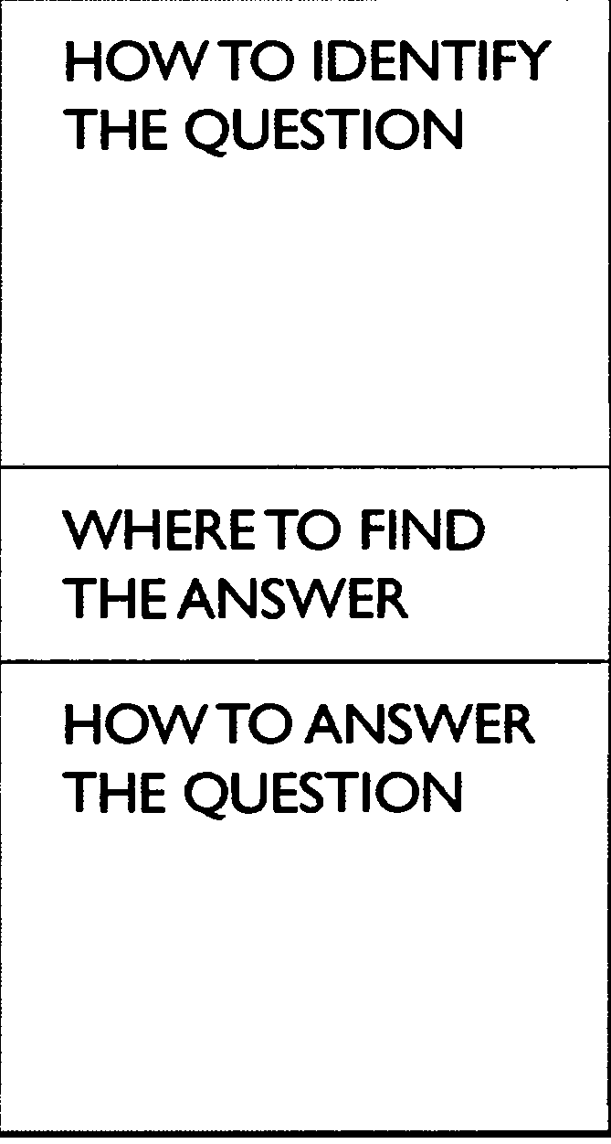
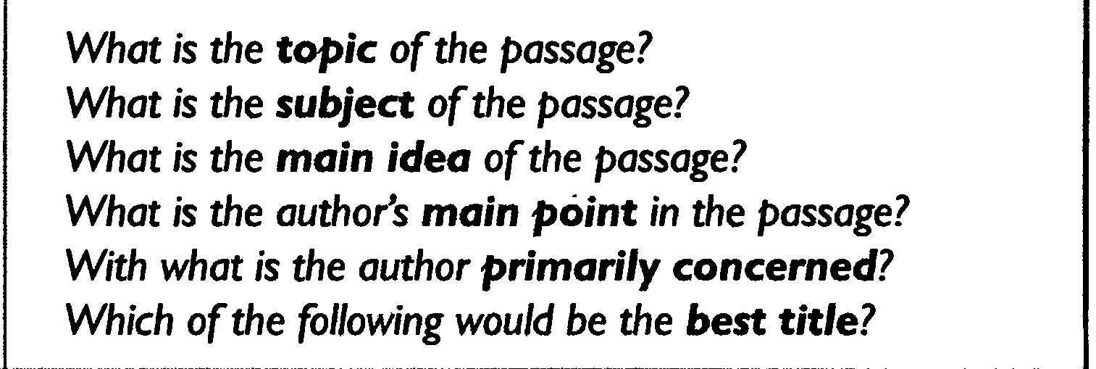
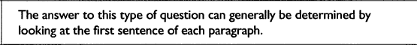
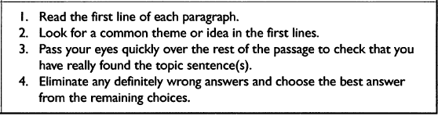

Here is a paragraph to consider. Look for the main idea of this paragraph:

The life of a doctor is not easy. Martin works a very long day, and he is very busy with a variety of activities. He spends a lot of time with people, but he also spends a lot of time working on reports in his office.

* What is the main idea of this paragraph?
If you said that the life of a doctor is not easy, you are correct.
The CNA’s in this office can’t always come to work on the same schedule each week. Sometimes they have to talk to each other and work out differences in the schedule. They usually can do this without any trouble. Ben, Victoria, and Alex work together very well.

* What is the main idea of the paragraph?
If you said that they can all work together well, you are correct.

Skimming for the topic & Main Idea
Hint: Remember that the topic is just a word or noun phrase – a few words. It is not a sentence.
- The main idea is in a sentence or two and can be found at the beginning, middle, or end of a paragraph.
- Each Paragraph has a main idea.

1Do you have a favorite season? 2Winter, fall, and spring have many advantages. 3However, summertime is my favorite season because it offers the tranquility of the beach as well as the exhilaration of outdoor sports. 4First, sitting on the other side of a sand dune, hidden by sea oats and sedge, I like looking at the Atlantic Ocean, scanning for dolphins and pelicans. 5Looking at something larger than I am gives me a sense of awe and gratitude and provides a backdrop for some deep musings.6Second, summertime provides me with the chance to go sailing, surfing, and hiking along the shore. 7The exercise enhances my sense of well being and creates a feeling of optimism.
The topic of the paragraph is
a. sailing and surfing.
b. summertime.
c. seasons at the beach.
d. ways to develop optimism.
The main idea of the paragraph is
a. sentence 1. b. sentence 2. c. sentence 3. d. sentence 4.
Understanding Pronoun Reference
Because a pronoun REFERS to a noun or TAKES THE PLACE OF that noun, you have to use the correct pronoun so that your reader clearly understands which noun your pronoun is referring to.
Therefore, pronouns should:
- Agree in number
If the pronoun takes the place of a singular noun, you have to use a singular pronoun.
If a student parks a car on campus, he or she has to buy a parking sticker.
(NOT: If a student parks a car on campus, they have to buy a parking sticker.)
HINT
Remember:
The words everybody, anybody, anyone, each,
neither, nobody, someone, a person, etc. are singular and take singular pronouns.
Examples:
Everybody ought to do his or her best. (NOT: their best)
Neither of the girls brought her umbrella. (NOT: their umbrellas)
2. Agree in person
If you are writing in the "first person" (I), don't confuse your reader by switching to the "second person" (you) or "third person" (he, she, they, it, etc.). Similarly, if you are using the "second person," don't switch to "first" or "third.“
When a person comes to class, he or she should have his or her homework ready.
(NOT: When a person comes to class, you should have your homework ready.)
Choosing the Correct Pronoun
Circle the pronoun that agrees in number with its antecedent in each sentence.
- Each of the girls makes (her, their) own clothes.
- The jury finally made (its, their) decision.
- It often seems that television programmers are not concerned with (its, their) viewers.
- Both Tim and Tony write (his, their) mothers twice a week from camp.
Vocabulary: Recognizing Word Meanings

- ____ determine
- ____afford
- ____reflect
- ____nontraditional
- ____drawback
- ____ statistic
- ____ discipline
- ____ aspect
- ____involves
- ____ tuition
- ____ entire
- ____ creative
- unusual
- disadvantage
- side, part, or characteristic
- developing new ideas
- fact in the form of a number
- control
- whole
- decide on
- have enough money for
- show
- fees (money) for school
- includes

Lecture 2
Getting Meaning From Context
Here are another three ways that will help you to guess new words:
- The words for example, for instance, such as, and among them:
Example: Almost four billion people will be living in cities in developing countries such as India and Nigeria.
Meaning: Developing Countries : not rich country
2. Sometimes another word or words in another sentence or sentence part has the opposite meaning from a new vocabulary item:
Example: In some cities, instead of worsening, urban life is getting much better.
Worsening = much better
3. A definition or explanation follows the connecting words that is or in other words:
Example: The downtown shopping area is now a pedestrian zone-in other words, an area for walkers only, no cars.
A pedestrian zone is an area for walkers only.
Let’s Do it Together
People spend hours in gridlock –that is, traffic so horrible that it simply doesn’t move – when thet commute.
Gridlock = _______
Under his leadership, city planners established priorities – in other words, a list of what was most important.
Priorities = __________________
Identifying Supporting Details
- Specific Details (facts, ideas, and examples) that support and develop the main idea.

- Let’s go and read the following passage to identify the main idea, the supporting details of each idea and the conclusion.
Identifying the Main idea & Supporting Details
Why I Want to Learn English(1) There are three reasons why I want to learn English. (2) One reason is that English has become an international language.(3) It is now used by most international companies, including the company where I work, for business communication. (4) Another reason why I want to learn English is so that I can travel to English-speaking countries. (5) The United States, England, Australia and many other countries all use English as their primary language. (6) Finally, I want to learn English because I plan to move to the U.S. in the future. (7) I will become a manager for my company soon. (8) For all these reasons, I am very excited about learning English.
Identify the topic sentence:
Identify the conclusion:
Identify the first main point:
Identify the second main point:
Identify the third main point:
Identify the support detail for the first main point:
Identify the support detail for the second main point:
Identify the support detail for the third main point:
Understanding Italics
It’s used :
- Emphasis
Example:
Overcrowding is a huge problem in that city.
2. A foreign word in an English sentence
Example:
In open areas in Seoul, Kaenari blooms everywhere in the spring.
Understanding Contrast
Sometimes writers use contrast to express an idea. In other words, they begin with the opposite of the point that they want to make.

You use contrast clauses when you want to make two statements, one of which contrasts with the other or makes it appear unexpected or surprising. Some contrast clauses – called concessive clauses – are introduced by conjunctions such as although, even though or while.

Let’s Go and see the following example →
Although Mrs. Sims had lived in Hong Kong all her life, she knew very little Cantonese.
Hint: Contrast
Don’t use but in sentences beginning with although, even though or while. Here is a mistake:
Although Kelvin worked hard, but he failed the examination.
You will sometimes see the word albeit used in formal English. Albeit can come before an adjective, adverb, or adverbial phrase.
Example:
Jayne participated in the charity walk, albeit rather reluctantly.
Scanning
Scanning is often confused with skimming, but is in fact a distinct reading strategy involving rapid but focused reading of text, in order to locate specific information, e.g. looking for particular details such as dates, names, or certain types of words. It is processing print at a high speed while looking for answers to specific questions. When you scan, you must begin with a specific question which has a specific answer. Scanning for information in this way should be both fast and accurate.

Let’s Do Scanning
Pulp Friction
Every second, 1 hectare of the world's rainforest is destroyed. That's equivalent to two football fields. An area the size of New York City is lost every day. In a year, that adds up to 31 million hectares -- more than the land area of Poland. This alarming rate of destruction has serious consequences for the environment; scientists estimate, for example, that 137 species of plant, insect or animal become extinct every day due to logging. In British Columbia, where, since 1990, thirteen rainforest valleys have been clearcut, 142 species of salmon have already become extinct, and the habitats of grizzly bears, wolves and many other creatures are threatened. Logging, however, provides jobs, profits, taxes for the government and cheap products of all kinds for consumers, so the government is reluctant to restrict or control it.
1.How many species of salmon have become extinct in BC?
a. 27
b. 31
c. 137
d. 142
Much of Canada's forestry production goes towards making pulp and paper. According to the Canadian Pulp and Paper Association, Canada supplies 34% of the world's wood pulp and 49% of its newsprint paper. If these paper products could be produced in some other way, Canadian forests could be preserved. Recently, a possible alternative way of producing paper has been suggested by agriculturalists and environmentalists: a plant called hemp.
2.How much of the world's newsprint paper is supplied by Canada?
a. 31 %
b. 49%
c. 34%
d. 19%
However, there is a problem: hemp is illegal in many countries of the world. This plant, so useful for fibre, rope, oil, fuel and textiles, is a species of cannabis, related to the plant from which marijuana is produced. In the late 1930s, a movement to ban the drug marijuana began to gather force, resulting in the eventual banning of the cultivation not only of the plant used to produce the drug, but also of the commercial fibre-producing hemp plant. Although both George Washington and Thomas Jefferson grew hemp in large quantities on their own land, any American growing the plant today would soon find himself in prison -- despite the fact that marijuana cannot be produced from the hemp plant, since it contains in the drug).
What drug can be obtained from a relative of hemp?
a. Cocaine b. heroin c. Amphetamine d. marijuana

Lecture 3
Campus Life is Changing. Chapter One
A
For many years in the United States, most undergraduate students (in their first four years of college) were 18 to 22 years old. They attended college full-time, lived in a dormitory on campus, and expected many “extras” from their colleges, not just classes. But things began to change in the 1970’s, and are very different now. Today, these “traditional” students are less than one-quarter (1/4) of all college students. These days the nontraditional students are the majority; they are different from traditional undergraduates in several ways. They are older. Many attend college part-time because they have families and jobs. Most live off campus, not in dormitories. These traditional students don’t want the extras that colleges usually offer. They aren’t interested in the sports, entertainment, religious groups, and museums that are part of most U.S. colleges. They want mainly good-quality classes, day or night, at a low cost. They also hope for easy parking, access to information technology, and polite service. Both time and money are important to them.
1. What is the Topic? __________________________________________________________
2. What is the Main Idea? ______________________________________________________
3. According to the passage, how today students are different from traditional students?
Non-traditional students are the minority.
Non-traditional students are not working these days.
Non-traditional students live on campus.
Non-traditional students are majority and part-timers
As you read, it’s important to begin noticing words that often go together. Go back to A paragraph. Find words to complete the following phrases and write them in the blanks. Most are prepositions.
Paragraph A
Lived ______________________ a dormitory ______________ campus.
Many ______________________ college part-time (verb)
Access _____________________ information technology

Look back at the reading selection “Campus Life is Changing” to find the meanings of the following pronouns. What does each pronoun refer to?
They (Paragraph A, line 2) ______________________________________
They (paragraph A, line 6) ____________________________________
Them (Paragraph A, line 12)
B
Psychological test reflect different learning styles in this new student population, too. Each person has a certain learning style, and about 60 percent of the new students these days prefer the sensing style. This means that they are very practical. They prefer a practice-to-theory method of learning, which is experience first and ideas after that. They often have difficulty with reading and writing and are unsure of themselves. Most of these students are attending college because they want to have a good job and make a lot of money.

What is the Topic?___________________________________________________
What is the Main Idea?________________________________________________
According to the passage, what do 60 percent of the new students prefer these days?
a. They prefer a practice – to- theory method of learning.
b. They prefer a theory-to-practice theory method of learning.

C
In contrast other students (but not as many) prefer the intuitive learning style. These students love ideas. They prefer a theory-to-practice method of learning and enjoy independent, creative thinking. These “intuitive” are not very practical. They are attending college because they want to create unique works of art or study philosophy or someday help in the field of science.
Topic:____________________________________________
Main Idea:________________________________________

There is a drawback for the students who prefer the sensing style of learning. A majority of college professors prefer the intuitive learning style. These teachers value independent thinking and creative ideas. Students in the sensing group are at a disadvantage because their way of thinking doesn’t match their teachers’.
Topic: ______________________________________________
Main idea:___________________________________________
Words in phrases : Paragraph D :
are ________ a disadvantage.
Understanding Pronoun References: Their (Paragraph D, line 4)_______________________

F
On all college campuses, student life is very different from what it used to be because of technology – specifically, the internet. At most colleges, all entering first-year students receive an email address. Dormitory rooms offer high-speed Internet access. Computer systems are available to everyone in computer labs, the library, and student centers. Application for classes and registration are usually now possible online. Most schools offer entire courses online. Many professors still have “office hours,” when students can come to talk with them about class work or ask for help. But increasingly, students can contact professors 24 hours a day, thanks to email. In many classes, students complete assignments and even take exams online. Perhaps most important for both students and professors, research is now easier and faster because of the new technology.
Topic:___________________________________
Main Idea:_______________________________________
Understanding pronoun references: Them (paragraph F, line 6)
Words in phrases: As you read, it’s important to begin noticing words that often go together. Go back to F paragraph. Find words to complete the following phrases and write them in the blanks. Most are prepositions.
Life is different because ______________________ technology
Are available ______________________________ everyone
Students _____________________________ exams (verb)

Section: B
Directions: Read the following paragraphs and choose the correct main idea for each paragraph

“There are several events that can change the Earth's surface very quickly. Volcanoes can erupt and spread lava, rock and ash for several miles. Earthquakes can leave large cracks in the Earth's surface.”
What is the main idea?
1. Several events can change the Earth's surface.
2. Earthquakes can cause large cracks.
3. Volcanoes can be dangerous.
4. Earthquakes
“Most of the world's volcanoes are part of the "The Ring of Fire." This is a ring of volcanoes that form a circle around the Pacific Ocean. Thousands of volcanoes make up "The Ring of Fire." These volcanoes formed the sea floor and many underwater mountains.’
What is the main idea?
1. There are thousands of volcanoes in the world.
2. Most volcanoes are part of the "Ring of Fire."
3. Some underwater mountains are volcanoes.
4. The Ring of Fire
1. On the one hand, there are many advantages to this system. On the other hand, there are also several drawbacks.
On the one hand =_______________from one point of view
On the other hand = _________________________________
2. In a number of countries, education is both compulsory – required- and universal, available to everyone, at least in primary school (elementary school)
Compulsory=_________________________________________
Universal= ___________________________________________
Primary school=_______________________________________
3. There are many more schools in cities than in rural areas.
Rural = ___________________________________
4. Public schools are all both free and egalitarian; all students are considered equal and learn the same material.
Egalitarian = ________________________________________
5. College students need great discipline; in order to make time for their studies, they need the self-control to give up hobbies, sports, and social life.
Discipline =_________________________________________
6. Results on these exams affect the entire family because there is high status, or social position, for a whole family in which children have high test scores.
Entire= ___________________________________________
Status=___________________________________________
7. Students themselves decide if they want college-preparatory or vocational classes in high school; no national exam determines this for them.
Determines = __________________________________________
Lecture 4
A City That’s Doing Something Right
There's good news and bad news about life in modern cities—first, the bad.
People who study population growth predict a nightmare by the year 2025: the
global population will be more than 8 billion, and almost 4 billion of these
people will be living in cities in developing countries such as India and Nigeria.
Population growth is already causing unbelievable overcrowding. Due to overcrowding,
these cities have problems with air pollution, disease, and crime. People spend
hours in gridlock—that is, traffic so horrible that it simply doesn't move—when
they commute daily from their homes to their work and back. There isn't enough
water, transportation, or housing. Many people don't have access to health
services or jobs. Now the good news: in some cities, instead of worsening
urban life is actually getting much better.
What does developing countries mean?
What does gridlock mean?
What does predict mean? To say in advance that something will happen
What does commute mean?
What does worsening mean?
Paragraph B : A City and It Mayor
It might not be a surprise to find that life in affluent cities is improving. But what about cities that aren't rich? The city of Curitiba, Brazil, proves that it's possible for even a city in a developing country to offer a good life to its residents. The mayor of Curitiba for twenty-five years, Jaime Lerner, was an architect and a very practical person. Under his leadership, the city planners established a list of priorities—in other words, a list of what was most important to work on. They decided to focus on the environment and on the quality of life. With an average income of only about $2000 per person per year, Curitiba has the same problems as many cities. However, it also has some creative solutions.
Identify The Main Idea :______________________________________________________________________
What does affluent mean?
What does priorities mean?
Paragraph C: Garbage Collection
[C] One creative solution is the method of garbage collection. In neighborhoods that garbage trucks can't reach, poor people bring bags of trash to special centers. At these centers, they exchange the trash for fresh produce—such as potatoes and oranges—or for bus tickets. At a recycling plant, workers separate bottles, plastic, and cans from other trash. Two-thirds of Curitiba's garbage is recycled, which is good for the environment. And the plant gives jobs to the poorest people, which improves their lives.
Tash →
Produce→
What does recycling plant mean?
Paragraph D. Transportation
D] Due to careful planning, Curitiba does not have the same traffic problems that most cities have. The statistics are surprising. The population has grown—now twice the size it was in 1974—but traffic has actually decreased 30 percent. Curitiba needed a mass-transit system but couldn't afford an expensive subway. City planners began, instead, with an unusual system of buses in the center lanes of five wide major streets..
What does a mass-transit mean?

Paragraph E: The Environment
To make the environment both cleaner and more beautiful, Curitiba has strict laws against polluters. But it also has low taxes for companies that have green areas, so several hundred major industries such as Pepsi and Volvo have offices in the city. Bringing natural beauty into the city is a priority. For this reason, Curitiba gave 1.5 million young trees to neighborhoods to plant and take care of. And the downtown shopping area is now a pedestrian zone—in other words, for walkers only, no cars—and is lined with gardens.
What does pedestrian zone means?
Paragraph F: A Symbol of the Possible
Clearly, overcrowding in big cities worldwide is the cause of serious problems. However, the example of Curitiba provides hope that careful planning and creative thinking can lead to solutions to many of them. Curitiba is truly, as Lewis Mumford once said of cities in general, a "symbol of the possible.
Find a sentence in the conclusion which seems to mean about the same main idea of the whole passage.
Paragraph A: Sick-Building Syndrome
Elizabeth Steinberg was a healthy sixteen-year-old student on the tennis team at St. Charles High School, west of Chicago, Illinois. But in the fall of 1977, he started to have strange health problems. The same thing happened to dozens of teachers and students at the school. They went to doctors for treatment of a number of symptoms such as sore throats, tiredness, headaches, and respiratory (breathing) difficulties. Doctors treated respiratory infections with antibiotics, but the condition didn't seem to improve, except—mysteriously—on weekends and over vacations, when the symptoms disappeared. Experts came to investigate and find the cause. They discovered that St. Charles High, like thousands of other schools and office buildings nationwide, is a "sick building"—in other words, a building that creates its own indoor air pollution.
Topic :
Main Idea :
Understanding Pronoun Reference: They (paragraph a, Line 4)
Paragraph B
People have worried about smog for many years, and the government hasspent billions of dollars to try to clean up the air of big cities. But now we find that there is no escape from unhealthful air. Recent studies have shown that air inside many homes, office buildings, and schools is full of pollutants: chemicals, mold, bacteria, smoke, and gases. These pollutants are causing a group of unpleasant and dangerous symptoms that experts call "sick-building syndrome." First discovered in 1982, sick-building syndrome most often includes symptoms similar to the flu (watering eyes, headaches, and so on) and respiratory infections such as tonsillitis, bronchitis, and pneumonia.
Topic:
Topic sentence:
What is the closest meaning to the word “Several” ?
Understanding pronoun reference: these (par b, line 5).

Paragraph C
Although most common in office buildings and schools, the indoor pollution that causes sick-building syndrome can also occur in houses. Imagine a typical home. The people who live there burn oil, wood, or gas for cooking and heating. They might smoke cigarettes, pipes, or cigars. They use chemicals for cleaning. They use hundreds of products made of plastic or particleboard—that is, an inexpensive kind of board made of very small pieces of wood held together with a chemical. These products give off chemicals that we can't see but that we do breathe in. In some homes, carbon monoxide from cars in the garage can enter the house. And in many areas, the ground under the building might send a dangerous gas called radon into the home. The people in the house are breathing in a "chemical soup."
Topic:
Topic Sentence or main idea:
Understanding Pronoun Reference:
1. they (paragraph c, line 3)
2. them (paragraph c, line
Paragraph D
There are several solutions to the problem of sick-building syndrome, among them cleansing the building. First, of course, experts must determine the specific cause in any one building. Then workers probably need to take out carpets, wallpaper, and ceiling tiles in order to remove mold and bacteria. Also, they need to clean out the air conditioning system and completely rebuild the system of ventilation. They should remove synthetic products and bring in natural products, instead, if they are available.
Topic:
Main idea:
Understanding Pronoun Reference: them (line 1)
Understanding pronoun reference : they ( line5)
Understanding Parts of Speech
Nown | Verb | Adjective | Adverb
Beauty, beautification | Beautify | Beautiful | Beautifully
Creation |  | Creative | Creatively
Crowd |  | Crowded | X
Difference |  | Different | Differently
 | X | Difficult | X
Efficiency | X | Efficient
Pollution, pollutant | Pollute |  | X
 | Predict | Predictable | Predictably
Safety | Save |  | Safely
 | Solve | Solvable | X
x | Worsen | worse

Next complete each sentence below with words from the preceding chart. Use the correct form of the base word and write the part of speech in the parentheses after each blank – (n) for noun, (v) for verb, (adj) for adjective, and (adv) for adverb.
- Solve
They are trying to find a ____solution ____ (n.) to the problem of overcrowding, but this is a difficult problem to ______ solve____ (v.).
2. Pollute
Most people know about air _______ ( ) in big cities, but they’re just beginning to learn about the many _______ ( ) that we have inside buildings.
3. Crowd
There are _____ ( ) of people everywhere ; the mass-transit system is especially _____ ( ).
4. Save
The city is not _____ ( ) because of crime. People can’t leave their homes _____ ( ) at night, and the police can’t provide for their _____ ( ).
5. Beautify
Many people bring plants into their homes because the plants are _____ ( ). However, it's possible that these plants not only ______ ( ) the environment but also clean the air.
6. Differ
The causes of indoor air pollution ____ ( ) from area to area. One reason for the _____ ( ) is that people hear their homes _____ ( ). People in some areas burn wood for hear; in other areas, they use something ______ ( ).

Lecture 5
Getting Meaning from Context
- Definition
A definition gives the meaning of words. The writer may use words, phrases, or statements to define something. The writer will use key words, or signal words to identify a definition so you need to look for them. See examples of key words below.
Key words is/are means/mean
is/are called what this means is
is/are known as consist of
is/are defined as refer to
is/are described as may be seen as
e.g.
Someone who explores and studies caves is known as a spelunker.
an unfamiliar word = spelunker
signal words = is known as
definition = someone who explores and studies caves

Exercise 1
Use signal words as your clues to find the meaning of the underlined words. Circle signal words and write their meaning in the space provided.
1. The encyclopedia defines astrology as “the ancient art or science of divining the fate and future of human beings from indications given by the positions of stars and other heavenly bodies.”
astrology means______________________________________
2. Sales literature means printed matters that contain information on the goods.
Sales literature means_________________________________
3. The part at the back of the car used for holding luggage is called the car boot in United Kingdom, whereas Americans would refer to this as the car’s trunk.
car boot means______________________________________
- 2. Restatement
The writer may use other words, phrases, or sentences to provide the meaning of difficult words. We call this restatement; the writer describes it again or in a different way. Signal words for restatement are in the “Key words box” below.

or
that is to say
in other words
i.e. or that is

- e.g.
- The surface of Africa consists mainly of plateaus, or large flat areas, although these occur at different levels.
- an unfamiliar word = plateaus
signal word = or
meaning = large flat areas

Exercise 2
Use signal words as your clues to find the meaning of the underlined words. Circle signal words and write the meaning in the space provided.
1. According to Indian custom, a great dowry of money and objects is given to the bridegroom, in other words, it is a dot.
dot = ______________________________________
2. There are several types of aerosol cans. Simple ones contain a liquefied gas, called the propellant, in which material is dissolved, i.e., melt.
dissolved =__________________________________
3. Our youth nowadays should not engage in intoxicating things such as alcohol, cigarettes, and tranquilizers, that is to say, they should not ingest them.
engage =___________________________________
- 3. Punctuation marks
Punctuation is used to describe the meaning of unfamiliar words. The writer will write unfamiliar words and then use punctuation, words, phrases, or sentences to explain the meaning of the new words. Such punctuation is in the “Key words box” below.
, commas
, , appositive
( ) parentheses
- - dashes
; semicolon
: colon

- e.g. Full-color pictures are printed using only black and three colors: yellow, cyan (a light blue) and magenta (a light purple).
- an unfamiliar word = cyan and magenta
signal punctuation = ( )
- meaning : cyan = a light blue and magenta = a light purple
- The use of computers to handle text, or word processing, was foreseen in the 1950s.
- an unfamiliar word = handle text
signal punctuation = , ,
meaning : handle text = word processing

Exercise 4
Use signal words as your clues to find the meaning of the underlined words. Circle signal words and write the meaning in the space provided.
1. Both facsimile (known as fax) and electronic mail (email) are ways of sending documents.
Facsimile =______________________________________
Electronic mail =__________________________________
2. An FM radio DJ (disk jockey) broadcasts over the airwaves.
DJ =___________________________________________
3. Infection - becoming ill through contact with bacteria - of the respiratory system such as the nose, the throat, and the chest is among the most common of all diseases.
Infection =______________________________________

4. Examples
help us to understand the meaning of new words. See key words or signal words used for
showing examples in the “Key words box”.
such as
like
for example, …
for instance
is / are

e.g.Use navigation buttons, such as, the “Next” button, the “Previous” button, the “Menu” button, and the “Exit” button, to go back and forth or jump to other topics while you are using your English software.
unfamiliar words = navigation buttons
signal word = such as
meaning = buttons on computer program that are used for turn on pages

Exercise 5
Use signal words as your clues to find the meaning of the underlined words by choosing the best answer for each question. Circle signal words.
1. Some people in the North of Thailand do wickerwork, for example, they make elephants, turtles, plates, beds, and chairs, from teak trees for earning money.
a) silver handicraft
b) bronze handicraft
c) niello handicraft
d) wood handicraft
2. The Savanna grasslands are the home of grazing animals such as elephants, giraffes, antelopes and zebras. Lions, leopards and hyenas also live there.
a) non-backbone animals
b) meat-eating animals
c) invertebrate animals
d) grass-eating animals
3. A tourist guide advised them to see the elephant round up. There was racing, colorful war procession, marching, kicking a ball and tug-of-war between men and elephants.
a) show b) breed
c) sleep d) born

5. Contrast
You can guess the meaning of new words by using signal words of contrast. They will show the opposite meaning of the new words. See key words or signal words of contrast in the “Key words box”.
Key words
but instead of even though in contrast to
yet in spite of although as opposed to
unlike despite however on the other hand
whereas fond of still provided that
e.g.
Although Dara and Vipa are very close friends but they are very different. Suda spends a lot of money to buy things while Vipa loves to economize.

a) spend more money b) save money
c) buy things more than before d) keep things in a safe place
Exercise 6
Use signal words as your clues to find the meaning of the underlined words by choosing the best answer for each question. Circle signal words.
1. Ladda was promoted to be the chief secretary of the manager of the company, whereas her colleague, Somechai, was penalized.
a) promoted
b) punished
c) exiled
d) Rewarded
2. Although small pox has almost been eradicated. Malaria is prevalent in Kanchanaburee, Thailand. A policeman just died from the PF (Plasmodium Falsiparum) malaria last month.
a) destroyed completely
b) common found
c) fear of disease
d) Furbish
3. The plane is scheduled to leave for Phuket at 7:00 am but the plane departure has been postponed for two hours. That is to say, it will leave at 9:00 am instead.
a) retard
b) stop
c) extend
d) went back

6. Similarity
You can guess the meaning of new words by using signal words of similarity. They will display the same meaning of the new words. See key words or signal words of similarity in the “Key words box”.
Key words
like similarly in the same way
as the same as just as

e.g.
Indonesia is producing Ford cars and trucks. Soon, Thailand and Vietnam will be
producing the same products with, no doubt, the same quality.
What does the words “the same products” mean? ___________________________
What is your clue? ___________________________________________________
Exercise 7
Use signal words as your clue to find the meaning of the underlined words. Circle signal words and write the meaning in the space provided.
- Learning should not be limited to the classroom or with teachers. We can learn by ourselves about things that are not taught by teachers. Similarly, “self-learning” is encouraged for our education system.
What does the words “self-learning” mean? -------------------------
2. Thailand and South Korea have made a break-through in developing a new technology that enables high-speed Internet connections, just as phone service links are made efficiently through electric power lines. Both countries have joined hands to do business.
What do the words “high-speed Internet connections” mean?

7. Pictures
“A picture is worth more than a thousand words” (an old Chinese saying) so a picture can help you to guess the meaning of a new word. Look at the pictures below and choose the best answer to explain the pictures.
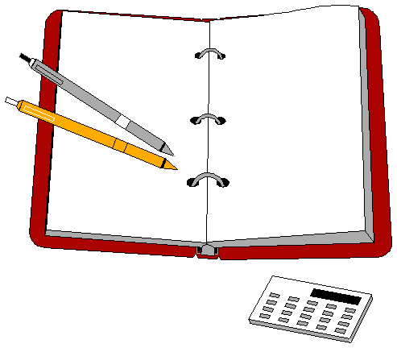
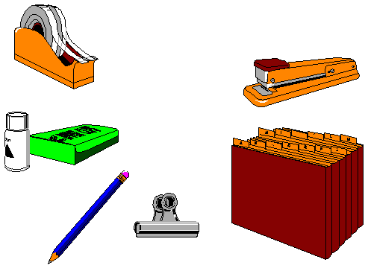



Which is the best description for the above picture?
- For Sale
- Equipment used in an office
- c) Instruments for you

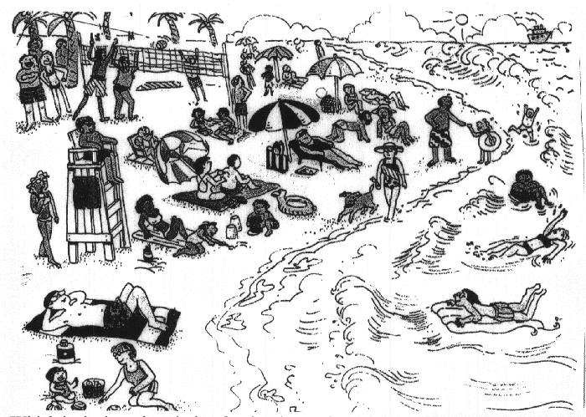
Which is the best description for the above picture?
a) Holiday on beach
b) Beautiful beach
c) Activity of people

( بالتوفيق للجميع أخوكم / سحاب الليل )

