2- Activation :
After Setup Finish you must activation the sage line
Go to Start --> all programs --> Sage --> Sage line50
Click Right --> Run as administrator
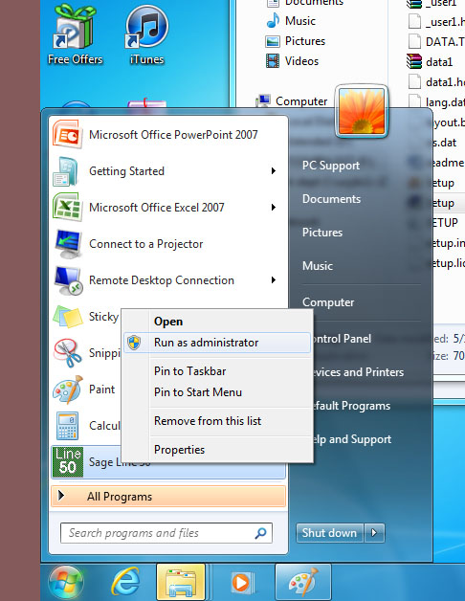

In ActiveSetup Wizard
Press next
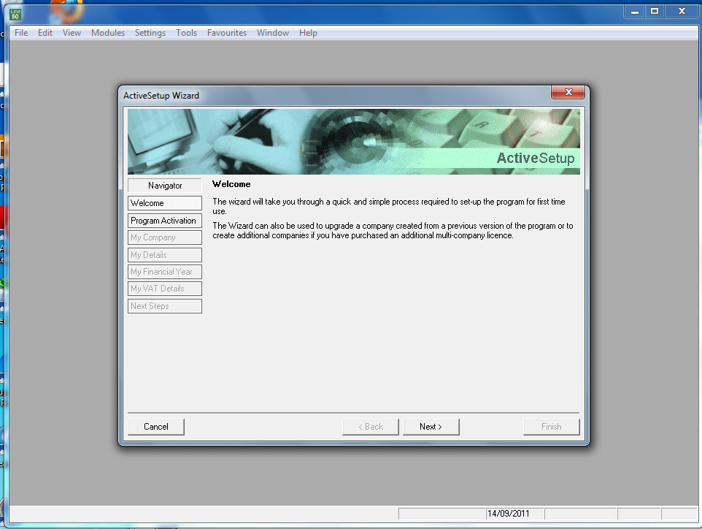

Enter the Serial No (u208302) and Activation Key (jfolfvq) from ’ Documentation and Serial key’ that you have it in ‘Sageline50’ folder
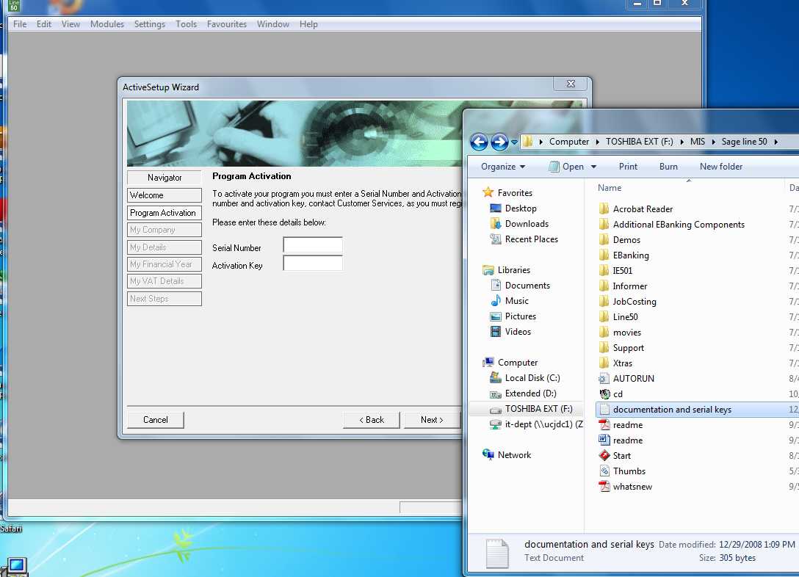

Press next
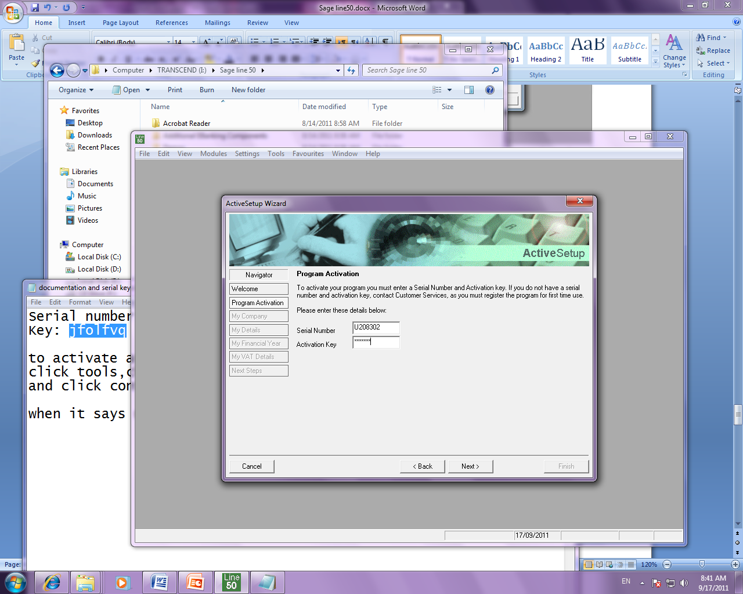

Press next
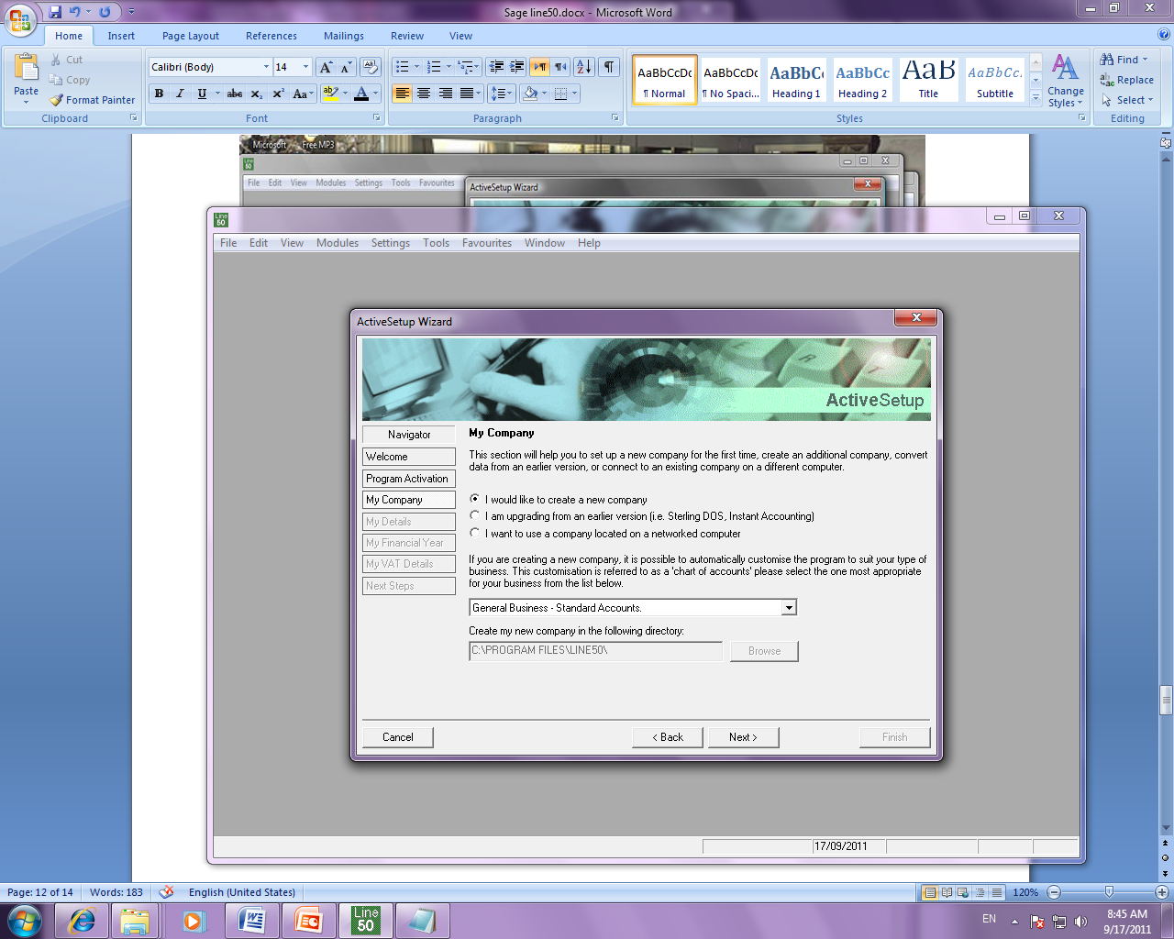

Enter company name
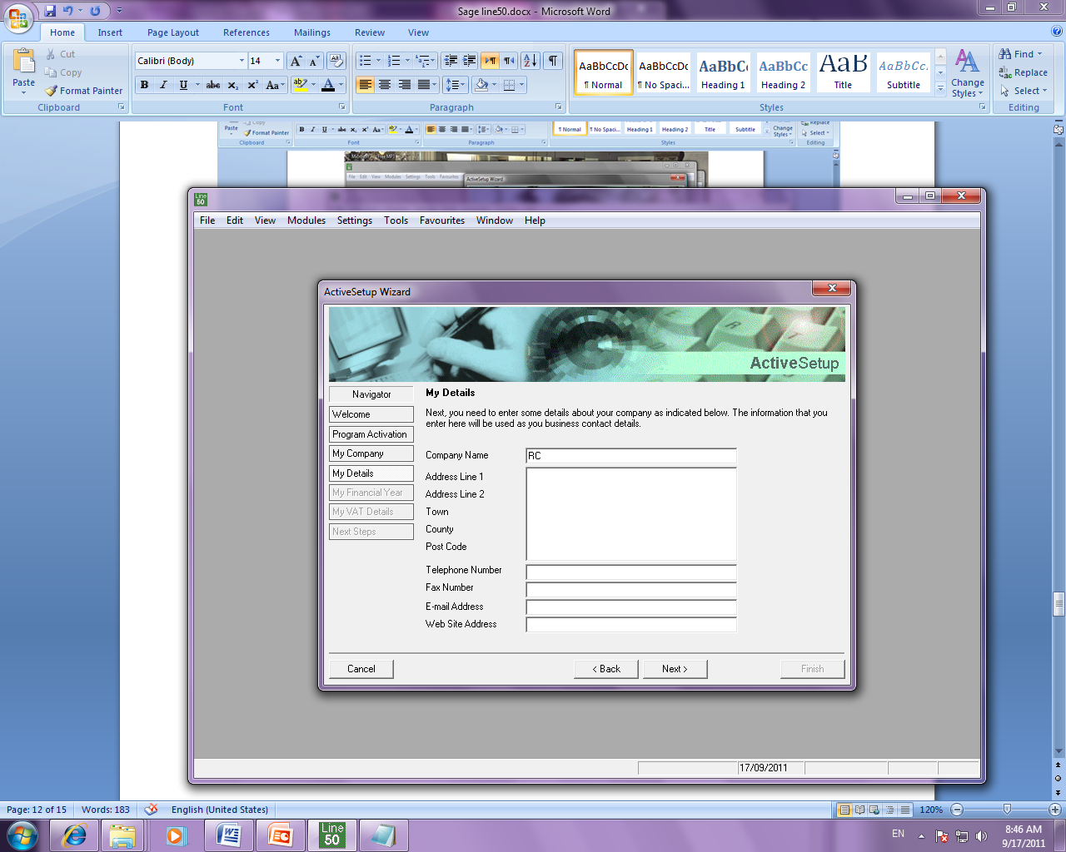
EX . Rc , then press Next

Enter my financial year
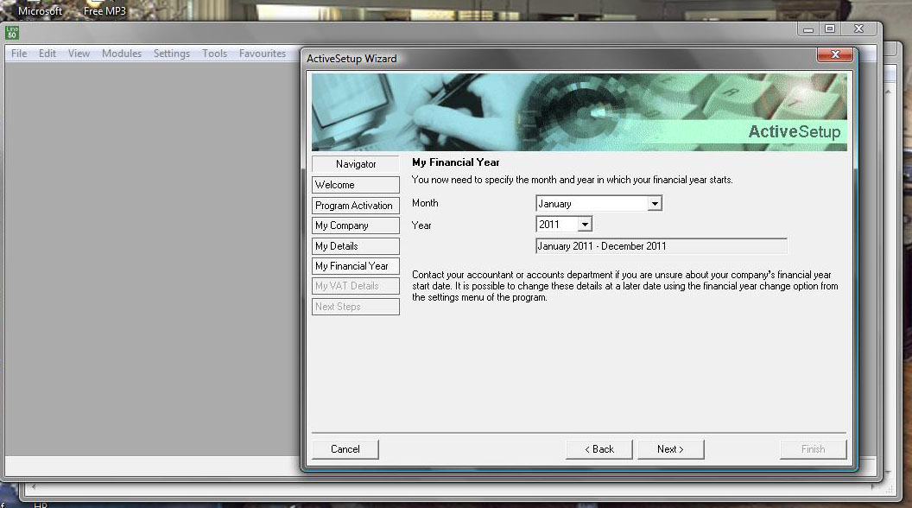

Press Next
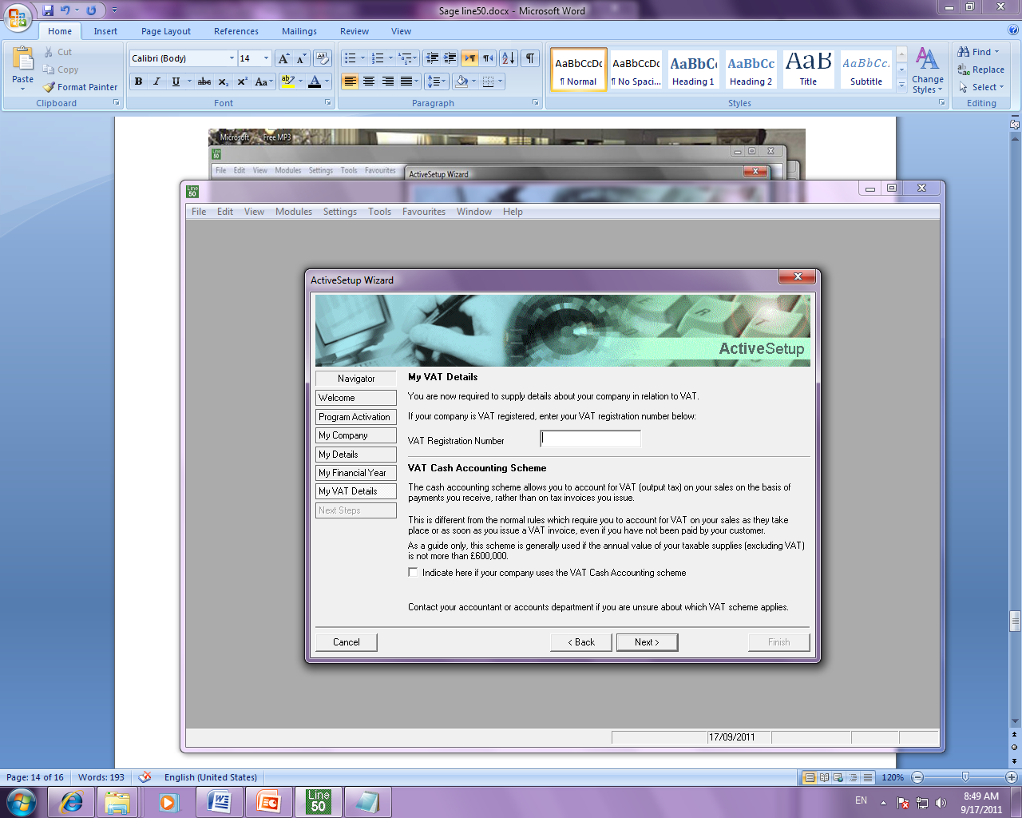

Press finish
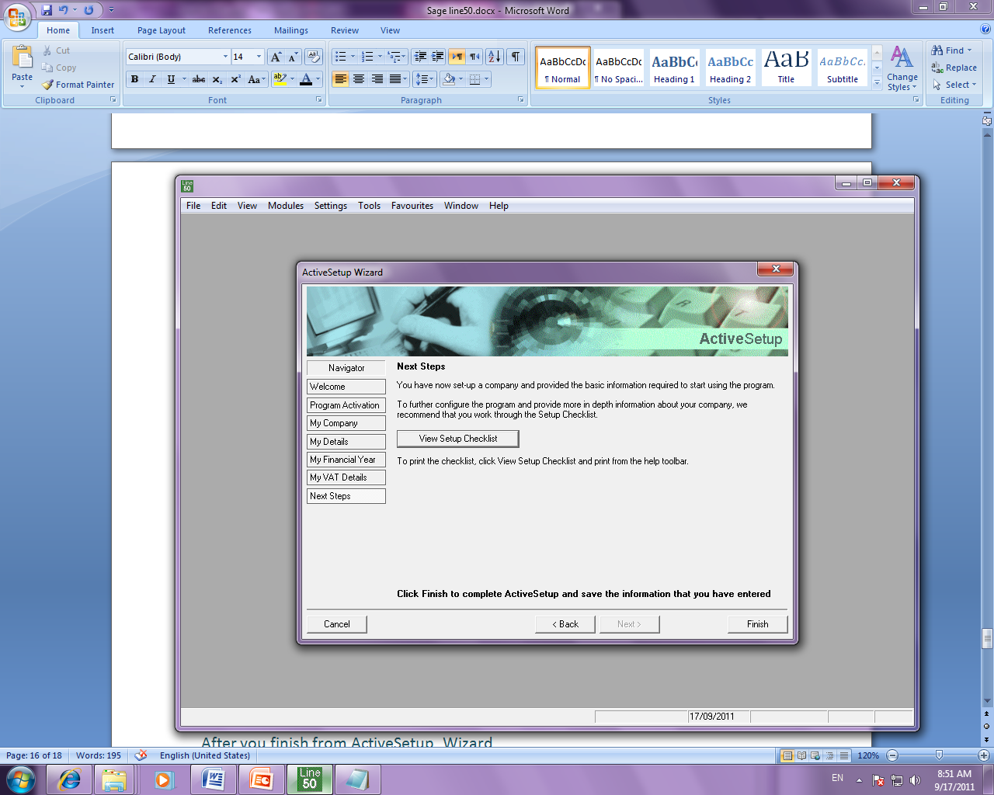

Press ok
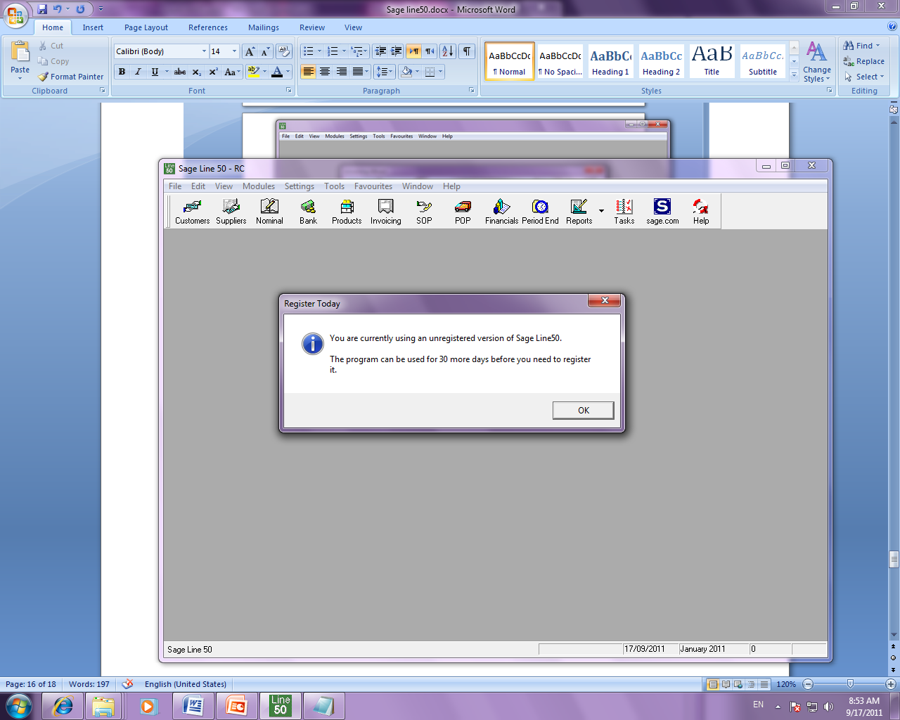

After you finish from ActiveSetup Wizard
We do upgrad program
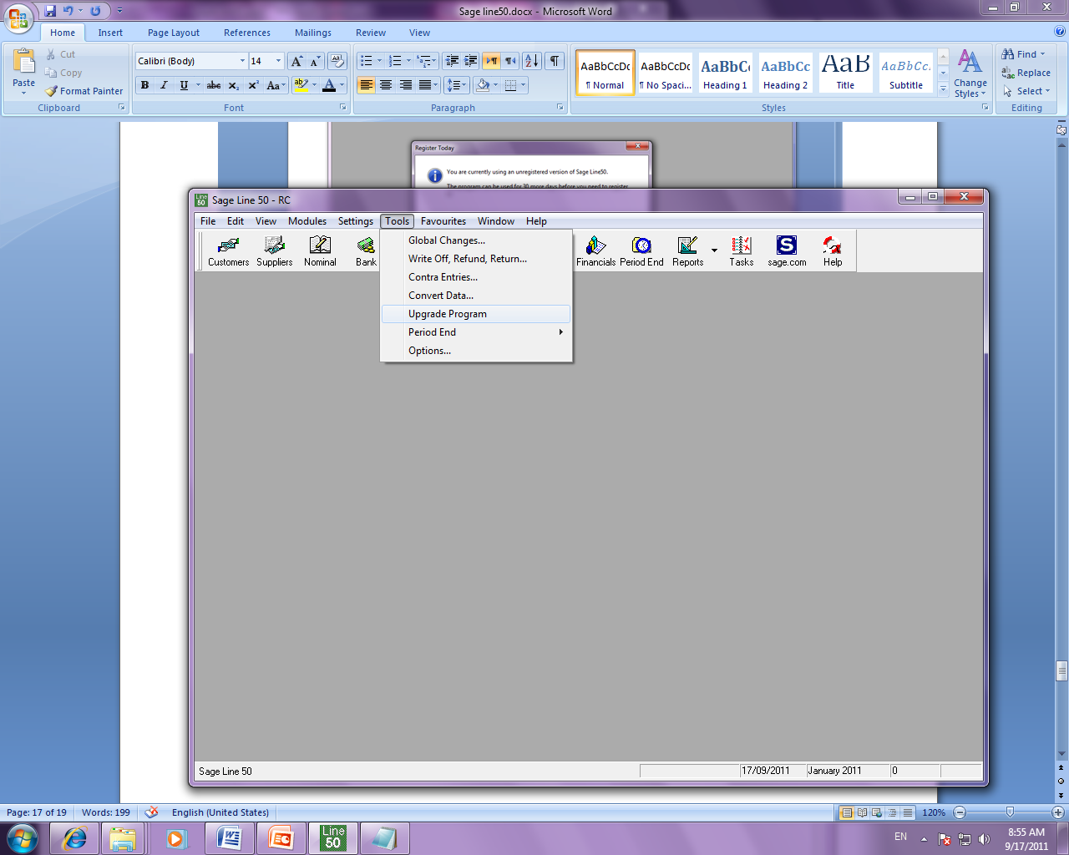
Open the Sage Line50 program then →Tools → upgrade program

Put the Registration information
Press continue
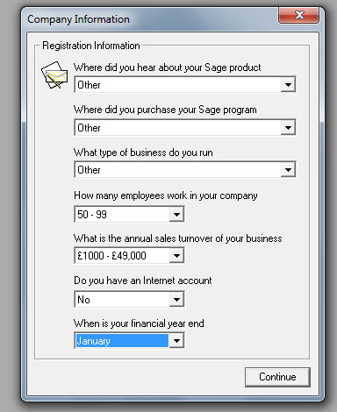

Enter New Key(deigcbg) from ’ Documentation and Serial key’ that you have it in ‘Sageline50’ folder
Press Continue
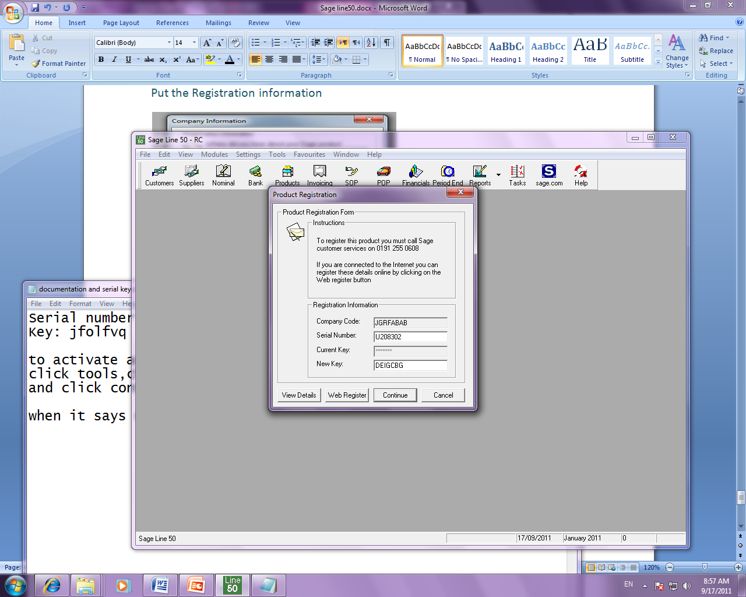

Press ok

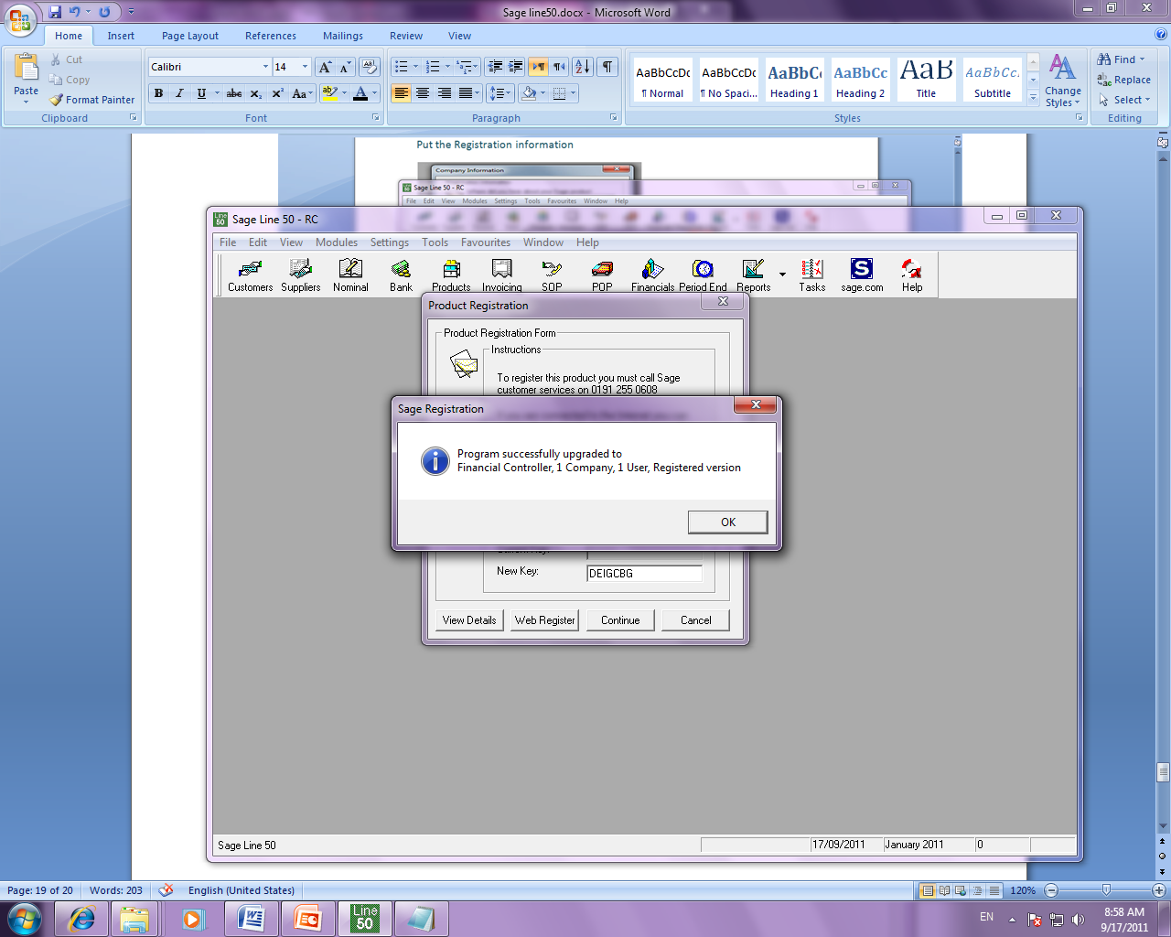

Now you Finish installation and you can work with Sage Line Program
