Lecture 4
The Modern English Novel :
Heart of Darkness
Beginning through Marlow’s being hired as a steamboat captain – summery
At sundown, a pleasure ship called the Nellie lies anchored at the mouth of the Thames, waiting for the tide to go out. Five men relax on the deck of the ship: the Director of Companies, who is also the captain and host, the Lawyer, the Accountant, Marlow, and the unnamed Narrator. The five men, old friends held together by “the bond of the sea,” are restless yet meditative, as if waiting for something to happen. As darkness begins to fall, and the scene becomes “less brilliant but more profound,” the men recall the great men and ships that have set forth from the Thames on voyages of trade and exploration, frequently never to return. Suddenly Marlow remarks that this very spot was once “one of the dark places of the earth.” He notes that when the Romans first came to England, it was a great, savage wilderness to them. He imagines what it must have been like for a young Roman captain or soldier to come to a place so far from home and lacking in comforts.
This train of thought reminds Marlow of his sole experience as a “fresh-water sailor,” when as a young man he captained a steamship going up the Congo River. He recounts that he first got the idea when, after returning from a six-year voyage through Asia, he came across a map of Africa in a London shop window, which reinvigorated his childhood
Heart of Darkness
fantasies about the “blank spaces” on the map.
Marlow recounts how he obtained a job with the Belgian “Company” that trades on the Congo River (the Congo was then a Belgian territory) through the influence of an aunt who had friends in the Company’s administration. The Company was eager to send Marlow to Africa, because one of the Company’s steamer captains had recently been killed in a scuffle with the natives.
Analysis :
Marlow’s story of a voyage up the Congo River that he took as a young man is the main narrative of Heart of Darkness. Marlow’s narrative is framed by another narrative, in which one of the listeners to Marlow’s story explains the circumstances in which Marlow tells it. The narrator who begins Heart of Darkness is unnamed, as are the other three listeners, who are identified only by their professional occupations. Moreover, the narrator usually speaks in the first-person plural, describing what all four of Marlow’s listeners think and feel.





Whatever happens we have got
The Maxim gun, and they have not
Hilaire Belloc 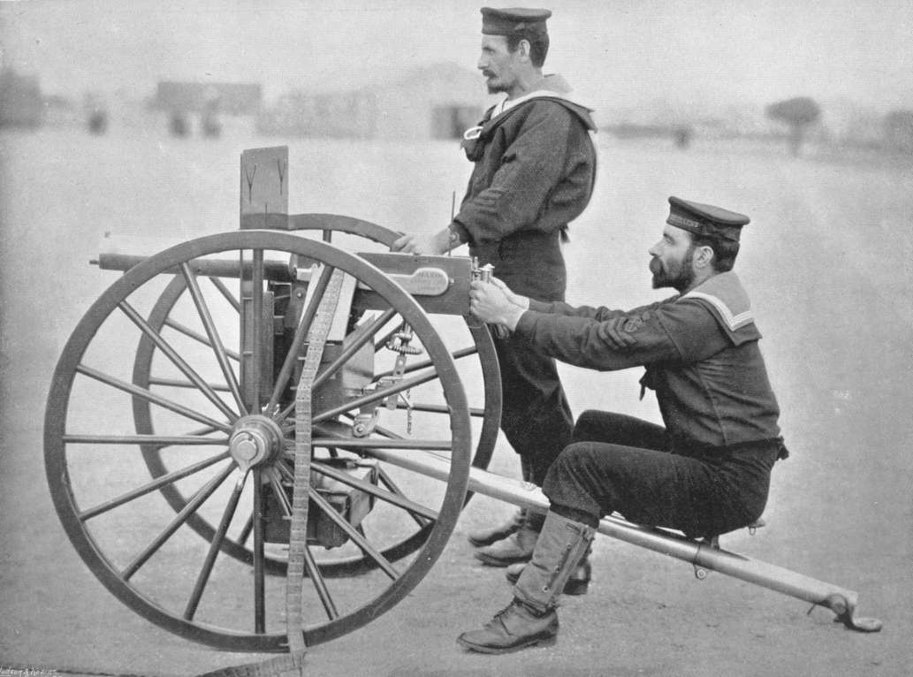 .

Heart of Darkness
The unanimity and anonymity of Marlow’s listeners combine to create the impression that they represent conventional perspectives and values of the British establishment.
For the narrator and his fellow travelers, the Thames conjures up images of famous British explorers who have set out from that river on glorious voyages. The narrator recounts the achievements of these explorers in a celebratory tone, calling them “knight-errants” of the sea, implying that such voyages served a sacred, higher purpose. The narrator’s attitude is that these men promoted the glory of Great Britain, expanded knowledge of the globe, and contributed to the civilization and enlightenment of the rest of the planet.
At the time Heart of Darkness was written, the British Empire was at its peak, and Britain controlled colonies and dependencies all over the planet. The popular saying that “the sun never sets on the British Empire” was literally true. The main topic of Heart of Darkness is imperialism, a nation’s policy of exerting influence over other areas through military, political, and economic coercion.
.
The narrator expresses the mainstream belief that imperialism is a glorious and worthy enterprise. Indeed, in Conrad’s time, “empire” was one of the central values of British subjects, the fundamental term through which Britain defined its identity and sense of purpose.
From the moment Marlow opens his mouth, he sets himself apart from his fellow passengers by conjuring up a past in which Britain was not the heart of civilization but the savage “end of the world.” Likewise, the Thames was not the source of glorious journeys outward but the ominous beginning of a journey inward, into the heart of the wilderness. This is typical of Marlow as a storyteller: he narrates in an ironic tone, giving the impression that his audience’s assumptions are wrong, but not presenting a clear alternative to those assumptions. Throughout his story, distinctions such as inward and outward, civilized and savage, dark and light, are called into question. But the irony of Marlow’s story is not as pronounced as in a satire, and Marlow’s and Conrad’s attitudes regarding imperialism are never entirely clear.
From the way Marlow tells his story, it is clear that he is extremely critical of imperialism, but his reasons apparently have less to do with what imperialism does to colonized peoples than with what it does to Europeans. Marlow suggests, in the first place, that participation in imperial enterprises degrades Europeans by removing them from the “civilizing” context of European society, while simultaneously tempting them into violent behavior because of the hostility and lawlessness of the environment. Moreover, Marlow suggests that the mission of “civilizing” and “enlightening” native peoples is misguided, not because he believes that they have a viable civilization and culture already, but because they are so savage that the project is overwhelming and hopeless. Marlow expresses horror when he witnesses the violent maltreatment of the natives, and he argues that a kinship exists between black Africans and Europeans, but in the same breath he states that this kinship is “ugly” and horrifying, and that the kinship is extremely distant. Nevertheless, it is not a simple matter to evaluate whether Marlow’s attitudes are conservative or progressive, racist or “enlightened.”
In the first place, one would have to decide in relation to whom Marlow was conservative or progressive. Clearly, Marlow’s story is shaped by the audience to whom he tells it. The anonymous narrator states that Marlow is unconventional in his ideas, and his listeners’ derisive grunts and murmurs suggest that they are less inclined to question colonialism or to view Africans as human beings than he is. His criticisms of colonialism, both implicit and explicit, are pitched to an audience that is far more sympathetic toward the colonial enterprise than any twenty-first-century reader could be. The framing narrative puts a certain amount of distance between Marlow’s narrative and Conrad himself. This framework suggests that the reader should regard Marlow ironically, but there are few cues within the text to suggest an alternative to Marlow’s point of view.
Marlow’s visit to the Company Headquarters through his parting with his aunt - summery
After he hears that he has gotten the job, Marlow travels across the English Channel to a city that reminds him of a “whited sepulchre” (probably Brussels) to sign his employment contract at the Company’s office. First, however, he digresses to tell the story of his predecessor with the Company, Fresleven. Much later, after the events Marlow is about to recount, Marlow was sent to recover Fresleven’s bones, which he found lying in the center of a deserted African village. Despite his reputation as mild mannered, Fresleven was killed in a scuffle over some hens: after striking the village chief, he was stabbed by the chief’s son. He was left there to die, and the superstitious natives immediately abandoned the village. Marlow notes that he never did find out what became of the hens.

Arriving at the Company’s offices, Marlow finds two sinister women there knitting black wool, one of whom admits him to a waiting room, where he looks at a map of Africa color-coded by colonial powers. A secretary takes him into the inner office for a cursory meeting with the head of the Company. Marlow signs his contract, and the secretary takes him off to be checked over by a doctor. The doctor takes measurements of his skull,
remarking that he unfortunately doesn’t get to see those men who make it back from Africa. More important, the doctor tells Marlow, “the changes take place inside.” The doctor is interested in learning anything that may give Belgians an advantage in colonial situations.
With all formalities completed, Marlow stops off to say goodbye to his aunt, who expresses her hope that he will aid in the civilization of savages during his service to the Company, “weaning those ignorant millions from their horrid ways.” Well aware that the Company operates for profit and not for the good of humanity, and bothered by his aunt’s naïveté, Marlow takes his leave of her. Before boarding the French steamer that is to take him to Africa, Marlow has a brief but strange feeling about his journey: the feeling that he is setting off for the center of the earth.


Analysis :
This section has several concrete objectives. The first of these is to locate Marlow more specifically within the wider history of colonialism. It is important that he goes to Africa in the service of a Belgian company rather than a British one. The map that Marlow sees in the Company offices shows the continent overlaid with blotches of color, each color standing for a different imperial power. While the map represents a relatively neutral way of describing imperial presences in Africa, Marlow’s comments about the map reveal that imperial powers were not all the same. In fact, the yellow patch—“dead in the center”—covers the site of some of the most disturbing atrocities committed in the name of empire. The Belgian king, Leopold, treated the Congo as his private treasury, and the Belgians had the reputation of being far and away the most cruel and rapacious of the colonial powers. The reference to Brussels as a “whited sepulchre” is meant to bring to mind a passage from the Book of Matthew concerning hypocrisy. The Belgian monarch spoke rhetorically about the civilizing benefits of colonialism, but the Belgian version of the practice was the bloodiest and most inhumane
This does not, however, mean that Conrad seeks to indict the Belgians and praise other colonial powers. As Marlow journeys into the Congo, he meets men from a variety of European nations, all of whom are violent and willing to do anything to make their fortunes. Moreover, it must be remembered that Marlow himself willingly goes to work for this Belgian concern: at the moment he decides to do so, his personal desire for adventure far outweighs any concerns he might have about particular colonial practices. This section of the book also introduces another set of concerns, this time regarding women. Heart of Darkness has been attacked by critics as misogynistic, and there is some justification for this point of view. Marlow’s aunt does express a naïvely idealistic view of the Company’s mission, and Marlow is thus right to fault her for being “out of touch with truth.” However, he phrases his criticism so as to make it applicable to all women, suggesting that women do not even live in the same world as men and that they must be protected from reality. Moreover, the female characters in Marlow’s story are extremely flat and stylized. In part this may be because Marlow uses women symbolically as representatives of “home.” Marlow associates home with ideas gotten from books and religion rather than from experience.
Home is the seat of naïveté, prejudice, confinement, and oppression. It is the place of people who have not gone out into the world and experienced, and who therefore cannot understand. Nonetheless, the women in Marlow’s story exert a great deal of power. The influence of Marlow’s aunt does not stop at getting him the job but continues to echo through the Company’s correspondence in Africa. At the Company’s headquarters, Marlow encounters a number of apparently influential women, hinting that all enterprises are ultimately female-driven.
Marlow’s departure from the world of Belgium and women is facilitated, according to him, by two eccentric men. The first of these is Fresleven, the story of whose death serves to build suspense and suggest to the reader the transformations that Europeans undergo in Africa. By European standards, Fresleven was a good and gentle man, not one likely to die as he did. This means either that the European view of people is wrong and useless or else that there is something about Africa that makes men behave aberrantly. Both of these conclusions are difficult to accept practically or politically, and
thus the story of Fresleven leaves the reader feeling ambivalent and cautious about Marlow’s story to come.
The second figure presiding over Marlow’s departure is the Company’s doctor. The doctor is perhaps the ultimate symbol of futility: he uses external measurements to try to decipher what he admits are internal changes; moreover, his subjects either don’t return from Africa or, if they do, don’t return to see him. Thus his work and his advice are both totally useless. He is the first of a series of functionaries with pointless jobs that Marlow will encounter as he travels toward and then up the Congo River.
.

